Comparative studies reveal variability in the use of tidal stream environments by seabirds
James J. Waggitt^{a, b, c,} ; Alexandra M.C. Robbins^{d, f} ; Helen M. Wade^{c, e} ; Elizabeth A. Masden^{e} ; Robert W. Furness^{d, g} ; Angus C. Jackson^{e, h} ; Beth E. Scott^{b}

a School of Ocean Sciences, Bangor University, Menai Bridge LL59 5AB, UK
b Institute of Biological and Environmental Sciences, University of Aberdeen, Aberdeen AB24 2TZ, UK
c Marine Scotland Science, Marine Laboratory, Aberdeen AB11 9BD, UK
d College of Medical, Veterinary and Life Sciences, University of Glasgow, Glasgow G12 8QQ, UK
e Environmental Research Institute, North Highland College, University of the Highlands and Islands, Thurso KW14 7EE, UK
f Scottish Natural Heritage, Perth PH1 3EW, UK
g MacArthur Green, Glasgow G20 6NT, UK
h Cornwall College Newquay, Newquay TR7 2LZ, UK

Published in Marine Policy, Volume 81, July 2017, Pages 143–152

Abstract: The global increase in tidal stream turbine installations creates a need to identify and mitigate any impacts on seabird populations. Within Scotland, UK, the vulnerability of black guillemots Cepphus grylle and European shags Phalacrocorax aristotelis is dependent on their tendency to exploit microhabitats characterised by fast mean horizontal current speeds (≥2 ms^{–1}), and tidal states with maximum current speeds, within tidal stream environments. Identifying consistencies in their relative use of different microhabitats (fast versus slow mean horizontal current speeds) and tidal states (increasing/decreasing versus maximum currents) across these habitats could assist risk assessment and mitigation measures at both a regional and development site level. Datasets from shore-based surveys collated across 6 tidal stream environments showed that the probability of detecting foraging black guillemots and European shags tended to be higher in fast and slow microhabitats, respectively. However, differences between microhabitats were reversed and/or marginal in 3 out of the 5 sites used for each species. Differences between tidal states were almost always marginal. These variabilities show that a species' vulnerability could differ greatly among development sites, and environmental impact assessments (EIA) must quantify habitat-use using dedicated and site-specific surveys to reduce uncertainty. However, a greater understanding of the mechanisms underlying variation in the use of tidal stream environments is needed when selecting a suite of potential development sites that reduce the possibility of population-level impacts. The current collection of physical and biological data across tidal stream environments could therefore prove invaluable for the protection of seabird populations.

Keywords: Cepphus grylle; Phalacrocorax aristotelis; Marine spatial planning; Marine renewable energy installations; Environmental impact assessment; Shore-based survey

1. Introduction
Increases in offshore anthropogenic activities (e.g. marine renewable energy extraction, oil/gas extraction, fisheries, shipping) place threats on seabird populations via mechanisms such as habitat modification, reduced prey abundance/quality, disturbance, and collisions with structures. There is a need to identify and mitigate threats if populations of species are to be protected [1]. One means of identifying potential impacts is to establish the range of threats posed by a particular anthropogenic activity, and then assess which species are vulnerable to this range of threats. These assessments often involve descriptions of the behaviour or ecology of a species, followed by an informed evaluation of whether this behaviour or ecology makes them vulnerable [2]; [3]; [4]; [5]; [6] ; [7]. The quantification of behavioural or ecological tendencies, at least those aspects which are relevant to the threat of concern, can assess the extent of potential impacts on a population. For instance, quantifying the flight heights of a species can help to estimate the number of population members that may collide with moving components of wind turbines [8]. By enabling effort and resources to focus on particularly vulnerable species, these descriptions and quantifications can also aid environmental impact assessments (EIA) aiming to minimise the possibility of localised impacts from a specific activity [9].

Scotland, UK, has pledged to provide 100% of its energy from renewable sources by 2020 [10]. This has led to widespread interest in the development of marine renewable energy installations, in particular the extraction of tidal stream energy due to the prevalence of exploitable resource across this region [11]. However, Scotland is an important area for breeding seabirds [12], and this has raised concerns regarding the impacts of tidal stream energy extraction on these populations [13]. Mortality or serious injuries resulting from collisions between pursuit-diving seabirds and moving components remain the principal concern [14], as does the possibility of reduced foraging opportunities due to seabirds avoiding areas immediately around installations (displacement) [13] ; [15]. Current assessments suggest that black guillemot Cepphus grylle and European shag Phalacrocorax aristotelis populations may be particularly vulnerable to collisions and displacement due to their tendency to exploit tidal stream environments, performance of deep dives whilst exploiting benthic fish, and year-round residency [2]. Scotland supports 86% and 57% of the UK black guillemot and European shag populations, respectively [12]. Therefore, identifying and mitigating impacts on these species is a research priority. However, studies focussing on black guillemot and European shag use of tidal stream environments remain scarce [16]. Consequently, there is much uncertainty surrounding these assessments [7]. Nevertheless, the increases in leased and proposed development sites within Scotland, alongside the requirement to assess potential impacts on seabird populations, have encouraged several studies into their behaviour and ecology within these habitats [17]; [18]; [19]; [20] ; [21]. This provides an opportunity to investigate the possibility of consistencies in habitat-use, and contribute towards the identification and mitigation of impacts at a regional and development site level.

The assessment of a species' vulnerability to collisions and displacement can be broadly divided into two components: (1) the likelihood of a species interacting with an installation, (2) the likelihood of a species interacting with a rotating blade [22]. Such assessments require an understanding of the spatial and temporal use of tidal stream environments by a species. Firstly, interactions between strong horizontal currents and complex topography in tidal stream environments cause the former to accelerate on the seaward side(s) of headlands and islands, but decelerate in the wake of these features, creating adjacent areas of greatly contrasting speeds [16]. Therefore, these habitats are divisible into areas characterised by generally fast (≥2 m s⁻¹) or slow (<2 m s⁻¹) mean horizontal current speeds (see [23]). Studies have found species foraging on benthic fish to associate with either fast or slow microhabitats [18]; [23] ; [24]. As the majority of installations will be found in fast microhabitats, driven by the need to maximise energy returns [25], any species associating with these areas are considered more vulnerable [22]. Secondly, horizontal current speeds in tidal stream environments change greatly across ebb-flood tidal cycles, from almost stationary to >4 m s⁻¹ in some extreme cases [16]. Studies have also found species foraging on benthic fish to associate with either increasing/decreasing [17] or maximum currents [23]. Due to the faster rotation of blades during maximum currents, any species associating with this tidal state are also considered more vulnerable [14] ; [26]. Combining information on the tendency of a species to exploit fast or slow microhabitats, and also increasing/decreasing or maximum currents, across Scotland would offer insights into possibility of collisions and displacement having impacts within this region [22].
This study compares the relative use of microhabitats, and the relative use of fast microhabitats over different current speeds, by black guillemots and European shags in tidal stream environments across Scotland during the breeding season. Datasets from methodologically similar shore-based surveys, recording spatial and temporal distributions, were collated across this region. Two questions relevant to the assessment of a species' vulnerability to collisions and displacement at a regional scale were then asked: (1) do species consistently associate with a particular microhabitat (fast versus slow) across all study sites, (2) do species consistently associate with fast microhabitats during a particular tidal state (maximum versus increasing/decreasing currents) across all study sites? The implications of the answers to the questions, with regard to the identification and mitigation of any negative impacts at a regional and development site level, were then discussed.

2. Methods

2.1. Study sites and survey periods
Shore-based surveys were performed in six sites across the Highlands and Islands region of Scotland: (1) Bluemull Sound, Yell, Shetland (60° 41.96′ N, 0° 58.75′ W), (2) Rousay Sound, Rousay, Orkney (59° 8.94′ N, 3° 6.66′ W), (3) The Fall of Warness, Eday, Orkney (59° 8.99′ N, 2° 45.24′ W); (4) Inner Sound, Stroma, Caithness (58° 39.53′ N, 3° 8.96′ W); (5) Kylerhea, Isle of Skye, Inner Hebrides (57° 14.56′ N, 5° 39.35′ W) and (6) Sound of Islay, Islay, Inner Hebrides (55° 50.19′ N, 6° 5.69′ W). All surveys were connected with academic research seeking to understand the use of tidal stream environments by seabirds (e.g. [17]; [19] ; [20]), and were undertaken between May and July when breeding adults were incubating or rearing chicks [12]. The locations of sites and tidal stream energy resource in Scotland are shown in Fig. 1. Sites spanned a large geographic range, and covered every sub-region containing exploitable resource within Scotland (Orkney, Shetland and the Hebrides). The most northerly and southerly sites were 620 km apart; however, they could be broadly divided into northern (Bluemull Sound, Rousay Sound, Fall of Warness and Inner Sound) and western (Kylerhea and Sound of Islay) locations. Sites could also be broadly divided into narrow channel (Bluemull Sound, Rousay Sound, Kylerhea and Sound of Islay) and headland (Fall of Warness and Inner Sound) habitats, based upon their topographic features. All sites covered relatively small areas (<~ 4 km²) where maximum horizontal currents exceeded 2 m s⁻¹[11]. Therefore, all sites were considered suitable for tidal stream energy extraction [27]. However, there were no tidal stream turbines present within any of the sites before or during surveys. Whilst up to 8 installations may be present at the European Marine Energy Centre (EMEC) in the Fall of Warness, the nearest was located approximately 500 m to the south of the site [17]. Although considered to be abundant in the locality, black guillemots and European shags were not included in the analyses for Kylerhea and Inner Sound, respectively, because too few foraging individuals were recorded in the survey area (Table 1).

2.2. Microhabitat categorisation
Fast and slow microhabitats were defined using hydrodynamic model outputs (Bluemull Sound, Inner Sound) or visual observations (Fall of Warness, Kylerhea, Rousay Sound and Sound of Islay). The need for two approaches was due to differences in the availability of hydrodynamic model outputs among sites at the time of microhabitat categorisation. MIKE 21 2D Hydrodynamic model outputs [28] at <100 m resolution, quantifying horizontal current speeds at the sea surface across a typical ebb-flood tidal cycle, were used at both Bluemull Sound [29] and Inner Sound [30]. When visual observations were used, methods were based on those used previously by Holm and Burger [23]. Fast microhabitats were identified as areas containing strong and relatively laminar current flow across most of the ebb-flood tidal cycle. All other parts of the site were then categorised as slow microhabitats. Discrimination of fast and slow microhabitats were aided by the prominent shear lines that form between areas of greatly contrasting horizontal current speeds (Fig. 2), and also by the headlands and islands which denote the position of these microhabitat [16]. Microhabitat categorisation using visual observations was performed during calm (Beaufort scale≤2) and clear weather conditions, when hydrodynamic and topographic features were clearly visible from the shoreline. The use of visual observations was only possible due to the small area (<~4 km²) of sites. The areas of fast and slow microhabitats within each site are shown in Fig. 3. Despite the use of two methods, fast and slow microhabitats represent discrete and conspicuous areas in tidal stream environments [16]. Therefore, the accuracy of microhabitat categorisation should be consistent across sites.

2.3. Tidal state categorisation
Tidal state was identified using times of high and low water sourced from the POLTIPS software (Version 3.0, National Oceanography Centre) at the nearest available location to each site. The times of high and low water were then adjusted to account for the distance between each site and this location. These adjustments were based upon local knowledge and/or assessment of hydrodynamic model outputs where available. Within tidal stream environments, the ebb-flood tidal cycle is typically divided into six categories, defined by the speed and direction of the prevalent horizontal currents: increasing ebb, maximum ebb, decreasing ebb, increasing flood, maximum flood and decreasing flood [31]. Increases in foraging seabirds could be associated with certain tidal states within a site [16] ; [32]. However, impacts from collisions and displacement concern the rotation of moving components, which are linked to horizontal current speeds rather than direction. To aid interpretation and increase statistical power (by decreasing the degrees of freedom), the ebb-flood tidal cycle was divided into two categories based upon its horizontal current speed: increasing/decreasing currents and maximum currents.

2.4. Foraging distributions
Shore-based survey methods were similar among sites: (1) observers were situated at fixed vantage points on coastlines next to the survey area; (2) at discrete time intervals, the observer visually scanned the survey area using a telescope (between 20 and 77 times magnification, depending upon the site) to locate foraging seabirds; (3) the observer scanned against the direction of the prevailing current in fast microhabitats to avoid double-counting foraging seabirds drifting with the flow. It was assumed that all seabirds on the sea surface were encountered during or between diving bouts, as breeding Alcidae and Phalacrocoridae are primarily engaged in foraging activities when at-sea [33] ; [34]. Whilst seabirds rest immediately alongside their nest sites during breeding seasons [35], such behaviour was mainly observed in particularly shallow and sheltered water, which were not included in scans.

Despite general similarities, specific methods differed among sites. In sites >2 km wide (Fall of Warness and Inner Sound), surveys focussed upon a subset of the site containing fast and slow microhabitats (Fig. 3), whereas in those <2 km wide (Bluemull Sound, Kylerhea, Sound of Islay, and Rousay Sound) surveys covered the majority of the site (Fig. 2). At four sites (Fall of Warness, Kylerhea, Sound of Islay and Rousay Sound), observers carefully controlled the speed of scans to ensure a consistent scan duration (Table 1). At the time of detection, foraging seabirds were assigned to either fast or slow microhabitats. To ensure accurate assignment, scans were only performed when hydrodynamic and topographic features used to identify the locations of microhabitats were visible. At Bluemull Sound, the duration of scans lasted until the observer was confident all foraging seabirds had been detected (Table 1). The distance and bearing to sightings were immediately recorded, which allowed allocation to fast or slow microhabitats post-survey [19]. In the Inner Sound, the duration of scans also lasted until the observer was confident that all foraging seabirds had been detected (Table 1). At the time of detection, sightings were assigned to one of nine grid cells (Fig. 3), which were classified as either fast or slow microhabitats post-survey. At both Bluemull Sound and Inner Sound, a compass and rangefinder (calibrated using local landmarks) were used to record the positions of foraging seabirds [19] and the boundaries of grid cells [20], respectively. A single vantage point was used at Bluemull Sound, Fall of Warness, Kylerhea, Inner Sound and Rousay Sound. By contrast, five vantage points were used at the Sound of Islay. However, the observer only occupied a single vantage point during a survey, each covering around a third of the site.

2.5. Statistical analysis
Generalised linear mixed effect models (GLMM) with binomial distributions were used to quantify differences in the probabilities of encountering foraging seabirds between microhabitats and tidal state. Separate models were performed for each species. The presence or absence of foraging seabirds was the response variable, with microhabitat (fast or slow) and tidal state (increasing/decreasing or maximum currents) as fixed and categorical explanatory variables, and sea state (Beaufort scale) as a fixed and continuous explanatory variable. Sea state was included to account for decreases in the detectability of foraging seabirds during periods of high winds. A presence-absence modelling approach was taken due to the large number of zero or low counts (percentage of 0 or 1 counts: Black Guillemot=77%, European Shag=72%) and overdispersion in overall counts (variance to mean ratio: Black Guillemot=6.58, European Shag=4.55), which hindered the robust statistical analysis of abundance data. However, large counts of either species were rare (mean count: black guillemots=1.23, European shags=1.47), meaning that a presence-absence modelling approach would detect broad associations with either microhabitat or tidal state. Microhabitat and tidal state were both modelled with site as an interaction term, therefore quantifying differences in relationships with microhabitat or tidal state among sites. Date was included as a random effect to account for daily variances in the detectability of foraging seabirds among surveys that were not associated with fixed factors, such as variations in weather conditions other than sea state. This approach also accounted for strong temporal autocorrelation seen in the residuals of these models when performed without a random effort. Fast and slow microhabitat area (km²) was included as an offset to correct for differences in their extent within and among sites (Table 1). The microhabitat area at the Sound of Islay was divided by three, as each survey only covered third of the survey area (Table 1).

Conventional analyses accounting for possible decreases in the detectability of foraging seabirds as a function of distance from observers [36] were not possible, because the underlying assumption of a homogenous distribution is almost certainly violated in shore-based surveys covering expansive areas [37] ; [38]. There could also be decreases in the detection of foraging seabirds as a function of current complexity and distance to land [39]. Whilst the possibility of including distance as an additional explanatory variable was also considered [39], the close collinearity between distance and microhabitat in many sites (see. Fig. 3) prevented this. The likely collinearity between microhabitat and current complexity/distance to land presented similar issues. However, as survey areas were never more than 2 km away from the vantage point, and because telescopes at high magnification were used, spatial variations in the detectability of foraging seabirds linked to distance, current complexity and proximity to coastlines would have been minimised [39]. Therefore, any broad associations with microhabitats or tidal states should be identified by shore-based surveys.

As all explanatory variables were statistically significant (p<0.05) model selection was not performed, and inference was based upon full models. Residuals associated with fixed effects showed no evidence of strong temporal autocorrelation, whilst plots of intercepts associated with random effects resembled normal distributions; they were centred upon 0 and showed relatively few outliers (Supplementary material S1). The probabilities of encountering foraging seabirds as a function of microhabitat, and tidal state within fast microhabitats, were then predicted from model parameters for each site. Within these predictions, values of sea state were maintained as 0 to indicate optimal weather conditions. Comparable probabilities (fast versus slow microhabitats, increasing/decreasing versus maximum currents) were quantified using proportional differences (Pd). Pd represented the absolute difference between the two predicted values divided by the minimum predicted value, and quantified the relative differences between microhabitats and tidal states within each site. Pd also overcame any differences in the general likelihood of detecting foraging seabirds, linked to variations in scan duration and extent (Table 1), by basing comparisons among sites on relative rather than absolute probabilities. Analyses were performed using the ‘lme4′ [40] package in R Statistics (version 3.1.1, R Development Core Team 2014).

3. Results

3.1. Black guillemots
The probability of detecting foraging black guillemots was higher in fast microhabitats at 3 sites (Bluemull Sound, Rousay Sound, Fall of Warness), in slow microhabitats at 1 site (Sound of Islay), and identical across both microhabitats at 1 site (Inner Sound: Fig. 4). However, the magnitude of these differences varied among sites. Pd values at Fall of Warness (Pd=0.46) and Sound of Islay (Pd=2.50) indicate much more frequent use of one microhabitat, whereas those at Rousay Sound (Pd=0.07) and Bluemull Sound (Pd=0.02) suggest relatively similar use of both microhabitats. The probability of detecting foraging black guillemots in fast microhabitats was higher in maximum currents at 2 sites (Bluemull Sound, Fall of Warness), and decreasing/increasing currents at 3 sites (Rousay Sound, Inner Sound, Sound of Islay: Fig. 5). However, Pd values at Bluemull Sound (Pd=0.01), Rousay Sound (Pd=0.07), Fall of Warness (Pd=0.04), Inner Sound (Pd=0.07) and Sound of Islay (Pd=0.12) suggest relatively similar use of fast microhabitats across tidal states. General differences in the strength and type of associations among sites could neither be attributed to topography (channel versus headland) nor geographical location (northern versus western).

3.2. European shags
The probability of detecting foraging European shags was higher in fast microhabitats at 1 site (Bluemull Sound), and in slow microhabitats at 4 sites (Rousay Sound, Fall of Warness, Kylerhea and Sound of Islay: Fig. 4). However, the magnitude of differences varied among sites. Pd values at Bluemull Sound (Pd=1.62) and Sound of Islay (Pd=4.41) indicate much more frequent use of one microhabitat, whereas those at Kylerhea (Pd=0.15), Fall of Warness (Pd=0.20) and Rousay Sound (Pd=0.14) suggest relatively similar use of both microhabitats. The probability of detecting foraging European shags in fast microhabitats was higher in maximum currents at all sites (Fig. 5). Again the magnitude of differences varied among sites. Pd values at Kylerhea (Pd=0.41) indicate relatively high use of fast microhabitats at maximum currents. By contrast, those at Bluemull Sound (Pd=0.12), Rousay Sound (Pd=0.03), Fall of Warness (Pd=0.02), and Sound of Islay (Pd=0.10) suggest relatively similar use of fast microhabitats across tidal states. General differences in associations among sites could neither be attributed to topography (channel versus headland) nor geographical location (northern versus western).

4. Discussion
This study collated datasets from methodologically similar shore-based surveys at 6 tidal stream environments in Scotland to determine whether black guillemots and European shags showed consistencies in their relative use of microhabitats (fast versus slow), and current speeds within fast microhabitats (maximum versus increasing/decreasing currents), across sites. Such information could aid assessments aiming to identify and mitigate any impacts from tidal stream turbine installations, at both a regional and development site level. The probability of detecting foraging black guillemots and European shags tended to be higher in fast and slow microhabitats respectively, although these differences were either reversed or marginal in the 3 out of 5 sites studied for each species. Therefore, whilst microhabitat often had a strong influence on the foraging distribution of a species in some sites, associations with microhabitats were variable across sites within species. The probability of detecting European shags was higher in maximum currents in all sites; however, these differences were marginal in 4 out of 5 sites. The probability of detecting black guillemots showed variable relationships with tidal state, and these differences were marginal across all sites. Therefore, tidal state had a relatively minor influence on the foraging distribution of a species across all sites. The possible ecological mechanisms underlying these results are discussed below. The implications of these results for the identification and mitigation of potential impacts on black guillemots and European shags from tidal stream turbine installations are then outlined.

4.1. Habitat-use
Spatial and temporal variations in horizontal current speeds often explain the foraging distributions of a species within tidal stream environments [16]. However, this study shows that the magnitude and manner of this relationship is not consistent within species among sites. Therefore, it seems likely that species are responding to local processes within sites, resulting in site-specific habitat-use. Differences in foraging strategies among hydrodynamically similar microhabitats have also been recorded among European shags exploiting benthic fish in more benign habitats [41].

4.2. Microhabitat
Foraging strategies within tidal stream environments could depend on local prey species and availability, regardless of physical similarities. Whilst generally foraging on benthic fish, black guillemots [42]; [43] ; [44] and European shags [45] exploit a range of species. Those exploiting relatively mobile prey (e.g. gadoids) could favour faster currents due to increased encounters with disorientated and isolated fish [46]; [47] ; [48], whereas those exploiting more sedentary prey (e.g. butterfish Pholis gunnellus, burrowing sandeels Ammodytes marinus) could favour slower currents which facilitate prolonged searches on the seabed [41] ; [49]. Cultural patterns could also determine foraging strategies, with individuals learning and copying prey selection from conspecifics [50]. Therefore, differences in prey communities and prey selection among sites could explain variations in microhabitat associations [51] ; [52]. Any influence of prey on these results may not only reflect consistent disparities among sites, but also temporal changes within sites due to the different time-periods (month and year) covered at each site [53]. Additionally, species could exploit physical features which are not directly correlated with horizontal current speeds, but are instead linked to the local topography. For instance, intense turbulence and upward/downward vertical currents [16]; [18] ; [32] in areas of steep seabed may increase prey exploitability [47] ; [48]. Local topography also influences seabed characteristics, with consequences on the abundance and diversity of benthic prey [18] ; [41]. For instance, burrowing sandeels favour certain sediments [54] whereas butterfish densities could increase with macroalgae cover [55]; both are important prey species for black guillemots and European shags in Scotland [43] ; [45]. Therefore, differences in the location of these features among sites, with respect to the relative positions of slow and fast microhabitats, could also explain variations in microhabitat associations.

4.3. Tidal state
Strong relationships with tidal state generally concern species that exploit pelagic prey and/or have expansive foraging ranges [16]. Maximum currents may be needed to advect and aggregate shoaling clupeids/sandeels from neighbouring habitats [56]. Wide ranging species could exploit a site during optimal foraging conditions, but alternative sites during other times. The general absence of strong tidal patterns in foraging behaviour could be a consequence of black guillemots and European shags predominantly benthic diet [2] and/or their short foraging ranges [57] ; [58], encouraging continued use of a site regardless of tidal state. However, it needs acknowledging that the absence of strong relationships with tidal state could also be a consequence of the need to generalise analytical approaches across sites. Previous studies analysing the Fall of Warness dataset showed variations in the density of foraging black guillemots and European shags across the ebb-flood tidal cycle [17]. Discrepancies between these results, based upon the same dataset, are likely to reflect the more detailed analysis of tidal states in the previous study; analyses which was not possible in this study due to limitations in the spatial and temporal resolution of hydrodynamic information available for other sites. However, whilst the possibility of relationships with tidal state cannot be dismissed, it can be concluded that broad associations with either maximum or increasing/decreasing currents were largely absent across sites.

4.4. Survey methods
Using visual observations to identify microhabitats creates the possibility of subjectivity in where observers place boundaries; an influential decision given that areas between slow and fast microhabitats may be associated with higher levels of foraging activity [18]. Incorrect assignment of foraging seabirds at the boundaries of microhabitats could also occur if visual reference points (e.g. shear-lines, coastlines or islands) cannot be seen in poor weather. Using grid cells to quantify the location of foraging seabirds also means that those at the boundaries of microhabitats, spanning both slow and fast microhabitats, needed to be assigned as one. Because visual categorisation was restricted to calm and clear weather, it is unlikely that aforementioned issues explained much of the variation among sites. By contrast, issues concerning categorisation of grid cells cannot be overcome. However, the location of installations is likely to be based on mean horizontal current speeds [25]. Therefore, with regards to assessing the likelihood of interactions with installations, basing categorisation on mean horizontal current speeds in a grid cell is considered appropriate.

Whilst differences in methods amongst sites were deemed negligible with regard to the aims of this study, eliminating these differences would have facilitated a more comprehensive and detailed comparison of black guillemot and European shag use of tidal stream environments across Scotland. As hydrodynamic model [59] outputs provide quantifiable and comparable measurements of horizontal current speeds, their use is recommended. These outputs could also enable the identification of additional microhabitats believed to enhance foraging opportunities e.g. areas of intense turbulence and upward/downward vertical currents [18]. The development of a standardised shore-based survey method, as done for vessel-based surveys several decades ago [60], is also recommended. This method should ideally record the geographical coordinates of foraging seabirds to assure they are allocated to the correct microhabitat; an approach which could also enable wider data-use, and would be seen as an economical and efficient use of resources.

4.5. Development site implications
There is a legal obligation to identify and mitigate any localised impacts on seabirds from specific developments (European Directive: 85/337/EEC). A combination of information on the tendency of a species to occupy a site, forage immediately around installations therein, and then dive to depths near moving components, can help to quantify a species' vulnerability to collisions and displacement within a particular development site [22]. Because of the tendency of black guillemots and European shags to occupy tidal stream environments and perform deep dives whilst exploiting benthic fish, a precautionary approach is to assume that all individuals near development sites are highly vulnerable to impacts [7]. Whilst the results within this study per-se are constrained to breeding seasons in Scotland, they demonstrate the potential for vulnerability to differ among development sites within a region. For example, black guillemots exploiting the site at the Sound of Islay appear more susceptible than those exploiting that at the Fall of Warness. Differences could also occur on a local scale; comparisons with previous studies suggest that black guillemots in the northern sector of the Fall of Warness are more susceptible than those in the southern sector [18]. It is therefore essential that EIA assess the vulnerability of a species using dedicated and site-specific surveys, rather than findings from physically and geographically similar sites. However, as seasonal variations in foraging strategies do occur in tidal stream environments [18], these surveys must account for temporal variations in microhabitat-use by covering multiple years and seasons.

4.6. Regional implications
There is a responsibility to assess population-level impacts from the widespread extraction of tidal stream energy on black guillemots and European shags at a regional level, to assist in the environmentally sustainable growth of the industry [10]. Any assessment would require estimations of the proportions of regional populations that could regularly interact with installations [22]. The variability in microhabitat associations indicates that this proportion could depend largely upon the sites selected for developments, and the tendency of black guillemots and European shags to exploit fast microhabitats at these sites. A-priori predictions of microhabitat associations would benefit those tasked with selecting a suite of potential development sites which reduce the likelihood of population-level impacts. However, it is clear that a much greater understanding of the ecological mechanisms driving variations in microhabitat associations among sites is needed first [13]. The intense interest in tidal stream environments at the present time means that detailed physical properties [61] and prey communities [62]; [63]; [64] ; [65] are being recorded across these habitats in many regions, including academic and site-characterisation surveys. This data collection provides opportunities to better understand and predict variations among sites, and could prove invaluable to the protection of seabird populations. A strategic and government-led collation of data would facilitate the performance of such studies by increasing the quantity and quality of information available for analyses [22].

Acknowledgements: This study was funded by a NERC Case studentship supported by OpenHydro Ltd and Marine Scotland Science (NE/J500148/1). Shore-based surveys were funded by NERC (NE/J004340/1) and Scottish Natural Heritage (SNH), and through the Marine Renewable Energy and the Environment (MaREE) project (funded by Highlands and Islands Enterprise, the European Regional Development Fund, and the Scottish Funding Council). We thank the following people for their assistance during shore-based surveys: Jenny Campbell, Adam Cockram, Mike Cockram, Louise Cockram, Mark Cockram, Kate Cockram, Ross McGregor, Karen Hall, Melissa Bruns, Kate Tyler, Lynn Thompson, Jim Nangle, William Simpson, Jo Robertson, Peter Jones, Fiona McGillivray, Helen Chance, Colin Williams, Suzanne Robinson. We also thank the North Yell Development Group, MeyGen, Natural Power, Peter Evans, Ian Davies, Pauline Goulet, Jan Hiddink, Leigh Howarth, Shaun Fraser, Zoe Mackay, Benjamin Williamson, Jeanette Zamon and several anonymous reviewers for their various contributions to this study.

References

[1] J.P. Croxall, S.H.M. Butchart, B.G. Lascelles, A.J. Stattersfield, B. Sullivan,
A. Symes, P. Taylor, Seabird conservation status, threats and priority actions: a
global assessment, Bird Conserv. Int. 22 (2012) 1–34.
[2] R.W. Furness, H.M. Wade, A.M.C. Robbins, E.A. Masden, Assessing the sensitivity of
seabird populations to adverse effects from tidal stream turbines and wave energy
devices, ICES, J. Mar. Sci. 69 (2012) 1466–1479.
[3] R.W. Furness, M.L. Tasker, Seabird-fishery interactions: quantifying the sensitivity
of seabirds to reductions in sandeel abundance, and identification of key areas for
sensitive seabirds in the North Sea, Mar. Ecol. Prog. Ser. 202 (2000) 253–264.
[4] R.W. Furness, H.M. Wade, E.A. Masden, Assessing vulnerability of marine bird
populations to offshore wind farms, J. Environ. Manag. 119 (2013) 56–66.
[5] J.M. Williams, M.L. Tasker, I.C. Carter, A. Webb, A method of assessing seabird
vulnerability to surface pollutants, Ibis 137 (1995) 147–152.
[6] S. Garthe, O. Hüppop, Scaling possible adverse effects of marine wind farms on
seabirds: developing and applying a vulnerability index, J. Appl. Ecol. 41 (2004)
724–734.
[7] H.M. Wade, E.A. Masden, A.C. Jackson, R.W. Furness, Incorporating data uncertainty
when estimating potential vulnerability of Scottish seabirds to marine
renewable energy developments, Mar. Policy 70 (2016) 108–113.
[8] I.R. Cleasby, E.D. Wakefield, S. Bearhop, T.W. Bodey, S.C. Votier, K.C. Hamer,
Three-dimensional tracking of a wide-ranging marine predator: flight heights and
vulnerability to offshore wind farms, J. Appl. Ecol. 52 (2015) 1474–1482.
[9] S. Jay, C. Jones, P. Slinn, C. Wood, Environmental impact assessment: retrospect
and prospect, Environ. Impact Assess. Rev. 27 (2007) 287–300.
[10] I.M. Davies, R. Watret, M. Gubbins, Spatial planning for sustainable marine
renewable energy developments in Scotland, Ocean Coast. Manag. 99 (2014)
72–81.
[11] ABPmer, Atlas of UK Marine Renewable Energy Resources. 〈http://www.
renewables-atlas.info/〉, 2008.
[12] P.I. Mitchell, S.F. Newton, N. Ratcliffe, T.E. Dunn, Seabird populations of Britain
and Ireland, Poyser, London, UK, 2004.
[13] B.E. Scott, R. Langton, E. Philpott, J.J. Waggitt, Seabirds and marine renewables:
are we asking the right questions? in: M.A. Shields, A.I.L. Payne (Eds.), Marine
Renewable Energy and Environmental Interactions, Springer, London, UK,
2014, pp. 81–92.
[14] B. Wilson, R.S. Batty, F. Daunt, C. Carter, Collision risks between marine renewable
energy devices and mammals, fish and diving birds, Report by the Scottish
Association of Marine Science for the Scottish Executive, 2007.
[15] R. Langton, I.M. Davies, B.E. Scott, Seabird conservation and tidal stream and wave
power generation: information needs for predicting and managing potential
impacts, Mar. Policy 35 (2011) 623–630.
[16] S. Benjamins, A. Dale, G. Hastie, M. Lea, B.E. Scott, J.J. Waggitt, B. Wilson,
Confusion reigns? A review of marine megafauna interactions with energetic tidal
features, Oceanogr. Mar. Biol. Annu. Rev. 53 (2015) 1–54.
[17] J.J. Waggitt, P. Cazenave, R. Torres, B.J. Williamson, B.E. Scott, Predictable
hydrodynamic conditions explain temporal variations in the density of benthic
foraging seabirds in a tidal stream environment, ICES J. Mar. Sci. 73 (2016)
2677–2686.
[18] J.J. Waggitt, P. Cazenave, R. Torres, B.J. Williamson, B.E. Scott, Quantifying
pursuit-diving seabirds use of fine-scale physical features in tidal stream environments,
J. Appl. Ecol. 53 (2016) 1653–1666.
[19] A.M.C. Robbins, D.M. Bailey, D. Thompson, R.W. Furness, Going with the flow:
quantifying seabird usage of high-energy tidal environments from shore-based
vantage points, Proc. 2nd World Seab. Conf., 2015.
[20] H.M. Wade, Investigating the Potential Effects of Marine Renewable Energy
Developments on Seabirds, University Of Aberdeen, 2015.
[21] E.A. Masden, S. Foster, A.C. Jackson, Diving behaviour of black guillemots Cepphus
grylle in the Pentland Firth, UK: potential for interactions with tidal stream energy
developments, Bird. Study 60 (2013) 547–549.
[22] J.J. Waggitt, B.E. Scott, Using a spatial overlap approach to estimate the risk of
collisions between deep diving seabirds and tidal stream turbines: a review of
potential methods and approaches, Mar. Policy 44 (2014) 90–97.
[23] K.J. Holm, A.E. Burger, Foraging behavior and resource partitioning by diving birds
during winter in areas of strong tidal currents, Waterbirds 25 (2002) 312–325.
[24] G.S. Drew, J.F. Piatt, D.F. Hill, Effects of currents and tides on fine-scale use of
marine bird habitats in a Southeast Alaska hotspot, Mar. Ecol. Prog. Ser. 487 (2013)
275–286.
[25] P.L. Fraenkel, Tidal Current Energy Technologies, Ibis. 148, 145–151, 2006.
[26] M.C. Grant, M. Trinder, N.J. Harding, A diving bird collision risk assessment
framework for tidal turbine. Scottish Natural Heritage Report No. 773, 2014.
[27] J. Adams, D. Krohn, S. Matthews, B. Valpy, Wave and tidal energy in the UK, state
of the industry report.Report by Renewable UK, 2012.
[28] DHI, MIKE 21 Tidal Analysis and Prediction Module Scientific Documentation,
2009.
[29] R. Halliday, Shetland Islands – Wave and Tidal Resource, Report by Natural Power,
2011.
[30] E. Rollings, MeyGen Phase 1 EIA Scoping Document, 2011.
[31] J.E. Zamon, Mixed species aggregations feeding upon herring and sandlance schools
in a nearshore archipelago depend on flooding tidal currents, Mar. Ecol. Prog. Ser.
261 (2003) 243–255.
[32] G.L. Hunt, F. Mehlum, R.W. Russell, D. Irons, M.B. Decker, P.H. Becker, Physical
processes, prey abundance, and the foraging ecology of seabirds, Int. Ornithol.
Congr. (1999) 2040–2056.
[33] T.J. Evans, M. Kadin, O. Olsson, S. Akesson, Foraging behaviour of common murres
in the Baltic Sea, recorded by simultaneous attachment of GPS and time-depth
recorder devices, Mar. Ecol. Prog. Ser. 475 (2013) 277–289.
[34] S. Wanless, T. Corfield, M.P. Harris, S.T. Buckland, J.A. Morris, Diving behaviour of
the shag Phalacrocorax aristotelis (Aves: Pelecaniformes) in relation to water depth
and prey size, J. Zool. 231 (1993) 11–25.
[35] C.A. McSorley, B.J. Dean, A. Webb, J.B. Reid, Seabird use of waters adjacent to
colonies: implications for seaward extensions to existing breeding seabird colony
Special Protection Areas, Joint Nature Conservation Comittee Report No. 329,
2003.
[36] S.T. Buckland, D.R. Anderson, K.P. Burnham, J.L. Laake, D.L. Borchers, L. Thomas,
Introduction to Distance Sampling, Oxford University Press, Oxford, UK, 2001.
[37] M.L. Mackenzie, L.A.S. Scott-Hayward, C.S. Oedekoven, H. Skov, E.M. Humphreys,
E.A. Rexstad, Statistical modelling of Seabird and Cetacean data: guidance
document, Report by the University of St Andrews for Marine Scotland Science,
2015.
[38] Scottish Natural Heritage, Guidance Note: Assessing collision risk between underwater
turbines and marine wildlife, Report by Scottish Natural Heritage, 2016.
[39] J.J. Waggitt, P.S. Bell, B.E. Scott, An evaluation of the use of shore-based surveys for
estimating spatial overlap between deep-diving seabirds and tidal stream turbines,
Int. J. Mar. Energy 8 (2014) 36–49.
[40] D. Bates, M. Maechler, B.M. Bolker, S. Walker, lme4: linear mixed-effects models
using Eigen and S4. R package version 1.0-5, 2013, doi:http://CRAN.R-project.org/
package=lme4.
[41] Y. Watanuki, F. Daunt, A. Takahashi, M. Newell, S. Wanless, K. Sato, N. Miyazaki,
Microhabitat use and prey capture of a bottom-feeding top predator, the European
shag, shown by camera loggers, Mar. Ecol. Prog. Ser. 356 (2008) 283–293.
[42] M.S.W. Bradstreet, Thick-billed murres and black guillemots in the Barrow Strait
area, N.W.T., during spring: diets and food availability along ice edges, Can. J. Zool.
58 (1980) 2120–2140.
[43] P.J. Ewins, The diet of black guillemots Cepphus grylle in Shetland, Holarct. Ecol. 13
(1990) 90–97.
[44] D.K. Cairns, Diet and foraging ecology of black guillemots in northeastern Hudson
Bay, Can. J. Zool. 65 (1987) 1257–1263.
[45] S. Wanless, M.P. Harris, European shag, in: P.I. Mitchell, S.F. Newton, N. Ratcliffe,
T.E. Dunn (Eds.), Seabird Populations of Britain and Ireland, T. & A Poyser, London,
UK, 2004, pp. 146–159.
[46] J.C. Liao, A review of fish swimming mechanics and behaviour in altered flows,
Philos. Trans. R. Soc. B Biol. Sci. 362 (2007) 1973–1993.
[47] M.R. Enstipp, D. Gremillet, D.R. Jones, Investigating the functional link between
prey abundance and seabird predatory performance, Mar. Ecol. Prog. Ser. 331
(2007) 267–279.
[48] K.A. Crook, G.K. Davoren, Underwater behaviour of common murres foraging on
capelin: influences of prey density and antipredator behaviour, Mar. Ecol. Prog. Ser.
501 (2014) 279–290.
[49] J.P. Heath, H.G. Gilchrist, When foraging becomes unprofitable: energetics of
diving in tidal currents by common eiders wintering in the Arctic, Mar. Ecol. Prog.
Ser. 403 (2010) 279–290.
[50] E.D. Wakefield, T.W. Bodey, S. Bearhop, J. Blackburn, K. Colhoun, R. Davies,
R.G. Dwyer, J.A. Green, D. Gremillet, A.L. Jackson, M.J. Jessopp, A. Kane,
R.H.W. Langston, A. Lescroël, S. Murray, M. Le Nuz, S.C. Patrick, C. Peron,
L.M. Soanes, S. Wanless, S.C. Votier, K.C. Hamer, Space partitioning without
territoriality in gannets, Science 341 (2013) 68–70.
[51] Y. Watanuki, K. Ishikawa, A. Takahashi, A. Kato, Foraging behavior of a generalist
marine top predator, Japanese cormorants (Phalacrocorax filamentosus), in years of
demersal versus epipelagic prey, Mar. Biol. 145 (2004) 427–434.
[52] K.H. Elliott, K.J. Woo, A.J. Gaston, S. Benvenuti, L. Dall’Antonia, G.K. Davoren,
Seabird foraging behaviour indicates prey type, Mar. Ecol. Prog. Ser. 354 (2008)
289–303.
[53] H.B. Anderson, P.G.H. Evans, J.M. Potts, M.P. Harris, S. Wanless, The diet of
common Guillemot Uria aalge chicks provides evidence of changing prey communities
in the North Sea, Ibis 156 (2014) 23–34.
[54] P.J. Wright, H. Jensen, I. Tuck, The influence of sediment type on the distribution of
the lesser sandeel, Ammodytes marinus, J. Sea Res. 44 (2000) 243–256.
[55] J.H. Koop, R.N. Gibson, Distribution and movements of intertidal butterfish Pholis
gunnellus, J. Mar. Biol. Assoc. U. Kingd. 71 (1991) 127–136.
[56] J.E. Zamon, Seal predation on salmon and forage fish schools as a function of tidal
currents in the San Juan Islands, Washington, USA, Fish. Oceanogr. 10 (2001)
353–366.
[57] C.B. Thaxter, B.G. Lascelles, K. Sugar, A.S.C.P. Cook, S. Roos, M. Bolton,
R.H.W. Langston, N.H.K. Burton, Seabird foraging ranges as a preliminary tool for
identifying candidate Marine Protected Areas, Biol. Conserv. 156 (2012) 53–61.
[58] E. Owen, Black guillemot (Cepphus grylle) tracking in Orkney, 2013 and 2014,
Scottish Natural Heritage Report No. 903, 2015.
[59] R. Torres, R.J. Uncles, Modelling of Estuarine and Coastal waters, in: E. Wolanski,
D.S. McLusky (Eds.), Treatise on Estuarine and Coastal Science, Academic Press,
Waltham, UK, 2011, pp. 395–427.
[60] M.L. Tasker, P.H. Jones, T.J. Dixon, B.F. Blake, Counting seabirds at sea from ships:
a review of methods employed and a suggestion for a standardized approach, Auk
101 (1984) 567–577.
[61] L.S. Blunden, A.S. Bahaj, Tidal energy resource assessment for tidal stream
generators, J. Power Energy 221 (2007) 137–146.
[62] M. Broadhurst, C.D.L. Orme, Spatial and temporal benthic species assemblage
responses with a deployed marine tidal energy device: a small scaled study, Mar.
Environ. Res. 99 (2014) 76–84.
[63] M. Broadhurst, S. Barr, C.D.L. Orme, In-situ ecological interactions with a deployed
tidal energy device; an observational pilot study, Ocean Coast. Manag. 99 (2014)
31–38.
[64] C.G. Moore, Preliminary assessment of the conservation importance of benthic
epifaunal species and habitats of the Pentland Firth and Orkney Islands in relation
to the development of renewable energy schemes. Scottish Natural Heritage Report
No. 352, 2010.
[65] B.J. Williamson, P. Blondel, E. Armstrong, P.S. Bell, C. Hall, J.J. Waggitt, B.E. Scott,
A self-contained Subsea platform for acoustic monitoring of the environment
Around marine renewable energy devices - field deployments at wave and tidal
energy sites in Orkney, Scotland, IEEE J. Ocean. Eng. 41 (2015) 67–81.

Study Site | Month | Year | Study Period (Wk) | VP | Scan | Mc | IDc | Fast (km²) | Slow (km²) | Scan Duration (min) | Species
Bluemull Sound | June-July | 2010-2011 | 16 | 1 | 114 | 38 | 76 | 0.94 | 0.69 | 34 | SH,BG
Rousay Sound | June-July | 2007 | 4 | 1 | 2166 | 776 | 1390 | 0.79 | 0.64 | 10 | SH,BG
Fall of Warness | May | 2013 | 1 | 1 | 256 | 77 | 179 | 0.44 | 0.44 | 20 | SH,BG
Inner Sound | July | 2012 | 1 | 1 | 60 | 26 | 34 | 0.24 | 1.54 | 20 | BG
Kyle Rhea | June-July | 2013 | 8 | 1 | 350 | 144 | 206 | 0.55 | 0.76 | 30 | SH
Sound of Islay | June | 2008 | 4 | 5 | 2454 | 802 | 1652 | 3.67 | 4.78 | 10 | SH,BG

Table 1: A summary of the shore-based surveys performed at each study site. Study Period = Time between the first and last survey. VP = Number of vantage points used. Scan = total number of scans across both microhabitats. Mc = number of scans performed during periods of maximum currents in either slow or fast microhabitats, IDc = number of scans performed during periods of increasing/decreasing currents in either slow or fast microhabitats. Fast = spatial extent of the fast microhabitat (mean current speeds ≥ 2ms⁻¹). Slow = spatial extent of the slow microhabitat (mean current speeds < 2ms⁻¹). Survey Duration = the duration of each shore-based survey. This represented the mean survey duration at Bluemull Sound and Inner Sound, and the time period between consecutive surveys performed at Rousay Sound, Fall of Warness, Inner Sound and Kylerhea. SH = European shag. BG = Black guillemot.
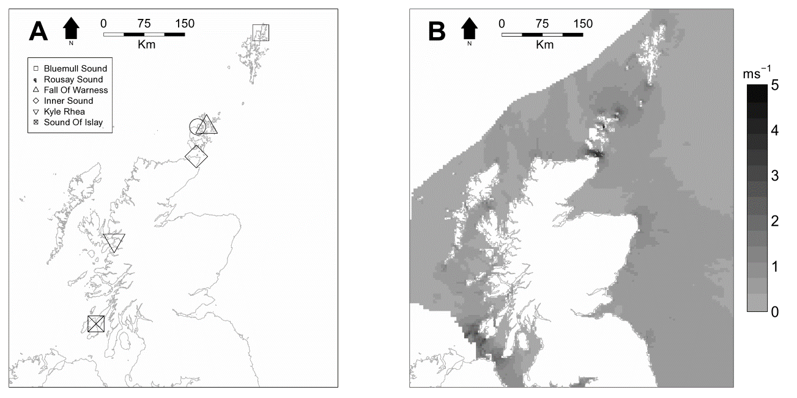
Fig. 1. The locations of the six study sites in Scotland, UK are shown in A. The distribution of tidal stream resources, shown in mean spring tide current speeds (m s−1) are shown in B.
Tidal stream resource information was obtained from the Atlas of UK marine renewable energy resources [10].

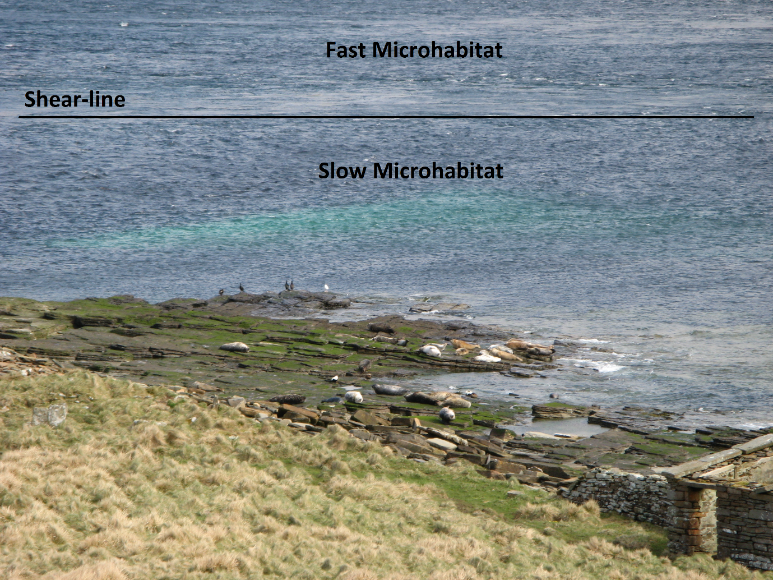
Fig. 2. A photograph taken at Rousay Sound, Scotland, UK showing the location of the shear-line which was used to identify and discriminate between slow and fast microhabitats.

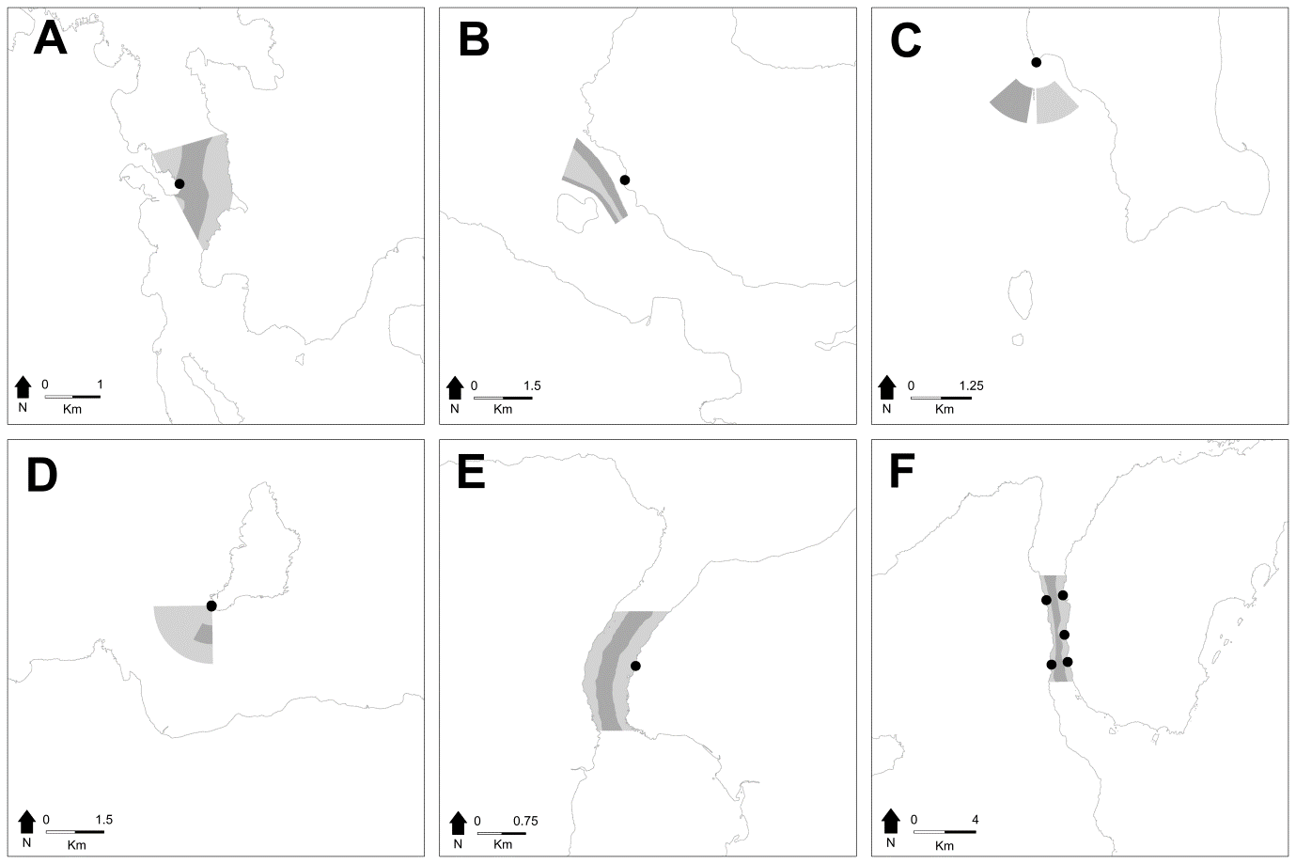
Fig. 3. The locations of fast microhabitats (dark grey polygon), slow microhabitats (light grey polygon) and vantage points (black points) within the six study sites in Scotland, UK: (A)
Bluemull Sound, (B) Rousay Sound, (C) Fall of Warness, (D) Inner Sound, (E) Kylerhea and (F) Sound of Islay. The locations of these study sites within the region are shown in Fig. 1.

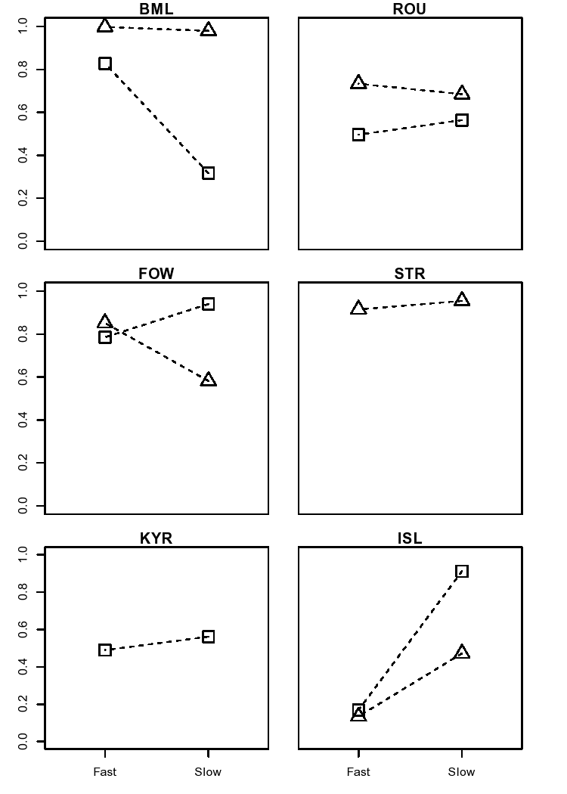
Fig. 4. The predicted probabilities of detecting foraging black guillemots (triangle) and European shags (square) as a function of microhabitat and study site in Scotland, UK. Predictions were made using generalised linear mixed effect models (GLMM). Fast=fast microhabitats, Slow=slow microhabitats, BML=Bluemull Sound, ROU=Rousay Sound, FOW=Fall of Warness, STR=Inner Sound, KYR=Kylerhea and ISL=Sound of Islay.
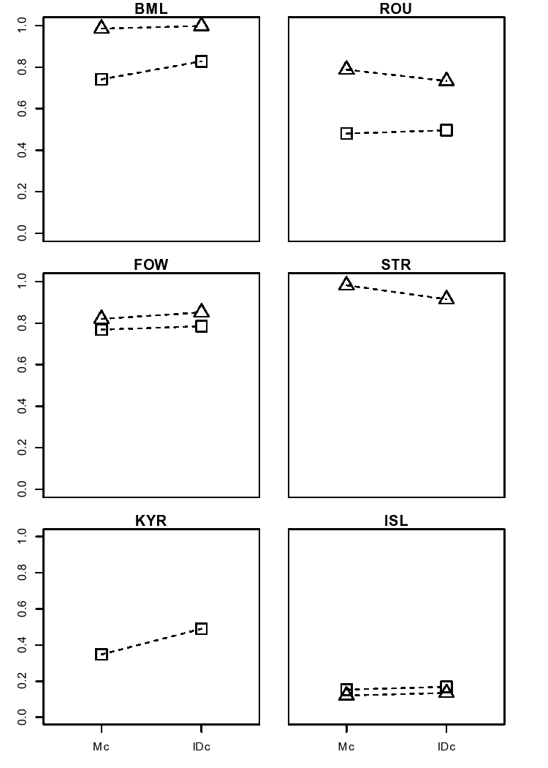
Fig. 5. The predicted probabilities of detecting foraging black guillemots (triangle) and European shags (square) in fast microhabitats as a function of tidal state and study site in Scotland, UK. Predictions were made using generalised linear mixed effect models (GLMM). Mc=Maximum currents, IDc=Increasing/Decreasing currents, BML=Bluemull Sound, ROU=Rousay Sound, FOW=Fall of Warness, STR=Inner Sound, KYR=Kylerhea and ISL=Sound of Islay.

