Amine adducts of (4-ClC₆H₄)₃B₃O₃, Lewis acidity of triarylboroxines, and an XRD study on the related tetraphenylboroxinate(1-) salt, [C₆H₁₁NMe₃][Ph₄B₃O₃].

Michael A. Beckett,^{a*} Simon J. Coles,^{b} Peter N. Horton,^{b} Charlotte L. Jones,ª Elizabeth V. Marshallª and Thomas Perry.ª

ªSchool of Chemistry, Bangor University, Bangor, UK, LL57 UW
^{b}School of Chemistry, University of Southampton, Southampton, UK, SO17 1BJ

*Corresponding Author: Prof. M.A. Beckett
tel: +44(1248)388433
email: m.a.beckett@bangor.ac.uk

ABSTRACT

The stoichiometric reactions of amines with tri(4-chlorophenyl)boroxine (CPB) led to the formation of adducts CPB.L {L = morpholine (1a), benzylamine (1b) cyclohexylamine (1c), 2-picoline (1d), 4-picoline (1e), piperidine (1f)} and (CPB)₂.(4,4’-trimethylenedipiperidine) (1g). Compounds 1a-1g have been characterised by NMR (¹¹B, ¹H, ¹³C), IR spectroscopy and powder-XRD. VT ¹H NMR spectra on 1a and 1d-1g were consistent with a ligand exchange/recombination process and activation energies of 49 – 58 kJmol⁻¹ were obtained. The synthesis of [C₆H₁₁NMe₃][Ph₄B₃O₃] (2) from Ph₂BOBPh₂, PhB(OH)₂ and [C₆H₁₁NMe₃][OH] in a 1:4:2 ratio in MeOH/H₂O is also reported. Compound 2 was characterized by thermal analysis (TGA/DSC), spectroscopy (IR, NMR) and 1a, 1b and 2 were further characterized by single-crystal XRD studies.

Keywords:

Boroxine, Tri(4-chlorophenyl)boroxine; Triarylboroxine; Tetraphenylboroxinate(1-); VT NMR; XRD structures.

1. Introduction
Adducts of triarylboroxines with N-donor ligands are well documented with the first report appearing in 1933 [1]. A few years later, Burg reported the syntheses of 1:1 adducts of ammonia and trimethylamine with trimethylboroxine [2]. In 1958, Snyder et al. [3] proposed that the structure of these adducts involved the coordination of the nitrogen atom of the ligand to one of the boron atoms in the boroxine rings (Figure 1a) and since then there have been several reports of 1:1 adducts of triarylboroxines with N-donor ligands [4-22]. Diamine ligands have been reported to bridge between two boroxine acceptors [4] and N-donor ligand / boroxine stoichiometric ratios other than 1 / 1 have also been investigated [4, 6, 23]. The structures of these adducts and their applications in batteries, COFs and NLO materials have been recently reviewed [14]. Triarylboroxine adducts have been studied through ¹H NMR spectroscopy in solution, and in 1968 Ritchey [5] concluded that at room temperature the three boron centres were equivalent. Yalpani and Boese [6] reinvestigated these systems using variable temperature (VT) ¹H NMR studies and concluded that in solution there is a temperature dependent fluctuation of the amine between the three borons of the boroxine ring. More recent VT NMR studies concluded that neither steric congestion [7] nor electronic effects of the aryl rings of the triarylboroxines [8] dominate ΔG‡ for this ligand exchange process and that it is likely to be associated with disruption of the B-O π-system [7, 8]. Computational work on the formation of boroxines from boronic acids and their adducts have also been reported [13, 18, 24]. This manuscript describes the preparation of some previously unreported amine adducts of tri(4-chlorophenyl)boroxine (CPB). In order to gain further insight into the ligand dissociation/recombination process occurring in solution in these complexes we have studied several CPB complexes by VT ¹H NMR. Single-crystal XRD structures of two examples are also reported, together with the synthesis and XRD structure of a related tetraphenylboroxinate(1-) salt, [trimethyl(cyclohexyl)ammonium][Ph₄B₃O₃].

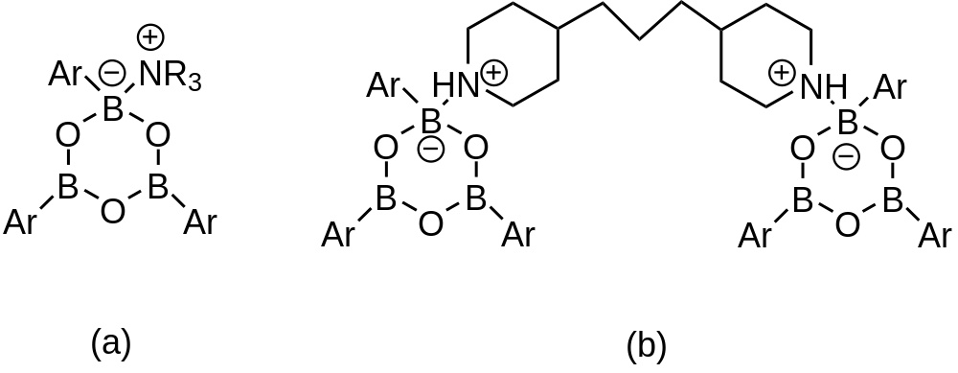

Figure 1. (a) Schematic drawing of a 1:1 triarylboroxine.amine adduct: Ar = 4-ClC₆H₄, amine = morpholine (1a), benzylamine (1b) cyclohexylamine (1c), 2 -picoline (1d), 4-picoline (1e), piperidine (1f) and (b) 2:1 adduct Ar = 4-ClC₆H₄ (1g).

2. Experimental
2.1 General
All chemicals were obtained commercially. (4-ClC₆H₄)₃B₃O₃ was obtained by dehydration (oven 100 ºC, 24h) of the commercially available boronic acid, 4-ClC₆H₄B(OH)₂. NMR spectra were obtained on a Bruker Avance-400 spectrometer with ¹H, ¹¹B, ¹³C, and ³¹P spectra (CDCl₃ unless stated otherwise) obtained at 400, 128, 101, and 162 MHz, respectively. NMR data are reported in ppm with positive chemicals shifts (δ) to high frequency (downfield) of TMS (¹H, ¹³C), BF₃.OEt₂ (¹¹B) and H₃PO₄ (³¹P). Infra-Red spectra were obtained as KBr pellets on a Perkin-Elmer FTIR spectrometer over 450-4000 cm⁻¹. TGA and DSC analysis was performed (in air) between 10 and 800 ºC on a SDT Q600 V.4.1 Build 59 instrument using Al₂O₃ crucibles, with a ramp rate of 10 ºC per minute. Powder XRD data were obtained on a Philips 1050/37 X-ray diffractometer equipped with an iron filter, using Cu-Kα radiation (λ = 0.154056 nm) with a continuous scan between 2θ = 5º-75º and Philips X’Pert software. CHN analysis was carried out at OEA Laboratories Ltd, Callington, Cornwall. Single crystal X-ray crystallography was carried out at the EPSRC National Crystallographic Service at the University of Southampton.

2.2 Preparation of triarylboroxine.amine adducts.
The triarylboroxine.amine adducts were all prepared using a general procedure [10], as detailed in Section 2.2.1 for compound 1a.

2.2.1 Preparation of tri(4-chlorophenyl)boroxine.morpholine, CPB.C₄H₉NO (1a).
Morpholine (0.11g, 1.25 mmol) was added to a stirred suspension of (4-ClC₆H₄)₃B₃O₃ (0.50 g, 1.20 mmol) in Et₂O (20 ml), under an dry N₂ atmosphere. After the solid dissolved (approximately 10 minutes) the solution was filtered and the solvent removed under vacuum. The resulting white solid product was recrystallized from CHCl₃ (0.55 g, 92% yield). Mp: 217 – 220 °C. Elemental Anal. Calc. (%) for C₂₂H₂₁B₃Cl₃NO₄: C, 52.6; H, 4.2; N, 2.8. Found (%): C, 52.4; H, 4.3; N, 2.8. NMR (CDCl₃, RT). ¹H δ/ppm: 3.05-3.12 (br m, 5H), 3.78 (br s, 4H), 7.37 (d, 6H), 7.90 (d, 6H). ¹³C δ/ppm: 44.43 (2CH₂), 66.09 (2CH₂), 128.04 (6CH), 135.44 (6CH). ¹¹B δ/ppm: 21.0. IR (KBr disk) ν_{max}/cm⁻¹: 3437 (br), 3214 (vs), 3070, 3026, 2982, 2854 (m), 1591 (vs), 1484 (s), 1433 (s), 1410 (s), 1374 (m), 1326 (s), 1280 (s), 1248 (m), 1191 (s), 1125 (s), 1088 (s), 1044 (m), 1012 (s), 889 (m), 848 (m), 812 (s), 766 (s), 727 (m), 664 (s), 624, 538, 452 (s). p-XRD: d spacing/Å (% rel. int.): 5.43 (100), 3.45 (95), 3.63 (77), 3.82 (68), 5.36 (54), 5.47 (53).

2.2.2 Preparation of tri(4-chlorophenyl)boroxine.benzylamine, CPB.C₇H₉N (1b).
0.61 g, 98% yield. Mp: 155 – 157 °C. Elemental Anal. Calc. (%) for C₂₅H₂₁B₃Cl₃NO₃: C, 57.5; H, 4.1; N, 2.7. Found (%): C, 57.1; H, 4.1; N, 2.7. NMR (CDCl₃, RT). ¹H δ/ppm: 3.72 (s, br, NH₂), 3.93 (s, 2H, CH₂), 7.18 (m, 2H), 7.34 – 7.41 (m, 9H), 7.94 (d, 6H). ¹³C δ/ppm: 45.11 (CH₂), 128.08 (CH), 128.19 (CH), 129.15 (CH), 135.23 (CH), 136.26 (C). ¹¹B δ/ppm: 19.8. IR (KBr disk) ν_{max}/cm⁻¹: 3434 (br), 3274 (s), 3205 (s, br), 3219 (s, br), 3067 (s), 3033 (s), 1920 (s), 1593 (vs, br), 1402 (s), 1376 (s), 1344 (s), 1324 (s), 1289 (s, br), 1243 (s), 1206 (m), 1115 (s), 1083 (s, br), 1050 (m), 1014 (s), 992 (s), 958, 938, 916, 881 (m, br), 822 (s, br), 775 (s), 732 (s), 700 (s), 669 (s), 628, 604, 541 (m), 522 (m), 480 (m), 453 (s). p-XRD: d spacing/Å (% rel. int.): 3.98 (100), 3.38 (92), 4.69 (58) 2.03 (69).

2.2.3 Preparation of tri(4-chlorophenyl)boroxine.cyclohexylamine, CPB.C₆H₁₃N (1c).
0.51 g, 89% yield. Mp: 177 – 181 °C. Elemental Anal. Calc. (%) for C₂₄H₂₅B₃Cl₃NO₃: C, 56.1; H, 4.9; N, 2.7. Found (%): C, 54.7; H, 4.8; N, 2.5. NMR (CDCl₃, RT). ¹H δ/ppm: 1.09-1.26 (m, 5H), 1.59 (d, 1H), 1.70 (d, 2H), 1.98 (d, 2H), 2.97 (m, 1H), 3.55 (br s, 2H), 7.38 (d, 6H), 7.90 (d, 6H). ¹³C δ/ppm: 24.31 (2CH₂), 24.91 (CH₂), 33.50 (2CH₂), 51.22 (C), 128.04 (6CH), 135.20 (6CH), 136.21 (C-Cl). ¹¹B δ/ppm: 22.2. IR (KBr disk) ν_{max}/cm⁻¹: 3436 (br), 3275 (m), 3233 (m), 3072 (w), 2935 (s, br), 2858 (s), 1592 (s), 1562 (m), 1434 (m), 1408 (s), 1376 (m), 1339 (m), 1327 (m), 1285 (s, br), 1243 (m), 1189 (m), 1120 (m), 1081 (s), 1013 (s), 982 (m), 821 (s), 765 (s, br), 733 (m), 662 (m), 582, 451 (s). p-XRD: d spacing/Å (% rel. int.): 3.48 (100), 4.72 (78), 4.12 (55), 4.01 (48), 4.40 (47), 4.89 (44).

2.2.4 Preparation of tri(4-chlorophenyl)boroxine.2-picoline CPB.C₆H₇N (1d).
0.44 g, 72% yield. Mp: 289 – 291 °C. Elemental Anal. Calc. (%) C₂₄H₁₉B₃Cl₃NO₃: C, 56.7; H, 3.8; N, 2.8. Found (%): C, 56.2; H, 3.8; N, 2.2. NMR (CDCl₃, RT). ¹H δ/ppm: 2.75 (s, 3H, CH₃), 7.30 (d, 1H), 7.38 (m, 7H), 7.81 (t, 1H), 7.92 (d, 6H), 9.07 (d, 1H). ¹³C δ/ppm: 23.56 (CH₃), 122.13 (CH), 126.84 (CH), 128.15 (CH), 135.80 (CH), 136.97 (C-Cl), 139.44 (CH), 146.19 (CH), 157.94 (C). ¹¹B δ/ppm: 23.4. IR (KBr disk) ν_{max}/cm⁻¹: 3436 (br), 3071, 3035, 2940, 1620 (m), 1594 (s), 1563 (m), 1485 (m), 1406 (s, br), 1374 (m, br), 1344 (s, br), 1327 (s, br), 1294 (s, br), 1283 (s, br), 1121 (s), 1082 (s, br), 1043 (m, br), 1014 (s), 977 (m), 822 (m), 808 (m), 760 (s, br), 740 (s, br), 694 (m), 613 (s), 457 (s). p-XRD: d spacing/Å (% rel. int.): 5.47 (100), 3.63 (61), 3.49 (53), 11.12 (49), 3.70 (39), 5.27 (35).

2.2.5 Preparation of tri(4-chlorophenyl)boroxine.4-picoline, CPB.C₆H₇N (1e).
0.59 g, 97% yield. Mp: 192 – 195 °C. Elemental Anal. Calc. (%) C₂₄H₁₉B₃Cl₃NO₃: C, 56.7; H, 3.8; N, 2.8. Found (%): C, 56.7; H, 3.7; N, 2.7. NMR (CDCl₃, RT). ¹H δ/ppm: 2.50 (s, 3H, CH₃), 7.35 (d, 6H), 7.42 (d, 2H), 7.93 (d, 6H), 8.80 (d, 2H). ¹³C δ/ppm: 21.72 (CH₃), 126.61 (CH), 127.94 (CH), 135.14 (CH), 143.03 (CH). ¹¹B δ/ppm: 19.9. IR (KBr disk) ν_{max}/cm⁻¹: 3434 (br), 3072, 3029, 1633 (m), 1593 (s, br), 1563 (m), 1485 (m), 1433 (s, br), 1407 (s, br), 1378 (m, br), 1325 (s, br), 1278 (s), 1246 (s), 1206 (s), 1179 (m), 1118 (m), 1081 (s, br), 1043 (m), 1014 (s), 984 (s), 854 (m), 822 (m), 803 (m), 762 (s, br), 743, 732, 696 (m), 660 (m), 636 (m), 508 (m), 453 (s). p-XRD: d spacing/Å (% rel. int.): 4.62 (100), 5.39 (78), 3.46 (56), 3.58 (44), 4.97 (36), 3.25 (27).

2.2.6 Preparation of tri(4-chlorophenyl)boroxine.piperidine, CPB.C₅H₁₁N (1f).
0.59 g, 98% yield. Mp: 127 – 130 °C. Elemental Anal. Calc. (%) for C₂₃H₂₃B₃Cl₃NO₃: C, 55.2; H, 4.6; N, 2.8. Found (%): C, 55.1; H, 4.6; N, 2.8. NMR (CDCl₃, RT). ¹H δ/ppm: 1.66 (s, br, 6H), 2.80 (s, br, 5H), 7.37 (d, 6H), 7.91 (d, 6H). ¹³C δ/ppm: 23.05 (CH₂), 25.37 (CH₂), 127.90 (CH), 135.44 (CH). δ_{B} (ppm):24.6.IR (KBr disk) ν_{max}/cm⁻¹: 3520 (br), 3223 (vs), 3069 (m), 3026, 2956 (m, br), 2870 (m), 1912, 1591 (vs), 1484 (s), 1435 (s, br), 1410 (s, br), 1376 (m, br), 1326 (s, br), 1282 (s, br), 1246 (s, br), 1188 (s), 1121 (s), 1085 (s, br), 1044 (m), 1012 (s), 971 (m), 868 (m), 810 (s), 766 (s, br), 728 (m), 662 (s), 614 (m), 512, 477, 450 (s). p-XRD: d spacing/Å (% rel. int.): 3.54 (100), 3.55 (70), 3.67 (39), 3.68 (39), 3.95 (34), 3.18 (30).

2.2.7 Preparation of bis(tri(4-chlorophenyl)boroxine).4,4’-trimethylenedipiperidine, (CPB)₂.C₁₃H₂₆N₂ (1g).
1.72 g, 92 % yield. Mp: 247 – 250 °C. Elemental Anal. Calc. (%) for C₃₁H₃₈B₃Cl₃N₂O₃: C, 56.6; H, 4.8; N, 2.7. Found (%): C, 56.3; H, 4.8; N, 2.6. NMR (CDCl₃, RT). ¹H δ/ppm: 1.06-1.23 (m, 10H), 1.35 (br s, 2H), 1.82 (d, 4H), 2.55 (br s, 4H), 2.75 (br s, 2H), 3.38 (br s, 4H), 7.36 (d, 12H), 7.88 (br s, 12H). ¹³C δ/ppm: 23.28, 31.56, 34.45, 36.19, 45.14. ¹¹B δ/ppm: not obtained. IR (KBr disk) ν_{max}/cm⁻¹: 3415 (br), 3229 (m), 3072 (m), 3031 (m), 2928 (m), 2856 (m), 1592 (vs), 1562 (s), 1486 (s), 1435 (s), 1415 (s), 1380 (m), 1330 (m), 1278 (s), 1247 (m), 1196 (s), 1172 (s), 1120 (s), 1097 (s), 1083 (s), 1044 (s), 1014 (vs), 985 (m), 972 (m), 857(m), 828 (m), 816 (m), 769 (s), 733 (m), 670 (m), 663, 629, 612. p-XRD: d spacing/Å (% rel. int.): amorphous solid.

2.3 Lewis acidity measurements of triarylboroxines.
The Et₃PO (TEPO) adduct of tri(4-chlorophenyl)boroxine, CPB.TEPO, was prepared in situ in an NMR tube by the addition of a slight excess of CPB to TEPO dissolved in CDCl₃ (0.5 mL). NMR (CDCl₃, RT). ¹H δ/ppm: 1.15 – 1.23 (m, 9H, 3CH₃), 1.78 – 1.87 (m, 6H, 3CH₂), 7.35 – 7.47 (m, 6H, 6CH), 7.76 – 8.10 (m, 6H, 6CH). ¹³C δ/ppm: 5.66 (d, ²J = 4.7 Hz, CH₃), 18.96 (d, ¹J = 67.6 Hz, CH₂), 128.45 (CH arom.), 136.77 (CH arom.). ¹¹B δ/ppm: 29.1. ³¹P δ/ppm: 62.0 (AN = 46).

2.4 Preparation of [C₆H₁₁NMe₃][Ph₄B₃O₃] (2)
[C₆H₁₁NMe₃]I (2.16 g, 8.01 mmol) was dissolved in water (50 ml) and the Dowex 550Å monosphere resin (OH⁻ form) was added to the solution which was stirred for 48 h. The resin was removed by filtration and the solvent was removed from the filtrate by rotary evaporation to give an oil. The oil was made up to 100 ml in a 1:1 methanol/water solution and an aliquot of this solution (25 ml, containing 2 mmol) was reacted with PhB(OH)₂ (0.47g, 3.86 mmol) and Ph₂BOBPh₂ (0.34 g, 0.98 mmol). The solvent was then removed (via rotary evaporation/suction filtration) to yield the product, [C₆H₁₁NMe₃][Ph₄B₃O₃] (2), as a white powder (0.77g, 75%) . M.p. 220 - 225°C. Elemental Anal. Calc. for C₃₃H₂₀B₃O₃N: C, 74.6; H, 7.6; N, 2.6. Found: C, 74.5; H, 7.6; N, 2.6. NMR (acetone-d₆, RT): ¹H δ/ppm: 1.18 (q, 1H), 1.35 (q, 2H), 1.52 (q, 2H), 1.63 (d, 1H), 1.92 (d, 2H), 2.28 (d, 2H) 3.15 (s, 9H), 3.37 (t, 1H), 6.80 (t, 2H), 7.05 (t, 4H), 7.30 (m, 6H), 7.75 (d, 4H), 8.22 (m, 2H). ¹³C δ/ppm: 24.35, 25.06, 25.93, 50.56, 75.25, 123.15, 125.75, 126.88, 129.08, 131.72, 134.59. ¹¹B δ/ppm: 3.4 (1B), 26.9 (2B). IR (KBr disk) ν_{max}/cm⁻¹: 3068 (w), 3012 (w), 2859 (w), 1598 (m), 1469 (m), 1448 (vs), 1421 (s), 1355 (m), 1274 (m), 1231 (vs), 1162 (m), 1145 (m), 1110 (m), 1064 (m), 1025 (m), 953 (m), 867 (m), 770 (m), 751 (m), 702 (vs), 676 (s), 620 (m), 572 (s). TGA: oxidation of organics to leave 1.5B₂O₃ (220-390 ºC): residue 20.1% (calc 19.7%). The crude product was recrystallized from acetone to give small (colourless) crystals suitable for an XRD analysis.

2.5 XRD analysis of 1a, 1b, and 2.
XRD data Crystallographic data for compounds 1a, 1b and 2 are given in Table 1. The crystallographic data collection of compounds were performed on either a Rigaku AFC12 goniometer equipped with an enhanced sensitivity HG Saturn 724+ detector mounted at the window on an FR-E+ SuperBright molybdenum rotating anode generator with either HF Varimax optics (compound 1a) or VHF Varimax optics (compound 1b) or a Rigaku 007-HF copper rotating anode with AFC11 goniometer with Saturn944+ CCD area detector (compound 2) all at 100(2) K. Cell determinations and data collections were carried out using CrystalClear [25]. With the data reduction, cell refinement and absorption correction using CrysAlisPro [26]. Using Olex2 [27] the structures were solved using SHELXT [28] and models refined with SHELXL [29]. H1 in 1a was allowed to freely refine as it is involved in hydrogen bonding and all other hydrogen atoms were refined in riding positions.

Table 1. Crystal data and structure refinement for compounds 1a, 1b, and 2.

Compound | 1a | 1b | 2
Empirical formula | C₂₂H₂₁B₃Cl₃NO₄ | C₂₅H₂₁B₃Cl₃NO₃ | C₃₃H₄₀B₃NO₃
Formula weight | 502.18 | 522.21 | 531.09
Temperature | 100(2) K | 100(2) K | 100(2) K
Wavelength | 0.71075 Å | 0.71075 Å | 1.54187 Å
Crystal system | Triclinic | Triclinic | Orthorhombic
Space group | P−1 | P−1 | Pca2₁
Unit cell dimensions | a = 8.8330(2) Å | a = 10.8662(3) Å | a = 34.3666(1) Å
 | b = 11.7778(2) Å | b = 11.6419(4) Å | b = 19.9735(1) Å
 | c = 12.3245(3) Å | c = 21.0508(4) Å | c = 17.2662(1) Å
 | α = 81.153(2)° | α = 88.316(2)° | α = 90°
 | β = 76.271(2)° | β = 89.333(2)° | β = 90°
 | γ = 68.541(2)° | γ = 70.864(2)° | γ = 90°
Volume | 1156.00(5) Å³ | 2514.75(12) Å³ | 11851.89(10) Å³
Z | 2 | 4 | 16
Density (calculated) | 1.443 Mg / m³ | 1.379 Mg / m³ | 1.191 Mg / m³
Absorption coefficient | 0.427 mm⁻¹ | 0.393 mm⁻¹ | 0.567 mm⁻¹
F(000) | 516 | 1072 | 4544
Crystal | Block; Colourless | Lath; Colourless | Plate; Colourless
Crystal size | 0.130 × 0.080 × 0.050 mm³ | 0.170 × 0.040 × 0.010 mm³ | 0.48 × 0.40 × 0.04 mm³
Reflections collected | 20528 | 32418 | 85957
Independent reflections | 5284 [R_{int} = 0.0220] | 11479 [R_{int} = 0.0236] | 18721 [R_{int} = 0.0231]
Data / restraints / parameters | 5284 / 0 / 302 | 11479 / 0 / 631 | 18721 / 1 / 1454
Goodness-of-fit on F² | 1.040 | 1.023 | 1.079
Final R indices [F² > 2σ(F²)] | R1 = 0.0288, wR2 = 0.0754 | R1 = 0.0461, wR2 = 0.1108 | R1 = 0.0321, wR2 = 0.0810
R indices (all data) | R1 = 0.0324, wR2 = 0.0775 | R1 = 0.0613, wR2 = 0.1192 | R1 = 0.0333, wR2 = 0.0819
Absolute structure parameter | n/a | n/a | 0.03(4)
Largest diff. peak and hole | 0.405 and −0.225 e Å⁻³ | 1.467 and −0.877 e Å⁻³ | 0.410 and −0.199 e Å⁻³

3. Results and discussion
3.1 Formation of amine complexes of tri(4-chlorophenyl)boroxine
One to one amine adducts of tri(4-chlorophenyl)boroxine (CPB) were readily prepared by the direct interaction of the organic base with a suspension of the boroxine in Et₂O (Scheme 1). The CPB is insoluble Et₂O, but the suspension readily dissolved upon addition of amines to form pale yellow solutions of the products, which were isolated in high yields after removal of the solvent and recrystallization of the residue. Six adducts, formulated as PCB.L {L = morpholine (1a), benzylamine (1b), cyclohexylamine (1c), 2-picoline (1d), 4-picoline (1e), piperidine (1f)} based on elemental analysis data, spectroscopic analysis (NMR) and from single crystal XRD studies on representative samples (1a, 1b), were prepared. The IR spectra of compounds 1a-1f all show strong very strong bands in the region 1500-1200 cm⁻¹ assigned to B-O stretches of the boroxole ring [3, 9, 30]. The X-ray structures of 1a and 1b (Section 3.2) clearly demonstrate that they are 1:1 adducts and that the amine ligands are coordinated to one the three boron centres of the CPB rings.
Compounds 1a-1f were air-stable, white solids with clearly defined melting points. These solids were readily soluble in chlorinated solvents, but less soluble in Et₂O and petroleum ether. CPB was also reacted with 4,4’-trimethylenedipiperidine in a 2:1 stoichiometric ratio to form a 2:1 adduct (Scheme 1).

(4-ClC₆H₄)₃B₃O₃ + L → (4-ClC₆H₄)₃B₃O₃.L (1a-f)
{L = morpholine (1a), benzylamine (1b),
cyclohexylamine (1c), 2-picoline (1d),
4-picoline (1e), piperidine (1f)}

2(4-ClC₆H₄)₃B₃O₃ + L → {(4-ClC₆H₄)₃B₃O₃}₂.L (1g)
{L = 4,4’-trimethylenedipiperidine}

Scheme 1

3.2 XRD structural studies on tri(4-chlorophenyl)boroxine.morpholine (1a) and tri(4-chlorophenyl)boroxine.benzylamine (1b).
The solid-state structures of 1a and 1b confirm their formulations as 1:1 adducts. Compound 1a has one unique molecule within its asymmetric unit whereas the asymmetric unit of 1b contains two independent molecules. The bond distances and angles in the two molecules of 1b are generally not significantly different and their gross structures are the same; for brevity only dimensions of the molecule containing B1 are discussed here. Full bond distance and bond angle details are available for 1a and 1b in the Supplementary Information. The crystallographically determined structures confirm that they are both 1:1 amine adducts of tri(4-chlorophenyl)boroxine, and the structures of 1a and 1b are shown in Figures 2 and 3, respectively. Bond lengths and angles associated with the boroxole (B₃O₃) rings are given in the captions to these Figures. The boroxole rings of the adducts in 1a and 1b contain two three-coordinate trigonal planar boron centres (B2 and B3), three two-coordinate angular oxygen atoms (O1, O2, and O3), and a tetrahedral four-coordinate boron centre (B1). These almost planar boroxole rings adopt an envelope conformation, with B1 being 0.0906(16) Å (1a) and 0.150(3) Å (1b) away from the best plane of O1, O2 and O3. The four-coordinate boron (B1) in 1a has a distorted tetrahedral geometry with bond angles in the range of 103.33(9) – 114.61(10)° and the three-coordinate boron atoms (B2 and B3) have bond angles in the range of 117.20(11) – 121.46(11)°. The three ring two-coordinate oxygen atoms have bond angles in the range of 119.34(10) – 122.18(10)°. The coordinated morpholine ligand is found to be in a chair conformation and there is an intermolecular H-bond between N1-H1 atom of the morpholine ligand an Cl2 atom of a neighbouring molecule {d(N-H) 0.869(17) Å; d(H…Cl), 2.512(17) Å; d(N…Cl), 3.3775(11) Å; < (NHCl), 174.3(14)º}. A similar description can be applied to 1b where angles about the distorted tetrahedral boron (B1) range from 104.85(15) – 114.00(16)°, the two trigonal boron atoms range from 118.29(18) – 121.03(18)° and three two-coordinate ring oxygen atoms range from 119.17(16) – 122.90(16)°. The aryl rings of the benzylamine ligand in 1b sits close to perpendicular to the boroxole ring (79.13(7)°). The C-Cl bond lengths in 1a {1.7444(12) -1.7567(12) Å} are just longer than those observed in 1b {1.7413(19) - 1.746(2) Å}. The B-N and B-O bond lengths in 1a and 1b (see captions to Figures 2 and 3) are consistent with bond lengths observed in other amine triarylboroxine adducts [4, 6-13, 15, 16], amine adducts of related BOSi ring systems [31, 32], and tetraorganylboroxinate(1-) [33-36] systems. The B-O distances are described in more detail in Section 3.5.

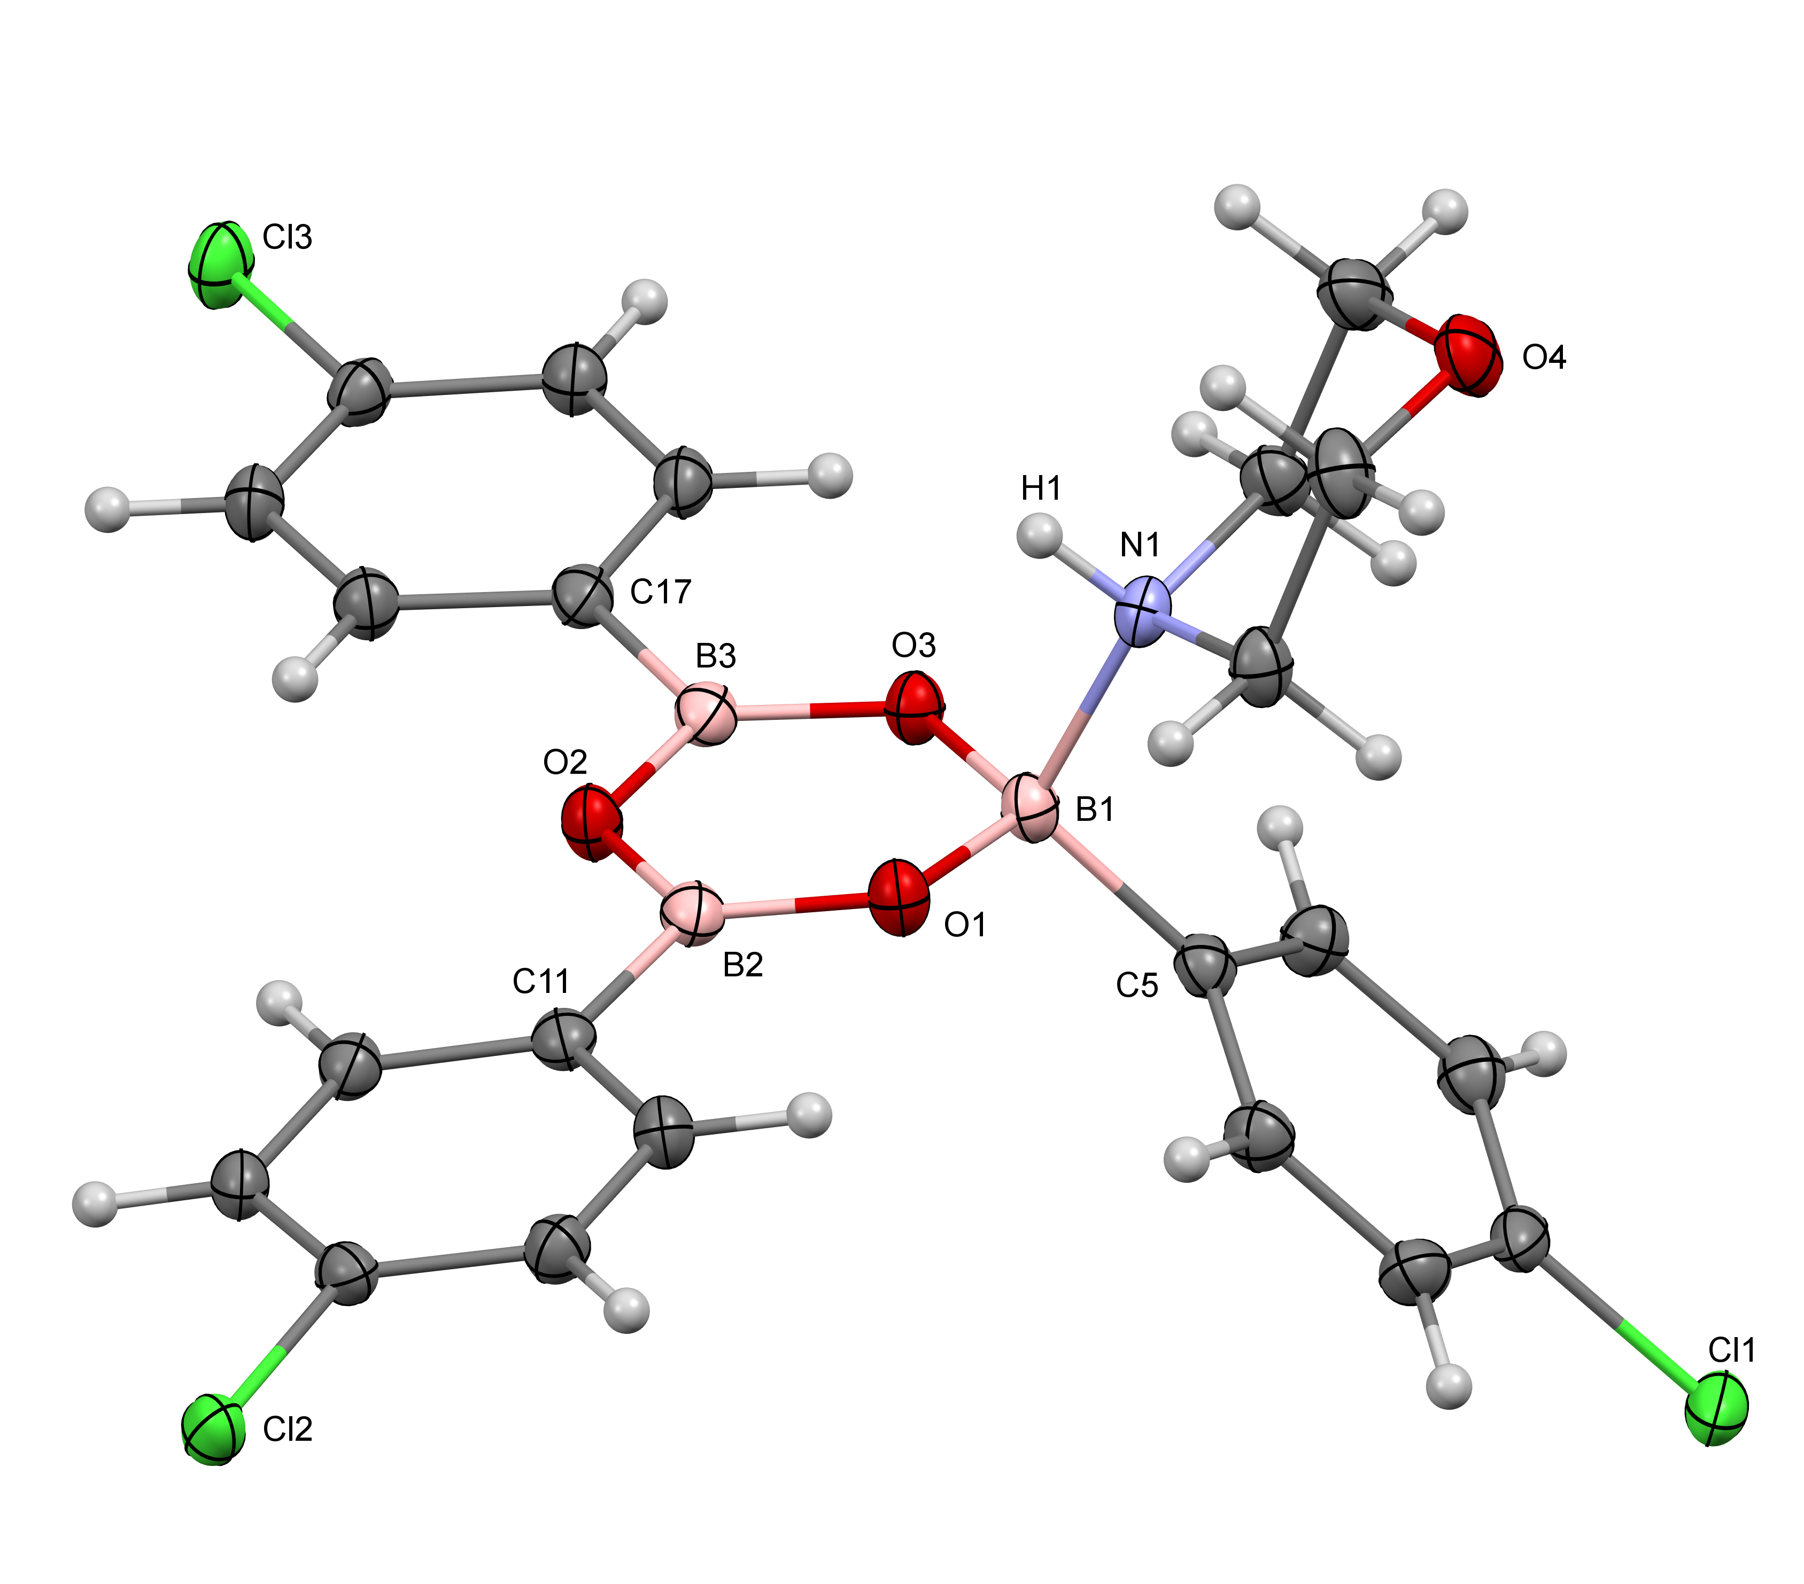

Figure 2. Drawing of the molecular structure of tri(4-chlorophenyl)boroxine.morpholine (1a), showing selected labelling. Distances (Å): B1-O1, 1.4551(15); O1-B2, 1.3473(16); B2-O2, 1.3836(16); O2-B3, 1.3849(16); B3-O3, 1.3519(16); O3-B1, 1.4621(15); B1-N1, 1.6543(16); B1-C5, 1.6073(18); B2-C11, 1.5655(18); B3-C17, 1.5684(18).

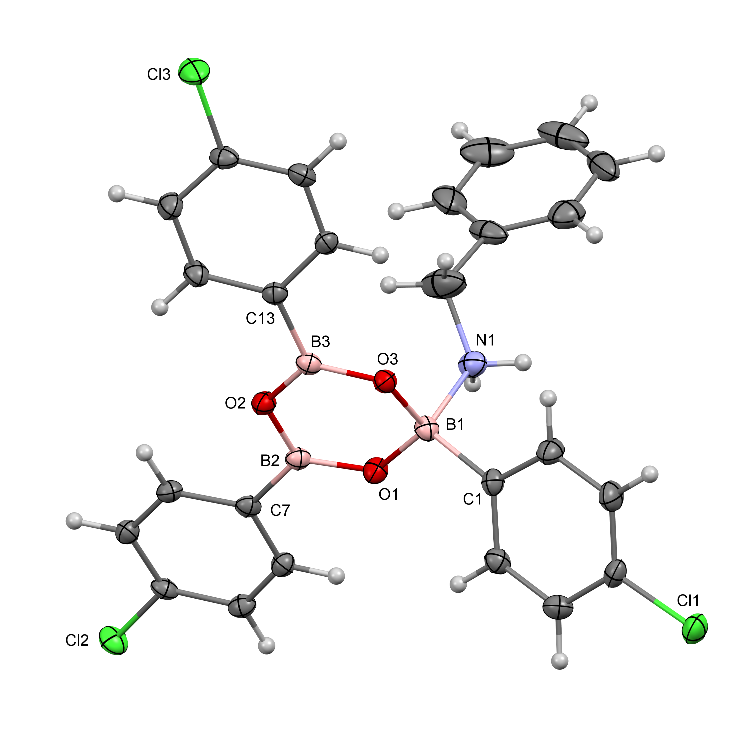
Figure 3. Drawing of one of the two independent molecules in the solid-state structure of tri(4-chlorophenyl)boroxine.benzylamime (1b), showing selected labelling. Distances (Å): B1-O1, 1.450(3); O1-B2, 1.352(3); B2-O2, 1.390(3); O2-B3, 1.386(3); B3-O3, 1.362(3); O3-B1, 1.458(2); B1-N1, 1.683(3); B1-C1, 1.608(3); B2-C7, 1.568(3); B3-C13, 1.563(3).

3.3 Variable temperature 1H NMR studies on the ligand dissociation/recombination process.
At first sight the ¹H and ¹³C data of the 1a-1g are inconsistent with the XRD structures since at room temperature all adducts displayed three equivalent CPB aryl rings and not the expected 2:1 signals. However, this has been noted before in related compounds and has been explained by a fluxional process involving rapid (at room temperature) ligand exchange [5-12]. Room temperature solution ¹¹B{¹H} NMR spectra of 1a-1g gave a broad weak signals in the range of 20-23 ppm for the 1:1 adducts, and were consistent with data on related systems [5-12]. These chemical shifts are indicative of a weighted average, associated with ligand exchange, situated in between that expected for a three coordinate boron signal (ca. 30 ppm) and a four coordinate boron signal (ca. 4 ppm). Variable temperature ¹H NMR spectroscopy (+35 to -35 °C, 5 °C intervals) on 1a, 1d, 1e, 1f and 1g was undertaken in CDCl₃ in order to further characterize the ligand exchange process. The aromatic region of 1g is shown in Figure 4 as a representative example.
6.0
6.2
6.4
6.6
6.8
7.0
7.2
7.4
7.6
7.8
8.0
8.2
8.4
8.6
8.8
9.0
9.2
f1 (ppm)
1
2
3
4
5
May12-2015-nmr
Supervisor Name MAB
CJ29415-B
-10 deg
May12-2015-nmr
Supervisor Name MAB
CJ29415-B
0 deg
May12-2015-nmr
Supervisor Name MAB
CJ29415-B
10 deg
May12-2015-nmr tmdp cpb
Supervisor Name MAB
CJ29415-B
20 deg x2
May12-2015-nmr
Supervisor Name MAB
CJ29415-B-CPB
30 deg

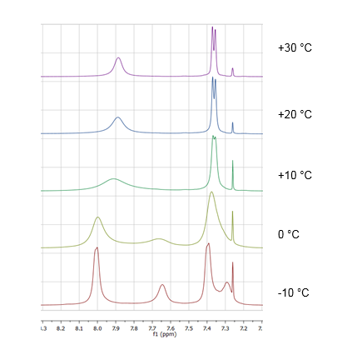

Figure 4. Variable temperature ¹H NMR signals of the aryl substituents on tri(4-chlorophenyl)boroxine in 1g.

At -10 °C the aryl rings protons of 1g appear as four separate signals at 7.29, 7.39, 7.65 and 8.00 ppm, with the relative intensities 8:4:8:4 and consistent with slow ligand exchange relative to the NMR timescale. Upon warming, the two upfield signals (associated with protons which are at the meta to the boron atoms) broaden, coalesce at -5 °C, and then sharpen into a doublet at 7.37 ppm. Likewise, the two lower-field signals (associated with protons at the ortho to the boron atoms) broaden, coalesce at +5 °C, and then sharpen into a broad singlet upon warming. The Gibbs free energy of activation (ΔG‡) for a 1:1 ligand exchange process can be calculated [37] from the ligand-exchange rate (k) at coalescence temperature (T_{c}) and the low temperature peak separation at slow-exchange (δ_{v}). This approach is strictly only correct for a 1:1 site exchange [12] although can give useful approximations for 2:1 systems. The calculated ΔG‡ data for 1a, 1e, 1f and 1g can be found in Table 2. Data was not available for 1d since slow exchange was not observed in the ¹H NMR spectra at -35 °C. The ΔG‡ values obtained for these CPB.amine complexes lie in the range of 49-58 kJmol⁻¹. These data are at the high end of ranges reported for ligand exchange for various N-donor ligands at tri(3,5-dimethylphenyl)boroxine (MXB, 45-49 kJmol⁻¹ [10]), tri(4-methylphenyl)boroxine (PTB, 43-46 kJmol⁻¹ [10] ), tri(2-methylphenyl)boroxine (OTB, 43-49 kJmol⁻¹ [7]), tri(4-nitrophenyl)boroxine (MNB, 50 kJmol⁻¹ [8]) and tri(4-bromophenyl)boroxine (PBB, 39-54 kJmol⁻¹ [8 ]). Comparative data are available for morpholine as a ligand in 1a for boroxines PBB, PTB and MXB; the activation energy for morpholine.PCB is calculated to be the highest, by 2-5 kJmol⁻¹. Likewise, data for 1e can be directly compared with that for 4-picoline.OTB and 1e is higher by 5 kJ mol⁻¹. However, these differences are likely to be within experimental error and may not indicate possible trends.

Compound | T_{c} (K) | δ_{ν} (Hz) | k  (s⁻¹)ª | ΔG‡ (kJmol⁻¹)^{b}
1a^{c} | 255 | 50 | 111 | 54
1a^{d} | 260 | 160 | 355 | 51
1e^{c} | 258 | 95 | 211 | 51
1e^{d} | 253 | 225 | 500 | 49
1f^{c} | 283 | 55 | 122 | 58
1f^{d} | 293 | 175 | 389 | 57
1g^{c} | 268 | 50 | 111 | 55
1g^{d} | 278 | 175 | 389 | 54

Table 2. Variable temperature ¹H NMR data. ª k = 2^{-1/2}πδ_{ν}. ^{b}ΔG‡ = -RTln(khk_{B}⁻¹T⁻¹). ^{c} From upfield aromatic doublet of (4-ClC₆H₄)₃B₃O₃.L. ^{d} From downfield aromatic doublet of (4-ClC₆H₄)₃B₃O₃.L.

3.4 Measurement of Lewis acidity of (4-ClC₆H₄)₃B₃O₃
Gutmann’s Acceptor numbers (AN) are generally accepted as useful way to assess the relative Lewis acidity of solvents [38, 39]. The AN of a particular solvent is calculated from ³¹P{¹H} NMR chemical shifts of triethylphosphine oxide (TEPO) dissolved in that solvent. This scale has two fixed points, with the weak Lewis acid hexane at zero, and the strong Lewis acid antimony pentachloride at 100. A modification of this procedure, involving the synthesis of Et₃PO adducts of Lewis acids (often in situ), enables the acidity of the Lewis acid to be determined by a ³¹P NMR measurement [40-42]. The Et₃PO adduct of CPB proved difficult to isolate following the synthetic procedures used above but nevertheless was prepared in in situ. The ³¹P NMR shift of CPB.Et₃PO (62.0 ppm) gave an AN number of 46, indicative of moderate Lewis acidity. This value slightly extends the AN range (49-51) reported for the triorganoboroxines Ph₃B₃O₃, (4-BrC₆H₄)B₃O₃ and Me₃B₃O₃ [9] and demonstrates that the 4-chlorophenyl groups have little effect on the Lewis acidity of the triarylboroxine. The CPB is a considerably weaker Lewis acid than the perfluorinated derivatives (C₆F₅)₃B₃O₃ (AN = 86) and (C₆F₅)₃B (AN = 82), which contain the strongly electron withdrawing pentafluorophenyl groups [42-44].

3.5 Synthesis of and XRD studies on trimethyl(cyclohexyl)ammonium tetraphenylboroxinate (2).
The tetraryltriboroxinate(1-) anion is isoelectronic with Lewis base adducts of triarylboroxines, Ar₃B₃O₃.L. Whilst there are many reported crystal structures of Lewis base adducts of boroxines, structures containing tetraryltriboxinate(1-) anions are much rarer and are limited to the following few examples: [NMe₄][Ph₄B₃O₃] [33], [(^{t}Bu₃PAu)₄P][Ph₄B₃O₃] [34], [Me₃NCH₂CH₂OH][Ph₃B₃O₃] [35], and [Ph₂B{OCH₂NMe(CH₂)_{n}}₂][Ph₄B₃O₃] (n = 4, 5) [36]. [(^{t}Bu₃PAu)₄P][Ph₄B₃O₃] was prepared serendipitously, whereas the other salts were all prepared by the procedure first described by Rittig and co-workers [33]. Herein we report the synthesis of one further example in a salt containing the trimethyl(cyclohexyl)ammonium cation and report on its solid-state structure.
[C₆H₁₁NMe₃][Ph₄B₃O₃] (2) was prepared in high yield following the method of Rittig and co-workers from Ph₂BOBPh₂, PhB(OH)₂ and [C₆H₁₁NMe₃][OH] in a 1:4:2 ratio in MeOH/H₂O solution [33]. Compound 2 was characterized by satisfactory elemental analysis data, IR and NMR (¹H, ¹¹B, ¹³C) spectroscopy, thermal analysis (TGA/DSC) and a single-crystal XRD study.
NMR spectra (room temperature) for 2 were recorded in d₆-acetone and ¹H and ¹³C spectra were fully consistent with the anion and cation present. In particular, and in contrast to 1a-1g, the ¹¹B spectrum of 2 showed two peaks, of relative intensity 2:1 and at chemical shifts expected for three-coordinate {O₂BC} and four-coordinate {O₂BC₂} centres [45].
The thermal properties of 2 were determined by TGA/DSC analysis in air over the temperature range of 25-800°C (see Supplementary Information). The salt decomposed in a single-stage process (220-390 °C) by oxidation (exothermic) of the organics present with the formation of B₂O₃. Oxidation of organics to leave B₂O₃ is always observed in the thermolysis of organic cation polyborates [46]. At the start of this decomposition process there is a small endothermic peak (230 ºC) in the DSC trace and this corresponds to the sample’s melting point.
The single-crystal XRD analysis showed that 2 is correctly formulated as a salt with discrete cations and anions, [C₆H₁₁NMe₃][Ph₄B₃O₃]. Within the unit cell there are 4 independent cations and 4 independent anions. These ions can be differentiated in the Supplementary Information with cations containing N121, N131, N141 or N151, and anions containing B1, B31, B61, or B91. A diagram of ions in containing N131 and the B1 is shown in Figure 5, and a discussion of the structure is restricted to this anion pair. The other independent ions within the structure are very similar and full details are available in Supplementary Information. The cyclohexyl ring of the cation adopts a chair conformation with the bulky trimethylamine group equatorial in all four of the independent cations.

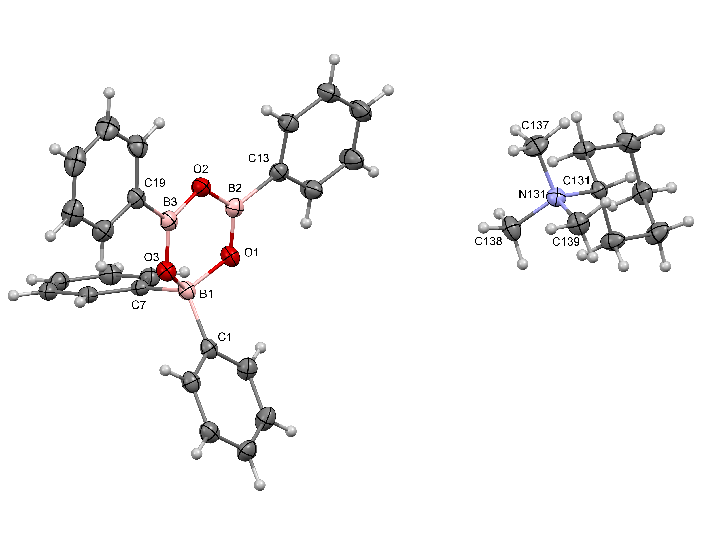

Figure 5. Drawing of one of the four independent cations and anions in the solid-state structure of trimethy(cyclohexyl)ammonium tetraphenylboroxinate(1-) (2), showing selected labelling. Distances (Å): B1-O1, 1.510(3); O1-B2, 1.332(3); B2-O2, 1.394(3); O2-B3, 1.399(3); B3-O3, 1.339(3); O3-B1, 1.500(3); B1-C1, 1.628(4); B1-C7, 1.630(3); B2-C13, 1.578(3); B3-C19, 1.569(3), N131-C131, 1.553(3), N131-C137, 1.498(3); N131-C138, 1.503(3); N131-C139, 1.498(3).

The tetraphenylboroxinate(1-) anion in 2 has the same gross boroxole ring structure as adducts 1a and 1b, with a neutral amine donor replaced by an anionic phenyl(1-) ligand. The boroxole ring adopts an envelope conformation with the four-coordinate boron (B1) out of the plane containing O1, O2 and O3 by 0.366(3) Å. The two B-C bond lengths of the four-coordinate bond are not significantly different from one another but these bonds are significantly longer than the B_{trig}-C bond lengths. These bond lengths and B-O ring distances are given in the caption to Figure 5. As has been noted previously for related structures [6, 10, 33], and confirmed here for structures 1a, 1b and 2, there are significant differences in ring B-O bond lengths of the boroxole ring. In particular, B2-O1 and B3-O3 are significantly shorter than those found in the triarylboroxines PTB and Ph₃B₃O_{3,} (ca. 1.38 Å) [7, 47] and Et₃B₃O₃ [48] since adduct formation localizes B-O π-bonding between these pairs of atoms (Figure 6) as the B-O bonding at the tetrahedral B1 lengthens to a distance associated with a bond order of one.

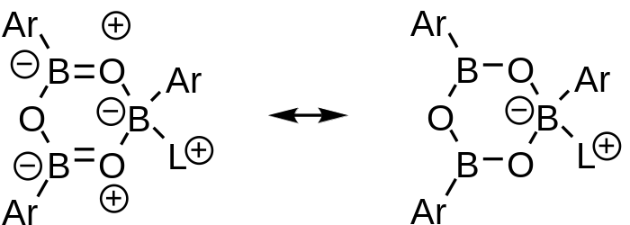

Figure 6. The resonance structure on the left makes an important contribution to the boroxole ring bonding in the tetraphenylboroxinate(1-) (Ar =Ph; L = Ph⁻) anion in 2
and to the amine adducts of tri(4-chlorophenyl)boroxine, 1a and 1b.

4. Conclusions
A number of adducts of N-donor adducts of tri(4-chlorophenyl)boroxine (PCB) have been prepared and two examples (PCB.L, L = morpholine, cyclohexylamine), together with a tetraphenylboroxinate(1-) salt have been characterized crystallographically. These structures shown a variation of ring BO bond-lengths of the boroxole ring consistent with π-bonding between the oxygen atoms adjacent to the four-coordinate boron and the other two boron atoms. In solution, ligand dissociation / recombination occurs and this has been followed by variable temperature NMR spectroscopy. The experimentally determined ΔG‡ values obtained for these CPB.amine complexes lie in the range of 49-58 kJmol⁻¹, and although these data are at the high end of ranges reported for ligand exchange for other triarylboroxine adducts, such differences may be within experimental error and may not have significance.

Acknowledgements. We thank the EPSRC for the use of the NCS X-ray crystallographic service (Southampton).

Supplementary Information. Crystallographic data for 1a, 1b, 2 have been deposited with the Cambridge Crystallographic Data Centre with CCDC1810671, 1810673, 1810672. Copies of this information may be obtained free of charge from the Director, CCDC, 12 Union Road, Cambridge, CB2 1EZ (fax +44 1223 336033) or email:deposit@ccdc.cam.ac.uk or www: http://www.ccdc.cam.ac.uk. Crystallographic data are also available as supplementary material.

5. References

[1] D.L. Yabroff, G.E.K. Branch, J. Am. Chem. Soc., 55 (1933) 1663-1655.
[2] A.B. Burg, J. Am. Chem. Soc., 62 (1940) 2228-2234.
[3] H.R. Snyder, M. S. Konecky, W.J. Lennarz, J. Am. Chem. Soc., 80 (1958) 3611-3615.
[4] J.F. Mariategui, K. Niedenzu, J. Organomet. Chem., 369 (1989) 137-145.
[5] J.M. Ritchey, Synthesis and properties of addition complexes of boroxines and other selected boron containing systems, PhD thesis, University of Colorado (1968).
[6] M. Yalpani and R. Boese, Chem. Ber., 116 (1983) 3347-3358.
[7] M.A. Beckett, G.C. Strickland, K.S. Varma, D.E. Hibbs, M.B. Hursthouse, K.M.A. Malik, J. Organomet. Chem., 535 (1997) 33-41.
[8] M.A. Beckett, D.E. Hibbs, M.B. Hursthouse, P. Owen, K.M.A. Malik, K.S. Varma, Main Group Chem., 2 (1998) 251-258.
[9] M.A. Beckett, D.S. Brassington, P. Owen, M.B. Hursthouse, M.E. Light, K.M.A. Malik, K.S. Varma, J. Organomet. Chem., 585 (1999) 7-11.
[10] M.A. Beckett, G.C. Strickland, K.S. Varma, D.E. Hibbs, M.B. Hursthouse, K.M.A. Malik, Polyhedron, 14 (1995) 2623-2630.
[11] M.A. Beckett, P. Owen, G.C. Strickland, K.S. Varma, Phosphorus, Sulfur Silicon Relat. Elem., 124/125 (1997) 509-512.
[12] Q. G. Wu, G. Wu, L. Brancaleon, S. Wang, Organometallics, 18 (1999) 2553-2556.
[13] J. Beckmann, D. Dakternieks, A. Duthie, A.E.K. Lim, E.R.T. Tiekink, J. Organomet. Chem., 633 (2001) 149-156.
[14] A.L. Korich, P.M. Iovine, Dalton Trans., 39 (2010) 1423-1431.
[15] W.H. Pearson, S. Lin, P.M. Iovine, Acta Cryst., E64 (2008) o235.
[16] G. Ferguson, A.J. Lough, J.P. Sheehan, T.R. Spalding, Acta Cryst., C46 (1990) 2390-2392.
[17] M.K. Das, J.F. Mariategui, K. Niedenzu, Inorg. Chem., 26 (1987) 3114-3116.
[18] N.G. Nair, M. Blanco, W. West, F.C. Weise, S. Greenbaum, V.P. Reddy, J. Phys. Chem., 113 (2009) 5918-5926.
[19] M.R.J. Elsegood, M.C. Kimber, Tet. Let., 56 (2015) 346-349.
[20] S. Saha, R.K. Kottalanka, T.K. Panda, K. Harms, J. Organomet. Chem., 745-746 (2013) 239-334.
[21] A. Torres-Huerta, M. de Jesus Velasquez-Hernandez, D. Martinez-Otero, H. Hopfl, V. Jancik, Cryst. Growth & Design., 17 (2017) 2438-2452.
[22] J. Cruz-Huerta, G. Campillo-Alvarado, H. Hopfl, P. Rodriguez-Cuamatzi, V. Reyes-Marquez, J. Guerrero-Alvarez, D. Salazar-Mendoza, N. Farfan-Garcia, Eur. J. Inorg. Chem., (2016) 355-365.
[23] W.L. Fielder, M.M. Chamberlain, C.A. Brown, J. Org, Chem., 26 (1961) 2154-2155.
[24] A. Sporzynski, H. Szatylowicz, J. Organomet. Chem., 470 (1994) 31-33.
[25] CrystalClear (2008-2014), Rigaku Corporation, The Woodlands, Texas, U.S.A.
[26] CrysAlisPro Software Systems (2015), Rigaku Oxford Diffraction, Yarnton, Oxford,
[27] O.V. Dolomanov, L.J. Bourhis, R.J. Gildea, J.A.K. Howard, H. Puschmann, J. Appl. Cryst., 42 (2009) 339- 341.
[28] G.M. Sheldrick, Acta Cryst., A71 (2015) 3-8.
[29] G.M. Sheldrick, Acta Cryst., C27 (2015) 3-8.
[30] L. Santucci, H. Gilman, J. Am. Chem. Soc., 80 (1958) 193-195.
[31] M.A. Beckett, D.E. Hibbs, M.B. Hursthouse, K.M.A. Malik, P. Owen, K.S. Varma, J. Organomet. Chem., 595 (2000) 241-247.
[32] A. Torres-Huerta, M. de J. Velasquez-Hernandez, L.G. Ramirez-Palma, F. Cortes-Guzman, D. Martinez-Otero, U. Hernandez-Balderas, Inorg. Chem., 56 (2017)10032-10043.
[33] W. Kliegel, H.-W. Motzkus, S.J. Rettig, J. Trotter, Can. J. Chem., 63 (1985) 3516-3520.
[34] E. Zeller, H. Beruda, H. Schmidbaur, Chem. Ber., 126 (1993) 2033-2036.
[35] M.A. Beckett, S.J. Coles, M.E. Light, L. Fischer, B.M. Stiefavter-Thomas, K.S. Varma, Polyhedron, 25 (2006) 1011-1016.
[36] M.A. Beckett, E.L. Bennett, P.N. Horton, M.B. Hursthouse, J. Organomet. Chem., 695 (2010) 1080-1083.
[37] H.S. Gutowsky, C. H. Holm, J. Chem. Phys., 25 (1956) 1228-1234.
[38] U. Mayer, V. Gutmann, W. Gerger, Monat. Chem., 106 (1975) 1235- 1257.
[39] V. Gutmann, Coord. Chem. Rev., 18 (1975) 225-255.
[40] I.B. Sivaev. V.I. Bregadze, Coord Chem. Rev., 270/271 (2014) 75-88.
[41] M.A. Beckett, G.C. Strickland, J.H. Holland, K.S. Varma, Polymer, 37 (1996) 4629-4631.
[42] M.A. Beckett, D.S. Brassington, S.J. Coles, M.B. Hursthouse, Inorg. Chem. Commun., 3 (2000) 530-533.
[43] P.N. Horton, M.B. Hursthouse, M.A. Beckett, M.P. Rugen-Hankey, Acta Cryst., E60 (2004) o2204-o2206.
[44] M.A. Beckett, D.S. Brassington, M.E. Light, M.B. Hursthouse, J. Chem. Soc., Dalton Trans., (2001) 1768-1172.
[45] H. Noeth, B. Wrackmeyer, ‘Nuclear magnetic spectroscopy of boron compounds’, in NMR Basic Principles and Progress, 14 (1978) Springer Verlag.
[46] M.A. Beckett, Coord. Chem. Rev., 323 (2016) 2-14.
[47] C.P. Brock, R.P. Minton, K. Niedenzu, Acta Cryst., C43 (1987) 1775-1779.
[48] R. Boese, M. Polk, D. Blaser, Angew Chem. Int, Ed. Engl., 26 (1987) 245-247.

