Assessing bottom-trawling impacts based on the longevity of benthic invertebrates

Running title: Effects of bottom trawling on seabed biota

Hiddink, J.G.ª, Jennings, S.^{b,c,d}, Sciberras, M.ª, Bolam, S.G.^{d}, Cambiè, G.^{d}, McConnaughey, R.A.^{e}, Mazor, T. ^{f}, Hilborn, R.^{g}, Collie, J.S.^{h}, Pitcher, R.^{f}, Parma, A.M.^{i}, Suuronen, P. ^{j}, Kaiser, M.J.^{al}, Rijnsdorp, A.D.^{k}

ªSchool of Ocean Sciences, Bangor University, Menai Bridge, Anglesey, LL59 5AB, United Kingdom, +44 (0)1248 382864, email: j.hiddink@bangor.ac.uk
^{b}International Council for the Exploration of the Sea, H. C. Andersens Boulevard 44-46, 1553 Copenhagen V, Denmark
^{c}School of Environmental Sciences, University of East Anglia, Norwich Research Park, NR4 6TJ, United Kingdom.
^{d}Centre for Environment, Fisheries and Aquaculture Science, Lowestoft Laboratory, Pakefield Road, Lowestoft, Suffolk NR33 0HT, UK
^{e}RACE Division, Alaska Fisheries Science Center, National Marine Fisheries Service, NOAA, 7600 Sand Point Way NE, Seattle, WA 98115, USA.
^{f}CSIRO Oceans & Atmosphere, EcoSciences Precinct 41, Boggo Road, Dutton Park, QLD 4102, GPO Box 2583, Brisbane, QLD 4001, Australia.
^{g}School of Aquatic and Fishery Sciences, University of Washington, Box 355020, Seattle, WA, 98195, USA
^{h}Graduate School of Oceanography, University of Rhode Island, Narragansett, RI, 02882, USA.
^{i}Centro Nacional Patagónico, CONICET, Puerto Madryn, Argentina.
^{j}Fisheries and Aquaculture Department, Food and Agriculture Organisation of the United Nations, Viale delle Terme di Caracalla, 00153, Rome, Italy. Current address: Natural Resources Institute Finland (Luke)
Latokartanonkaari 9, FI-00790 Helsinki
^{k}Wageningen UR, PO Box 68, 1970 AB IJmuiden, The Netherlands.
^{l}Current address: Marine Stewardship Council, 1 Snow Hill, London, EC1A 2DH
Abstract
- Bottom trawling is the most widespread human activity directly affecting seabed habitats. Assessment and effective management of the effects of bottom trawling at the scale of fisheries requires an understanding of differences in sensitivity of biota to trawling. Responses to disturbance are expected to depend on the intrinsic rate of increase of populations (r), which is expected to be linearly related to the reciprocal of longevity.
- We examine the relationship between the longevity of benthic invertebrates and their response to bottom trawling; both in terms of the immediate mortality following a trawl pass and their subsequent rates of recovery. We collate all available data from experimental and comparative trawling studies, and test how longevity influences these aspects of sensitivity.
- The shortest-lived organisms (<1yr) increased in abundance shortly after experimental trawling, but showed no response to trawling in longer-term comparative studies. Conversely, the abundance of biota with a life-span >1yr decreased by ~9% immediately following a trawl pass. The effect of bottom trawling in comparative studies increased with longevity, with a 2-3× larger effect on biota living >10yr than on biota living 1-3yr. We attribute this difference to the slower recovery rates of the longer-lived biota.
- The observed relationship between the intrinsic rate of population increase (r, our metric of recovery rate) and the reciprocal of longevity matches theoretical expectation and predicts that the sensitivity of habitats to bottom trawling is higher in habitats with higher proportions of long-lived organisms.
- Synthesis and Applications. Where the longevity of a species or the longevity distribution of a community is known or can be inferred, our estimates of depletion and intrinsic rate of increase can be combined with high-resolution maps of trawling intensity to assess trawling impacts at the scale of the fishery or other defined unit of assessment. Our estimates of r may also be used to estimate recovery times following other forms of seabed disturbance.
Alternative language abstract: Dutch
Beoordelen van bodemvisserijeffecten op basis van de levensduur van bentische ongewervelde dieren
1. Trawlvisserij op de zeebodem is de meest voorkomende menselijke activiteit met rechtstreekse gevolgen voor habitats op die zeebodem. Om de effecten van bodemtrawls op de schaal van de visserij te kunnen beoordelen en effectief te beheren, is inzicht nodig in gevoeligheid voor trawlvisserij van verschillende dieren. Reacties op verstoringen zullen naar verwachting afhangen van de intrinsieke groeisnelheid van populaties (r). We verwachten dat die omgekeerd evenredig is aan de levensduur van soorten.
2. We onderzoeken de relatie tussen de levensduur van bentische ongewervelde dieren en hun reactie op bodemtrawls; zowel in termen van de onmiddellijke sterfte na een trawltrek als van de daaropvolgende herstelpercentages. We verzamelen alle beschikbare gegevens uit experimentele en vergelijkende trawlonderzoeken en testen hoe de levensduur van soorten deze aspecten van gevoeligheid beïnvloedt.
3. De aantallen kortlevende organismen (<1 jaar) namen toe kort na experimentele trawlvisserij, maar vertoonden in vergelijkende studies op langere termijn geen reactie op trawlvisserij. De talrijkheid van dieren met een levensduur >1 jaar nam af met ~ 9% onmiddellijk na een trawltrek. Het effect van bodemtrawls in vergelijkende studies nam op langere termijn toe met de levensduur. Er was een 2-3 x groter effect op dieren die >10 jaar leefden dan op dieren die 1-3 jaar oud worden. We schrijven dit verschil toe aan het tragere herstel van de langer levende dieren.
4. De waargenomen relatie tussen de intrinsieke snelheid van de toename (r) en het omgekeerde van de levensduur van een soort komt overeen met de theoretische verwachting. Hiermee wordt voorspeld dat de gevoeligheid van habitats voor bodemtrawls hoger is als er sprake is van hogere percentages langlevende organismen.
5. Synthese en toepassingen. Als de levensduur van een soort of de levensduur van een gemeenschap bekend is of kan worden afgeleid, kunnen onze schattingen van sterfte en intrinsieke groeisnelheid worden gecombineerd met hoge resolutie kaarten van de intensiteit van de trawlvisserij om de impact van trawlvisserij op de schaal van de visserij te bepalen.
Keywords: benthic invertebrates, bottom trawl, ecosystem approach to fisheries management, impact assessment, life-history meta-analysis, systematic review
Introduction
Development of ecosystem-based fisheries-management strategies requires assessments of the distribution and impact of bottom trawling and the status of sediment-dwelling biota and habitats (Rice & Rochet, 2005; Rice et al., 2012; Rijnsdorp et al., 2016). Since biota and habitats differ in their degree of exposure and sensitivity to bottom trawling, knowledge of their distribution and sensitivity is required to assess impact and to formulate options or identify priorities for conservation and management.

Bottom trawls, here defined as any towed bottom-fishing gear including otter trawls, beam trawls, scallop dredges and hydraulic dredges, are used to catch fish, crustaceans and bivalves living in, on or close to the seabed (Sainsbury, 1986). Bottom trawling is by far the most extensive anthropogenic physical disturbance in the marine environment (Eigaard et al., 2016), but also makes an important contribution to global food supply and accounts for 35M tonnes of annual fish catches (combined weight of reported landings, estimated discards and estimated landings from illegal, unreported and unregulated (IUU) fishing; Watson & Tidd, 2018). Bottom trawling reduces benthic invertebrate biomass, numbers and diversity (Sciberras et al., 2018), and selects for communities that are dominated by fauna with fast life-histories (Tillin et al., 2006; van Denderen et al., 2015) and/or that experience low rates of mortality per trawl pass (Pitcher et al., 2000). These effects can lead to changes in community production, trophic structure and function (Hiddink et al., 2006). While frequency of disturbance is governed by exposure to fishing activity, mortality rates (d) depend on the penetration depth of the gear into the sediment (Hiddink et al., 2017), the morphology and size of biota and their position relative to the sediment surface (Duplisea et al., 2002; Sciberras et al., 2018). Capacity to withstand disturbance depends on life-history characteristics, such that species with higher intrinsic rates of increase (r), and therefore higher recovery rates, are expected to display smaller decreases in abundance in response to a given rate of mortality (Duplisea et al., 2002).

Intrinsic rates of population increase tend to be higher in species with higher metabolic rates (e.g. Brown et al., 2004; Savage et al., 2004). Owing to compensatory adjustments in their life-histories, these species tend to have earlier maturity, higher annual reproductive output and higher natural mortality, the latter leading to lower average life span (Hoenig, 1983; Charnov, 1993). Conversely, species with a lower metabolic rate have later maturity, lower annual reproductive output and lower natural mortality, leading to greater average longevity. Compensatory trade-offs between these life-history parameters lead to “life-history invariants” allowing one life-history parameter to be used as a reasonable proxy for several others (Beverton & Holt, 1959; Charnov, 1993). We therefore infer that the effect of any given rate of trawl mortality on a population will depend on its life-history, whereby populations with low r, low natural mortality rates (M) and greater longevity (T_{max}) have an increased sensitivity to trawling disturbance (Duplisea et al., 2002). For example, Tillin et al. (2006) demonstrated that benthic epifauna with T_{max} >10yr decreased in abundance with trawling, but that no such reduction occurred for fauna in the same areas with T_{max} <2yr.

The widespread adoption of Vessel Monitoring Systems for fisheries has revolutionised our capacity to map the exposure of seabed habitats to trawling disturbance at high resolution (Eigaard et al., 2016). However, information on the benthic biota in the trawled areas may be sparse, and the distribution, variety or abundance of biota is often inferred by collating existing data. These data usually come from surveys and monitoring programmes that may not focus on the components and attributes of the community that provide effective indicators of trawling impacts. For example, many data are composed of counts by species but provide no information on body size or biomass, both of which are more informative indicators of trawling impacts (Hiddink et al., 2006). Given that the dedicated collection of habitat data for the large-scale analysis of trawling impacts will require significant investment and long-term changes to existing surveys, current assessments of trawling impacts should seek to make best use of available data to describe the distribution and sensitivity of benthic biota. Approaches have included making better use of species count data by assigning traits to species to describe aspects of the functional or life-history characteristics of a community (e.g. Tillin et al., 2006). If the species present and their numeric abundances are known then traits such as longevity, that determine responses to elevated mortality, can be assigned to provide metrics of community sensitivity.

Our primary objective is to examine the relationship between the longevity of benthic invertebrates (T_{max}) and their response to trawling, both in terms of the mortality induced by the passage of a trawl and their recovery following trawling. The resultant relationships can be used to infer sensitivity to trawling for species of known longevity or communities with a known longevity distribution, for the purposes of assessing trawling impacts and informing habitat conservation and ecosystem-based fishery management. A secondary objective of this study is to demonstrate the use of the estimated fraction mortality per trawl pass (depletion d) and r for calculating the relative benthic status (RBS) of seabed fauna after trawling. The RBS method was developed and described by Pitcher et al. (2017) and is a spatial and quantitative environmental risk assessment method for assessing trawling impacts.

Methods

We collated all available data from experimental and comparative trawling studies using a systematic review methodology. Three different types of studies were included: 1) experimental studies where a defined area was experimentally trawled, while another area was not trawled, 2) comparative “trawled vs untrawled” contrast (TU) studies where a commercially trawled area was compared with a reference that was not trawled or only lightly trawled, and 3) comparative trawl gradient studies (TG) which included studies of benthic communities over gradients of commercial trawling frequency. Experimental trawling studies were used to estimate depletion d. The TU studies were used to compare the effect of a typical bottom trawl fishery on the abundance of organisms with different longevities; these studies do not provide parameter estimates, but the outcomes from this analysis are used to examine the validity of the relationship between longevity and trawling response. The TG studies were used to estimate the intrinsic rate of increase r for these groups. The validity of estimates of d and r were tested using field observations from the North Sea.

Data sources and study inclusion criteria
Data were collated from published experimental and comparative studies of the effects of bottom trawling on seabed habitat and biota following a systematic review protocol (Hughes et al., 2014), thereby avoiding selection bias. Studies were included if the abundance B (as numbers or biomass) of benthic species, genera and families, of either infauna and/or epifauna, was reported. Our analysis of comparative studies assumed that other environmental variables were not systematically related to trawling intensity, and we did not include studies in our analysis where this assumption was violated. Gradients in trawling effort may be driven by fishing regulation and seabed obstructions, but are also observed in areas of homogenous habitat (e.g. Hiddink et al., 2006). Data for number of individuals and biomass were combined in a single analysis, justified based on the analysis of Hiddink et al. (2017).

Overall there were 32 articles reporting 53 experimental studies, and 31 articles providing data on 30 comparative TU studies and 9 comparative TG studies. Four of the comparative TU studies provided a quantitative estimate of trawling intensity in both locations and were therefore included in both the TG and the TU analyses. The studies included in the analyses covered a wide range of trawl gears (otter trawl, towed dredge and hydraulic dredge), habitats (mud, sand, gravel and biogenic habitats), and faunal composition (infauna and epifauna). Studies were concentrated in temperate areas of Europe and North America, whereas very few studies were from tropical areas (Tables S1 and S2 and Figures S1 and S2).

Longevity
Depletion and recovery parameters were estimated for benthic fauna with different longevity, which was defined as the maximum-recorded age of a species T_{max} in years. Owing to scarce data and high uncertainty in T_{max} estimates for individual species, longevities were assigned to taxa with a fuzzy-coding approach using the existing database of Bolam et al. (2017). This database assigns fractional scores to each of four T_{max} categories (<1, 1-3, 3-10, >10yr, chosen to encompass the range of possible attributes of all the taxa), depending on the affinity of the species with these categories, and summing to one (Chevenet et al., 1994; explained in more detail in Tillin et al., 2006). Fuzzy coding allows taxa to exhibit multiple T_{max} categories to different degrees, and helps to address the uncertainty in and absence of direct T_{max} measurements for many benthic invertebrate species and expected differences in T_{max} within species linked to latitude and environment. After coding, the abundance of each taxon was multiplied with its proportional affinity. Consequently, the abundance of each taxon within a study was divided across T_{max} categories within that study in proportion to its fuzzy membership. Subsequently, the affinity-adjusted abundance was summed over all species in a study for each T_{max} category, yielding a total abundance per T_{max} category, which was used for the analyses below.

Analysis of experimental studies
Depletion d by T_{max} category was estimated using data collated from experimental studies, which quantified the abundance of biota following one or more trawling events. We used the log response-ratio (lnRR) for abundance B as the response variable, calculated as ln(B_{trawled}/B_{control}). Depletion d was estimated using weighted Meta-Analysis via Linear Mixed-Effects Models (using the function rma.uni in package metafor in R, Viechtbauer, 2010) according to the model: lnRR_{ij} = a_{j} + β_{j} log₂ (t_{ij} + 1) + α_{i} + ε_{ij} (eqn 1) for study i and T_{max} category j; α is the random study effect; ε is the Gaussian error term. t is the time in days since trawling. Depletion d_{j} was estimated as d_{j} = –(1–e^{aj}) (eqn 2). Time t was transformed using a base-2 logarithm to provide a linear approximation to a logistic recovery as non-linear curves proved difficult to fit directly to the available data given the relatively low number of replicate studies. Studies were weighted by the inverse of their variance estimate, as is normal practice in meta-analyses. The combined variance for multiple species with the same T_{max} within a study and T_{max} category was calculated following Borenstein et al. (2009). Many experimental studies were excluded from the analysis as they did not include a measure of variance. The carrion generated by trawling as a result of the direct mortality of organisms on the seabed, and by discarding of by-catch, produces food subsidies for scavenging species and can lead to a short-term influx of scavengers in recently trawled areas (Ramsay et al., 1997). Data for scavenging species collected within two days of experimental fishing disturbance were therefore removed from the data-set prior to analyses as in Sciberras et al. (2018).

Analysis of comparative trawled vs untrawled (TU) contrast studies
Trawled vs untrawled (TU) contrast studies were used to compare the effect of a typical bottom trawl fishery on the abundance of groups of organisms with different longevities. Most TU studies did not give trawling frequency, but where trawling frequency was quantified, the mean trawling frequency was 3.36 y⁻¹ in the trawled area (range: 0.2 to 12.9) and 0.1 y⁻¹ in the reference area (range: 0.0 to 0.4). TU studies were analysed using weighted Meta-Analysis via Linear Mixed-Effects Models with the log response-ratio (lnRR) for B as the response variable, by fitting the model lnRR_{ij} = ln(B_{trawled ij}/B_{reference ij})= k_{j} + α_{i} + ε_{ij} (eqn 3) with intercept k_{j} for T_{max} category j; α is the random study effect; ε is the Gaussian error term. Studies were weighted by the inverse their variance estimate as described above. SI Text S1 describes how comparative TU studies were treated when trawling was not continuous but stopped or started in one of the areas during the study.

Analysis of comparative trawl gradient (TG) studies
RBS of seabed fauna (species or communities) can be estimated based on the assumptions that (1) the recovery of biomass or numbers (abundance B) of biota after trawling is described by the logistic growth equation and the rate of recovery is therefore determined by the intrinsic rate of increase and (2) that the equilibrium solution of the logistic growth equation can be used to estimate abundance B as a fraction of carrying capacity K for an environment subject to fishing disturbance (F). This equilibrium solution of the logistic growth equation can be used to estimate RBS, which is abundance B as a fraction of K. Gradient studies were used to estimate the intrinsic rate of increase r for species with different T_{max} following eqn 4, as described in detail in Hiddink et al. (2017).

RBS = B/K = 1 - F d/r (eqn 4)

In this case, trawling effort (F) is defined as the total area swept by trawl gear within a given area of seabed in one year divided by that area of seabed (units y⁻¹). Depletion d is the fraction mortality per trawl pass estimated from experimental trawling studies. The intrinsic rate of population increase r is estimated from the slope of eqn 1. Eqn 1 suggests that r is constant, but in communities composed of species with a range of r values, trawling selects for species with faster life-histories that are more resilient, and therefore, r can be expected to increase with F. The r value that we want to estimate is for recovery of the community to its original unfished state, and therefore is the r at F = 0. We found that the relationship between community B/K and F for communities is well-approximated by a log-linear relationship. We, therefore, estimated r at F = 0 and assuming a log-linear relationship between RBS and F using a linear mixed effects model, log₁₀(RBS_{ij}) = b1 F_{i} + b2 F_{i}×T_{max ij} + α_{i} + ε_{ij} (eqn 5), where b1 is the general slope for effort F_{i} and b2 is the slope for F_{i}× T_{max ij} with T_{max} as continuous variable; α is the random study effect; ε is the Gaussian error term. This model does not include the main effect of T_{max}, and although in most analyses this would be undesirable because it would lead to biased parameter estimates, it is appropriate here because the effect of trawling at F = 0 has to be zero (Hector et al., 2010). We modelled ‘study’ as a random effect, to account for the non-independence of observations within a study. Because the model would not converge using T_{max} as a categorical fixed effect, and because it is not possible to fit a continuous relationship between the intrinsic rate of increase and T_{max} with T_{max} as a categorical fixed effect, T_{max} categories were converted to a continuous variable following the method described in SI Text S2. Continuous T_{max} for each T_{max} category was 0.5 (<1yr), 2.1 (1-3yr), 6.5 (3-10yr) and 12.6 years (>10yr). The resulting r~T_{max} relationship is not particularly sensitive to the exact values chosen here.

Because the slope in Eqn 4 equals d/r, r can be estimated from the slope using the depletion d estimate from the analysis of the experimental studies. We used the estimate for depletion rate d for biota with a lifespan of >1yr of d = 0.09 as estimated in Figure 1A. However, it is necessary to take account of the log-linear relationship we used between RBS and F, and the uncertainty in the estimates (for a derivation see Hiddink et al., 2017). The resulting uncertainty intervals capture both the probabilistic uncertainty resulting from the linear model and the vagueness inherent in the fuzzy coding of T_{max}.

Time to recovery was estimated as the time taken to recover from a given level of abundance to 0.95K assuming logistic population recovery using the equations in Text S5 in Hiddink et al. (2017). We report the recovery time from 0.50 to 0.95K unless otherwise stated.

We checked the assumptions of all statistical analyses by visual inspection of the normalized residuals (Zuur et al., 2009).

Assessment of benthic status
The performance of the estimates d and r for predicting benthic status was tested using field observations from the North Sea by applying the quantitative method of Pitcher et al. (2017). We modelled the predicted effect of trawling on B by T_{max} category using Eqn 4. As an example, we describe how trawling affects the abundance of communities composed respectively of long and short-lived taxa in the Results. For this assessment we require F, d, K and r for each grid-cell (ideally around 1 km²) in the area of assessment, for each T_{max} category. The values of r and d depend on the environmental conditions and fishing gears used in each cell respectively. Our analyses indicated that biota with a T_{max} <1yr are not consistently impacted by trawling, and therefore not included in our assessment.

Since we sought to compare sensitivity to trawling in different T_{max} categories, we applied the estimates of d, r, B and K by T_{max} category. For each T_{max} category, a category-specific K was expressed as fraction of K for all T_{max} categories (=1). This fraction is habitat-specific and was derived by Rijnsdorp et al. (2018) from the cumulative biomass distribution of infaunal invertebrates by T_{max} category in the North Sea, as determined from grab and box core samples in untrawled locations (the effects of not including epifauna in these estimates is not known). Because we express category-specific K as a fraction, K = ΣK_{j} = 1 (eqn 6) over T_{max} categories j (although the approach could be based on absolute estimates of category-specific K if they were available).

The assessment method was tested by comparing the RBS predicted from trawling frequency with epifaunal biomass estimates at sites subject to different levels of trawling intensity in four North Sea areas with different habitat types (Dogger Bank - shallow sand, Hills - highly dynamic shallow sand, Northwest Rough - deeper sand, Silver Pit - deeper muddy sand). The sampling design and methods were described in Hiddink et al. (2006). Even at low trawling intensity, epifaunal biomass differs substantially among these areas of the North Sea (Hiddink et al. 2006). To address these differences in K a location effect was included in the linear model (B_{sk}= b1 RBS_{sk}+ b2_{k} RBS_{sk}+ ε_{sk} (eqn 7), where b1 is the general slope and b2 the slope effect for location k with RBS_{sk} for replicate s).

Results

Estimating depletion d from experimental studies
For T_{max} categories 1-3, 3-10 and >10yr mean depletion was 9% (95% CI, 1.6-15.9%) per trawl pass (Figure 1a, Table S3) and the magnitude of depletion was not related to T_{max}. For the T_{max} category <1yr, abundance increased immediately after trawling (Figure 1a, Table S3). This unexpected increase cannot be explained by an influx of scavengers as they were excluded.

Comparative Trawled-Untrawled studies, TU
The abundance of benthic macroinvertebrates in trawled locations was lower than in reference locations for all T_{max} categories >1yr. There was no significant change in abundance for organisms <1yr (mean increase of 18%, 95% CI, -24% to +86%), but there was a significant decrease in abundance of 37% (95% CI, -57% to -7%) for organisms >10yr (Figure 1b). Whilst the effect of fishing was to reduce abundance of organisms, the response did not differ significantly among organisms with different T_{max} (test statistic Q_{M3} = 5.1, P = 0.16). Nevertheless, the estimate went from being not significantly different from zero for organisms <3yr (95% CI overlapping 0) to significant for organisms >3yr (Figure 1b).

Estimating the intrinsic rate of increase r from comparative gradient studies, TG
The effect of trawling on relative abundance was significant with a negative F × T_{max} interaction (t₂₂₆ = -3.24, P = 0.0013) indicating that organisms with different T_{max} respond differently to trawling. Each unit increase in F (yr⁻¹) resulted in a mean decrease of 3.8% in abundance for organisms with T_{max} = 1-3yr, 11.1% decrease for organisms with T_{max} = 3-10yrs and a 20.4% decrease in abundance for biota with a T_{max} >10 yr (Figure 2a). A re-analysis excluding trawling intensities of >10 yr⁻¹ shows that the slopes of the log₁₀(RBS) vs trawling frequency relationship for biota with a T_{max} = 1-3 years were particularly influenced by data at F > 10yr⁻¹ (Figure S4). Estimates of r, derived from the slopes in Figure 2 and the depletion rates d in Figure 1a, ranged from 2.41 yr⁻¹ for biota with a T_{max} = 1-3yr, through 1.24 yr⁻¹ for biota with a T_{max} = 3-10yr, to r = 0.34 yr⁻¹ for biota with a T_{max} >10yr. These r estimates translate to estimates of median time to recovery (T) from 0.5K to 0.95K of 1.2 (0.55 - 2.78 uncertainty interval), of 2.4 (1.37 – 4.16) and 8.7 (3.51 – 22.50) years respectively (Figure 2b, Table S3). The relationship between 1/T_{max} and r (Figure 3) is consistent with the linear relationship predicted by theory derived in Supplementary material Text S3 (or more precisely, based on these data we cannot reject theory that suggests there should be a linear relationship) and may be used to approximate r for species for which T_{max} is known .

Assessment method and validation
Relative benthic status (RBS) within a T_{max} category is predicted to decline linearly with trawling frequency (Figure 4a-c). The RBS of longer-lived biota declines faster because of a lower r (Figure 4c). The total biomass or RBS of a community with a high fraction of long-lived species therefore decreases further for a given increase in F because the long-lived taxa are much more sensitive to trawling (Figure 4d), while the RBS of a community with a high fraction of short-lived species shows a smaller response to trawling (Figure 4e).

The validation exercise demonstrated a positive correlation between the observed total epifaunal community biomass and predicted RBS over gradients of trawling intensity in the North Sea (Figure 5, effect of RBS F_{1,29}=77.0, P<0.001, interaction between RBS and location representing differences in K between areas, F_{3,29}=11.76, P<0.001, R²=0.77).

Discussion

This meta-analysis of experimental and comparative trawling impact studies demonstrates that decreases in the relative abundance of longer-lived fauna in trawled areas are greater than those of fauna with shorter lifespans. These differences are attributed to the lower intrinsic rates of increase of longer-lived fauna and, consequently, to their lower capacity to sustain trawling-induced mortality. The intrinsic rate of increase was estimated to be seven times lower for longer-lived (>10yr) than for shorter-lived fauna (1-3yr) and the corresponding time to recovery from 0.5K to 0.95K increased from 1.22 yr (0.55 - 2.78 uncertainty interval) to 8.7 yr (3.51 – 22.50). The reported relationships can be used to estimate sensitivity to trawling for species or communities with a known longevity or longevity distribution and to estimate recovery times following trawling. While the community may not recover to the size and age composition associated with no trawling within this time, the recovery of abundance is likely to correlate to the recovery of ecosystem processes, such as bioturbation. Given that some of the longest-lived benthic biota in the longer-lived (>10yr) category can live for 100+ yr (e.g. the ocean quahog Arctica islandica, 507 years, Butler et al., 2013), full recovery to the pre-trawling age structure is unlikely to occur for such biota on any time-frame if any trawling persists. For taxa that form biogenic structures (e.g., the Ross worm Sabellaria spinulosa or the horse mussel Modiolus modiolus), the recovery rate of the biogenic structures will be slower than the recovery rates of the individual organisms that make up the structures (Rijnsdorp et al., 2016). Therefore, where biogenic species are prevalent and the focus of assessment is on habitat status, the time required to rebuild the structures should be used to assess the sensitivity to trawling rather than the longevity of the individual organisms that build the structure. Consequently, the results of this study are most relevant for communities of free-living animals in and on soft and mobile sediments.

The relationship showing that the impact of trawling was greater for greater longevity in gradient studies was characterised by high uncertainty (eqn 5), in part because some relationships were driven by a few data points. Our systematic review methodology means that we deliberately included all available datasets worldwide that passed the screening criteria, so much of the uncertainty reflects real-world variation, caused, for example, by differences in the physical and ecological characteristics of different ecosystems. We consider our conclusions robust because the patterns observed in both the TU and TG studies are consistent, and match theoretical expectations. The large uncertainty nevertheless means that diverse responses are feasible because factors other than longevity contribute to faunal responses to bottom trawling.

Efforts to link longevity T_{max} and the intrinsic rate of increase r could be more rigorous and less vague (vagueness as expressed by the fuzzy coding process) if reliable point estimates of T_{max} were available. However, in contrast with groups such as fish and birds, life-history data for benthic invertebrates are rather limited and ageing methods are uncertain or not developed for most groups, except bivalves. The fuzzy approach enabled assimilation of the patchy and inconsistent knowledge that does exist. However, unlike for probabilistic uncertainty, it is not clear how to assimilate and report the resulting vagueness in the subsequent meta-analyses or to carry forward the effects of the absolute loss of information that results from defuzzification into the next steps of the analysis. Consequently, the results of statistical tests may be ambiguous. For other steps in our method the treatment of uncertainty is not ambiguous as estimated uncertainty in T_{max} (input) for any given species can be expressed as estimated uncertainty in r (output). In addition to working with T_{max,} there would, in the future, also be options to work with other life-history parameters that may be estimated more easily. These include using natural mortality, estimated directly or from size-based analyses of populations or the size or age at maturity. However, in practice, we are a long way from doing this for most benthic invertebrate species despite progress in some areas and for some groups (e.g. Palomares & Pauly, 2010). In general, for assessing fishing impacts and other effects of elevated mortality, a shift away from conventional sampling of species identity and numbers for multivariate community analyses towards a focus on life-history traits of populations would advance our capacity to assess fishing impacts and the impacts of other forms of seabed disturbance that result in mortality of benthic biota.

The linear relationship between reciprocal longevity and r is consistent with theoretical expectations, but this assessment was based on a comparison with just three data points given limitations of the longevity database and the absence of species-specific longevity estimates for most benthic species. Tests using more categories of longevity estimates or individual longevity estimates may in future give us more confidence that the data matches the theoretical expectation. Regardless of the shape of the relationship, communities with a greater mean longevity are shown to be more sensitive to a given rate of mortality due to trawling disturbance, and maintain a relatively lower RBS, consistent with observations. Assessments of impacts based on knowledge of the longevity distribution of the community are appealing because they account for the interaction of other forms of disturbance (primarily, but not exclusively, natural disturbance) and trawling disturbance. In the absence of trawling, the longevity distribution of benthic communities will vary among habitats, reflecting the influence the environment, including processes such natural disturbance of sediments by waves and tides, which affect the life-histories and mortality of species present (Rijnsdorp et al., 2018). For example, large-scale sediment movements during winter storms in shallow areas, or summer hypoxia in the Baltic Sea, are associated with high natural mortality rates and with communities dominated by shorter-lived fauna with a higher r. Our results suggest these types of communities will be relatively more resilient to a given frequency of trawling disturbance than communities with low natural disturbance levels.

Synthesis and Applications

Quantitative descriptions of trawling impacts contribute to state of the environment reports, environmental risk assessments and advice on options for balancing the benefits of fish production and protection of the marine environment. At present, most descriptions are presented as overlays of the distribution of fishing activity on habitat distribution or sensitivity maps or spatial assessments of the relative reductions in total abundance resulting from trawling (e.g. Jennings et al., 2012; Eigaard et al., 2016). However, the new relationship between the longevity of species and r can be combined with high-resolution maps of trawling intensity to enable assessment of the risks and impacts of bottom trawling on the abundance of species or communities with defined longevity or recovery time. This would be achieved by generating estimates of r from longevity and using these within the RBS framework of Pitcher et al. (2017). It is important to take account of the substantial uncertainty around the r ~ longevity relationship by providing estimates of the mean as well as the upper and lower bounds of the effects of bottom trawling.

Quantification of the relationship between longevity and r is especially valuable; longevity is a species’ characteristic that often matters for conservation and management agencies because it resonates with societal concerns about the loss of long-lived species (e.g. Garcia et al., 2014). Our approach allows RBS and associated uncertainty to be estimated for any species with defined longevity deemed to be of ‘concern’ and for the presentation of options to show how alternative values of F would affect the RBS of species with different longevity. Outputs of such analyses will support demands from conservation and management agencies, the fishing industry and certification bodies for better quantitative information on the impacts of bottom trawling and the consequences of adopting alternate management options.

Authors' Contributions
JH, AR and SJ conceived the ideas and designed methodology. All authors contributed to data-collation. JH analysed the data and led the writing of the manuscript. All authors contributed critically to the drafts and gave final approval for publication.

Acknowledgements
The study was funded by the European Union project BENTHIS EU-FP7 312088, the David and Lucile Packard Foundation, the Walton Family Foundation, and many fish producers (full list in Hiddink et al., 2017). Additional funding was provided by the UK Department of Environment, Food and Rural Affairs (project MF1225), the U.S. National Oceanic and Atmospheric Administration, the FAO, NERC (NE/L003279/1, Marine Ecosystems Research Programme; NE/K001639/1: Shelf Sea Biogeochemistry programme), and the Marine Stewardship Council. We thank Vicenc Torra for advice on defuzzification.

Data accessibility
The longevity database and the data collated in the systematic review will be made available from Dryad Digital Repository.

References

Beverton, R.J.H. & Holt, S.J. (1959) A review of the lifespans and mortality rates of fish in nature, and their relation to growth and other physiological characteristics. Ciba Foundation Symposium-The Lifespan of Animals (Colloquia on Ageing), Volume 5 (ed. by G.E.W. Wolstenholme and M. O'conner), pp. 142-180. John Wiley & Sons, Chichester, UK.
Bolam, S.G., Garcia, C., Eggleton, J., Kenny, A., Buhl-Mortensen, L., Gonzalez-Mirelis, G., van Kooten, T., Dinesen, G., Hansen, J., Hiddink, J.G., Sciberras, M., Smith, C., Papadopoulou, N., Gumus, A., Hoey, G.V., Eigaard, O.R., Bastardie, F. & Rijnsdorp, A.D. (2017) Differences in biological traits composition of benthic assemblages between unimpacted habitats. Marine Environmental Research, 126, 1-13.
Borenstein, M., Hedges, L.V., Higgins, J.P.T. & Rothstein, H.R. (2009) Introduction to Meta-Analysis. Wiley, Chichester, UK.
Brown, J.H., Gillooly, J.F., Allen, A.P., Savage, V.M. & West, G.B. (2004) Toward a metabolic theory of ecology. Ecology, 85, 1771-1789.
Butler, P.G., Wanamaker, A.D., Scourse, J.D., Richardson, C.A. & Reynolds, D.J. (2013) Variability of marine climate on the North Icelandic Shelf in a 1357-year proxy archive based on growth increments in the bivalve Arctica islandica. Palaeogeography, Palaeoclimatology, Palaeoecology, 373, 141-151.
Charnov, E.L. (1993) Life History Invariants: Some Explorations of Symmetry in Evolutionary Ecology. Oxford University Press, Oxford, UK.
Chevenet, F., Doledec, S. & Chessel, D. (1994) A fuzzy coding approach for the analysis of long-term ecological data. Freshwater Biology, 31, 295-309.
Duplisea, D.E., Jennings, S., Warr, K.J. & Dinmore, T.A. (2002) A size-based model of the impacts of bottom trawling on benthic community structure. Canadian Journal of Fisheries and Aquatic Sciences, 59, 1785-1795.
Eigaard, O.R., Bastardie, F., Hintzen, N.T., Buhl-Mortensen, L., Buhl-Mortensen, P., Catarino, R., Dinesen, G.E., Egekvist, J., Fock, H., Geitner, K., Gerritsen, H., González, M.M., Jonsson, P., Kavadas, S., Laffargue, P., Lundy, M., Mirelis, G.G., Nielsen, J.R., Papadopoulou, N., Posen, P.E., Pulcinella, J., Russo, T., Sala, A., Silva, C., Smith, C., Vanelslander, B. & Rijnsdorp, A.D. (2016) The footprint of bottom trawling in European waters: distribution, intensity and seabed integrity. ICES Journal of Marine Science, 74, 847-865.
Garcia, S.M., Rice, J. & Charles, A. (2014) Governance of marine fisheries and biodiversity conservation: interaction and co-evolution. John Wiley & Sons.
Hector, A., von Felten, S. & Schmid, B. (2010) Analysis of variance with unbalanced data: an update for ecology & evolution. J Anim Ecol, 79, 308-16.
Hiddink, J.G., Jennings, S., Kaiser, M.J., Queirós, A.M., Duplisea, D.E. & Piet, G.J. (2006) Cumulative impacts of seabed trawl disturbance on benthic biomass, production and species richness in different habitats. Canadian Journal of Fisheries and Aquatic Sciences, 63, 721-736.
Hiddink, J.G., Jennings, S., Sciberras, M., Szostek, C.L., Hughes, K.M., Ellis, N., Rijnsdorp, A.D., McConnaughey, R.A., Mazor, T., Hilborn, R., Collie, J.S., Pitcher, R., Amoroso, R.O., Parma, A.M., Suuronen, P. & Kaiser, M.J. (2017) Global analysis of depletion and recovery of seabed biota following bottom trawling disturbance. Proceedings of the National Academy of Sciences, 114, 8301–8306.
Hoenig, J.M. (1983) Empirical use of longevity data to estimate mortality rates. Fishery Bulletin, 82, 898-903.
Hughes, K.M., Kaiser, M.J., Jennings, S., McConnaughey, R.A., Pitcher, R., Hilborn, R., Amoroso, R.O., Collie, J., Hiddink, J.G., Parma, A.M. & Rijnsdorp, A. (2014) Investigating the effects of mobile bottom fishing on benthic biota: a systematic review protocol. Environmental Evidence, 3:23
Jennings, S., Lee, J. & Hiddink, J.G. (2012) Assessing fishery footprints and the tradeoffs between landings value, habitat sensitivity and fishing impacts to inform marine spatial planning and an ecosystem approach. ICES Journal of Marine Science, 69, 1053-1063.
Palomares, M. & Pauly, D. (2010) SeaLifeBase. World Wide Web Electronic Publication,< www. sealifebase. org, version>(12/2010),
Pitcher, C.R., Poiner, I.R., Hill, B.J. & Burridge, C.Y. (2000) Implications of the effects of trawling on sessile megazoobenthos on a tropical shelf in northeastern Australia. ICES Journal of Marine Science, 57, 1359-1368.
Pitcher, C.R., Ellis, N., Jennings, S., Hiddink, J.G., Mazor, T., Kaiser, M.J., Kangas, M.I., McConnaughey, R.A., Parma, A.M., Rijnsdorp, A.D., Suuronen, P., Collie, J.S., Amoroso, R., Hughes, K.M. & Hilborn, R. (2017) Estimating the sustainability of towed fishing-gear impacts on seabed habitats: a simple quantitative risk assessment method applicable to data-limited fisheries. Methods in Ecology and Evolution, 8, 472-480.
Ramsay, K., Kaiser, M.J., Moore, P.G. & Hughes, R.N. (1997) Consumption of fisheries discards by benthic scavengers: utilization of energy subsidies in different marine habitats. Journal of Animal Ecology, 66, 884-896.
Rice, J., Arvanitidis, C., Borja, A., Frid, C., Hiddink, J.G., Krause, J., Lorance, P., Ragnarsson, S.Á., Sköld, M., Trabucco, B., Enserink, L. & Norkko, A. (2012) Indicators for Sea-Floor Integrity under the European Marine Strategy Framework Directive. Ecological indicators, 12, 174–184.
Rice, J.C. & Rochet, M.J. (2005) A framework for selecting a suite of indicators for fisheries management. ICES Journal of Marine Science, 62, 516-527.
Rijnsdorp, A.D., Bolam, S.G., Garcia, C., Hiddink, J.G., Hintzen, N., Kooten, T.v. & Denderen, P.D.v. (2018) Estimating the sensitivity seafloor habitats to disturbance by bottom trawling impacts based on the longevity of benthic fauna. Ecological Applications, 28, 1302-1312.
Rijnsdorp, A.D., Bastardie, F., Bolam, S.G., Buhl-Mortensen, L., Eigaard, O.R., Hamon, K.G., Hiddink, J.G., Hintzen, N.T., Ivanović, A., Kenny, A., P., L., Nielsen, R.N., O’Neill, F.G., Piet, G.J., Polet, H., Sala, A., Smith, C., van Denderen, P.D., van Kooten, T. & Zengin, M. (2016) Towards a framework for the quantitative assessment of trawling impact on the seabed and benthic ecosystem. ICES Journal of Marine Science, 73, S1: i127-i138.
Sainsbury, J.C. (1986) Commercial fishing methods. Fishing News Books, Oxford.
Savage, V.M., Gillooly, J.F., Brown, J.H., West, G.B. & Charnov, E.L. (2004) Effects of body size and temperature on population growth. The American Naturalist, 163, 429-441.
Sciberras, M., Hiddink, J.G., Jennings, S., Szostek, C.L., Hughes, K.M., Kneafsey, B., Clarke, L.J., Ellis, N., Rijnsdorp, A.D., McConnaughey, R.A., Hilborn, R., Collie, J.S., Pitcher, C.R., Amoroso, R.O., Parma, A.M., Suuronen, P. & Kaiser, M.J. (2018) Response of benthic fauna to experimental bottom fishing: a global meta-analysis. Fish and Fisheries, 19, 698-715.
Tillin, H.M., Hiddink, J.G., Kaiser, M.J. & Jennings, S. (2006) Chronic bottom trawling alters the functional composition of benthic invertebrate communities on a sea basin scale. Marine Ecology Progress Series, 318, 31-45.
van Denderen, P.D., Bolam, S.G., Hiddink, J.G., Jennings, S., Kenny, A., Rijnsdorp, A.D. & van Kooten, T. (2015) Similar effects of bottom trawling and natural disturbance on composition and function of benthic communities across habitats. Marine Ecology Progress Series, 541, 31–43.
Viechtbauer, W. (2010) Conducting meta-analyses in R with the metafor package. Journal of Statistical Software, 36, 1-48.
Watson, R.A. & Tidd, A. (2018) Mapping nearly a century and a half of global marine fishing: 1869–2015. Marine Policy, 93, 171-177.
Zuur, A.F., Ieno, E.N., Walker, N.J., Saveliev, A.A. & Smith, G.M. (2009) Mixed effects models and extensions in ecology with R. Springer Verlag, New York.

Figures
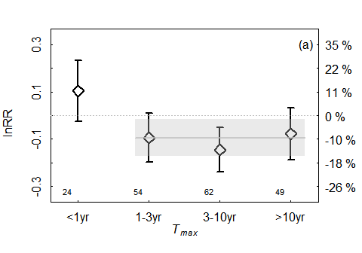
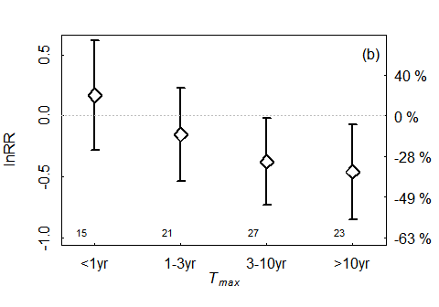
Figure 1. The effect of bottom trawling on the abundance of taxa (as log response ratio - lnRR) with different longevities (mean, 95% confidence interval). a) Effect of a single trawl pass in experimental studies. The grey line and shaded bar indicate the mean effect (d = 0.09) and confidence interval for biota with T_{max} > 1yr. b) The difference between control and impact locations in comparative TU studies of chronic trawling. If the 95% confidence interval overlaps lnRR = 0, the effect was not significant. The right-hand axis indicates the responses in % changes. The number of studies included in each estimate is given below each bar.

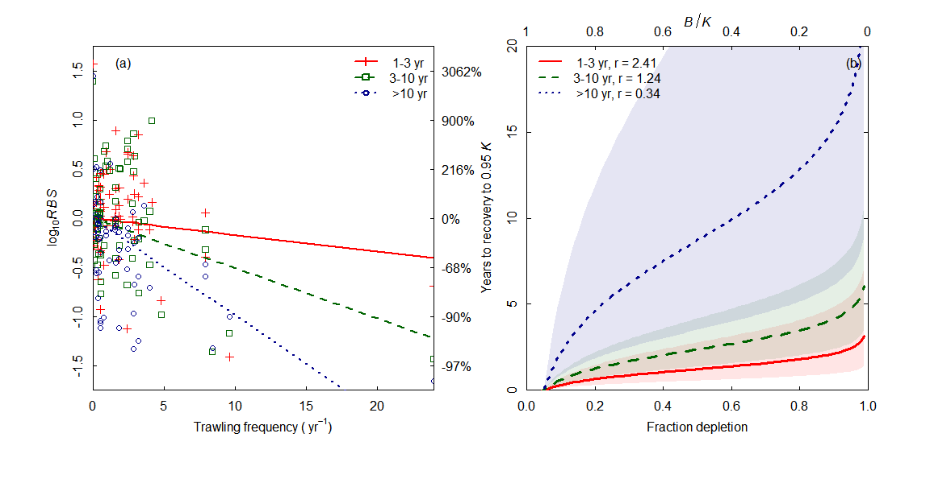

Figure 2. The response of different longevity categories to trawling: (a) The relationship between trawling frequency and abundance (biomass or numbers) of taxa in gradient studies; (b) estimated recovery time to 0.95K for depleted abundance as a function of estimated intrinsic rate of increase r and fraction depletion (= -(B/K-1). In (b) the shaded areas indicate the 95% uncertainty intervals for estimates. See Figure S4 for an analysis with data points at trawling frequency > 10 yr⁻¹ removed.

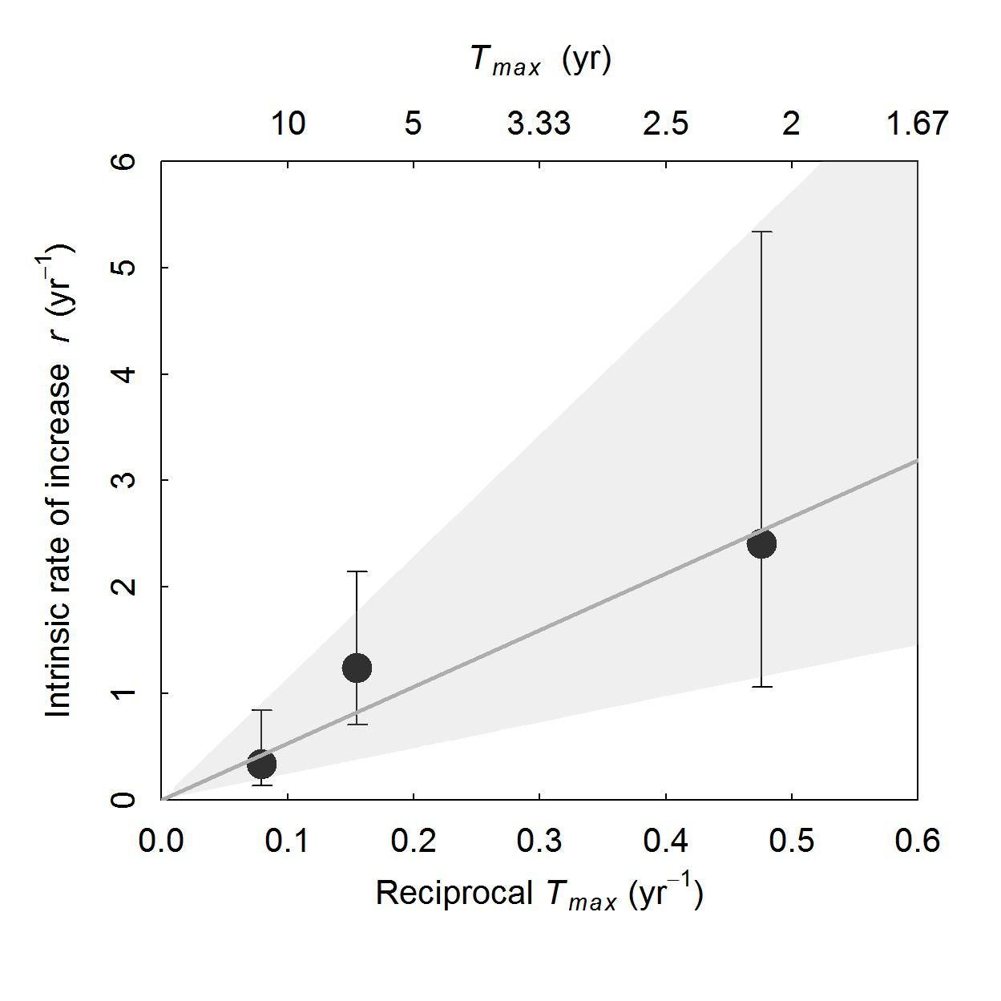

Figure 3. Relationship between r and T_{max} estimated from gradient studies (r = 5.31 / longevity, R² = 0.96, F_{1,1} = 73.9, P = 0.013).The points and error bars are r estimates and their 95% confidence intervals, while the solid line is the fitted regression line. The shaded areas indicats the regression fits through the upper and lower confidence intervals of the data (upper: r = 11.44 / longevity, lower: r = 2.43 / longevity).

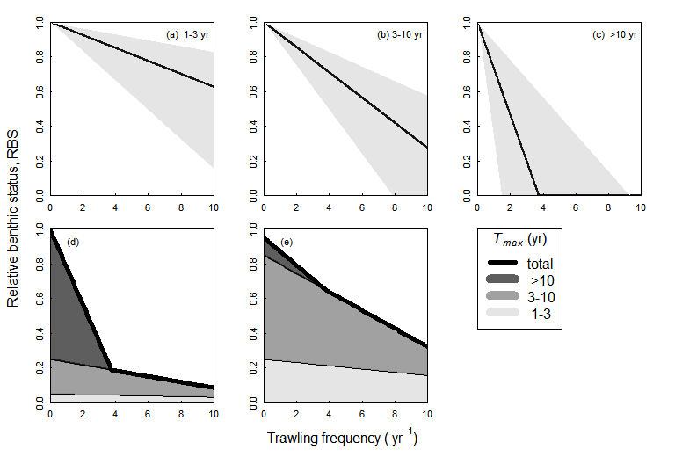
Figure 4. The response to trawling of biota of different longevity. (a-c): The predicted relative benthic status RBS of three longevity categories in response to trawling with their confidence intervals. (d-e): The response of predicted RBS to trawling for two hypothetical benthic communities with different longevity distributions: (d) scenario for a community with a large fraction of long-lived fauna, (e) scenario for a community with a high fraction of short-lived fauna.

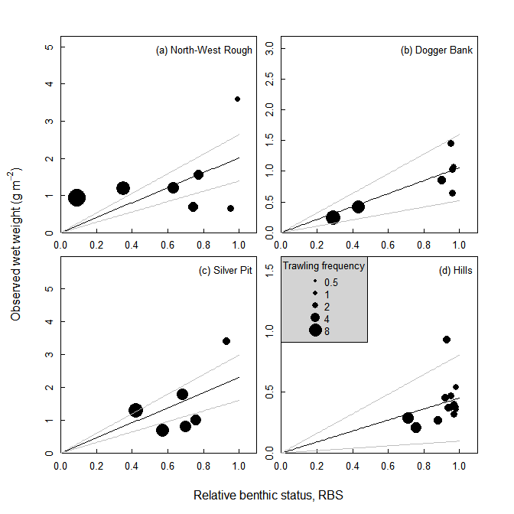
Figure 5. Relationship between the observed total community biomass of epifauna and predicted relative benthic status RBS in four fishing grounds in the North Sea with gradients of trawling intensity. Black lines indicate the fitted regression, grey lines the 95% confidence intervals. Bubble sizes are proportional to the trawling intensity (yr⁻¹) at each site.

