Designing vulnerable zones of nitrogen and phosphorus transfers to control water pollution in China
Zhaohai Bai,† Δ Jie Lu,†Δ Hao Zhao,†Δ Gerard L. Velthof,‡ Oene Oenema,‡ Dave Chadwick,§ John R. Williams,∥ Shuqin Jin,# Hongbin Liu,⊥ Mengru Wang, ⸸ Maryna Strokal, ⸸ Carolien Kroeze, ⸸ Chunsheng Hu,†* Lin Ma,†*
†Key Laboratory of Agricultural Water Resources, Center for Agricultural Resources Research, Institute of Genetic and Developmental Biology, The Chinese Academy of Sciences, 286 Huaizhong Road, Shijiazhuang 050021, Hebei, China.
‡ Wageningen University, Environmental Research, P.O. Box 47, 6700 AA, Wageningen, The Netherlands.
§School of Environment, Natural Resources and Geography, Bangor University, Bangor, LL57 2UW, U.K.
∥ADAS Boxworth, Cambridge, CB23 4NN, UK.
#Research Center for Rural Economy Ministry of Agriculture, No. 56, Xisizhuanta Hutong, Beijing 100810, China.
⊥Key Laboratory of Nonpoint Source Pollution Control, Ministry of Agriculture/Institute of Agricultural Resources and Regional Planning, Chinese Academy of Agricultural Sciences, Beijing, China.
⸸Water Systems and Global Change Group, Wageningen University and Research, Droevendaalsesteeg 4, Wageningen, 6708 PB, The Netherlands.
ΔThese authors contributed equally to this paper.
Corresponding author: *E-mail: malin1979@sjziam.ac.cn. E-mail: cshu@sjziam.ac.cn.
It has been reported that 31% of the rivers and six of nine major coastal bays in China have suffered from eutrophication, caused by elevated concentrations of nitrogen (N) and phosphorus (P). In addition, >60% of the monitored drinking water wells are severely contaminated, classified as level IV (I-V, where V is the worst) or worse^{1,2}. Transfers of N and P from agriculture are the main contributors to the poor water quality².

China has recently introduced water protection policies to address nutrient transfers to vulnerable watercourses, such as the 2015 Water-Pollution-Prevention-Control-Action -Plan. However, this policy focuses on the management of industrial effluents and includes only two mitigation strategies related to agriculture: (i) relocation of livestock farms outside the highly populated regions, and (ii) reduction of chemical fertilizer use to increase recycling of manure in crop production. These actions have been implemented without identifying the key regions that are vulnerable for NO₃⁻ and P leaching from agriculture to groundwater and surface waters. As a result, such policies may not have the desired effect in reducing N and P contamination in waters.

Designation and Role of Nutrient Vulnerable Zones in China
Nutrient Vulnerable Zones (NVZs) to control N and P use have the potential to reduce water pollution and increase the effectiveness of policies to protect water quality. However, such zones do not exist for Chinese water systems yet. NVZs have been introduced in United States (US) and European Union (EU) where significant contamination of water bodies by N and P from agricultural sources has occurred. The Nitrates Directive was implemented in the EU in 1991 and Clean Water Act was introduced in the US in 1972. All EU member states have to designate NVZs (https://water.jrc.ec.europa.eu/arcgis/apps/webappviewer/index.html?id=efab8e6ac9a840a086b63eed76094b3b), defined as areas of land draining to waters that are affected by NO₃⁻ pollution or that could be affected if action is not taken to decrease NO₃⁻leaching. In these NVZs, a number of key actions have to be taken to reduce NO₃⁻ leaching. As a result, nitrate leaching reduced by 16% between 2000 and 2008, and thereby water quality in NVZs is improving in the EU ³, and eutrophication of surface waters has been be prevented. The Clean Water Act in the US aims to reduce both N and P transfers to watercourses. Different states are required to submit a list of polluted and threatened watercourses and establish priority actions to reduce N and P pollution of surface water bodies⁴.

We argue for a need to design NVZs for Chinese agricultural systems. The criteria for the design of such nutrient vulnerable zones (for N and P losses to water) should include the following elements: (i) Information about the current eutrophication status of waters, based on monitoring data of NO₃⁻ and P concentrations in surface waters and groundwater; (ii) A comprehensive evaluation of the risks of NO₃⁻ and P leaching to groundwater from agriculture at regional levels; (iii) A comprehensive evaluation of the risk of N and P runoff to surface waters, and (iv) Risk analysis of nutrient losses to water from manure management. The regions where N and P concentrations are already excessive should be termed Vulnerable Zones, where immediate policies and actions should be implemented. Regions with high risk of N and P losses should be deemed as potential Vulnerable Zones, where further monitoring of N and P in the watercourses needed.

Designation of the NVZs is possible for China because of the existing information and knowledge. We combined existing information to support our views on the potential of designing the NVZs for China (Fig 1). We used the most recent monitoring data for NO₃⁻ concentrations in groundwater^{1,2} and surface waters², and a comprehensive evaluation of the risks of NO₃⁻ and P leaching and runoff in more than 2000 counties in 2012⁵ to show the extent of N and P Vulnerable Zones (NPVZs) in agricultural land in China (Fig 1). This illustrative example shows that the total area of NPVZs cover around 68 million ha arable land (51% of the agricultural land), of which 20% is potential NPVZs.

Implications for Research, Policy and Practice
We demonstrated an approach to designate NPVZs in China using existing data, and we provide an illustrative example in Fig 1. However, this is a first example with designations of NPVZs based on limited data and broad assumptions, so more research is needed to improve the quality of NPVZs designation, by quantifying surface water and groundwater contamination (and water table depth) at the regional level, and aggregating smaller areas of NPVZs into larger NPVZs to facilitate more efficient control and monitoring of action programs. Furthermore, NPVZs could become part of the recently implemented water protection policies, so that effective measures are targeted at the regions with highest N and/or P pollution.

Scientists also need to develop an action program for each NPVZ, including measures to reduce N and P leaching and runoff, e.g. by determining maximum N and P application rates for specific crops based on balanced fertilization to avoid over-fertilization. A coordinated program of national field experiments will be needed to quantify optimal nutrient application rates, also allowing for nutrients and their availability in manures, depending on crop type, soil type, climate and yield level.

Policy makers and scientists should work together to develop a cost-effective monitoring and reporting system. Standard methods for measuring water quality, and NO₃⁻ and P leaching and runoff concentration should be developed and widely applied to monitor the effectiveness of the nitrate action programs in NPVZs. A system to control and enforce the implementation of the mandatory measures should be developed, e.g. by recording the use of fertilizers and manure to assist nutrient management planning. Guidelines for farmers to apply the measures and to implement best available N and P management practices have to be developed, and a knowledge communication program designed to train farmers and extension officers.

ACKNOWLEDGMENTS
This work was financially supported by The National Key Research and Development Program of China (2016YFD0800106; 2016YFD0200105); the National Natural Science Foundation of China (31572210); the Hundred Talents Program of CAS; PIFI of CAS (2016DE008, 2016VBA073, 2017VCA0020, 2015VEA025); the UK-China Virtual Joint Centre for Improved Nitrogen Agronomy (CINAg) (BB/N013468/1); European Union’s Horizon 2020-FAIRWAY project (727984).

REFERENCES
- Gu, B.; Ge, Y.; Chang, S. X.; Luo, W.; Chang, J. Nitrate in groundwater of China: Sources and driving forces. Global Environ Chang. 2013, 23(5), 1112-1121.
- Han, D.; Currell, M. J.; Cao, G. Deep challenges for China’s war on water pollution. Environ Pollut. 2016, 218, 1222.1233.
- Velthof, G. L.; Lesschen, J. P.; Webb, J.; Pietrzak, S.; Miatkowski, Z.; Pinto, M.; Kros, J.; Oenema, O. The impact of the Nitrates Directive on nitrogen emissions from agriculture in the EU-27 during 2000–2008. Sci Total Environ. 2014, 468, 1225-1233.
- Manuel, J. Nutrient pollution: A persistent threat to waterways. Environ Health Persp. 2014, 122(11), A304.
- Wang, M. R.; Ma, L.; Strokal, M.; Ma, W. Q.; Liu, X. J.; Kroeze, Carolien. Hotspots for Nitrogen and Phosphorus Losses from Food Production in China: a County-scale Analysis. Environ Sci Technol. 2018, 52, 10, 5782-5791
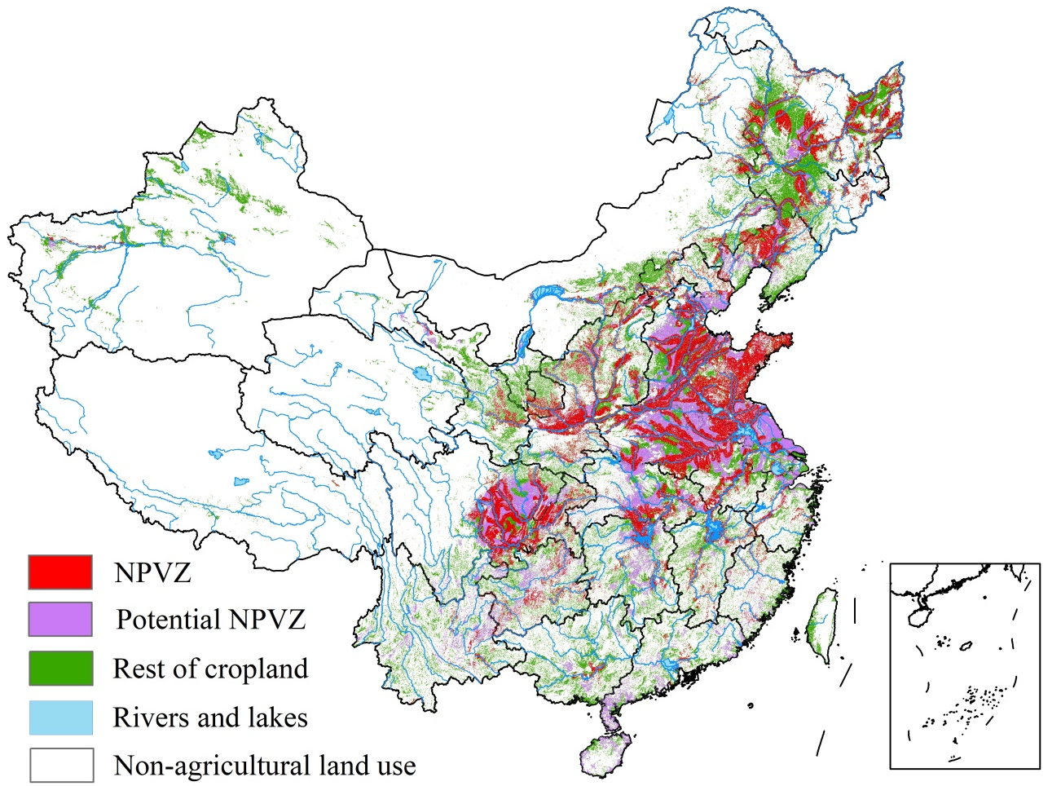
Figure 1. An illustrative example of nitrogen (N) and phosphorus (P) Vulnerable Zones (NPVZs) in China.
Note: Map was made based on existing data about: i) current surface and ground water contamination^{1,2}; ii) N and P leaching and runoff risk per hectare of agricultural land at the county level ⁶; iii) N and P runoff risk per hectare of agricultural land at the county level ⁶.

