The Quiet Eye Effect: A Test of the Perceptual and Kinematic Hypotheses

Germano Gallicchio and Christopher Ring
School of Sport, Exercise & Rehabilitation Sciences, University of Birmingham, UK

Running head: Quiet eye: Perceptual and kinematic hypotheses

Corresponding Author: Germano Gallicchio
School of Sport, Exercise & Rehabilitation Sciences
University of Birmingham
Edgbaston, Birmingham, B15 2TT, UK
Email: germano.gallicchio@gmail.com

Author note: This work was supported by Economic and Social Research Council Grant ES/J50001X/1

Abstract

The quiet eye effect describes the performance advantage associated with a long ocular fixation on a critical target of an action, prior to and during movement execution. Researchers have advocated a multi-measure approach to shed light on the mechanism(s) behind the association between ocular activity and motor performance. In this study we used psychophysiological methods to test whether the quiet eye period is associated with enhanced visual processing (visual hypothesis) or longer movement durations (postural-kinematic hypothesis). Thirty-two recreational golfers putted 20 balls to a 2-m distant target on a flat surface. We examined quiet eye duration and time-varying eye quietness using electrooculography, occipital alpha power using electroencephalography, and swing duration using kinematic sensors. Occipital alpha power, an inverse neural marker of visual processing, increased prior to and during swing execution, suggesting decreased visual processing compared to baseline. Correlations revealed that, despite the overall decrease, visual processing decreased less with a longer quiet eye and greater eye quietness. Importantly, swing duration was strongly and positively correlated with both indices of ocular activity: longer quiet eye and greater eye quietness were associated with longer swing duration. Our findings support the postural-kinematic hypothesis, confirming that the duration of the quiet eye is associated with a slow movement execution and question the role of visual processing in the final moments of closed-loop aiming tasks. We anticipate major advancements in the mechanistic understanding of the quiet eye effect as researchers adopt psychophysiological methods to examine eye movements in combination with measures of other biological systems.

Key words: Alpha power, Electrooculography, Golf putting, Kinematics, Visual processing
The way we move our eyes has been linked with the precision of movements requiring fine motor control, such as those used in target sports. Research using eye-tracking technology has revealed that, compared to novices, experts make fewer ocular fixations of longer duration on action-related locations prior to and during the execution of a motor skill (Mann, Williams, Ward, & Janelle 2007). The duration of the final ocular fixation on a critical target of the action, labelled the quiet eye (Vickers, 1996), has attracted much interest from researchers due to its ability to distinguish skilled from less skilled performers as well as successful from unsuccessful performance of experts (for reviews of studies see Lebeau et al., 2016; Mann, Williams, Ward, & Janelle, 2007; Rienhoff, Tirp, Strauß, Baker, & Schorer, 2016; Vickers, 2007; Wilson, Causer, & Vickers, 2015). In the case of golf putting, the quiet eye period has been defined as the duration of the final ocular fixation on the ball, with onset prior to the initiation of the swing movement and offset when the gaze deviates from the ball, potentially even after putter-ball impact (Vickers, 2007). Longer quiet eye durations have been reported for experienced versus novice golfers (Walters-Symons, Wilson, & Vine, 2017) and for holed versus missed putts in experienced golfers (Wilson & Pearcy, 2009).
Despite the large body of evidence endorsing the existence of the quiet eye effect, researchers still debate how it might influence performance. In order to advance our understanding and inform the design of training programs aimed at improving performance, researchers have recommended mechanistic and cross-disciplinary investigations to test the validity of the competing hypotheses (Causer, 2016; Williams, 2016; Wilson, Wood, & Vine, 2016). A comprehensive review of the putative mechanisms goes beyond the scope of the present work, and for a detailed account we refer the reader to a recent review by Gonzalez et al. (2017a). In the present study, we evaluated two mechanistic hypotheses: the visual hypothesis and the postural-kinematic hypothesis.
Visual hypothesis
Vision-action coupling constitutes a key element in the debate on quiet eye mechanisms. Researchers have described the quiet eye as a perceptual-cognitive phenomenon reflecting the selective processing of movement-related visual information through overt attention (see Posner, 1980). For example, in their study of the quiet eye in billiards, Williams et al. (2002, p. 197) concluded that ‘To execute the shot, players must successfully integrate visual information from the cue, cue ball, target ball, and pocket.’ The thesis that visual processing plays a major role in the quiet eye was emphasized by Vickers (2012), who referred to the dorsal cortical stream – a visual attention network (Corbetta & Shulman, 2002; Goodale & Milner, 1992) – to explain the putative mechanism underlying the quiet eye effect. In short, enhanced processing of visual information has been the dominant mechanism in this context, even for closed-loop aiming tasks with stationary targets, such as golf putting. Indeed, in their study of the quiet eye in golf putting, Vine et al. (2015, p. 5) concluded that ‘visual information is being actively extracted and processed’ during the quiet eye period. In the current study we refer to this visual attention mechanism as the visual hypothesis.
Cognitive processes, including attention and perception, can be studied in an objective and unobtrusive manner by recording individuals’ electroencephalogram (EEG) as they perform goal-oriented actions. More specifically, the selective allocation of attentional resources to processing of visual information can be assessed using the magnitude of cortical oscillations (i.e., power) within the alpha frequency band (8-12 Hz) in the occipital regions of the brain. Importantly, studies have established that increased occipital alpha power reflects decreased visual processing (Romei, Gross, & Thut, 2010; Romei, Rihs, Brodbeck, & Thut, 2008; Vanni, Revonsuo, & Hari, 1997). EEG methods have been successfully implemented in sport research (for review see Cooke, 2013; Hatfield, Haufler, Hung, & Spalding, 2004). For example, EEG research has revealed that superior motor performance is associated with neural efficiency by alpha gating, which describes the allocation of attentional resources towards movement-related and away from movement-unrelated information processing (e.g., Gallicchio, Finkenzeller, Sattlecker, Lindinger, & Hoedlmoser, 2016; Gallicchio, Cooke, & Ring, 2017).
Given the extensive use of EEG in sport research it is surprising that, with one exception, the association between quiet eye and visual processing, assessed using EEG, has been largely neglected. The exception is the study by Janelle et al. (2000) that reported a positive correlation between quiet eye duration and EEG occipital alpha power in experienced marksmen. Contrary to the visual hypothesis, this finding suggests diminished visual processing during the quiet eye period in a shooting task. Given that this critical piece of evidence appears to have been overlooked within the quiet eye literature and, moreover, that this finding has never been replicated, the association between occipital alpha power and quiet eye duration warrants further investigation.
Postural-kinematic hypothesis
An alternative postural-kinematic hypothesis contends that the link between quiet eye and performance is accounted for by a kinematic mechanism: postural stability (involving trunk, limbs, head, and eyes) before and during movement is expected to lead to better performance and longer quiet eye. In the case of golf putting, a slower and more stable swing may be linked with (a) cleaner putter-ball impact to optimize impact velocity and angle and thereby ensure greater putting accuracy, and (b) greater likelihood of keeping the head and eyes still, resulting in delayed quiet eye offset and longer quiet eye. Each of these two elements is considered next.
First, the association between swing biomechanics/kinematics (i.e., a slow and stable movement) and superior putting performance is substantiated by research indicating that, compared to less skilled counterparts, expert golfers sway less (i.e., exhibit less centre of pressure variability) (e.g., Hurrion, 2009; McLaughlin, Best, & Carlson, 2008; Richardson, Hughes, & Mitchell, 2012), generate less lateral putter head acceleration (i.e., they are less likely to swing out of line) (e.g., Cooke et al., 2014; Sim & Kim, 2010), and putt more slowly (e.g., Delay et al., 1997; Gallicchio, Cooke, & Ring, 2018).
Second, the association between putting biomechanics/kinematics and longer quiet eye can be examined separately for stability and duration. The argument that greater movement stability is associated with longer quiet eye is supported by the finding that novice golfers trained to increase their quiet eye duration in a putting task also generated decreased lateral and vertical putter head acceleration, compared to a control group (Moore, Vine, Cooke, Ring, & Wilson, 2012). The argument that longer movement duration (i.e., slower swing) is associated with longer quiet eye is supported by evidence showing that experts swung for longer than novices and that movement duration was positively correlated with post-movement initiation quiet eye duration (Gallicchio et al., 2018). In other words, novices, who swung the putter quicker than experts, had less reason to keep their head still and dwell on the impact location, and more reason to start to track the moving ball sooner (see online supplementary material, Gallicchio et al., 2018). The net result was that novices exhibited an earlier quiet eye offset compared to experts. The current study aims to extend and replicate the study by Gallicchio and colleagues by testing the movement duration element of the postural-kinematic hypothesis, using both within- and between-participant analyses.
The Present Study
In the present study we had two aims. Our first aim was to assess whether ocular activity was associated with EEG occipital alpha power and thereby test a core tenet of the visual hypothesis. Our second aim was to assess whether ocular activity was associated with movement duration in order to test a core tenet of the postural-kinematic hypothesis. We used EEG to examine brain activity implicated with visual processing (e.g., Janelle et al., 2000), and movement sensors to examine the duration of the movement (e.g., Gallicchio et al., 2018). We used electrooculography (EOG) to score the quiet eye period in different phases of the movement (e.g., Gallicchio et al., 2018; Gonzalez et al., 2017b; Mann, Coombes, Mousseau, & Janelle, 2011). We supplemented quiet eye information with the novel ‘eye quietness’ index (Gallicchio et al., 2018), which, unlike quiet eye duration, measures the extent to which the eyes are quiet (rather than dichotomizing eye movements into a state of ‘quiet’ or ‘non quiet’) with high temporal resolution.
Method
Participants
We tested 32 right-handed male relatively-inexperienced recreational golfers (age: M = 20.09, SD = 2.04 years) with no formal golf handicap and occasional golf experience: they reported to have played 12.06 times (SD = 12.96) in the 12 months preceding testing. Participants were asked to refrain from alcohol, caffeine, and nicotine 3 hours prior to testing. All provided signed consent to take part in the study and were compensated with £10 and research credits. This study was approved by the local ethics committee.
Putting task
Participants putted golf balls (diameter 4.7 cm) to a 2-m distant target with a 91-cm blade-style putter on a 5 × 1.5 m flat surface (Turftiles; Stimpmeter value: 2.27 m). The target was a 6 mm diameter adhesive paper marker placed on the putting surface. Participants were instructed to execute the putt at their own pace (i.e., no time pressure) with the goal to “get the final position of the ball as close as possible to the target”. Prior to each putt participants were required to stand in a relaxed position and maintain their gaze on a fixation cross placed at eye level on the facing wall (c. 1.5 m away) for 4-5 s, until a 200-ms acoustic tone (cue stimulus) prompted them to prepare for the putt. This acoustic tone was generated by a piezo buzzer controlled by an Arduino Micro board (Arduino, Italy) interfaced with a computer running MATLAB (MathWorks, USA).
Procedure
Upon arrival in the laboratory, participants were briefed and instrumented for physiological recording. Then, participants performed 10 putts to a series of targets varying in distance and extent to familiarize them with the putting surface. Finally, participants putted 20 balls to a straight 2-m distant target. The average time between consecutive putts was 22.82 s (SD = 2.45). After each putt the researcher took a photo of the putting area using a ceiling-mounted camera and repositioned the ball for the next putt.
Physiological signals
Electrophysiological signals were recorded using an ActiveTwo system (BioSemi, Netherlands). The EOG was recorded using four electrodes applied on the participant’s skin near the eyes: two were placed at the outer canthi of each eye and the other two at the bottom of each eye. The EEG was recorded through 32 electrodes applied on scalp sites Fp1, Fp2, AF3, AF4, F7, F3, Fz, F4, F8, FC5, FC1, FC2, FC6, T7, C3, Cz, C4, T8, CP5, CP1, CP2, CP6, P7, P3, Pz, P4, P8, PO3, PO4, O1, Oz, O2 (10-20 system, Jasper, 1958). Additional electrodes were applied to the mastoids and to the chest (proximal lead-II ECG montage) for offline denoising purposes (described below). The signal was amplified and digitized at 2048 Hz with 24-bit resolution and no filter was set during recording. All channels were recorded in monopolar. Common mode sense and driven right leg electrodes were used to enhance the common mode rejection ratio of the signal.
Digital triggers (transistor-transistor logic inputs) were sent via parallel communication to the recording system in order to detect (a) the onset of the acoustic tone (prompting the participant to prepare for the putt), (b) the initiation of the backswing, and (c) the impact of the putter head with the ball. Participants were instructed to align the putter head with an infrared digital switch (E18-D80NK) when ready to putt: this sensor sent a digital trigger as the putter head moved away from the ball at the initiation of the backswing. In addition, a piezo sensor (MiniSense 100) attached to the back of the putter head was used to record putter-ball impact vibrations. This sensor was interfaced with the recording system to synchronize information about the impact with the electrophysiological signals.
After recording, we performed the following pre-processing steps. Signals were down-sampled to 512 Hz. For the analysis of the quiet eye, the electrodes positioned at the canthi of each eye were re-referenced to each other to create a bipolar horizontal EOG channel. Then we applied a 30 Hz low-pass filter (Finite Impulse Response, filter order = 2^8) according to EOG guidelines (Marmor et al., 2011). No high-pass filter was applied in order to preserve flat sections of the signal, typical of ocular fixations (Acuña et al., 2014). Epochs were segmented from -9 to +3 s (0 s = backswing initiation) and the voltages were linearly detrended (i.e., the best straight-line fit was subtracted to each epoch signal). Finally, a 125-ms median filter was applied to attenuate ocular overshoots while preserving sharp vertical edges typical of ocular saccades (Bulling et al., 2011; Juhola, 1991). Figure 1 shows the horizontal EOG channel from selected trials for illustration. All single-trial waveforms can be accessed from the online supplemental material (Supplement S1).
For the analyses of EEG activity and eye quietness we applied a 0.1-40 Hz band-pass filter (Finite Impulse Response, filter order = 2^15). Two types of epochs were segmented from -3.5 to +1.5 s relative to (a) the acoustic tone (cue stimulus) and (b) the initiation of the backswing. Voltages were mean-centered within each epoch. Epochs were visually inspected and were discarded from all subsequent analyses if they showed movement or electrical artefacts. The mean number of backswing-centered epochs that were retained was 19.84 (SD = 0.37, minimum = 19). The mean number of tone-centered epochs that were retained was 19.75 (SD = 0.51, minimum = 18). Independent Component Analysis (Makeig et al., 1996) was performed to attenuate any electrical artefacts due to ocular, cardiac, and muscular activity in the EEG signal using the EOG and ECG channels. Finally, the EEG channels were average-referenced.
Measures
Quiet eye. Quiet eye durations (ms) were calculated for two periods and were obtained by further processing the horizontal EOG signal: QE_{pre} defined as quiet eye onset to backswing initiation, and QE_{post} defined as backswing initiation to quiet eye offset. Onset and offset of the quiet eye were identified through a threshold algorithm. Specifically, voltages at successive time points were compared with the voltage at the instant of the initiation of backswing (i.e., time = 0 s). Quiet eye onset and offset were respectively defined as the farthest time points preceding and following backswing initiation that did not exceed a certain threshold (Gallicchio et al., 2018). We evaluated the quiet eye durations for 30 threshold options (ranging from 5 to 150 µV in 5 µV steps). We conducted exploratory analyses using all of these threshold settings (Figure 2), however, for our main analyses, we chose a threshold of 60 µV, corresponding with eye movements of 3° of visual angle (Shackel, 1967). This choice was informed by visual inspection revealing that, compared to other thresholds (including 20 µV corresponding with 1° of visual angle), the 60 µV threshold detected most accurately the duration of the final fixation, commencing with the foot of the final square wave prior to backswing initiation (Figure 1). Moreover, 60 µV is the same threshold deemed optimal in a previous study (Gallicchio et al., 2018). The interested reader can inspect the single-trial quiet eye durations identified by the different threshold options in the online supplemental material (Supplement S1).
Eye quietness. Eye quietness (%) was computed as the standard deviation of the horizontal EOG channel (HEOG-SD) in eight non-overlapping 0.5 s intervals ranging from -3 to +1 s (0 s = backswing initiation) (Gallicchio et al., 2018). Each HEOG-SD value reflected how much the eyes moved or were active in the horizontal plane: larger values indicated more and larger eye movements (hence less eye quietness); conversely, smaller values indicated fewer and smaller eye movements (hence greater eye quietness). Finally, HEOG-SD was baseline-corrected to reflect the percentage change relative to average HEOG-SD in the 2 s prior to the onset of the acoustic tone. This transformation was performed to minimize variability between participants and, moreover, this procedure is implemented as standard in the analysis of EEG signals (Pfurtscheller & Lopes da Silva, 1999).
Occipital alpha power. Time-frequency decomposition was performed through short-time Fast Fourier Transform (FFT), conducted on eight non-overlapping 0.5 s windows ranging from -3 to +1 s (0 s = backswing initiation), to match the windows used for the analysis of eye quietness. Prior to FFT, each window was mean-averaged, multiplied by a Hanning function to taper both ends, and then zero-padded to reach a length of 4 s, yielding a frequency resolution of 0.25 Hz. The amplitude of the signal resulting from the FFT was doubled for all positive frequencies and alpha power was computed as the squared amplitude in the 8-12 Hz frequency range. Then, alpha power was baseline-corrected to reflect the percentage change (Pfurtscheller & Lopes da Silva, 1999) relative to the average baseline activity in the 2 s prior to the onset of the acoustic tone (cue stimulus). Finally, occipital alpha power was obtained by averaging values for the O1, Oz, and O2 channels to create an occipital region of interest, consistent with previous research (e.g., Gallicchio et al., 2017).
Movement duration. The duration of the swing (ms) was measured as the time between backswing initiation and putter-ball impact. These two events were detected through a bespoke MATLAB script that combined data from the infrared switch and the piezo sensor.
Putting performance. Radial error (cm) was computed as the distance between the target and the terminal position of the ball after each putt. Scoring was performed through a bespoke MATLAB script that used the photos of the target area taken after each putt (Gallicchio & Ring, 2018).
Statistical Analyses
We used two statistical strategies to examine the associations between ocular activity (i.e., quiet eye and eye quietness) and (a) brain activity (i.e., occipital alpha power), (b) movement duration, and (c) putting performance (i.e., radial error). Correlations were computed using the Spearman’s rank test. Spearman’s rho (ρ) was used as the effect size, with values of .10, .30, and .50 reflecting small, medium, and large effects, respectively (see reference values for Pearson product-moment correlation in Cohen, 1992).
Our first strategy sought to capture the effects for each participant at the individual trial level. We refer to this as trial-level analysis. This strategy involved two steps. First, we correlated the two variables across all trials separately for each participant. Second, we performed a one-sample t test on the Fisher-Z transformed correlation coefficients across all participants (cf. Klostermann et al., 2014). For this analysis we report the group mean of the back-transformed Spearman’s rho correlation coefficient (ρ_{M}) along with the t value and the associated p value. Our second strategy sought to compare participants using the average scores over all of their trials; this is the typical correlation analysis. We refer to this as participant-level analysis. For this analysis we report the Spearman’s rho coefficient (ρ) and the associated p value. The purpose of each analysis and our selection of the pairs of measures is described next.
Quiet eye and eye quietness. We correlated quiet eye and eye quietness to cross-validate these two indices of ocular activity. More specifically, we correlated QE_{pre} with pre backswing initiation HEOG-SD (i.e., in the six time intervals from -3 to 0 s) and QE_{post} with post backswing initiation HEOG-SD (i.e., in the two time intervals from 0 to +1 s).
Correlates of occipital alpha power. We correlated ocular activity (i.e., quiet eye and eye quietness) with brain activity (i.e., occipital alpha power) to test the visual hypothesis. For the analyses involving the quiet eye, we correlated QE_{pre} with pre-backswing initiation occipital alpha power (i.e., in the six time intervals from -3 to 0 s), and QE_{post} with post-backswing initiation occipital alpha power (i.e., in the two time intervals from 0 to 1 s). For the analyses involving eye quietness, we correlated HEOG-SD and occipital alpha power in each of the eight time intervals from -3 to +1 s. In addition, we evaluated the specificity of any effect to the alpha band by conducting further analyses on activity in other EEG frequencies. We examined non-alpha frequencies to evaluate the extent to which any effect for the alpha band was unequivocally attributable to visual processing rather than indicating a non-cortical phenomenon, such as elevated somatic activity.
Correlates of movement duration. We correlated ocular activity (i.e., quiet eye and eye quietness) with movement duration to test the postural-kinematic hypothesis. Because it was necessary to measure movement duration from the initiation of the backswing, we correlated only the post-backswing initiation indices of ocular activity (i.e., QE_{post} and HEOG-SD in the two intervals from 0 to +1 s).
Correlates of performance. We correlated ocular activity (i.e., QE_{pre}, QE_{post}, and HEOG-SD in each of the eight time intervals from -3 to +1 s) with radial error to explore performance effects linked with gaze behaviour.
Results
Quiet eye and eye quietness
We computed the quiet eye for two intervals: before backswing initiation (QE_{pre}) and after backswing initiation (QE_{post}). The threshold algorithm at 60 µV identified the following mean durations: QE_{pre} 928 ms (SD = 501, range = 227 to 2623) and QE_{post} 819 ms (SD = 219, range = 367 to 1213). The main analyses reported below were conducted using the 60 µV threshold (see Measures section above for the rationale underlying this choice). Nonetheless, there is a healthy debate among quiet eye researchers about the appropriate choice of this threshold (i.e., visual angle), and therefore, we have displayed the influence of threshold choice on quiet eye duration in Figure 2A, which shows that the higher the threshold the longer the duration.
We analysed eye quietness (i.e., HEOG-SD) as a function of time (Figure 3). Smaller values reflected less variability, hence greater quietness. Eye quietness was best (i.e., largest effect size) described by a cubic pattern, F(1,31) = 16.84, p < .001, η_{p}² = .352, whereby quietness decreased until -1 s, increased until +0.5 s, and finally decreased after +0.5 s. It is worth mentioning that the greatest quietness was evident between 0 and +0.5 s, that is, during the execution of the swing.
To evaluate the utility of eye quietness as index of ocular activity we examined its correlation with quiet eye durations. The outcomes of trial- and participant-level correlations are reported in Table 1. Both types of analyses confirmed that greater eye quietness (i.e., smaller HEOG-SD) was associated with longer quiet eye durations before (i.e., in the time intervals from -1.5 to 0 s) and after (i.e., in the time intervals from 0 to +1 s) backswing initiation, with small to large effect sizes. It is noteworthy that this association held across multiple thresholds (Figure 2B and 2C).
Correlates of occipital alpha power
Occipital alpha power averaged 157 µV² (SD = 187, range = -59 to 693) in the 1 s prior to backswing initiation and 125 µV² (SD = 158, range = -55 to 535) in the 1 s following backswing initiation, indicating an overall increase from the pre-cue baseline. The topography of alpha power for the 32 EEG channels is presented in the online supplemental material (Supplement S2).
Quiet eye. Quiet eye durations correlated negatively with occipital alpha power, with small to large effect sizes (Table 2). More specifically, trial-level analyses revealed that longer QE_{pre} was associated with smaller increases in occipital alpha power from -2 to -1.5 s prior to backswing initiation. Longer QE_{post} was associated with smaller increases in occipital alpha power in the 1 s following backswing initiation (i.e., approximately during swing execution). Participant-level correlations revealed that participants who showed smaller increases in occipital alpha power from -3 to -2.5 s and in the 1 s prior to backswing initiation were those with longer QE_{pre}.
Eye quietness. HEOG-SD was positively correlated with occipital alpha power, with small to large effect sizes (Table 2). More specifically, trial-level correlations revealed that greater eye quietness (i.e., smaller HEOG-SD) was associated with smaller increases in occipital alpha power in the 2.5 s prior to backswing initiation. Participant-level correlations confirmed the same pattern for the 1 s following backswing initiation: participants with greater eye quietness were those with smaller increases in occipital alpha power.
Alpha specificity. The exploration of other (i.e., non-alpha) frequencies revealed that the association between occipital activity and ocular activity (i.e., quiet eye and eye quietness) was part of a more general phenomenon that was not specific to alpha band activity (Figure 4).
Correlates of movement duration
Movement duration averaged 719 ms (SD = 174, range = 427 to 1057). Correlations examined the relation between movement duration and ocular activity (i.e., quiet eye and eye quietness) to test the postural-kinematic hypothesis. Only the indices measured after backswing initiation were used in these analyses (i.e., QE_{post} and HEOG-SD in the two intervals from 0 to 1 s).
Quiet eye. Quiet eye duration was positively associated with movement duration, with medium to large effect sizes. The trial-level analysis revealed that movement duration was positively correlated with QE_{post}, ρ_{M}(18) = .32, t(31) = 4.19, p < .001. Participant-level analysis confirmed this association, revealing that participants who executed the swing more slowly were those with longer QE_{post}, ρ(30) = .53, p = .002.
Eye quietness. Eye quietness was inversely associated with movement duration, with small to medium effect sizes, and only for certain time intervals. More specifically, trial-level analyses yielded a negative correlation between movement duration and HEOG-SD in the interval from 0.5 to 1 s, ρ_{M}(18) = -.18, t(31) = -3.40, p = .002, but not from 0 to 0.5 s, ρ_{M}(18) = -.01, t(31) = -0.18, p = .86. Participant-level analyses confirmed the same general pattern, albeit these were not statistically significant: participants with longer movement durations tended to show greater eye quietness (i.e., smaller HEOG-SD) from +0.5 to +1 s, ρ(30) = -.27, p = .15, but not from 0 to +0.5 s, ρ(30) = .01, p = .92.
Correlates of performance
Putting performance was assessed as radial error (M = 22.64 cm, SD = 5.47, range = 9.93 - 35.05). Trial- and participant-level correlations examined the relation between radial error and ocular activity (i.e., quiet eye and eye quietness). These results are described below.
Quiet eye. Trial-level analyses revealed that radial error was not significantly correlated with QE_{pre}, ρ_{M}(18) = -.02, t(31) = -0.40, p = .69, and QE_{post}, ρ_{M}(18) = -.03, t(31) = -0.84, p = .41. Participant-level analyses also revealed non-significant correlations between radial error and QE_{pre}, ρ(30) = .12, p = .51, and between radial error and QE_{post}, ρ(30) = -.12, p = .53. Additional exploratory analyses conducted with less stringent thresholds for scoring the quiet eye duration revealed a negative and statistically significant relation between radial error and QE_{post} duration (see Figure 2B), providing some evidence that longer QE_{post} was associated with superior putting performance.
Eye quietness. No relation emerged between radial error and eye quietness (i.e., HEOG-SD) from -3 to + 1 s at the trial level, ρMs(18) = .00 to .06, ts(31) = -0.12 to 1.37, ps = .18 to 97, or at the participant level, ρs(30) = -.07 to .09, ps = .62 to .89.
Discussion
The goals of this study were to shed light on two putative mechanisms behind the quiet eye phenomenon. Specifically, we tested the link between ocular activity and visual processing (visual hypothesis) and the link between ocular activity and movement kinematics (postural-kinematic hypothesis). Our findings provided support for the postural-kinematic hypothesis and only limited support for the visual hypothesis. The implications of our findings are discussed below.
Quiet eye and eye quietness
Quiet eye was scored for separate movement phases: QE_{pre} before movement initiation and QE_{post} after movement initiation. A threshold of 60 µV (3° of visual angle; Shackel, 1967) yielded a total quiet eye duration of 1747 ms. Quiet eye durations associated with multiple thresholds and different phases of movement are illustrated in Figure 2A. As expected, larger thresholds yielded longer quiet eye durations, in line with the findings reported in a previous multiple-threshold EOG study (Gallicchio et al., 2018). Moreover, these quiet eye durations are consistent with those obtained using camera-based eye tracking in a similar sample (e.g., Walters-Symons, Wilson, & Vine, 2017).
Eye quietness was scored as the standard deviation of the horizontal EOG signal (HEOG-SD) as a function of time relative to the initiation of movement. A polynomial trend analysis revealed a cubic-shaped pattern consisting of three phases: first, increased ocular activity 1 to 2 s prior to movement initiation; second, decreased ocular activity (i.e., increased eye quietness) during movement execution; and third, increased ocular activity. It is possible that the increased ocular activity in the first and third phases is attributable to saccades directed towards the target prior to swing initiation and to the ball and target following swing execution, to confirm the target location and monitor the rolling ball towards the target location, respectively. Importantly, the increased eye quietness around movement execution should reflect the quiet eye period. This interpretation is supported by the finding that eye quietness was strongly associated with quiet eye durations around movement initiation. The link between quiet eye and eye quietness was robust because (a) both trial- and participant-level analyses yielded medium to large effect sizes (Table 1), (b) the effect emerged for multiple quiet eye thresholds (Figure 2), and (c) it replicated previous findings (Gallicchio et al., 2018).
Visual hypothesis
Occipital alpha power was measured as percentage change from a pre-putt baseline, during which participants fixated their gaze on a cross at eye level. The finding that this change score was positive indicates an increase from baseline, which can be interpreted as a withdrawal of cortical resources away from visual processing (Romei et al., 2008, 2010; Vanni et al., 1997). In other words, the participants performed less visual processing in the moments just before, during, and just after putting the ball. This evidence is in line with Janelle et al. (2000). Taken together, these key findings undermine the visual hypothesis.
The co-examination of EEG and EOG revealed that occipital alpha power correlated negatively with quiet eye durations (QE_{pre} and QE_{post}) and positively with eye quietness (HEOG-SD). The size of these effects ranged from small to large (Table 2) and emerged for different quiet eye thresholds (Figure 2). These results could be interpreted as suggesting that, despite the overall decrease in visual processing, it decreased less for longer quiet eye durations and greater eye quietness, providing some limited support for the visual hypothesis. Importantly, however, the fact that these effects were not specific for time, frequency, and cortical region raises doubts about the plausibility of this tentative interpretation. First, some of the significant correlations between occipital alpha and both quiet eye duration and eye quietness (Table 2) emerged for time intervals that preceding the onset of the quiet eye, suggesting that the alpha-gaze association is spurious rather than functional. Second, the correlations between occipital activity and gaze are not specific to the alpha frequency band (Figure 4), suggesting the association is driven by broadband general quiescence rather than alpha-related visual processing. Third, these correlations are not confined to the occipital region, whereas the putting-related increase in alpha power relative to baseline is localized to the occipital regions (see the online supplemental material, Supplement S2). Indeed, previous analyses on this dataset, reported in Gallicchio and Ring (2018), revealed that processing resources were gated towards the sensorimotor regions (and away from occipital and temporal regions), presumably reflecting increased attention to and processing of proprioceptive afference, expected to aid postural stability. Accordingly, any interpretation of the relationship between EEG occipital alpha power and ocular activity in terms of visual processing should be treated with caution: at the moment we cannot rule out a more parsimonious electrophysiological interpretation whereby postural-kinematic quiescence influenced EEG recordings across a broad spectrum of brain waves that includes alpha and across various cortical regions including the occipital one.
Postural-kinematic hypothesis
Both measures of ocular activity (quiet eye and eye quietness) were robustly associated with movement duration. First, longer post-movement initiation quiet eye durations (i.e., QE_{post}) were associated with longer swing durations. This association emerged for both trial- and participant-level analyses with large effect sizes and for multiple quiet eye thresholds (Figure 2). Second, greater eye quietness was associated with longer swing durations. Interestingly, this association emerged only for the time interval that overlapped the moment of putter-ball impact (i.e., from +0.5 to +1 s after movement initiation) and, therefore, it indicates that a longer duration swing was associated with greater and prolonged eye quietness. These results replicate previous findings (Gallicchio et al., 2018). Taken together, they provide additional support for one key element of the postural-kinematic hypothesis, namely, that ocular quiescence during movement is associated with longer movement durations in closed-loop aiming tasks.
In line with the predictions of the postural-kinematic hypothesis, these analyses focused exclusively on the post-movement initiation component of gaze behavior. It is noteworthy that the handful of studies that have examined the separate contribution of pre- and post-movement initiation quiet eye in golf putting have all attributed a greater importance to the latter (Causer et al., 2017; Gallicchio et al., 2018; Klostermann et al., 2014; Vine, Lee, Moore, & Wilson, 2013; Vine, Lee, Walters-Symons, & Wilson, 2015). These findings imply that previous quiet eye effects may be attributable, at least in part, to the kinematics of the movement: a longer post-movement initiation quiet eye is due to a longer (and smoother) movement execution.
Performance
Our study was designed to test the visual and postural-kinematic hypotheses by focusing on the neurophysiological and kinematic correlates of the quiet eye and eye quietness irrespective of performance. We found that gaze behavior was not consistently associated with putting performance (Figure 2). It is not possible to compare these mostly null findings with previous findings because there is a conspicuous absence of results – positive, negative, and null – within non-expert samples (Lebeau et al., 2016). Crucially, the inconsistent relation between gaze and performance does not undermine our findings pertinent to the visual and postural-kinematic hypotheses. Separate analyses conducted on the current dataset (see Gallicchio & Ring, 2018) revealed better putting performance in participants who exhibited greater EEG occipital alpha power. This effect was specific to the alpha frequency and the occipital region and thereby suggests that diminished visual processing aids performance. This finding is consistent with Loze, Collins, and Homes (2001) who reported that, compared to worst performance, best performance in a pistol-shooting task was accompanied by elevated occipital alpha, indicating reduced visual processing. Swing duration was not associated with putting performance in the current study whereas expert-novice differences have been reported previously (Delay et al., 1997; Gallicchio et al., 2018). It is likely that a range restriction effect (Cohen, Cohen, Aiken, & West, 2003) reduced the estimate of the swing-performance relationship in the current study because of a number of factors, including limited variability in performance scores, the homogeneity of putting ability, and short (easy) putting distance. Future studies using more difficult tasks and involving more diverse ability samples are needed to examine the extent to which the effect of gaze behaviour on performance can be attributed to visual processing and swing duration.
Limitations
The present findings need to be considered in light of some potential study limitations. First, our results on quiet eye duration might be biased by the fact that, unlike camera-based eye tracking, EOG does not provide spatial information on the gaze location. Despite observing that participants kept their head above the ball during the swing we cannot confirm whether their gaze was on the expected focus point (i.e., the ball) or on locations near this point (e.g., the putter head) during the quiet eye period. The uncertainty of gaze location is aggravated by the fact that the equivalence of 20 µV on the horizontal EOG signal with 1° of visual angle is more of a guideline than an exact mathematical law (Shackel, 1967). With this in mind, we recommend that researchers co-record EOG with camera-based eye tracking to determine which processing parameters (e.g., EOG threshold) provide the most accurate measures of quiet eye.
Second, we could not integrate horizontal and vertical eye movements because the EOG was not spatially calibrated. While we concede that the horizontal signal is more meaningful than the vertical signal in a putting task (which is performed in the frontal plane) we recommend that future studies calibrate the EOG signal (e.g., Gonzalez et al., 2017b) to achieve a better voltage-to-visual angle mapping.
Third, our analyses could not determine whether the association between quiet eye and activity in the visual regions of the brain was due to fixation on the critical focus location (i.e., the ball) or just a general ocular quiescence. To answer this question, future research should examine occipital alpha while individuals are instructed to fixate the critical focus location or an irrelevant spot nearby this location (cf. Lee, 2015; Williams, 2016). Connected to this point, future research should consider recording the EEG from a larger set of electrodes to distinguish activity from primary versus secondary visual regions of the brain. This point stems from an alternative interpretation of our findings: the increase in occipital alpha relative to resting baseline does not dismiss the visual hypothesis entirely. It is possible that this increase reflects diminished processing of task-irrelevant visual information, hence a sharpened visual focus on task-relevant visual information (i.e., the ball in golf putting).
Fourth, this study does not provide a comprehensive test of the postural-kinematic hypothesis. Future studies interested in this mechanism should assess movement smoothness and postural stability by recording, respectively, multi-axis movement acceleration (e.g., Cooke et al., 2014; Moore et al., 2012) and body sway (e.g., Hurrion, 2009) in relation to quiet eye duration.
Finally, by focusing on the association between ocular activity and visual processing / movement kinematics, our study tested only one path of the triadic model described by the visual and postural-kinematic hypotheses: we did not examine the role of visual processing or movement kinematics in the relation between quiet eye and performance. With the basic understanding accrued so far, future research is now well-equipped to address causality in the proposed mechanisms by employing experimental manipulations, diverse samples, difficult tasks, and process analyses.
Conclusion
Our study demonstrates the utility of adopting psychophysiological methods in quiet eye research. We anticipate valuable developments in the mechanistic understanding of this phenomenon as quiet eye researchers incorporate this methodology to study eye movements together with the activity of multiple other biological systems. Furthermore, the use of EOG opens new avenues for novel training programmes based on real-time eye quietness biofeedback. Our findings imply that the quiet eye may be indicative of a quiet body (cf. Obrist, Webb, & Sutterer, 1969) and question the role played by visual attention before and during movement execution in golf putting. It is entirely plausible that attention to visual information plays an important role at an earlier stage of movement planning – the so-called “green reading” in golf – where individuals make perceptual judgments on spatial features of the target scene (e.g., distance, slope) to calibrate movement parameters, such as force and direction (Carey, Jackson, Fairweather, Causer, & Williams, 2017). It is likely that individuals internalize these parameters into an action plan and maintain it in working memory before and during movement execution. Obviously, these ideas need to be addressed by future research. Finally, we foresee that a multi-method approach, such as the one that we advocate, will allow research teams to confirm the mechanism(s) underlying the quiet eye phenomenon as we approach the end of the third decade since its discovery.
References
Acuña, O. V., Aqueveque, P., & Pino, E. J. (2014, August). Eye-tracking capabilities of low-cost EOG system. In Engineering in Medicine and Biology Society (EMBC), 2014 36th Annual International Conference of the IEEE (pp. 610-613). IEEE. https://doi.org/10.1109/EMBC.2014.6943665
Bulling, A., Ward, J. A., Gellersen, H., & Troster, G. (2011). Eye movement analysis for activity recognition using electrooculography. IEEE transactions on pattern analysis and machine intelligence, 33(4), 741-753. https://doi.org/10.1109/TPAMI.2010.86
Carey, L. M., Jackson, R. C., Fairweather, M. M., Causer, J., & Williams, A. M. (2017). Perceptual-cognitive expertise in golf putting. In M. Toms (Eds.), Routledge International Handbook of Golf Science (pp. 173–182).
Causer, J. (2016). The future of quiet eye research—Comment on Vickers. Current Issues in Sport Science, 1, 1–4. https://doi.org/10.15203/CISS_2016.103
Causer, J., Hayes, S. J., Hooper, J. M., & Bennett, S. J. (2017). Quiet eye facilitates sensorimotor preprograming and online control of precision aiming in golf putting. Cognitive processing, 18(1), 47-54. http://doi.org/10.1007/s10339-016-0783-4
Cohen, J. (1992). A power primer. Psychological Bulletin, 112, 155–159. http://dx.doi.org/10.1037/0033-2909.112.1.155
Cohen, J., Cohen, P., West, S. G., & Aiken, L. S. (2003). Applied multiple regression/correlation analysis for the behavioral sciences (3rd Ed). NJ: Lawrence Erlbaum Associate.
Cooke, A. (2013). Readying the head and steadying the heart: A review of cortical and cardiac studies of preparation for action in sport. International Review of Sport and Exercise Psychology, 6, 122–138. https://doi.org/10.1080/1750984X.2012.724438
Cooke, A., Kavussanu, M., Gallicchio, G., Willoughby, A., McIntyre, D., & Ring, C. (2014). Preparation for action: Psychophysiological activity preceding a motor skill as a function of expertise, performance outcome, and psychological pressure. Psychophysiology, 51(4), 374–384. https://doi.org/10.1111/psyp.12182
Corbetta, M., & Shulman, G. L. (2002). Control of goal-directed and stimulus-driven attention in the brain. Nature reviews neuroscience, 3(3), 201. https://doi.org/10.1038/nrn755
Cousineau, D. (2005). Confidence intervals in within-subject designs: A simpler solution to Loftus and Masson’s method. Tutorials in Quantitative Methods for Psychology, 1, 42–45. https://doi.org/10.20982/tqmp.01.1.p042
Delay, D., Nougier, V., Orliaguet, J., & Coello, Y. (1997). Movement control in golf putting. Human Movement Science, 16, 597–619. https://doi.org/10.1016/S0167-9457(97)00008-0
Gallicchio, G., Cooke, A., & Ring, C. (2017). Practice makes efficient: Cortical alpha oscillations are associated with improved golf putting performance. Sport, Exercise & Performance Psychology, 6(1), 89–102. https://doi.org/10.1037/spy0000077
Gallicchio, G., Cooke, A., & Ring, C. (2018). Assessing ocular activity during performance of motor skills using electrooculography. Psychophysiology, 55(7), 1-12. https://doi.org/10.1111/psyp.13070
Gallicchio, G., & Ring, C. (2018). Don’t look, don’t think, just do it! Towards an understanding of alpha gating in a discrete aiming task. Psychophysiology, e13298. https://doi.org/10.1111/psyp.13298
Gallicchio, G., Finkenzeller, T., Sattlecker, G., Lindinger, S., & Hoedlmoser, K. (2016). Shooting under cardiovascular load: Electroencephalographic activity in preparation for biathlon shooting. International Journal of Psychophysiology, 109, 92-99. https://doi.org/10.1016/j.ijpsycho.2016.09.004
Gonzalez, C. C., Causer, J., Miall, R. C., Grey, M. J., Humphreys, G., & Williams, A. M. (2017a). Identifying the causal mechanisms of the quiet eye. European Journal of Sport Science, 17(1), 74–84. https://doi.org/10.1080/17461391.2015.1075595
Gonzalez, C. C., Causer, J., Grey, M. J., Humphreys, G. W., Miall, R. C., & Williams, A. M. (2017b). Exploring the quiet eye in archery using field-and laboratory-based tasks. Experimental brain research, 235(9), 2843-2855. https://dx.doi.org/10.1007%2Fs00221-017-4988-2
Goodale, M. A., & Milner, A. D. (1992). Separate visual pathways for perception and action. Trends in neurosciences, 15(1), 20-25. https://doi.org/10.1016/0166-2236(92)90344-8
Hatfield, B. D., Haufler, A. J., Hung, T. M., & Spalding, T. W. (2004). Electroencephalographic studies of skilled psychomotor performance. Journal of Clinical Neurophysiology, 21, 144–156. http://dx.doi.org/10.1097/00004691-200405000-00003
Hayes, A. F. (2018) Introduction to mediation, moderation, and conditional process analysis. A regression-based approach (2nd Ed.). NY: Guilford Press.
Hurrion, P. (2009). A biomechanical investigation into weight distribution and kinematic parameters during the putting stroke. International Journal of Sports Science & Coaching, 4, 89-102. https://doi.org/10.1260/174795409789577489
Janelle, C. M., Hillman, C. H., Apparies, R. J., Murray, N. P., Meili, L., Fallon, E. A., & Hatfield, B. D. (2000). Expertise differences in cortical activation and gaze behavior during rifle shooting. Journal of Sport and Exercise Psychology, 22(2), 167-182. https://doi.org/10.1123/jsep.22.2.167
Jasper, H. H. (1958). The ten-twenty electrode system of the International Federation. Electroencephalography and Clinical Neurophysiology, 17, 37–46.
Juhola, M. (1991). Median filtering is appropriate to signals of saccadic eye movements. Computers in biology and medicine, 21(1-2), 43-49. https://doi.org/10.1016/0010-4825(91)90034-7
Klostermann, A., Kredel, R., & Hossner, E. J. (2014). On the interaction of attentional focus and gaze: the quiet eye inhibits focus-related performance decrements. Journal of Sport and Exercise Psychology, 36(4), 392-400. https://doi.org/10.1123/jsep.2013-0273
Lebeau, J. C., Liu, S., Sáenz-Moncaleano, C., Sanduvete-Chaves, S.,Chacón-Moscoso, S., Becker, B. J., & Tenenbaum, G. (2016). Quiet eye and performance in sport: A meta-analysis. Journal of Sport and Exercise Psychology, 38(5), 441–457. https://doi.org/10.1123/jsep.2015-0123
Lee, D. H. (2015). The role of the quiet eye in golf putting (Doctoral dissertation thesis). Retrieved from Open Research Exeter (http://hdl.handle.net/10871/17707)
Loze, G. M., Collins, D., & Holmes, P. S. (2001). Pre-shot EEG alpha-power reactivity during expert air-pistol shooting: a comparison of best and worst shots. Journal of sports sciences, 19(9), 727-733. https://doi.org/10.1080/02640410152475856
Mann, D. T., Coombes, S. A., Mousseau, M. B., & Janelle, C. M. (2011). Quiet eye and the Bereitschaftspotential: Visuomotor mechanisms of expert motor performance. Cognitive Processing, 12(3), 223–234. https://doi.org/10.1007/s10339-011-0398-8
Mann, D. T., Williams, A. M., Ward, P., & Janelle, C. M. (2007). Perceptual-cognitive expertise in sport: A meta-analysis. Journal of Sport and Exercise Psychology, 29(4), 457–478. https://doi.org/10.1123/jsep.29.4.457
Makeig, S., Bell, A. J., Jung, T. P., & Sejnowski, T. J. (1996). Independent component analysis of electroencephalographic data. In D. Touretzky, M. Mozer, & M. Hasselmo (Eds.), Advances in neural information processing systems (Vol. 8, pp. 145–151). Cambridge, MA: MIT Press.
Marmor, M. F., Brigell, M. G., McCulloch, D. L., Westall, C. A., Bach, M., & International Society for Clinical Electrophysiology of Vision. (2011). ISCEV standard for clinical electrooculography (2010 update). Documenta Ophthalmologica, 122(1), 1–7. https://doi.org/10.1007/s10633-011-9259-0
McLaughlin, P., Best, R., & Carlson, J. (2008). Movement of the centre of pressure (COP) in the putting stroke. In D. Crews & R. Lutz (Eds.) Science and golf V: Proceedings of the World Scientific Congress of Golf (pp. 239-244). Meza, AZ: Energy in Motion.
Moore, L. J., Vine, S. J., Cooke, A., Ring, C., & Wilson, M. R. (2012). Quiet eye training expedites motor learning and aids performance under heightened anxiety: The roles of response programming and external attention. Psychophysiology, 49(7), 1005-1015. https://doi.org/10.1111/j.1469-8986.2012.01379.x
Obrist, P. A., Webb, R. A., & Sutterer, J. R. (1969). Heart rate and somatic changes during aversive conditioning and a simple reaction time task. Psychophysiology, 5(6), 696-723. http://psycnet.apa.org/doi/10.1111/j.1469-8986.1969.tb02872.x
Pfurtscheller, G., & Da Silva, F. L. (1999). Event-related EEG/MEG synchronization and desynchronization: basic principles. Clinical neurophysiology, 110(11), 1842-1857. https://doi.org/10.1016/S1388-2457(99)00141-8
Posner, M. I. (1980). Orienting of attention. Quarterly Journal of Experimental Psychology, 32(1), 3-25, https://doi.org/10.1080/00335558008248231
Richardson, A. K., Hughes, G., & Mitchell, A. C. S. (2012). Center of pressure excursion during the golf putting stroke in low, mid and high handicap golfers. International Journal of Golf Science, 1(2), 127-139. https://doi.org/10.1123/ijgs.1.2.127
Rienhoff, R., Tirp, J., Strauß, B., Baker, J., & Schorer, J. (2016). The ‘quiet eye’ and motor performance: A systematic review based on Newell’s constraints-led model. Sports Medicine, 46(4), 589–603. https://doi.org/10.1007/s40279-015-0442-4
Romei, V., Gross, J., & Thut, G. (2010). On the role of prestimulus alpha rhythms over occipito-parietal areas in visual input regulation: correlation or causation? Journal of Neuroscience, 30(25), 8692-8697. https://doi.org/10.1523/JNEUROSCI.0160-10.2010
Romei, V., Rihs, T., Brodbeck, V., & Thut, G. (2008). Resting electroencephalogram alpha-power over posterior sites indexes baseline visual cortex excitability. Neuroreport, 19(2), 203-208. https://doi.org/10.1097/WNR.0b013e3282f454c4
Shackel, B. (1967). Eye movement recording by electro-oculography. In P. H. Venables, & I. Martin (Eds.), A manual of psychophysiological methods. Amsterdam, Netherlands: North-Holland.
Sim, M., & Kim, J. U. (2010). Differences between experts and novices in kinematics and accuracy of golf putting. Human Movement Science, 29, 932–946. https://doi.org/10.1016/j.humov.2010.07.014
Vanni, S., Revonsuo, A., & Hari, R. (1997). Modulation of the parieto-occipital alpha rhythm during object detection. Journal of Neuroscience, 17(18), 7141-7147. https://doi.org/10.1523/JNEUROSCI.17-18-07141.1997
Vickers, J. N. (1996). Visual control when aiming at a far target. Journal of Experimental Psychology: Human Perception and Performance, 22(2), 342–354. https://doi.org/10.1037/0096-1523.22.2.342
Vickers, J. N. (2007). Perception, cognition, and decision training: The quiet eye in action. Champaign, IL: Human Kinetics.
Vickers, J. N. (2012). Neuroscience of the quiet eye in golf putting. International Journal of Golf Science, 1(1), 2-9. https://doi.org/10.1123/ijgs.1.1.2
Vine, S. J., Lee, D., Moore, L. J., & Wilson, M. R. (2013). Quiet eye and choking: Online control breaks down at the point of performance failure. Medicine & Science in Sports & Exercise, 45(10), 1988–1994. https://doi.org/10.1249/MSS.0b013e31829406c7
Vine, S. J., Lee, D. H., Walters-Symons, R., & Wilson, M. R. (2015). An occlusion paradigm to assess the importance of the timing of the quiet eye fixation. European Journal of Sport Science, 17(1), 85–92. http://www.tandfonline.com/doi/full/10.1080/17461391.2015.1073363
Walters-Symons, R. M., Wilson, M. R., & Vine, S. J. (2017). The quiet eye supports error recovery in golf putting. Psychology of Sport and Exercise, 31, 21-27. https://doi.org/10.1016/j.psychsport.2017.03.012
Williams, A. M., Singer, R. N., & Frehlich, S. G. (2002). Quiet eye duration, expertise, and task complexity in near and far aiming tasks. Journal of Motor Behavior, 34(2), 197-207. https://doi.org/10.1080/00222890209601941
Williams, A. M. (2016). Quiet eye vs. noisy brain: The eye like the brain is always active—Comment on Vickers. Current Issues in Sport Science, 1, 1–3. https://doi.org/10.15203/CISS_2016.116
Wilson, M. R., Causer, J., & Vickers, J. N. (2015). Aiming for excellence. In J. Baker, & D. Farrow (Eds.), Routledge handbook of sport expertise. New York, NY: Routledge.
Wilson, M. R., & Pearcy, R. C. (2009). Visuomotor control of straight and breaking golf putts. Perceptual and Motor Skills, 109(2), 555-562. https://doi.org/10.2466%2Fpms.109.2.555-562
Wilson, M. R., Wood, G. W., & Vine, S. J. (2016). Say it quietly, but we still do not know how quiet eye training works—Comment on Vickers. Current Issues in Sport Science, 1, 1–3. https://doi.org/10.15203/CISS_2016.117
Table 1. Trial-level analyses (i.e., average Spearman’s ρ and t values) and participant-level analyses (i.e., Spearman’s ρ) of the relation between quiet eye durations (QE_{pre} and QE_{post}) and eye quietness (HEOG-SD) in 8 0.5 time intervals from -3 to +1 s (0 s = backswing initiation).

 | QE_{pre} |  |  | QE_{post}
Time | ρ_{M}(18) | t(31) | ρ(30) | ρ_{M}(18) | t(31) | ρ(30)
-3 to -2.5 s | -.08 | -1.86† | -.00
-2.5 to -2 s | .01 | 0.16 | -.06
-2 to -1.5 s | -.02 | -0.29 | -.26
-1.5 to -1 s | -.12 | -2.48* | -.25
-1 to -0.5 s | -.30 | -5.85*** | -.42*
-0.5 to 0 s | -.31 | -4.34*** | -.42*
0 to +0.5 s |  |  |  | -.09 | -2.15* | -.29
+0.5 to +1 s |  |  |  | -.03 | -0.71 | -.40*
Note. Only relevant comparisons are reported: QE_{pre} with pre-movement initiation HEOG-SD (i.e., 6 intervals from -3 to 0 s) and QE_{post} with post-movement initiation HEOG-SD (i.e., 2 intervals from 0 to +1 s).
† < .10, * p < .05, ** p < .01, *** p < .001

Table 2. Correlations between ocular activity (QE_{pre}, QE_{post}, and HEOG-SD) and occipital alpha power in 8 0.5 time intervals from -3 to +1 s (0 s = backswing initiation). Spearman’s ρ is reported for the participant-level correlations. Average ρ and t values are reported for the within-participant correlations.

 | QE_{pre} |  |  | QE_{post} |  |  | HEOG-SD
Time | ρ_{M}(18) | t(31) | ρ(30) | ρ_{M}(18) | t(31) | ρ(30) | ρ_{M}(18) | t(31) | ρ(30)
-3 to -2.5 s | .00 | 0.02 | -.37* |  |  |  | 0.04 | 0.76 | .04
-2.5 to -2 s | .04 | 0.84 | -.27 |  |  |  | 0.11 | 2.61* | .09
-2 to -1.5 s | -.09 | -2.24* | -.28 |  |  |  | 0.13 | 3.04** | .21
-1.5 to -1 s | -.03 | -0.82 | -.29 |  |  |  | 0.12 | 2.47* | .07
-1 to -0.5 s | -.08 | -1.58 | -.44* |  |  |  | 0.12 | 2.37* | .32†
-0.5 to 0 s | -.09 | -1.54 | -.51** |  |  |  | 0.09 | 1.67 | .47**
0 to +0.5 s |  |  |  | -.14 | -3.38** | -.10 | 0.05 | 1.04 | .36*
+0.5 to +1 s |  |  |  | -.08 | -2.21* | -.28 | 0.08 | 1.84 | .42*
Note. Only relevant comparisons are reported: QE_{pre} with pre-movement initiation occipital alpha power (i.e., 6 intervals from -3 to 0 s) and QE_{post} with post-movement initiation occipital alpha power (i.e., 2 intervals from 0 to +1 s).
† < .10, * p < .05, ** p < .01, *** p < .001

Figure captions.

Figure 1. Voltage of the horizontal EOG channel as a function of time (0 s = backswing initiation) for selected putts. Increases and decreases in signal amplitude indicate saccades to the left and right, respectively, whereas a flat signal indicates absence of eye saccades (i.e., fixations). For each waveform, the grey line represents the original signal (low-pass filtered at 30 Hz); the black line represents the same signal after median filtering; orange and blue portions represent respectively QE_{pre} and QE_{post} durations identified with the 60 µV threshold; the red vertical line indicates putter-ball impact.

Figure 2. Effect of threshold (5-150 µV) on quiet eye durations (s) in the ‘pre’ and ‘post’ phases (panel A). Trial-level (panel B) and participant-level (panel C) analyses exploring the relation between quiet eye (s) and eye quietness (%), occipital alpha power (%), movement duration (s), and radial error (cm), as a function of thresholds (µV). Only relevant associations were tested (e.g., pre-movement initiation quiet eye duration with occipital alpha in the 1 s preceding movement initiation). The association between quiet eye and movement durations were conducted only for the post-movement initiation component of the quiet eye, in line with the predictions of the postural-kinematic hypothesis.

Figure 3. Eye quietness (HEOG-SD) as percentage change from the baseline (i.e., cross-trial average activity in the 2 s prior to the onset of the acoustic tone) as a function of time (i.e., 0.5-s non-overlapping intervals from -3 to +1 s; 0 s = movement initiation). Smaller values indicate less variability on the horizontal plane hence greater eye quietness. Error bars indicate within-participant SE computed through normalization of the outcome factor (Cousineau, 2005)

Figure 4. Trial-level (panel A) and participant-level (panel B) analyses exploring the relation between EEG power (%) in the 1 s preceding (-1 to 0 s) and following (0 to +1 s) backswing initiation and either quiet eye (s) or eye quietness (%), as a function of frequency (Hz).
Figure 1
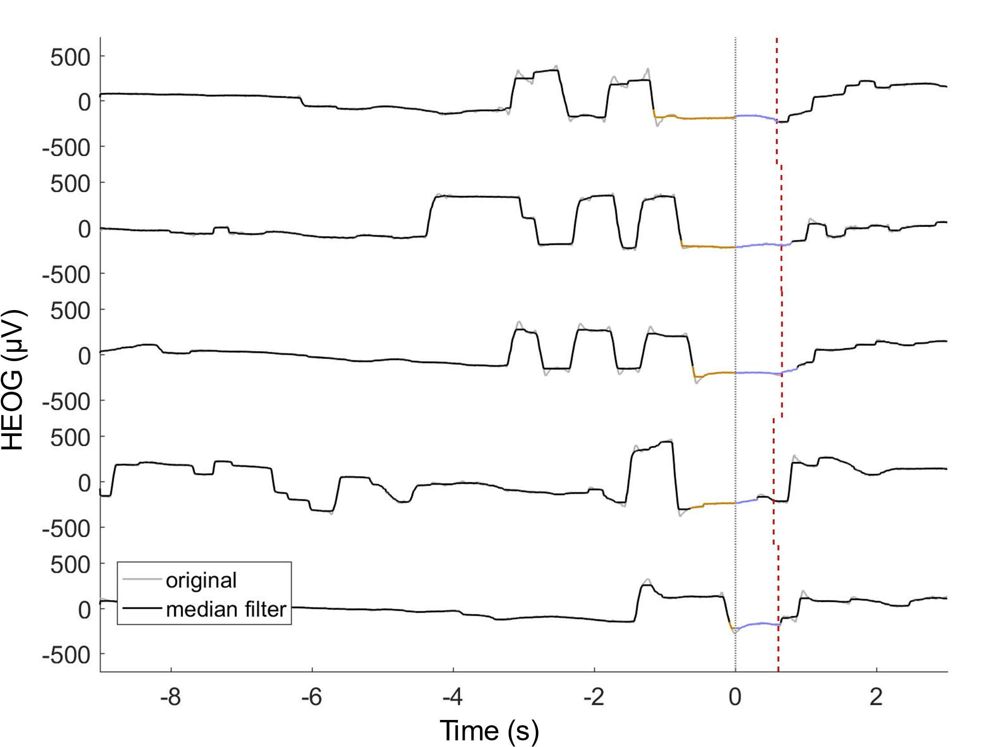
Figure 2
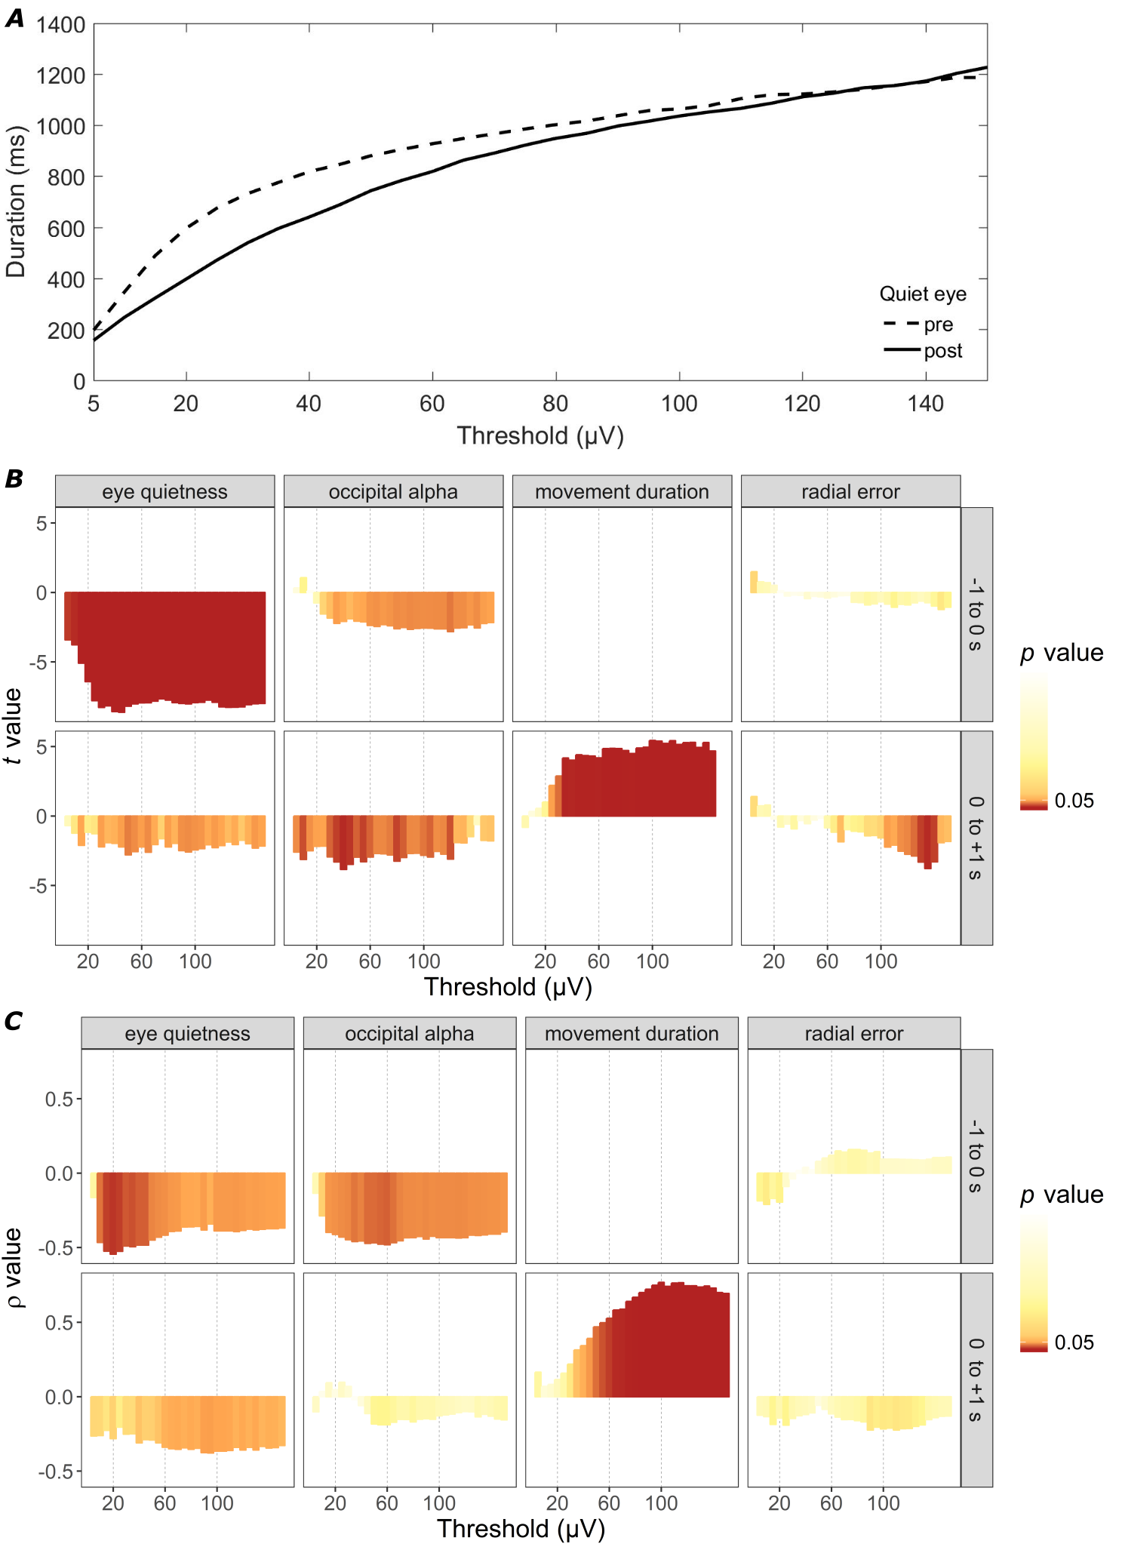
Figure 3
Figure 4
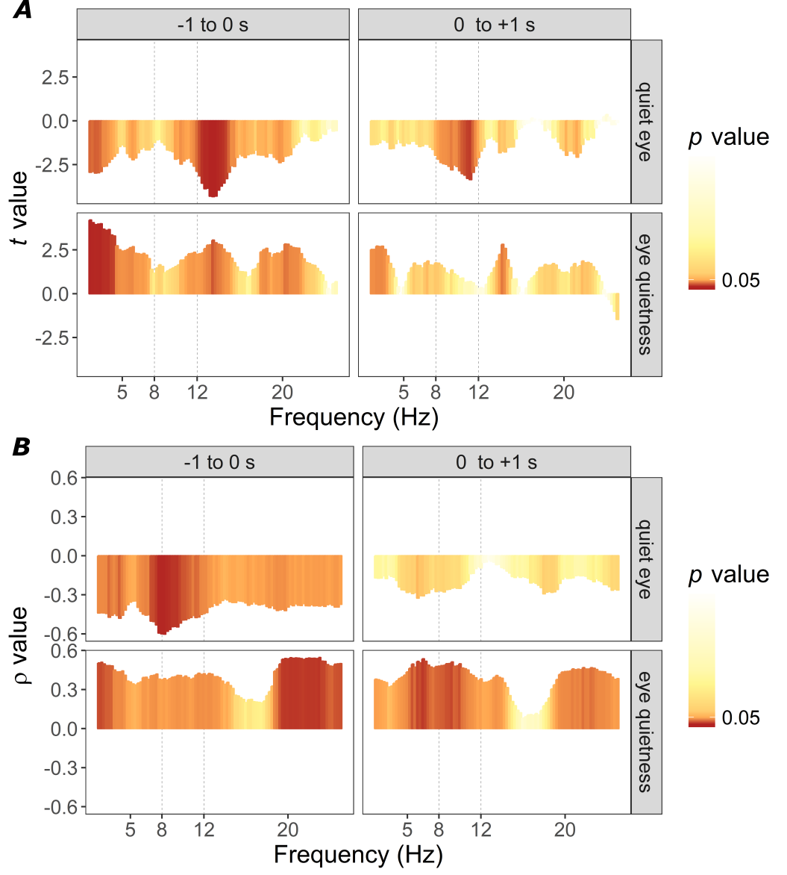

The current report describes new analyses of a larger golf putting dataset (Gallicchio & Ring, 2018).
Our study was not designed to examine the relationship between the mechanisms and performance. Given that quiet eye duration has not been linked with performance in non-expert samples (Lebeau et al., 2016), a more difficult task and a more heterogeneous sample would be required to evaluate these relationships in a golf putting task.
Movement duration was not significantly associated with radial error as revealed by trial-level analyses, ρM(18) = -.03, t(31) = -0.86, p = .40 and participant-level analyses, ρ(30) = -.05, p = .80.

