Root hairs and protein addition to soil promote leucine aminopeptidase activity of Hordeum vulgare L.
Abstract
Protein typically represents the largest input of organic nitrogen (N) into soil. Proteases subsequently make this protein available for use by both plants and microorganisms, however, the factors that regulate protein breakdown in the rhizosphere remain limited. Root exudation of carbon (C) and N into soil promotes microbial growth and thus enzyme production, which is further enhanced by root morphological traits such as root hairs. However, it is not clear how inputs of protein from external sources (e.g. necromass) affect enzyme activity in the rhizosphere. Insight into the interaction between protein addition and root morphology will enhance our knowledge of plant and microbial strategies for promoting N acquisition. Using soil zymography, we investigated the spatial distribution of leucine aminopeptidase activity in the rhizosphere of Hordeum vulgare L. with and without root hairs subject to localised protein addition. Seedlings of barley were grown for two weeks in rhizoboxes and soluble protein was applied 48 h before analysis of leucine aminopeptidase activity. In situ zymography was used to quantitatively visualise leucine aminopeptidase activity while ex situ sampling was used to determine its enzyme kinetics. In the zymograms, we found that mean and maximal leucine aminopeptidase activity was highest in the barley genotype with root hairs and in the presence of soil protein hotspots. This suggests that microorganisms and plant roots in the rhizosphere of genotypes with root hairs have a greater advantage in accessing protein hotspots in the soil. Leucine aminopeptidase activity did not follow the same trends when analysed by in situ zymography and ex situ sampling methods. Therefore, we recommend the use of in situ zymography to detect the spatial distribution of enzymatic hotspots and rhizosphere extent followed by ex situ sampling for assessing enzyme kinetics in the hotspot areas detected by in situ sampling. However, sampling biases must be considered to ensure enzyme activities are being interpreted as the true rhizosphere.
Key words: Nitrogen mineralisation; Enzyme activity; Soil zymography; Soil organic matter

1. Introduction
Protein is an important source of carbon (C) and nitrogen (N) for soil microorganisms and N is a key macronutrient for plant growth. Furthermore, protein is estimated to contribute ca. 40% of total soil N and 9-16% of soil organic C (Schulten and Schnitzer, 1997; Stevenson and Cole, 1999). However, soil protein is generally considered a stable fraction of soil organic matter (SOM) due to its ability to form many bonds and complexes with components in the soil matrix e.g. polyphenols and clay mineral surfaces (Rillig et al., 2007). Yet, many soil systems have regular inputs of protein available for degradation and use by microorganisms. These include: plant litter, root biomass and decaying micro- and macrofauna as well as functional proteins released into the soil by plants and microorganisms to carry out specific functions (Rillig et al., 2007). Based on estimates of below-ground turnover in cropping systems, we estimate that the annual input of protein into soil from roots alone is 0.4-0.8 t ha⁻¹ y⁻¹ (Steingrobe et al., 2001). Considering the age of most agricultural soils and amount of protein held in SOM, this indicates that only a small amount of protein enters the stable SOM pool each year. Extracellular protease enzymes produced by microorganisms and plant roots break down proteins into oligopeptides and amino acids. However, whether plant root-derived proteases have any functional significance in N nutrition remains unclear (Greenfield et al., 2020a).
Microbial activity is typically greater in the rhizosphere (relative to the bulk soil) due to the high rates of root C and N exudation of a variety of compounds (e.g. carbohydrates, amino acids, enzymes, proteins and phenols) (Jones et al., 2009; Koo et al., 2005). Studies have found C and N exudation to enhance enzyme activities in the rhizosphere (Brzostek et al., 2013; Kandeler et al., 1994). Furthermore, protein mineralisation and protease activity have been found to be regulated by supply of substrate rather than limitations in protein turnover (Greenfield et al., 2020b). Thus, we hypothesise that the influx of soluble protein into the soil system is likely to stimulate protease activity in the rhizosphere. The rate of protein mineralisation is faster in soil-plant systems compared to bulk soil and particularly in the rhizosphere (Jan et al., 2009; Loeppmann et al., 2016). Due to the short turnover time of proteinaceous N, estimated to range from hours to days (Greenfield et al., 2020b; Hill et al., 2012; Jan et al., 2009), an excess of easily available C and N is likely to be depleted by the microbial community within a few days (Kuzyakov and Xu, 2013). However, few studies have investigated the spatial responses to external protein addition on enzyme activity in the rhizosphere (e.g. necromass hotspots) that can create ‘hot moments’ (Hill et al., 2019; Kuzyakov and Blagodatskaya, 2015).
Root morphology plays a major role in determining the quality, quantity and distribution of exudates on the surface of the root. One key root morphological trait which is known to increase C substrate availability for microorganisms is the presence of root hairs (Holz et al., 2018; Jones et al., 2009). They are also responsible for the majority of N uptake in roots (Waisel et al., 2002). Root hairs increase the rhizosphere extent of rhizosphere enzyme activity by increasing the surface area and volume of soil exploited by the root (Holz et al., 2020; Ma et al., 2018). Interestingly, it has been found that hairless genotypes compensate for the reduced surface area and volume by increasing enzyme activity close to the root surface in response to phosphorous (P) limitation (Holz et al., 2020). However, plants with root hairs are likely to be able to access N from larger soil volumes due to the larger rhizosphere extent and the greater diffusion rates of N relative to P. Understanding the interaction between protein addition and root morphology will further extend our knowledge of plant and microbial strategies for N acquisition.
The aim of this study was to determine the spatial distribution of leucine aminopeptidase activity in the rhizosphere of Hordeum vulgare L. with and without root hairs subject to localised protein addition. We applied soil zymography, a two-dimensional imaging technique, to visualise the spatial distribution of leucine aminopeptidase activity in the rhizosphere and measured leucine aminopeptidase kinetics in destructive soil samples to link in situ and ex situ techniques for assessing rhizosphere enzyme activity. We hypothesised that 1) protein addition would increase leucine aminopeptidase activity in the rhizosphere due to an increase in substrate availability, 2) root hairs would accelerate leucine aminopeptidase activity in the rhizosphere by providing a higher surface area and more root exudates, and 3) root hairs would increase the radial extent of leucine aminopeptidase activity in the rhizosphere due to the larger surface area of the root.

2. Materials & methods
2.1. Soil and plant preparation
The soil was collected from the top 20 cm of a grassland (Lolium perenne L.) sandy clay loam, classified as a Eutric Cambisol, located in Abergwyngregyn, Wales (53°13′ N, 4°00’ W). Prior to the experiment, the soil was 2 mm sieved to remove stones and plant residues. General soil properties are presented in Table 1. Soil pH(H₂O) and electrical conductivity (EC) were measured in a 1:5 (w/v) soil:distilled water suspension. Total organic C and total N were determined using a Leco CHN 2000 analyzer (Leco Corp., St Joseph, MI, USA). Dissolved organic C (DOC) and total dissolved N (TDN) were measured using 1:5 (w/v) soil:0.5 M K₂SO₄ extracts on a Multi-N/C Series NPOC-TN analyser (Analytik Jena, Germany). Dissolved organic nitrogen (DON) was calculated as the difference between TDN and dissolved inorganic N. Ammonium (NH₄⁺) and nitrate (NO₃⁻) concentrations were both determined colorimetrically according to the salicylic acid procedure of Mulvaney (1996) and VCl₃ procedure of Miranda et al. (2001), respectively. Plant-available P was measured using the 0.5 M acetic acid of Vaz et al. (1994). Rhizoboxes with inner dimensions of 12.5 × 12.5 × 2.5 cm were filled with soil to a final density of 1.2 g cm⁻³.

Table 1. General properties of the soil used in the experiments. Values are expressed on a dry weight basis and represent mean ± SE (n = 3).
Soil property | Units | Value
pH(H₂O) |  | 6.50 ± 0.11
Electrical conductivity | (µS cm⁻¹) | 34.4 ± 3.54
Total C  Total N | (g kg⁻¹)  (g kg⁻¹) | 31.5 ± 1.98  3.01 ± 0.20
DOC | (mg kg⁻¹) | 41.0 ± 5.21
DON | (mg kg⁻¹) | 7.28 ± 2.41
NH₄⁺ | (mg kg⁻¹) | 7.98 ± 4.14
NO₃⁻ | (mg kg⁻¹) | 1.98 ± 0.60
Available P | (mg kg⁻¹) | 3.54 ± 1.67

Two genotypes of barley (Hordeum vulgare L.), the wild type and a hairless mutant, were germinated on moist filter paper for 72 h. More detailed information on the two genotypes of barley and microscope images of the roots can be found in Brown et al. (2012). One seedling was planted at a depth of 5 mm into each rhizobox with 3 biological replications in separate boxes. The rhizoboxes were kept in a climate-controlled chamber at 20 ± 1 °C, 55 % relative humidity and 12 h photoperiod with a photosynthetically active radiation intensity of 500 μmol photons m⁻² s⁻¹. During the growth period, the rhizoboxes were kept inclined at an angle of 45° so that the roots grew along the lower wall of the rhizobox. The rhizoboxes were irrigated with distilled water to maintain a water content at 60% of the water holding capacity (i.e. 60% field capacity). No additional nutrients were added to the soils.
To determine the effect of protein hotspots on the plant-soil interface, bovine serum albumin (BSA) was added to soil in 0.5 cm tall protein horizontal bands (Fig. 1). BSA was chosen as it is a soluble protein and was used by Paungfoo-Lonhienne et al. (2008). Briefly, 100 μl of 6 mg ml⁻¹ BSA was added to each 0.5 x 0.5 cm area along a protein band. We found 100 μl to effectively cover a 0.5 cm x 0.5 cm area of the soil surface. The concentration of protein was used to ensure saturation of the soil with protein and was found to be the optimum protein concentration for plant growth by Paungfoo-Lonhienne et al. (2008). Three control bands were also added by pipetting 100 μl of sterile, distilled water into 0.5 x 0.5 cm regions along the band. Rhizoboxes were then incubated for 48 h, to allow sufficient time for microorganisms to respond to the protein addition, under the same conditions as growth before imaging.

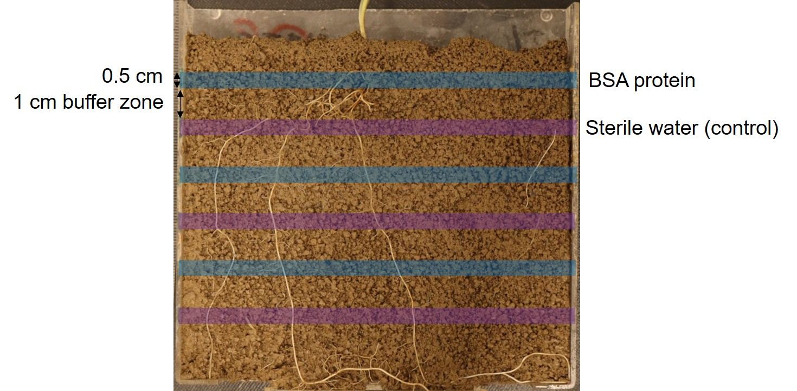
Figure 1. Rhizobox set-up showing the position of the protein and control (distilled water) horizontal bands in soil.

2.2. Soil zymography
After two weeks of growth and 48 h after soluble protein addition, direct zymography (Sannullah et al. 2016) was applied to visualise the activity of leucine aminopeptidase (E.C. 3.4.11.1). Leucine aminopeptidase was used as a proxy to measure protease activity. It catalyses the cleavage of N-terminus amino acids from peptide and protein substrates and is involved in fundamental plant rhizosphere processes and plant development e.g. degradation of storage protein (Kania and Gillner, 2015). Thin polyamide membrane filters (Tao Yuan, China) with a size of 10 × 10 cm and a pore size of 0.45 mm were saturated with 10 mM L-leucine-7-amido-4-methyl-coumarin hydrochloride (dissolved in 0.05 M Trizma buffer, pH 7). We chose pH 7 because the pH optimum of leucine aminopeptidase is ca. 7 (Puissant et al., 2019). The rhizoboxes were opened on the lower, rooted side and the saturated membranes were placed directly on to the root-soil surface. After 1 h incubation, the membranes were carefully removed from the rhizobox and any attached soil particles gently removed using a small soft brush. The membranes were placed under ultraviolet (UV) light in a dark room. The distance between the camera (EOS M50, Canon), the sample, and the UV light were fixed, and a photograph of the membrane taken. The camera settings were f/5.6, ISO 800, 40 mm zoom and exposure 1/40 seconds.
Images were calibrated by saturating 4 cm² membranes in 60 μl AMC with the following concentrations: 0, 0.05, 0.1, 0.2, 0.5, 1, 2, 3, 4, 5, 10 mM. The amount of AMC on an area basis was calculated from the volume of solution taken up by the membrane and its size (Spohn and Kuzyakov, 2014). The membranes used for calibration were imaged under UV light in the same way as described for the rhizoboxes. A calibration curve was fitted using a power function equation $y=ax^{b}$, by plotting concentrations (pmol mm⁻²) versus grey values obtained in Matlab (MATLAB, The MathWorks) using a script published in Razavi et al. (2019).

2.3. Image processing and analysis
Images were processed and analysed in ImageJ 1.x (Schindelin et al., 2012). Images were transformed to 32-bit grayscale images as matrices and corrected for light variations and camera noise (Razavi et al., 2016). The grey value blank from the 0 mM AMC standard was used as a referencing signal and subtracted from the zymograms. Then a power function ($y=ax^{b}$) of the calibration was used to relate the grey values to leucine aminopeptidase activity.
Root area was measured as the area of root per rhizobox surface using a triangle thresholding algorithm in ImageJ (Tajima and Kato, 2011). Leucine aminopeptidase hotspots were thresholded with mean + 2 standard deviations approach (Bilyera et al., 2020). An individual thresholding value for each replicate image was used.
Rhizosphere extent was measured as the distance of a region with at least 30% higher enzyme activity than the bulk soil from the point the enzyme activity started increasing to the point it ceased to increase using a threshold by a default algorithm in ImageJ (Tajima and Kato, 2011). Ten locations (lines across the root) in each band were selected and measurements taken. The diameter of the root was measured at the same locations as rhizosphere extent from root masks thresholded by a triangle algorithm in ImageJ (Tajima and Kato, 2011). Root diameter was then subtracted from the rhizosphere distance and divided by two to obtain the rhizosphere extent from the root surface (mm). Leucine aminopeptidase activity in the bulk soil was defined in the region with the absence of elevated activities. The mean and maximum leucine aminopeptidase activity across the rhizosphere extent was measured.

2.4. Enzyme kinetics
Rhizosphere enzyme kinetics were measured according to Marx et al. (2001) with some modifications. After two weeks of growth, soil was collected from the rhizosphere of each of the three protein and control bands and combined to make a composite sample for each treatment (protein or control) to give 0.2 g soil for each biological replicate (n = 3). Rhizosphere soil was collected carefully with a needle to avoid mixing with bulk soil from as close to the root surface as possible. A soil slurry was created by adding 20 ml of sterile deionised water to the soil. The soil slurry was homogenised by shaking at 250 rev min⁻¹ for 30 min. 50 μl of soil suspension, 100 μl a range of substrate concentrations from low to high (0, 5, 10, 20, 40, 80, 100, 200 μM) and 50 μl of Trizma buffer (pH 7) was added to a 96-well microplate. Fluorescence was measured in microplates at an excitation wavelength of 355 nm and an emission wavelength of 460 nm, and a slit width of 20 nm, with a Cary Eclipse Fluorescence Spectrophotometer (Agilent Corp., Santa Clara, CA). Enzyme activities were measured 30 min, 1 h and 2 h after adding soil solution, buffer and substrate solution. Microplates were incubated at 20°C between measurements. The difference between activities at 2 h and 1 h was used to determine AMC release in nmol per g dry soil per hour (nmol g⁻¹ dry soil⁻¹). The leucine aminopeptidase assays were performed in three analytical replicates. The Michaelis-Menten constant K_{m} and V_{max} were determined using the Michaelis-Menten equation:
$v= \frac{Vmax[S]}{Km+[S]}$ (1)
where V is the reaction rate (as a function of substrate concentration), [S] is the substrate concentration, K_{m} is the substrate concentration at half-maximal rate and V_{max} is the maximum reaction rate.

2.5. Statistical analysis
All statistical analyses were performed in R 3.5.0 (R Core Team, 2018). Treatments were performed in triplicate (n = 3). Normality of the data was determined by Shapiro-Wilk test (p > 0.05) then visually checked using qqnorm plots. Data without a normal distribution was square root transformed to achieve normality. Homogeneity of variance of the data was visually determined using residuals vs. fitted plots. Two-way ANOVAs followed by the Duncan Test (p < 0.05) were used to determine if there was a significant difference between root morphology and protein addition.

3. Results
Examples of leucine aminopeptidase zymograms clearly demonstrated the spatiotemporal distribution of enzyme activity in the rhizosphere of the two types of barley (+/- root hairs) (Fig. 2). Faint protein bands can be seen on the zymogram of barley without root hairs, but no bands are visible on the zymogram with root hairs. Root density was similar for the two barley genotypes (Table 2). Leucine aminopeptidase hotspots were twice the area for barley with root hairs although this was not significantly different (Table 2).
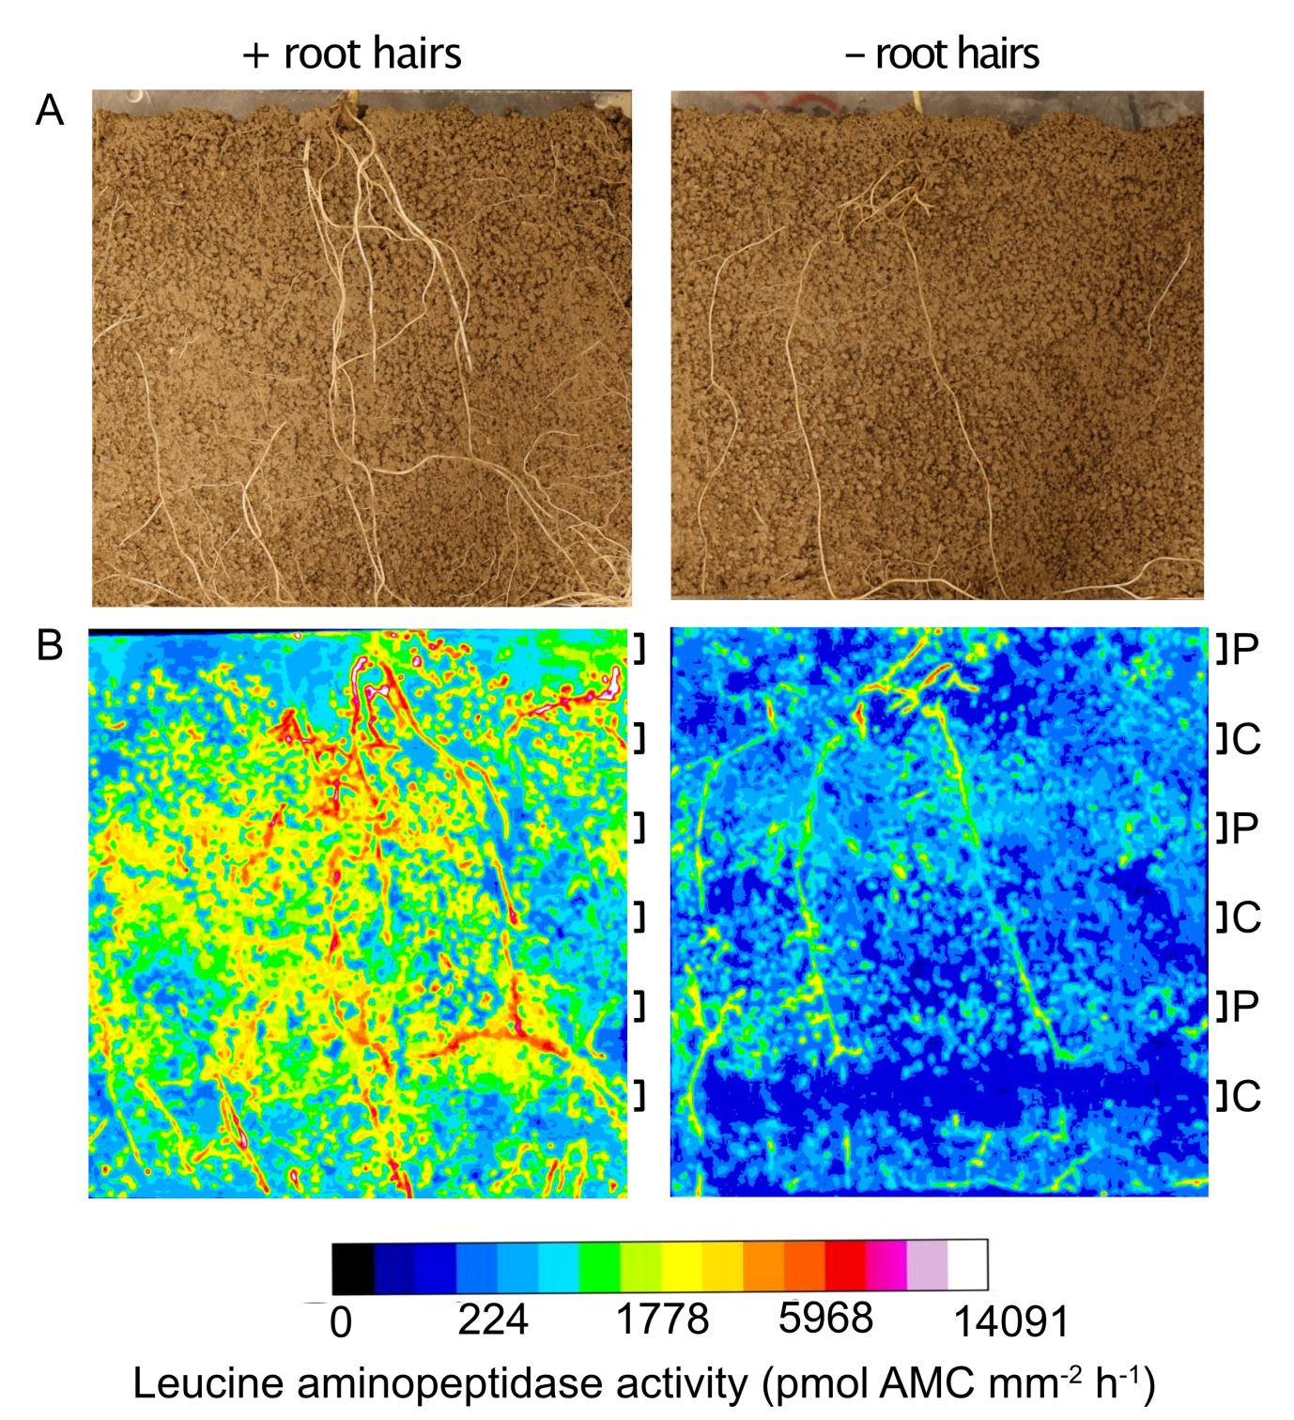

Figure 2. Examples of barley roots grown in rhizoboxes (A) and the spatial distribution of leucine aminopeptidase activity in the soil and rhizosphere of barley roots (B) with and without root hairs. Side colour bar is proportional to the enzyme activity (pmol mm⁻² h⁻¹) and protein (P) and control (C) band positions are indicated on the right-hand side of the zymograms.

Table 2. Root area and leucine aminopeptidase hotspot of the two barley genotypes per rhizobox. Values represent mean ± S.E (n = 3). Different lowercase letters indicate a significant difference between genotypes (p < 0.05).
 | + root hairs | - root hairs
Root area (cm² plant⁻¹) | 2.58 ± 0.28ª | 2.66 ± 0.44ª
Leucine aminopeptidase hotspot (cm² plant⁻¹) | 3.79 ± 1.36ª | 1.88 ± 0.33ª

The rhizosphere extent of the leucine aminopeptidase was significantly greater when soluble protein was added, but did not differ between barley root genotypes with or without root hairs except for the control band (Table 3; Fig. 3). Mean and maximum leucine aminopeptidase activity was 1.5 times higher in the protein-rich areas with root hairs compared to the control (Table 3, Fig. 3). In comparison between the barley genotypes, mean and maximal leucine aminopeptidase activity was highest (by over three times) in the protein band of the barley genotype with root hairs (Table 3, Fig. 3). The interaction between root hair and protein treatments was significant for rhizosphere extent only (Table 3).
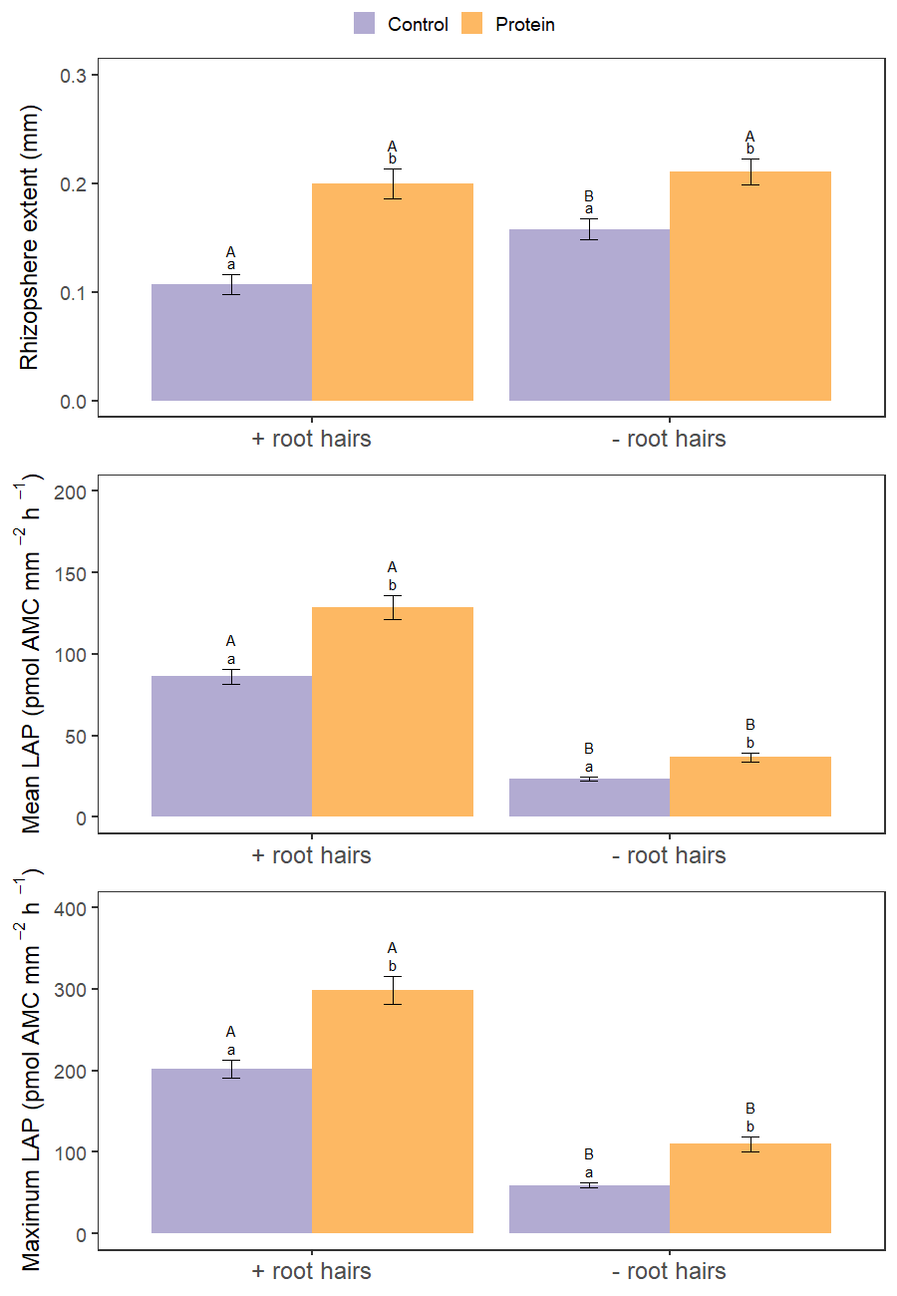
Figure 3. Rhizosphere extent of leucine aminopeptidase activity (distance from the root surface, mm), mean leucine aminopeptidase activity (LAP) across the rhizosphere and maximum leucine aminopeptidase activity of the rhizosphere (pmol AMC mm⁻² h⁻¹) for barley genotypes with and without roots hairs and with protein or control (sterile water) addition. Values represent mean ± SE (n = 90). Different lowercase letters indicate a significant difference between protein and control treatments and different uppercase letters indicate a significant difference between root hair genotype (p < 0.05).

Table 3. Two-way ANOVA results for each of the measured variables using p < 0.05 as the cut-off for statistical significance (as indicated by values in bold).
Variable | Residuals | Root hairs |  |  | Protein |  |  | Root hairs x protein
 |  | df | F | p | df | F | p | df | F | p
Rhizosphere extent | 356 | 1 | 14.7 | <0.001 | 1 | 47.0 | <0.001 | 1 | 5.0 | 0.03
Mean LAP activity | 356 | 1 | 419 | <0.001 | 1 | 41.5 | <0.001 | 1 | 3.38 | 0.07
Max LAP activity | 356 | 1 | 370 | <0.001 | 1 | 45.9 | <0.001 | 1 | 0.73 | 0.39
V_{max} | 8 | 1 | 1.26 | 0.29 | 1 | 0.05 | 0.83 | 1 | 0.004 | 0.95
K_{m} | 8 | 1 | 0.50 | 0.50 | 1 | 1.41 | 0.27 | 1 | 3.24 | 0.11
Note: LAP = leucine aminopeptidase activity, df = degrees of freedom, F = F value and p = p value.

Enzyme kinetics (V_{max} and K_{m}) showed no significant differences between roots with and without root hairs and protein addition (Table 3; Fig. 4). V_{max} was slightly higher in the barley genotype without root hairs whilst K_{m} was highest in the control treatment of the barley genotype without root hairs.
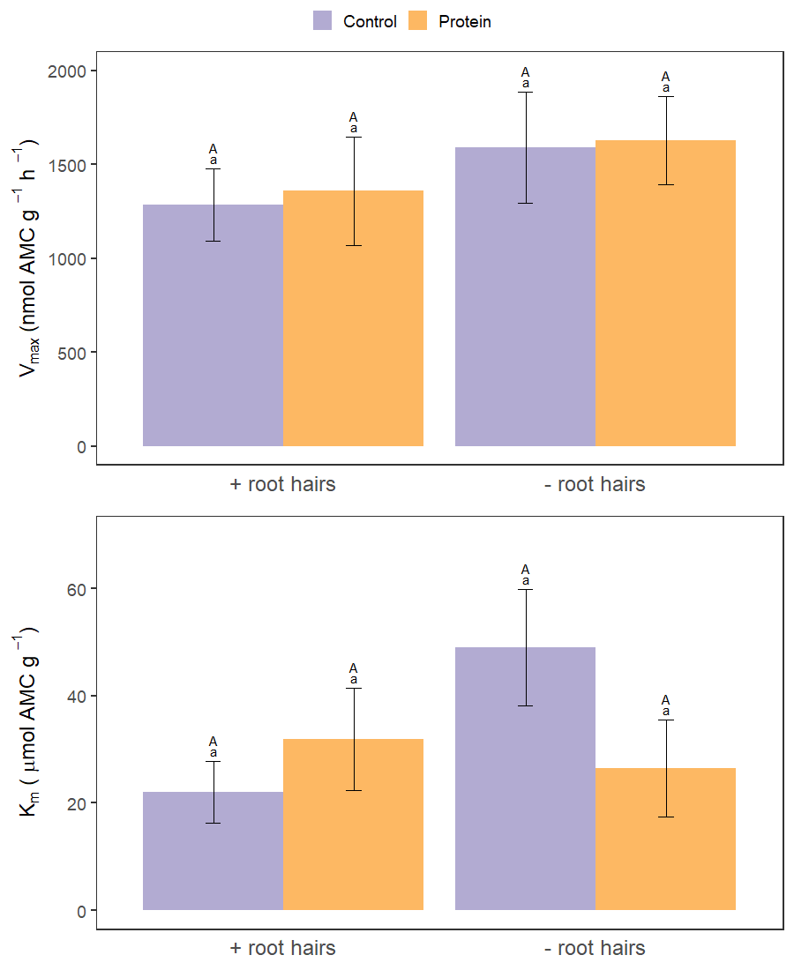
Figure 4. The kinetic parameters V_{max} (nmol AMC g⁻¹ h⁻¹) and K_{m} (µmol AMC g⁻¹) of soil leucine aminopeptidase activity for barley genotypes with and without roots hairs and with protein or control (sterile water) addition. Values represent mean ± SE (n = 3). Different lowercase letters indicate a significant difference between protein and control treatments and different uppercase letters indicate a significant difference between root hair genotype (p < 0.05).

4. Discussion
4.1. In situ versus ex situ sampling
Rhizosphere leucine aminopeptidase activity did not follow the same trends when analysed by in situ zymography and ex situ destructive sampling. This suggests these two methods are not measuring the same part of the rhizosphere or are causing unreliable results due to the sampling method. The rhizosphere extent of leucine aminopeptidase activity we measured in our experiment by zymography extended <0.2 mm beyond the root surface. Yet, our ex situ destructive sampling method involved collecting soil from distances up to 2 mm from the root surface. Our ability to constrain the sampling to smaller distances from the root surface proved impossible due to (a) logistical difficulties in recovering rhizosphere soil, (b) aggregation of the soil, and (c) the requirement for enough soil to perform the enzymatic assays. This shows that our ex situ measurements of leucine aminopeptidase activity included soil from around ten times further away from the root surface than the rhizosphere of the barley plants extended. It should also be noted that 20% of the enzyme reactions that occur in the volume of the rhizosphere are in direct contact with the zymograph membrane and, thus, 80% of rhizosphere enzyme activity is not measured by in situ zymography (Guber et al., 2018). Oburger and Jones (2018) reviewed sampling techniques used to measure root exudation from the rhizosphere and concluded that current techniques have myriad of problems that cause biases when determining exudation dynamics. These problems include: a) damage to roots and fungal hyphae, b) the sampling area is likely more related to bulk soil than the true rhizosphere area because not all soil adhered to the root surface (Neumann et al., 2009), and c) the removal of plant C inputs may induce changes in microbial metabolism (i.e. less metabolically active) and the types of organisms which remain active (Oburger and Jones, 2009). However, destructive sampling provides a quantitative measure of the rhizosphere effect per unit of soil mass. These measurements can then be linked to process rates (e.g. C and N mineralisation) per unit of soil mass. Therefore, we recommend in situ spatial sampling techniques for a more representative measurement of the spatial distribution of rhizosphere enzyme activity combined with ex situ assays to determine enzyme kinetics. Together these will provide an insight into the catalytic mechanism of the enzyme. However, caution is needed when interpreting rhizosphere enzyme activity from ex situ destructive sampling as it may greatly underestimate enzyme activity at the root surface.

4.2. Effect of root hairs and protein addition on rhizosphere leucine aminopeptidase activity
As we hypothesised, mean and maximum rhizosphere leucine aminopeptidase activity were highest for the barley genotype with root hairs. This was further demonstrated by a larger area of leucine aminopeptidase hotspots in the barley genotype with root hairs. It is likely that root hairs increase the availability of substrates in the rhizosphere through their high surface area per unit root length and thus greater rates of passive C exudation (i.e. which in turn increases microbial enzyme activity) (Holz et al., 2018; Jones et al., 2009). Thus, it appears that the increase in leucine aminopeptidase activity due to root hairs induces greater rhizosphere priming thereby enhancing the release of N from soil organic matter (SOM) required to fuel microbial growth (Brzostek et al., 2013; Dijkstra et al., 2013; Zhu et al., 2014). The rhizosphere extent of leucine aminopeptidase activity in the rhizosphere was largest when soluble protein was applied, and this enhancement was seen for both barley genotypes irrespective of the presence of root hairs. We hypothesised that root hairs would increase the area of high leucine aminopeptidase activity in the rhizosphere compared to roots without hairs via an increased surface area of the root for microbial colonisation (Gilroy and Jones, 2000; Haling et al., 2013). Similarly, an increased rhizosphere extent was observed when measuring phosphatase activity of barley with and without root hairs (Holz et al., 2020) as well as plants with differing length hairs (Ma et al., 2018). As the root areas were similar for both barley genotypes it is unlikely that root density affected specific root response to protein addition. A possible reason for the similar rhizosphere extents of leucine aminopeptidase activity could be a result of soluble protein addition having a more dominant effect on rhizosphere extent than the presence of root hairs. In addition, root hairs had a greater effect on the enzyme activity per root surface area rather than overall rhizosphere extent. Degradation of high-concentrations of organic compounds and substrates is energetically favourable for microbial decomposers (German et al., 2011). Thus, our evidence suggests that the available soluble protein promoted expression of proteases and enlarged the extent of rhizosphere independent of root morphology. Overall, the influence of the root on protease activity seems to be limited to a narrow zone <0.2 mm from the root surface. This is an efficient strategy for plants to compete with microorganisms in the rhizosphere for N (Kuzyakov and Xu, 2013). Enzyme activities are less reported than for many other rhizosphere properties (e.g. pH) which extend much further from the root surface. This could be due to slow diffusion of proteases relative to other solutes (e.g. H⁺) and that they are primarily produced by the most active microorganisms in the rhizosphere which are likely to be located on the rhizoplane.
As expected, soluble protein addition increased leucine aminopeptidase activity in the rhizosphere of the barley. Many studies have shown organic fertiliser to increase soil protease activity due to the removal of substrate limitation (Liu et al., 2019; Ma et al., 2020; Marinari et al., 2000; Melero et al., 2006; Niemi et al., 2008). Fewer studies have assessed protein amendments specifically, but those that have, have also found protein addition to increase protease activity (e.g. Geisseler and Horwath, 2009). The increase in protease activity has been shown to be faster and larger when amended with soluble protein e.g. casein compared to insoluble protein e.g. gluten and zein (Geisseler and Horwath, 2009). This is probably due to the greater ability of soluble proteins to diffuse through soil solution and thus come into contact with free exoenzymes and membrane-bound proteases. Protein addition also resulted in the largest rhizosphere extent in both the barley genotypes irrespective of the presence of root hairs by <50%. Our finding is supported by a study on the effect of root exudate compounds on artificial rhizosphere extent which found that alanine substantially increase the rhizosphere extent compared to water (Zhang et al., 2019).
Leucine aminopeptidase activity was higher in the rhizosphere with root hairs and protein addition compared to the other treatment combinations. This suggests that microorganisms and plant roots in the rhizosphere of barley genotype with root hairs have a greater advantage in utilising protein hotspots in the soil. The ability to obtain more N is particularly important in agricultural soils where crops tend to be more N limited (Rütting et al., 2018). It is important to note that this study was carried out with a low number of biological replicates (n = 3), one plant species, one soil type, one protease type and one time point. Therefore, further studies are needed in order to determine the effect of protein addition and root morphology on rhizosphere protease activity in different species, soil types and growth stages of plants.

5. Conclusions
We found the combination of root hairs and protein addition to produce the highest leucine aminopeptidase activity in the rhizosphere creating an advantage for plants with root hairs to access protein hotspots in soil. The ability to obtain more N from organic sources is particularly important in agricultural soils where crops tend to be more N limited and rely on inorganic N fertilisers. In addition, our results have shown clear evidence on the disparity between in situ and ex situ rhizosphere sampling methods for leucine aminopeptidase activity. Therefore, we recommend the combined use of in situ and ex situ sampling techniques when assessing rhizosphere enzyme activity, but consideration must be taken to determine biases in both sampling techniques.

Acknowledgements
We would like to thank Tim George and Lawrie Brown at the James Hutton Institute for supplying the wild type and mutant barley seeds. Thanks to John Langley for the soil property data. Thanks to Jonathan Roberts and Sarah Chesworth for their technical support. This work was supported by the UK Biotechnology and Biological Sciences Research Council and the Natural Environment Research Council [Grant number NE/M009106/1], by a Soils Training and Research Studentships (STARS) grant to LMG. STARS is a consortium consisting of Bangor University, British Geological Survey, UK Centre for Ecology and Hydrology, Cranfield University, James Hutton Institute, Lancaster University, Rothamsted Research and the University of Nottingham.

References
Bilyera, N., Kuzyakova, I., Guber, A., Razavi, B.S., Kuzyakov, Y., 2020. How “hot” are hotspots: Statistically localizing the high-activity areas on soil and rhizosphere images. Rhizosphere 16, 100259.
Brown, L.K., George, T.S., Thompson, J.A., Wright, G., Lyon, J., Dupuy, L., Hubbard, S.F., White, P.J., 2012. What are the implications of variation in root hair length on tolerance to phosphorus deficiency in combination with water stress in barley (Hordeum vulgare)? Ann. Bot. 110, 319–328.
Brzostek, E.R., Greco, A., Drake, J.E., Finzi, A.C., 2013. Root carbon inputs to the rhizosphere stimulate extracellular enzyme activity and increase nitrogen availability in temperate forest soils. Biogeochemistry 115, 65–76.
Dijkstra, F.A., Carrillo, Y., Pendall, E., Morgan, J.A., 2013. Rhizosphere priming: a nutrient perspective. Front. Microbiol. 4, 216.
Geisseler, D., Horwath, W.R., 2009. Relationship between carbon and nitrogen availability and extracellular enzyme activities in soil. Pedobiologia (Jena). 53, 87–98.
German, D.P., Chacon, S.S., Allison, S.D., 2011. Substrate concentration and enzyme allocation can affect rates of microbial decomposition. Ecology 92, 1471–1480.
Gilroy, S., Jones, D.L., 2000. Through form to function: Root hair development and nutrient uptake. Trends Plant Sci. 5, 56–60.
Greenfield, L.M., Hill, P.W., Paterson, E., Baggs, E.M., Jones, D.L., 2020a. Do plants use root-derived proteases to promote the uptake of soil organic nitrogen? Plant Soil.
Greenfield, L.M., Hill, P.W., Seaton, F.M., Paterson, E., Baggs, E.M., Jones, D.L., 2020b. Is soluble protein mineralisation and protease activity in soil regulated by supply or demand? Soil Biol. Biochem. 150, 108007.
Guber, A., Kravchenko, A., Razavi, B.S., Uteau, D., Peth, S., Blagodatskaya, E., Kuzyakov, Y., 2018. Quantitative soil zymography: Mechanisms, processes of substrate and enzyme diffusion in porous media. Soil Biol. Biochem. 127, 156–167.
Haling, R.E., Brown, L.K., Bengough, A.G., Young, I.M., Hallett, P.D., White, P.J., George, T.S., 2013. Root hairs improve root penetration, root-soil contact, and phosphorus acquisition in soils of different strength. J. Exp. Bot. 64, 3711–3721.
Hill, E.J., Jones, D.L., Paterson, E., Hill, P.W., 2019. Hotspots and hot moments of amino acid N in soil: Real-time insights using continuous microdialysis sampling. Soil Biol. Biochem. 131, 40–43.
Hill, P.W., Farrell, M., Jones, D.L., 2012. Bigger may be better in soil N cycling: Does rapid acquisition of small l-peptides by soil microbes dominate fluxes of protein-derived N in soil? Soil Biol. Biochem. 48, 106–112.
Holz, M., Zarebanadkouki, M., Carminati, A., Becker, J.N., Spohn, M., 2020. The effect of root hairs on rhizosphere phosphatase activity. J. Plant Nutr. Soil Sci. 183, 382–388.
Holz, M., Zarebanadkouki, M., Kuzyakov, Y., Pausch, J., Carminati, A., 2018. Root hairs increase rhizosphere extension and carbon input to soil. Ann. Bot. 121, 61–69.
Jan, M.T., Roberts, P., Tonheim, S.K., Jones, D.L., 2009. Protein breakdown represents a major bottleneck in nitrogen cycling in grassland soils. Soil Biol. Biochem. 41, 2272–2282.
Jones, D.L., Nguyen, C., Finlay, R.D., 2009. Carbon flow in the rhizosphere: Carbon trading at the soil-root interface. Plant Soil 321, 5–33.
Kandeler, E., Eder, G., Sobotik, M., 1994. Microbial biomass, N mineralization, and the activities of various enzymes in relation to nitrate leaching and root distribution in a slurry-amended grassland. Biol. Fertil. Soils 18, 7–12.
Kania, J., Gillner, D., 2015. Aminopeptidases isolated from plants of great economic value - role and characteristics. Chemik 69, 466–468.
Koo, B.-. J., Adriano, D.C., Bolan, N.S., Barton, C.D., 2005. Root exudates and microorganisms, in: Encyclopedia of Soils in the Environment. Elsevier, pp. 421–428.
Kuzyakov, Y., Blagodatskaya, E., 2015. Microbial hotspots and hot moments in soil: Concept & review 83, 184–199.
Kuzyakov, Y., Xu, X., 2013. Competition between roots and microorganisms for nitrogen: mechanisms and ecological relevance. New Phytol. 198, 656–669.
Liu, Y., Hou, H., Ji, J., Lv, Z., Liu, X., Liu, G., Li, Z., 2019. Long-term fertiliser (organic and inorganic) input effects on soil microbiological characteristics in hydromorphic paddy soils in China. Soil Res. 57, 459.
Loeppmann, S., Semenov, M., Blagodatskaya, E., Kuzyakov, Y., 2016. Substrate quality affects microbial- and enzyme activities in rooted soil. J. Plant Nutr. Soil Sci. 179, 39–47.
Ma, Q., Wen, Y., Wang, D., Sun, X., Hill, P.W., Macdonald, A., Chadwick, D.R., Wu, L., Jones, D.L., 2020. Farmyard manure applications stimulate soil carbon and nitrogen cycling by boosting microbial biomass rather than changing its community composition. Soil Biol. Biochem. 144, 107760.
Ma, X., Zarebanadkouki, M., Kuzyakov, Y., Blagodatskaya, E., Pausch, J., Razavi, B.S., 2018. Spatial patterns of enzyme activities in the rhizosphere: Effects of root hairs and root radius. Soil Biol. Biochem. 118, 69–78.
Marinari, S., Masciandaro, G., Ceccanti, B., Grego, S., 2000. Influence of organic and mineral fertilisers on soil biological and physical properties. Bioresour. Technol. 72, 9–17.
Marx, M.-C., Wood, M., Jarvis, S.., 2001. A microplate fluorimetric assay for the study of enzyme diversity in soils. Soil Biol. Biochem. 33, 1633–1640.
Melero, S., Porras, J.C.R., Herencia, J.F., Madejon, E., 2006. Chemical and biochemical properties in a silty loam soil under conventional and organic management. Soil Tillage Res. 90, 162–170.
Miranda, K.M., Espey, M.G., Wink, D.A., 2001. A Rapid, Simple Spectrophotometric Method for Simultaneous Detection of Nitrate and Nitrite. Biol. Chem. 5, 62–71.
Mulvaney, R.L., 1996. Nitrogen - Inorganic Forms, in: Methods of Soil Analysis. Part 3 - Chemical Methods. Soil Science Society of America, Madison, WI, USA, pp. 1123–1200.
Neumann, G., George, T.S., Plassard, C., 2009. Strategies and methods for studying the rhizosphere-the plant science toolbox. Plant Soil 321, 431–456.
Niemi, R., Vepsäläinen, M., Wallenius, K., Erkomaa, K., Kukkonen, S., Palojärvi, A., Vestberg, M., 2008. Conventional versus organic cropping and peat amendment: Impacts on soil microbiota and their activities. Eur. J. Soil Biol. 44, 419–428.
Oburger, E., Jones, D.L., 2018. Sampling root exudates – Mission impossible? Rhizosphere 6, 116–133.
Oburger, E., Jones, D.L., 2009. Substrate mineralization studies in the laboratory show different microbial C partitioning dynamics than in the field. Soil Biol. Biochem. 41, 1951–1956.
Paungfoo-Lonhienne, C., Lonhienne, T.G.A., Rentsch, D., Robinson, N., Christie, M., Webb, R.I., Gamage, H.K., Carroll, B.J., Schenk, M., Schmidt, S., 2008. Plants can use protein as a nitrogen source without assistance from other organisms. PNAS 105, 4524–4529.
Puissant, J., Jones, B., Goodall, T., Mang, D., Blaud, A., Gweon, H.S., Malik, A., Jones, D.L., Clark, I.M., Hirsch, P.R., Griffiths, R., 2019. The pH optimum of soil exoenzymes adapt to long term changes in soil pH. Soil Biol. Biochem. 138, 1076012.
R Core Team, 2018. R: A language and environment for statistical computing.
Razavi, B.S., Zarebanadkouki, M., Blagodatskaya, E., Kuzyakov, Y., 2016. Rhizosphere shape of lentil and maize: Spatial distribution of enzyme activities. Soil Biol. Biochem. 96, 229–237.
Razavi, B.S., Zhang, X., Bilyera, N., Guber, A., Zarebanadkouki, M., 2019. Soil zymography: Simple and reliable? Review of current knowledge and optimization of the method. Rhizosphere 11, 100161.
Rillig, M.C., Caldwell, B.A., Wösten, H.A.B.B., Sollins, P., 2007. Role of proteins in soil carbon and nitrogen storage: Controls on persistence. Biogeochemistry 85, 25–44.
Rütting, T., Aronsson, H., Delin, S., 2018. Efficient use of nitrogen in agriculture. Nutr. Cycl. Agroecosystems 110, 1–5.
Schindelin, J., Arganda-Carreras, I., Frise, E., Kaynig, V., Longair, M., Pietzsch, T., Preibisch, S., Rueden, C., Saalfeld, S., Schmid, B., Tinevez, J.Y., White, D.J., Hartenstein, V., Eliceiri, K., Tomancak, P., Cardona, A., 2012. Fiji: An open-source platform for biological-image analysis. Nat. Methods 9, 676–682.
Schulten, H.-R., Schnitzer, M., 1997. The chemistry of soil organic nitrogen: a review. Biol. Fertil. Soils 26, 1–15.
Steingrobe, B., Schmid, H., Gutser, R., Claassen, N., 2001. Root production and root mortality of winter wheat grown on sandy and loamy soils in different farming systems. Biol. Fertil. Soils 33, 331–339.
Stevenson, F.J., Cole, M.A., 1999. The Carbon Cycle, in: Stevenson, F.J., Cole, M.A. (Eds.), Cycles of Soil : Carbon, Nitrogen, Phosphorus, Sulfur, Micronutrients. Wiley, IL, USA, pp. 1–78.
Tajima, R., Kato, Y., 2011. Comparison of threshold algorithms for automatic image processing of rice roots using freeware ImageJ. F. Crop. Res. 121, 460–463.
Vaz, M.D.., Edwards, A.C., Shan, C.A., Cresser, M.S., 1994. Changes in the chemistry of soil solution and acetic-acid extractable P following different types of freeze/thaw episodes. Eur. J. Soil Sci. 45, 353–359.
Zhang, X., Dippold, M.A., Kuzyakov, Y., Razavi, B.S., 2019. Spatial pattern of enzyme activities depends on root exudate composition. Soil Biol. Biochem. 133, 83–93.
Zhu, B., Gutknecht, J.L.M., Herman, D.J., Keck, D.C., Firestone, M.K., Cheng, W., 2014. Rhizosphere priming effects on soil carbon and nitrogen mineralization. Soil Biol. Biochem. 76, 183–192.

