An interdisciplinary approach to understanding predator modification of antipredator traits in prey

A thesis presented for the degree of Doctor of Philosophy
By
Simon Karythis
September 2020

School of Ocean Sciences, Menai Bridge, Anglesey, LL59 5AB

Thesis Summary
Predators have a profound impact on the fitness of prey, able to consume them directly or affect them indirectly, through modulation of several physiological, morphological or behavioural traits intended to minimise the negative impacts of predation risk. Recent studies have shown that the outcome of predator-prey interactions are context dependent, with prey subject to different abiotic and biotic factors responding differently to the perception of risk. As short-term fluctuations in predation risk combine with more predictable large-scale environmentally driven differences in predation pressure, understanding the drivers of antipredator traits in prey is complex. Antipredator responses are further complicated by the ability of some parents to influence the antipredator responses of subsequent generations via parental effects. Therefore, in order to fully appreciate the drivers and implications of antipredator responses for prey, investigation must consider the impacts of risk in different contexts.
Through a combination of field and laboratory experiments I investigated the antipredator responses of prey exposed to different predation risk regimes throughout their development and the potential for parental effects to alter them. More specifically, my thesis examined the antipredator responses of the intertidal dogwhelk Nucella lapillus to the predation risk posed by the green shore crab Carcinus maenas. One of the knowledge gaps addressed in this thesis is the potential for individual vulnerability to direct predation to impact the physiological response of prey to the detection of a predator. Although ontogenic growth in dogwhelks can result in them reaching a size refuge from crab predation, little is known about the potential for the indirect effects of predation to persist past this point. Thus, the first part of my thesis (Chapter 2) investigates the potential pervasive influence predators have on prey, by comparing changes in oxygen consumption of vulnerable and invulnerable size classes of Nucella under predation risk. I was able to show that even once Nucella grow to a size refuge exposure to crab effluent is still able to elicit a metabolic response, showing that in some cases the indirect effects of predation risk can outlast the impacts of direct predation.
The second part of my thesis (Chapters 3,4,5) uses a long term breeding experiment to examine the combined influences of parental habitat (exposed versus sheltered rocky shores) where dogwhelks are exposed to different predation pressure and the risk regime under which newly hatched dogwhelks develop to examine physiological, morphological and behavioural responses. Findings presented in Chapter 3 showed, for the first time in this species, that the risk posed by crabs affects aspects of the long-term energy budget of Nucella, in addition to confirming previously demonstrated impacts on their growth. Using the Cellular Energy Allocation technique to investigate the energy allocation at the cellular level, my analysis revealed that the way in which Nucella store and utilise energy was influenced by developmental experience of risk, but responses of offspring from each parental habitat varied. Moreover, Nucella offspring invested proportionally more in shell growth than in somatic growth as the amount of time spent under risky conditions throughout development increased.
In Chapter 4 behavioural assays were used to examine the impact of risk on several short-term behavioural responses of Nucella bred under the long-term programme. There was surprisingly little influence of the parental background of offspring, the risk regime under which development occurred or risk perceived in experimental mesocosms on short term responses. However, the amount of time spent under risky conditions did influence refuge use in these individuals.
Finally, in Chapter 5 I examined how the patterns of risk faced by offspring of two populations of Nucella affected long-term foraging decisions. Although no robust conclusions can be drawn as to the importance of parental habitat in the responses of the two populations of Nucella used, I showed that Nucella from these two populations responded differently depending on the risk they experienced during development as well as that experienced throughout the foraging experiment.
My thesis as a whole, in addition to illuminating the importance of predation risk on the antipredator responses of prey at size refuge, adds to our understanding of how individual experience of risk can combine with parental effects to inform the antipredator responses of prey. Collectively, my results highlight the importance of incorporating individual experience with that of previous generations when aiming to investigate the impacts of predation risk on prey.

Declaration and Consent
Details of the Work
I hereby agree to deposit the following item in the digital repository maintained by Bangor University and/or in any other repository authorized for use by Bangor University.
Author Name: Simon Karythis
Title: An interdisciplinary approach to understanding predator modification of antipredator traits in prey
Supervisor/Department: Prof Stuart Jenkins, Dr Nia Whiteley, Dr Ian McCarthy, Dr Luiz Gimenez
Funding body (if any): Natural Environment Research Council (NERC) through the Envision Doctoral Training Partnership (grant ref. NE/L002604/1)
Qualification/Degree obtained: Doctor of Philosophy
This item is a product of my own research endeavours and is covered by the agreement below in which the item is referred to as “the Work”. It is identical in content to that deposited in the Library, subject to point 4 below.
Non-exclusive Rights
Rights granted to the digital repository through this agreement are entirely non-exclusive. I am free to publish the Work in its present version or future versions elsewhere.
I agree that Bangor University may electronically store, copy or translate the Work to any approved medium or format for the purpose of future preservation and accessibility. Bangor University is not under any obligation to reproduce or display the Work in the same formats or resolutions in which it was originally deposited.
Bangor University Digital Repository
I understand that work deposited in the digital repository will be accessible to a wide variety of people and institutions, including automated agents and search engines via the World Wide Web.
I understand that once the Work is deposited, the item and its metadata may be incorporated into public access catalogues or services, national databases of electronic theses and dissertations such as the British Library’s EThOS or any service provided by the National Library of Wales.
Statement 1:
This work has not previously been accepted in substance for any degree and is not being concurrently submitted in candidature for any degree unless as agreed by the University for approved dual awards.
Signed: ………………………..(candidate)
Date: 30th September 2020

Statement 2:
This thesis is the result of my own investigations, except where otherwise stated. Where correction services have been used, the extent and nature of the correction is clearly marked in a footnote(s).
All other sources are acknowledged by footnotes and/or a bibliography.
Signed: ……………………….. (candidate)
Date: 30th September 2020
Statement 3:
I hereby give consent for my thesis, if accepted, to be available for photocopying, for inter-library loan and for electronic repositories, and for the title and summary to be made available to outside organisations.
Signed: ……………………….. (candidate)
Date: 30th September 2020

Statement 4:
Choose one of the following options
a) I agree to deposit an electronic copy of my thesis (the Work) in the Bangor University (BU) Institutional Digital Repository, the British Library ETHOS system, and/or in any other repository authorized for use by Bangor University and where necessary have gained the required permissions for the use of third party material. | X
b) I agree to deposit an electronic copy of my thesis (the Work) in the Bangor University (BU) Institutional Digital Repository, the British Library ETHOS system, and/or in any other repository authorized for use by Bangor University when the approved bar on access has been lifted.
c) I agree to submit my thesis (the Work) electronically via Bangor University’s e-submission system, however I opt-out of the electronic deposit to the Bangor University (BU) Institutional Digital Repository, the British Library ETHOS system, and/or in any other repository authorized for use by Bangor University, due to lack of permissions for use of third party material.
Options B should only be used if a bar on access has been approved by the University.

In addition to the above I also agree to the following:
- That I am the author or have the authority of the author(s) to make this agreement and do hereby give Bangor University the right to make available the Work in the way described above.
- That the electronic copy of the Work deposited in the digital repository and covered by this agreement, is identical in content to the paper copy of the Work deposited in the Bangor University Library, subject to point 4 below.
- That I have exercised reasonable care to ensure that the Work is original and, to the best of my knowledge, does not breach any laws – including those relating to defamation, libel and copyright.
- That I have, in instances where the intellectual property of other authors or copyright holders is included in the Work, and where appropriate, gained explicit permission for the inclusion of that material in the Work, and in the electronic form of the Work as accessed through the open access digital repository, or that I have identified and removed that material for which adequate and appropriate permission has not been obtained and which will be inaccessible via the digital repository.
- That Bangor University does not hold any obligation to take legal action on behalf of the Depositor, or other rights holders, in the event of a breach of intellectual property rights, or any other right, in the material deposited.
- That I will indemnify and keep indemnified Bangor University and the National Library of Wales from and against any loss, liability, claim or damage, including without limitation any related legal fees and court costs (on a full indemnity bases), related to any breach by myself of any term of this agreement.

Signature:………………………………………
Date: 30th September 2020

Acknowledgements
Firstly, I would especially like to thank Professor Stuart Jenkins both for initially accepting me as a candidate, but also for his support throughout the project. His constant support, guidance, ideas, and general encouragement have played a major role in the work presented here, and I look forward to future collaborations. I would like to praise his patience in putting up and guiding a sometime headstrong candidate to produce this work. He went far and beyond what was required in teaching me the art of patient explaining, at least if being understood was the aim. I would like to thank Dr. Nia Whiteley for her help with both the theoretical and practical aspects of all the energetic analysis conducted in this thesis. Your patience in explaining complex biochemical concepts until a simple ecologist understood, was vital in the completion of this work. I would like to thank Dr. Luis Giménez for his help with the statistical procedures used to analyse the results of this thesis. Its completion required the use of serval relatively new analytical techniques, and he was more than able to explain it to a (now ex-) ANOVA focused ecologist. Finally, I would like to thank Dr. Ian McCarthy for his guidance and help with setting up the breeding program required to produce the animals I used in this thesis.
I would also like to thank Mauricio, Alistair, Sophie, Corinne, Nick and Tom for helping me with various aspects of field and lab work as well as help setting up the breeding experiment in the laboratory. Tom and Mauro provided great company and helped hash out ideas until they were practicable and deliverable. I would like to extend my gratitude to Berwyn, Gwyn, Ian, Stef, Wendy and Judy for all the help they have provided over the last 4 years. It is not an overstatement to say that this project would not have run as smoothly as it did if it wasn’t for your help with my random requests and for putting up with me in general.
Thank you to my mum and dad for their constant support throughout and their constant reassurance that all will be fine. Finally, I would like to thank AnnaMaria for putting up with me in spite of my many flaws and for giving up her warm life in Greece to spend her winters here with me in North Wales. I could not have done this without you.

Table of Contents

Chapater One General Introduction 1
1.1 Overview 2
1.2 Predator-prey interactions 4
1.2.1 Detection 4
1.2.2 Predator-induced stress response 6
1.2.3 Metabolic response to predation risk 7
1.2.4 Behavioural responses of prey 9
1.2.5 Morphological adaptations of prey 11
1.2.6 Foraging implications of predation risk 13
1.2.7 Parental effects and predation risk 14
1.2.8 Ecological impacts of indirect predation - TMIIs 15
1.3 Project overview 16
1.3.1 Predation risk and the intertidal dogwhelk Nucella lapillus 16
1.3.2 Parental effects 17
1.3.3 Wave-exposure and its impacts on Nucella 17
1.3.4 Ecological impacts of Nucella under predation risk 18
1.4 General methodology and experimental design 19
1.4.1 Site selection and field experiment 20
1.4.2 Laboratory reared Nucella 21
1.5 Thesis Outline 22
Chapater Two Prey vulnerability and predation pressure shape predator-induced changes in O₂ consumption and antipredator behaviour 24
2.1 Abstract 25
2.2 Introduction 26
2.3 Materials and Methods 28
2.3.1 Predator prey system 28
2.3.2 Site selection and predator numbers 29
2.3.3 Field measurements 29
2.3.4 Laboratory measurements 31
2.3.5 Statistical analysis 32
2.4 Results 33
2.4.1 Field results 33
2.4.2 Laboratory results 35
2.4.3 Laboratory behavioural responses 36
2.5 Discussion 38
2.5.1 Oxygen consumption in vulnerable Nucella 39
2.5.2 Oxygen consumption in invulnerable Nucella 40
2.5.3 Antipredator behaviour 40
2.5.4 Potential ecological importance 41
2.6 Conclusions 41
Chapater Three Parental effects and individual experience of predation risk informs growth and the energy budget of prey 44
3.1 Abstract 45
3.2 Introduction 46
3.3 Methods 48
3.3.1 Study System and general approach 48
3.3.2 Nucella collection and breeding 49
3.3.3 Risk Manipulation 51
3.3.4 Data collection 51
3.3.5 Data Analysis 53
3.4 Results 53
3.5 Discussion 60
Chapater Four Parental and individual experience of predation risk informs short-term antipredator responses in the dogwhelk, Nucella lapillus. 64
4.1 Abstract 65
4.2 Introduction 66
4.3 Methods 68
4.3.1 Nucella collection and breeding 68
4.3.2 Risk Regimes 68
4.3.3 Behavioural assay 69
4.3.4 Data Analysis 70
4.4 Results 70
4.5 Discussion 73
Chapater Five Parental effect and individual experience of predation risk informs the foraging behaviour of a wave-exposed and a wave-sheltered population of Nucella lapillus. 77
5.1 Abstract 78
5.2 Introduction 79
5.3 Methods 81
5.3.1 Site selection and Nucella Breeding 81
5.3.2 Risk Regimes 82
5.3.3 Foraging experiment 83
5.3.4 Data Analysis 85
5.4 Results 86
5.5 Discussion 92
Chapater Six General Discussion 95
Chapater Seven References 97

General Introduction
CHAPTER ONE

General Introduction

Overview
The impacts predators have on prey and the ecological systems they inhabit are indisputable, and as such are one of the corner stones of ecological research (Volterra 1928, Connell 1961a, Paine 1974a, Menge 1976, 1978a, 1983). Many early investigations into the impacts of predation viewed prey as passive units of energy to be consumed by a predator (Paine 1966) and as such investigations were conducted from the perspective of the predator. Their focus was therefore on the feeding rates of predators within different environmental and biological scenarios (Paine 1969, 1974b) and generally required the removal of predators from an area and the reporting of subsequent changes in distribution and abundance. These studies also highlighted the importance of direct predation on community composition, inter- and intraspecific competition (Connell 1961b, 1961a), species diversity, as well as showing impacts on the resources of seemingly unconnected species through trophic cascades (Carpenter et al. 1985).
Due to its considerable influence on an organism’s fitness, most prey are not passive in their interaction with predators, instead able to modify various behavioural and physiological traits in order to increase their chances of survival. Recent theoretical (Dill 1987, Lima and Dill 1990, Lima and Bednekoff 1999, Ferrari et al. 2009), experimental (Trussell et al. 2004, Viant 2007, Hawlena and Pérez-Mellado 2009, Matassa and Trussell 2014) and technological advances (Santini et al. 2000, Kamenos et al. 2006) have turned the focus of investigations towards the influence predators have on the traits of prey. It has become more apparent that the detection of a predator, is enough to affect the physiology (Hawlena et al. 2011, Van Dievel et al. 2016), behaviour (Lima and Dill 1990, Lima and Bednekoff 1999), morphology (Heller 1976) and life history (Laurila et al. 1998) of prey as well as the outcome of predator-prey interactions (Ydenberg and Dill 1986). These non-lethal impacts of predators based on how prey respond to the perception of predation risk, have been termed the indirect effects of predation (Dill 1987). Finally collective changes at the individual level can influence populations level processes (Beckerman et al. 1997, Schmitz et al. 1997, Matassa and Trussell 2011) and in some cases have been shown to be as important ecologically as the impacts of direct predation (Werner and Peacor 2003, Trussell et al. 2006a, 2017, Peacor and Werner 2014).
The response to a potential attack begins once the predator is detected. The inherently high costs of not responding to the detection of a predator, has resulted in prey evolving physiological stress responses which increase their chances of surviving the initial moments of the encounter (Beckerman et al. 2007, Van Dievel et al. 2016). For many animals the detection of a predator initiates a series of biochemical reactions designed to liberate energy to deal with an impending attack. The release of stress hormones enables energy to be mobilised to locomotory structures and increases the chance of escape (Steiner and Van Buskirk 2009). Stress hormones also regulate metabolic processes (Munck et al. 1984, Sapolsky et al. 2000) and increase heart rate to transport oxygen and metabolic reagents around the body, enabling prey to respond early enough to avoid being eaten. Although this “fight or flight” response is vital in surviving the immediate threat (Cannon, 1915), it comes at an energetic cost to prey. High metabolic rates require prey to replenish any used energy and this in turn entails increasing foraging rates which inevitably lead to more exposure to predation risk (Lima and Bednekoff 1999). Prey therefore modulate their behaviour (for example changes in microhabitat and the use of refuges or influences on foraging strategies) in order to minimise the impacts which predation risk has on their energy budget. Prolonged exposure to predation risk in many animals also results in more permanent morphological modifications which also reduce their chances of being injured or consumed by a predator (Hughes and Elner 1979).
In the next section I will attempt to describe in more detail the process by which indirect predation impacts prey and the ecosystems they inhabit. This description will begin with the detection of a predator, the resulting physiological response, the influences this may have on the short-term energetics of prey and the importance of compensatory mechanisms as an adaptive response to repeat or chronic exposure to predation risk. I will then describe the potential behavioural responses that arise under predation risk both as short- and long-term solutions to the threat posed by predators, with a focus on escape and avoidance responses as well as the individual and ecological influence of predator induced changes to prey foraging strategies. After a description of the influence of predation risk on the morphological traits of prey, I will conclude by attempting to illuminate the importance of the effects of indirect predation on the ecological processes that were once believed to be influenced solely through direct predation. A final section will provide information on how predation risk is not necessarily confined to a single generation, but rather can influence many traits of future generations.

Predator-prey interactions

Detection
Due to the unforgiving nature of failing to detect a predator early enough to escape, there is an inherent fitness inequality in early detection between predators and prey (Ydenberg and Dill 1986). If a predator misses the chance to consume a prey item, it will have little impact on its lifetime fitness. However, failure by prey to anticipate an attack by a predator could result in being eaten or injured. Therefore, as early detection of a predator has a potentially enormous impact on prey fitness, prey species are generally characterised by a high level of antipredator vigilance and have evolved a variety of early detection mechanisms (Beauchamp 2015), adapted to best detect predation risk in the environmental context they live in. Therefore, prey have evolved to use and potentially combine visual, acoustic, mechanical, electrical or chemical cues from predators in order to gain an edge prior to an encounter. The use or combined use of these modes of predator detection, can depend on the medium through which information is being transmitted, as well as the type of predator being detected. In addition to simple detection of predation risk, many prey are able to distinguish between different predators and to respond accordingly to the threat posed by each. For example, the nomadic wood warbler, Phylloscopus sibilatrix, responds by drastically increasing the number of calls at its nest following the detection of the Eurasian jay (Garrulus glandarius), its main nest predator. When warblers are instead exposed to visual cues from the least weasel (Mustela nivalis) which only poses a moderate threat to their nests, they only produced a moderate increase in calls at the nest (Maziarz et al. 2018).
The environmental conditions as well as the medium through which signals are sent and received by prey, ultimately affects the detection and reliability of the information transmitted (Lima and Dill 1990, Hay 2009). For animals relying on vision to detect a predator, for example, changes in light intensity at dusk and dawn are detrimental to the detection of a predator and their perception of risk (Lima 1988, 1998a). Once the light diminishes, prey that rely on visual detection are disadvantaged and therefore, many reduce the time they are exposed to predation risk. In one example, the dark-eyed junco (Junco hyemalis), modifies risk taking behaviour in accordance with the level of risk they perceive (Lima 1988). Juncos adjust the level of risk they are exposed to during foraging by selecting to forage in relatively safe areas when light conditions are poor, increasing their chances of escape in the event of an attack. As light conditions improve, Juncos increase their use of more exposed but potentially energetically superior foraging areas.
In the aquatic and marine realms many species rely on the detection of kairomones, that are inadvertently released by other taxa (Chivers and Smith 1998, Zimmer and Butman 2000, Hay 2009). These unintended chemical cues are carried through the water column by means of hydrodynamic mixing. Many prey rely on differences in kairomone composition, concentration and flux to locate the sender (see reviews by Chivers & Smith, 1998; Zimmer & Butman, 2000; Hay, 2009). These chemical signals form plumes, creating an olfactory seascape that animals must utilise to locate resources and avoid adversaries (Nevitt et al. 1995). As these chemical signals rely on water movement to be transmitted, they are affected by environmental conditions such as wave-action which can impact their reliability (Freeman and Hamer 2009). Weissburg and Zimmer-Faust (1993) argued that within an environment of differing hydrodynamic regimes (i.e. waves and tidal flux), prey may have a hydrodynamic refuge from predators during periods of high turbulence (Rochette et al. 1994). As prey also rely on kairomones to detect predators, these adverse hydrodynamic conditions will likely provide predators with a similar hydrodynamic refuge. This has been demonstrated by Large et al. (2011), who showed that the dogwhelk, Nucella lapillus, only adopted antipredator behaviour (cessation of movement) to effluent from the green shore crab, Carcinus maenas, under intermediate flow velocities, whereas no such behaviour was seen in slow- or fast-moving water.
The importance of predator detection and the potential influence that abiotic conditions may have on its reliability means that prey need to be flexible and able to adjust their responses based on previous experiences. In some cases, the plasticity of antipredator responses enable prey to “learn” from previous encounters and react differently in future ones (Lima and Dill 1990, Lima 1998a, Johnston et al. 2012). In one example, when the whelk, Nucella lamellosa, was preconditioned for 30 days with the scent of a predatory crab, it reduced the threshold concentration of crab effluent required to elicit a future antipredator response (Edgell 2010). Preconditioned whelks were able to react to dilute concentrations of crab effluent (50%), allowing them to adopt antipredator behaviours earlier than predator naïve individuals. Moreover, prey that depend on the safety of groups to avoid being eaten, do not have to rely on their own experience of risk, but rather are able to combine it with that of other group members (Powell 1974, Lima 1995). In an experiment designed to compare individual and group experience of risk on the response to predation risk of group members, Crane and Ferrari (2015) showed that the minnow, Pimephales promelas, preferred to rely on the behaviour of conspecifics when in a group rather than on their own learned experiences. This preference to rely on the collective behaviour of others over its own perception of predation risk indicates that minnows utilise a hierarchy of reliability when it comes to the detection and response to predation risk (Crane and Ferrari 2015).

Predator-induced stress response
As stated earlier, the detection of a predator commonly elicits a stress response (Rovero, Hughes, & Chelazzi, 1999) broadly consisting of changes to metabolism, the production of stress hormones as well as an increase in heart rate (Hertz et al. 1982, Slos and Stoks 2008, Creel et al. 2009, Clinchy et al. 2013, Chu et al. 2014). Shifts in these biochemical processes have evolved to enable prey to utilise energy faster, allowing them to better respond to an imminent threat (Angell 1915, Lima 1998b). Upregulation of the breakdown of energy reserves, mainly through the liberation of glucose, combines with an increase in heart rate, resulting in more energy reaching locomotory structures faster (Cooper and Blumstein 2015). However, these physiological stress responses of prey are not necessarily limited to the instant a predator is detected, but rather can persist long after the encounter has ended (Boonstra 2013). Behaviourally this may be more obvious, as animals may remain hidden even after a predator has gone (Morgan 1988), whereas the less conspicuous physiological changes may also persist for minutes or even hours after the predation risk has abated (Cooke et al. 2003). For example, when damselfly larvae (Enallagma spp.) are exposed to cues from a stickleback (Gasterosteus aculeatus), they show increases in oxygen consumption in line with the fight-or-flight response (Slos and Stoks 2008). However, they also produce stress proteins (Hsp70) to combat the adverse impacts of increased metabolism (Slos and Stoks 2008). These energetically costly stress hormones remain in the damselfly system long after the stress has been alleviated and are thought to add to the general growth inefficiencies seen in prey under predation risk (McPeek et al. 2001, McPeek 2004, Slos and Stoks 2008).
Intriguingly in some species, stress responses are not fixed and may be influenced by the context in which a predator is detected. The heart rate of the queen scallop, Aequipecten opercularis, for example, increases in the presence of its starfish predator (Asterias rubens), but this response depends on the quality of nearby refuges (Kamenos et al. 2006). Scallops provided with substrata suitable for use as a refuge in a laboratory experiment had a significantly lower heart rate than those detecting a predator without suitable refuge close by. The authors provide two possible explanations for this difference. It may be that the lack of a suitable refuge close-by increases scallop stress levels or that the increase in heart rate itself may be adaptive, enabling scallops to swim faster to locate a safe space to hide. Although ubiquitous in the interaction between a predator and its prey, stress responses can vary between species, but also between the different situations prey may find themselves in.

Metabolic response to predation risk
Predator induced changes in metabolic rate in the short-term may differ from those of prey exposed to predation risk over prolonged periods. In the short-term, increases in metabolic rate may help initial responses, but they generally come at an energetic cost and can therefore not be sustained indefinitely (Lima and Bednekoff 1999, Steiner and Van Buskirk 2009). To combat this, some prey have evolved to reduce the impacts predators have on their metabolic rate when exposure is prolonged. In one example, tadpoles (Rana temporaria) exposed to short-term risk show predictable increases in metabolic rate, leading to an enhanced ability to escape predators (Steiner and Van Buskirk 2009). When exposure is prolonged, tadpoles begin to acclimate to the levels of predator risk and their metabolism returns to pre-exposure levels. Reducing energetic demands when exposed to predation risk for prolonged periods, reduces the amount of time during which foraging is necessary, which in turn will reduce further exposure to predation risk (Steiner and Van Buskirk 2009).
These adaptive responses to prolonged exposure to predation risk are not always beneficial in the long term and can have large negative implications for other life history traits (Clinchy et al. 2004, Adamo and Baker 2011). These chronically induced indirect effects can impact prey fitness in many ways including a reduction in reproductive output (Creel et al. 2007), weakened immune response (Navarro et al. 2004) as well as hereditary reproductive performance passed on to offspring from parents exposed to chronic predation stress (Sheriff et al. 2010). For instance, the short-term exposure of the long-winged cricket (Gryllus texensis) to predation risk, results in enhanced escape behaviours through an increase in the concentration of blood stress hormones which subsides following the removal of risk (Adamo and Baker 2011). Repeat exposure results in prolonged increase in basal blood stress hormone levels. Predator conditioned crickets were able to sustain flight for far longer than unconditioned counterparts but elevated basal stress hormone levels over long periods also resulted in reductions in growth efficiency and it has been argued that it may also explain, at least in part, a reduction in reproductive investment in crickets under chronic risk (Adamo and Baker 2011). In another example, a short 3-day exposure of the tobacco hornworm caterpillar, Manduca sexta, to predation risk by the stink bug, Podisus maculiventris, showed that caterpillars increased energy assimilation efficiency to compensate for a 30-40% reduction in feeding rates compared to controls (Thaler et al. 2012). This compensation allowed the caterpillars to maintain similar growth rates to the unexposed controls. However, short-term increases in assimilation efficiency were compensated for by negatively impacting assimilation efficiency later in development. This indicates that the tobacco hornworm caterpillar uses a temporally dynamic compensatory mechanism allowing them to increase fitness during risky periods in the short-term and defer the negative impacts of predation risk to more safer periods in the future (Thaler et al. 2012). The example of the tobacco caterpillar provides evidence that short-term responses to risk may represent fitness trade-offs over the lifetime of prey, and that the real implications of short-term trade-offs between safety and risk may only become apparent in longer-term experiments.
The discovery of the ability of prey to compensate for the negative effects of predation in one instance by deferring them to the future, raises important questions regarding how prey respond to changes in the patterns of risk they experience. Theoretical and experimental investigations have shown that the temporal pattern of risk experienced by prey is an important driver in shaping their antipredator responses (Lima and Bednekoff 1999, Ferrari et al. 2008b, Matassa and Trussell 2014). As highlighted earlier, exposure to predation risk generally results in reductions in growth and impacts on post-consumptive efficiencies, although these may be compensated for in some cases (Van Dievel et al. 2016, Tigreros et al. 2018). For example, growth of the common dogwhelk, Nucella lapillus, under predation risk decreases relative to the amount of time spent under risky conditions and this difference is mainly driven by reductions in energy acquisition (Palmer 1990). However, when Trussell et al. (2011) exposed dogwhelks to variable and unpredictable patterns of predation risk through the manipulation of the amount of time spent under risk, their growth efficiencies do not follow the same linear pattern. Instead, analysis of dogwhelk growth efficiency (energy acquired converted into new growth) under different variable risk treatments, shows that although growth efficiencies are reduced by even a short exposure to predation risk (25% of the time), when exposure to risk was constant (100% of the time), growth efficiencies were higher than in treatments that provided some “safe times”.
The exact processes that underpin the impacts of unpredictable predation risk on prey growth rates are not fully understood, but some insight may come from another study highlighting the compensatory mechanism used by prey under risk. The beetle, Leptinotarsa decemlineata, is known to express intraclutch egg cannibalism when reared under adverse conditions, a process that increases their initial nutritional state (Tigreros et al. 2017). In their investigation, Tigreros et al., (2018) exposed cannibal and non-cannibal beetles to predation risk and then measured both physiological and behavioural changes in response to risk. The difference in nutritional state resulted in cannibal and non-cannibal beetles adopting different strategies to deal with the levels of risk. Low nutritional state non-cannibals responded physiologically by increasing metabolism but showed no changes in behaviour. On the other hand, high nutritional state cannibals responded behaviourally to risk and suspended feeding with metabolic rate remaining unaffected. The result was that both groups of beetles attained similar growth rates. This highlights the ability of prey to compensate physiologically and behaviourally depending on their own nutritional state. Investigations like this, provide insights into the potential mechanism that control the antipredator strategies adopted by prey.

Behavioural responses of prey
Once detected, the physiological reactions described above result in behavioural responses that will ultimately affect the chances of survival. Prey may choose to avoid predators if they detect them early enough to evade detection themselves or are unlikely to escape following an encounter (Cooper and Blumstein 2015). Avoidance behaviours can typically include changes of microhabitats and the use of refugia (Witman 1985). For instance, the small-mouthed salamander, Ambystoma texanum, is a highly active mesopredator, that rarely utilises refuges in the absence of predatory fish (Sih et al. 1988, Sih and Kats 1991). Refuge use increases dramatically however, when salamanders are exposed to chemical cues from the bluegill sunfish (Lepomis macrochirus), with up to 80% of individuals selecting the safety of a refuge over remaining exposed to predation. The presence of risk from the bluegill also affects the amount of times salamanders enter and exit refuges, with individuals more likely to remain within the confines of a refuge while the risk is still present (Sih et al. 1988). When predation pressure is less extreme (low probability of attack), but more persistent, avoidance behaviour can have impacts on broad scale distribution patterns of prey. For example, clear long-term predator avoidance behaviour can be seen in the vertical distribution of many intertidal gastropods, that face predation pressure from subtidal predators and increased desiccation risk with tidal height (Phillips 1976). These avoidance behaviours will inevitably impact the pressure placed on prey resources in the less risky microhabitats and hence can have important effects on community level processes (Yamada and Boulding 1996).
When early detection fails or if the chance of escaping an encounter are high, prey may adopt more drastic escape behaviours (Wirsing et al. 2010), such as shifts in speed and direction, body contortions, jumping or falling away from a predator (Wirsing et al. 2010). In general, escape responses have evolved predominantly to rapidly increase the distance between prey and predator (Cooper and Blumstein 2015). As with physiological responses, many escape behaviours of prey show a level of plasticity which enables them to adapt to different contexts (Mery and Burns 2010). In one instance, kangaroo rats (Heteromyidae spp.) previously exposed to a simulated attack by rattlesnakes (Crotalus spp.) altered their escape behaviour to increase their chances of survival when compared to non-exposed rats (Freymiller et al. 2017). With recent experience of an attack, kangaroo rats decreased their response times, increased their take-off velocity and combined with a steeper angle of jump greatly improved their chances of escaping future attacks. Similar enhancements in escape behaviour can be seen in the adaptive jumping response in the grasshopper, Melanoplus femurrubrum, when reared in the presence or absence of predatory cues (Hawlena et al. 2011). When reared under risk conditions, grasshoppers altered their technique to reduce the take-off time by 1.2 times. This combined with inflight changes increased their jumping distance by 2.6 times. These small changes in jumping technique doubtlessly enables chronically exposed grasshoppers to increase their chances of survival (Hawlena et al. 2011).
Prey express plasticity in various aspects of learned escape behaviours as well, including responding to new predators (neophobia, Ferrari et al., 2015), lower response thresholds (Edgell 2010) and acquiring new escape behaviours (Rochette et al. 1998). Much insight into the plasticity of the behavioural responses of prey has been gained from the study of antipredator behaviour in the common whelk, Buccinum undatum, in response to cues from predatory asteroids. Although whelks express avoidance behaviours and avoid areas populated by asteroids (Rochette et al. 1994), they can occasionally be found in high densities close to feeding asteroids. This behaviour enables them to take advantage of the inefficient feeding of the asteroid and gain a substantial part of their energy in this way (Rochette et al. 1995). However, this dangerous food source is only exploited by experienced mature whelks, with smaller immature whelks avoiding asteroids completely. Furthermore, adult whelks are able to distinguish between moving and stationary asteroids and only express escape behaviours to the former, thus minimising the energy lost from adopting unnecessary escape behaviours (Rochette et al. 1997). Further evidence of the whelks’ ability to adjust its response to the threat posed by a predator has been highlighted in experiments comparing populations of whelks naturally exposed to different asteroid predators (Rochette et al. 1996). Whelks from areas sympatric with the asteroid, Leptasterias polaris, increase mucus production and show enhanced levels of foot contortions (the most effective escape behaviour against L. polaris), which increase their chances of survival. Moreover, although sympatric juveniles do not express foot contortions, they nevertheless express less effective escape behaviours indicating that they recognise L. polaris as a threat. Enhanced escape behaviours are not present in adult whelks from populations not subject to predation by L. polaris, and juveniles show no response to this allopatric predator (Rochette et al. 1996).

Morphological adaptations of prey
Despite the potential effectiveness of antipredator behavioural responses, when exposure to risk is prolonged or repeated and attacks are unpredictable, many prey also develop predator-induced morphological defences (PIMDs; Bourdeau & Johansson, 2012) adapted to increase their likelihood of surviving a predatory encounter. PIMDs are designed to reduce the predation risk experienced by prey thus making it harder for predators to find, catch and/or consume them. PIMDs can include spikes, helmets and bulbus shapes of daphnia (Weiss 2019), changes in the body shape of fish (Díaz-Gil et al. 2020), development of bent morphs in barnacles (Lively 1986a, Murua et al. 2014), and increased shell thickening in gastropods (Hughes & Elner, 1979; Bourdeau, 2010). The development of PIMDs comes at a cost, with reduced energy available for growth and reproduction and increased metabolic costs due to potentially cumbersome morphologies accounting for much of the fitness losses associated with PIMDs (Bourdeau and Johansson 2012).
Although in some cases morphological changes can be reversed (Díaz-Gil et al. 2020), generally they represent more permanent responses to risk than those expressed behaviourally. For example, many gastropods increase the amount of shell deposition in relation to body growth as a response to exposure to predation risk (Hughes and Elner 1979). Potential differences in the predation pressure felt by separate populations can result in the formation of ecotypes, with thick shelled gastropods found in areas of high predation pressure and thin shelled individuals where predation is less intense (Appleton and Palmer 1988). Pascoal et al. (2012) showed that even once these ecotypes have been formed, they are able to, at least partially, alter their morphology if the predation risk they experience changes. However, the exact mechanism underpinning the development of these PIMDs is unclear. Although originally thought of as a direct result of the predatory cues themselves (Appleton and Palmer 1988), recent studies have argued that many of the inducible defences are a by-product of the behavioural responses of prey (Bourdeau 2010). Opposition to the direct link between cues and PIMDs point to strong correlations between inactivity and shell deposition, arguing that reductions in feeding rates relating to inactivity could account for their development.
Arguably, the most effective morphological defences against being attacked by a predator is growing to a size that is too large for them to exploit. The vulnerability of smaller individuals to predators is a well-established concept in predator-prey interactions (LaBarbera 1989, Scharf et al. 2000), with larger individuals generally harder to catch (Lundvall et al. 1999), harder to handle (Hughes and Elner 1979), or even potentially able to injure a predator during an attack. As prey size increases, the size classes of gape-limited predators that are able to consume them decreases and in some prey species individuals are able to grow to a large enough size that they are no longer susceptible to being eaten by a predator, therefore reaching a size refuge. For many predatory fish, for example, the gape size of their mouths defines the size of prey they are able to consume (Werner 1974, Scharf et al. 2000). Once prey surpass a predator’s maximum gape size, they are essentially safe from direct predation from that predator. For intertidal gastropods, reaching a size refuge means growing to a size at which the shell is impervious to attacks from crushing predators, such as crabs. As individuals increase in size, they reduce the size classes of crabs that have the strength to break their shell, ultimately obtaining sizes that render them impervious to attack by crabs of any size (Hughes and Elner 1979). For example, as the limpet, Patella vulgata, increases in size, it reduces the size classes of the crab Necora puber, that are able to consume them (Silva et al. 2010). However, a small percentage (6%) of P. vulgata obtain sizes larger than 41mm in length which is too big for even the largest N. puber to exploit.
Apart from reducing susceptibility to predation, increases in prey body size can also have profound effects on an individual’s ecological performance (LaBarbera 1989). Body size has been shown to influence inter- and intraspecific competition, foraging as well as reproduction, with larger individuals having a disproportionate impact on these population level processes (De Roos et al. 2003). Despite the relative acceptance of this ontogenic scaling of ecological performance, most of the literature focuses on the growth/risk trade-offs of prey trying to reach a size refuge. By contrast little attention has been paid to the potential for the indirect effects of predation to persist even after prey are no longer susceptible to direct predation. In one of the few studies to investigate the persistence of indirect effects of predation in prey at size refuge comes from studies of sea urchin grazing. In their study Pessarrodona et al., (2019) showed that the indirect impacts of risk posed by the presence of the omnivorous fish Diplodus sargus, were strongest on larger size classes of sea urchins than on smaller ones. Importantly they showed that predation risk influenced the foraging of sea urchins that had reached a size refuge even though they were no longer susceptible to direct predation from D. sargus. This important finding highlights the potential for indirect predation to influence both prey and the wider ecosystem even after pressure from direct predation has diminished.

Foraging implications of predation risk
One of the most important influences of predation risk on prey, is its impacts on foraging (Lima and Dill 1990, Lima 1998a). Foraging in many taxa comes with an inherent reduction in antipredator vigilance and therefore prey must strike a balance between the risk of an attack and the risk of starvation (Lima and Bednekoff 1999). As such, reductions in energy acquisition during risky periods is ubiquitous in prey species (Lima and Dill 1990, Lima 1995). In one instance, the number of oysters consumed by the carnivorous snail, Stramonita haemastoma, is reduced by 50% when exposed to predatory cues from the stone crab, Menippe adina. Moreover, as prey are forced to find other foraging opportunities, energetically rich foraging patches may be situated in more exposed and therefore more risky areas, as the safest patches are exploited first (Elner and Hughes 1978). For instance, the insectivorous lizard, Acanthodactylus beershebensis, reduces its foraging activity in more profitable open ground when in high risk situations, opting to take shelter under shrubs (Hawlena and Pérez-Mellado 2009). This behavioural change results in a change of diet, as lizards are exposed to a different suite of prey when sheltering under shrubs.
These predator-induced changes in microhabitat place a strain on the resources within refuges as prey are forced to exploit the resources within a refuge during extended periods of risk. Intertidal dogwhelks (Nucella lapillus) need to seek the security of a refuge to escape both predation by crabs and the potential of being dislodged by wave-action. By doing so they exert pressure on the resources surrounding their refuges. As such, the likelihood of encountering a median sized barnacle (dogwhelk prey) increases with distance from the refuge (Johnson et al. 1998). The quality and availability of refuges have been shown to have an important influence on the indirect effects of predation risk on prey. Donelan et al (2017) have shown that potential energetic gains due to the combined effect of the ability to continue foraging as well as the safety provided by the refuge can alleviate up to half the negative impacts of predation risk on dogwhelks. Therefore, prey must weigh up the potential benefits and costs of foraging in an area as often the more profitable foraging grounds may also be accompanied by higher levels of predation risk (Lima and Dill 1990).

Parental effects and predation risk
Importantly, the impacts of predation risk are not necessarily confined to a single generation, but instead may modify traits in subsequent generations as well (Mousseau and Dingle 1991, Mousseau and Fox 1998). One clear negative impact predation risk can have on the offspring generation of prey is through impacts on reproductive investment. The shield bug (Elasmucha ferrugata) is able to invest different amounts of energy in their eggs in accordance with the amount of predation risk they are likely to face (Mappes et al. 1997). Eggs at the edge of broods are at highest risk from predatory attack and therefore receive the least amount of energy, when compared to those laid on the centre of broods. This lower investment translates into lower levels of offspring fitness in shield bug offspring hatched from the edge of broods. Negative impacts of predation risk on offspring are not solely due to differences in maternal reproductive effort. Offspring of risk experienced parents of the threespined stickleback (Gasterosteus aculeatus) were less likely to respond to predation risk and had higher levels of mortality than offspring of unconditioned parents (Mcghee et al. 2012), despite hatching from similar sized eggs.
There are also, however, several other ways in which predation risk experienced by parents can be more beneficial to the fitness of their offspring. These parental effects tend to be strongest when the parental experience of risk is closely correlated with that which their offspring are likely to experience (Vermeij 1982, Mousseau and Dingle 1991, Pascoal et al. 2012a). When females of the common lizard (Zootoca vivipara) were exposed to predatory cues from adult green whip snakes (Hierophis viridiflavus) during gestation, they produced offspring that expressed higher levels of antipredator traits as well as more pronounced antipredator behaviour, than those of nonexposed females (Bestion et al. 2014). Predator exposed mothers produced offspring with longer tails which increases their escape ability once attacked. The same offspring dispersed on average three times as far as offspring of non-exposed mothers, increasing their chances of avoiding the high-risk environment experienced by their mothers. However, despite the obvious benefits to offspring, not all parental antipredator traits are as transmitted to the next generation. For example, offspring of predator conditioned parents of the freshwater snails (Physa acuta) retain high crush resistance shell, but do not show any of the antipredator behavioural traits exhibited by their parents (Beaty et al. 2016). Studies into the potential for parental experience to inform the traits of offspring will allow us to begin to fully appreciate the pervasive effects of predation risk as well as the potential adaptive responses of prey.

Ecological impacts of indirect predation - TMIIs
In addition to the impacts that predators have on their prey, they are also able to indirectly influence other taxa through trophic cascades (Vanni and Findlay 1990). A consequence of direct predation is the reduction of the density of prey which in turn will reduce the pressure placed on prey resources. These are referred to as Density Mediated Indirect Interactions (DMIIs) and for many years were thought to be the main indirect impact predators have on their community. However, over the last four decades, ecologists has also demonstrated that indirect impacts on prey traits can also cause cascade effects, similar to those caused by DMIIs (Trussell et al. 2004). When community level changes are brought about through modification of prey traits (physiological, morphological or behavioural) by the perception of predation risk, they are known as Trait Mediated Indirect Effects (TMIIs). A compelling example comes from the PIMDs developed by the barnacle, Chthamalus anisopoma, exposed to cues from the carnivorous gastropod, Acanthina angelica (Raimondi et al. 2000). When exposed to predatory cues this species of barnacle develops into a “bent morph”, which reduces its probability of being consumed by A. angelica (Lively 1986b). When Raimondi and colleagues (2000) in turn manipulated the densities of bent morphs, they found that it affected the competition for dominance between mussels (Brachiodontes semilaevis) and encrusting algae (Ralfsia sp). If A. angelica consumed barnacles (non-bent morphs) then this promoted the dominance of the mussels, whereas if it induced the bent morph rather than consume them, then it promoted the growth of the encrusting algae (Raimondi et al. 2000). In another example, Trussell et al., (2017) used a intertidal rock pool food web to demonstrate that the presence of a crab predator influenced the cover of the fucoid algae (Ascophyllum nodosum), through modifications of both herbivorous and carnivorous gastropod foraging. Although predictably they demonstrated increases in the fucoid cover when herbivore feeding was suppressed, they also found that suppression of both herbivorous and carnivorous foraging resulted in the highest levels of fucoid cover. This they argue is a result of the persistence of fucoids on the shells of barnacles which were not consumed by the carnivorous gastropods that supressed their foraging in the presence of risk from their crab predator. Finally, although the strength of DMIIs and TMIIs are likely to be context dependent (Luttbeg et al. 2003) there is some evidence that at least in some cases TMIIs may rival or even exceed the strength of DMIIs (Trussell et al. 2006a). It will be important to incorporate the ecological implications of both DMIIs and TMIIs if we are to fully appreciate the impacts predation and its risk have on ecological communities.

Project overview

Predation risk and the intertidal dogwhelk Nucella lapillus
The intertidal dogwhelk Nucella lapillus (Nucella hereafter) is a carnivorous gastropod that plays an important role as an intermediate consumer, influencing the demography of its mussels and barnacles prey (Menge 1978a, 1978b, Hughes et al. 1999), but also impacting community dynamics by clearing space and enabling the recruitment of other species (Crothers 1985, Trussell et al. 2017). Nucella is also an important prey species of the green shore crab, Carcinus maenas (hereafter Carcinus) and both inhabit rocky shore habitats along a gradient of wave exposures, across most of the North Atlantic (extensive description see Crothers, 1985). This predator-prey system has been used extensively in investigations into the impacts of direct and indirect predation (Hughes and Elner 1979, Aschaffenburg 2008, Matassa and Trussell 2014), with a combination of field and laboratory investigations enabling a deep understanding of their interaction.
As with most intertidal invertebrates, Nucella is able to identify the presence of Carcinus through the detection of kairomones that are inadvertently released by crabs and transported through the water column. As such the reliability of these chemical signals can be affected by the prevailing hydrodynamic conditions (Chivers and Smith 1998, Zimmer and Butman 2000, Hay 2009). When flows are either too fast or too slow, Nucella do not respond to Carcinus effluent, and instead only adopt antipredator behaviours under intermediate flows (Large et al. 2011). Details relating to a potential stress response of Nucella following detection of Carcinus are limited, with only a single study showing that if the stress response is indeed present, it is not related to the upregulation of Hsp stress molecules (Chu et al. 2014), as is the case for other prey species (Slos and Stoks 2008). Despite this lack of knowledge relating to the stress response of Nucella, they do express a range of behavioural and morphological responses to the detection of Carcinus. Reductions in movement (Large and Smee 2010), predator avoidance (Vadas et al. 1994), increases refuge use (Donelan et al. 2017), reduced foraging rates (Freeman et al. 2014, Matassa and Trussell 2014), decreases in growth (Trussell et al. 2006b), increases in shell deposition (Trussell 1996, Pascoal et al. 2012a, Large and Smee 2013) are all responses that are typical of Nucella exposed to Carcinus effluent. (Palmer 1990, Aschaffenburg 2008). Furthermore, investigations into how changes in the pattern of risk experienced by Nucella have highlighted its importance in their responses to predation risk. After initially showing that predation risk negatively impacts Nucella growth (Trussell et al. 2006b), Trussell et al. (2011) showed that although foraging and growth rates were negatively correlated with time spent under risky conditions, Nucella had higher levels of growth efficiency (converting energy consumed into new growth) when risk was constantly high than when it was unpredictable.

Parental effects
As Nucella are direct developers and there is little migration between distinct populations, Nucella parents are able to increase the fitness of their offspring by forewarning them about the prevailing predation pressure through parental effects. Parental influence of offspring antipredator traits include influences on shell morphology (Pascoal et al. 2012b, 2012a), impacts on growth and assimilation efficiencies (Donelan and Trussell 2018a, 2019) as well as foraging (Donelan and Trussell 2015) and antipredator behaviour (Donelan and Trussell 2018b). For example, Pascoal et al., (2012) showed that laboratory reared Nucella retained their parental shell morphologies, but that the heritability of these morphologies diminished with subsequent generations. Other studies have shown the ability of Nucella to inform the behaviour of their offspring (Donelan and Trussell 2018b, 2019). When parental couples of Nucella were exposed to predation risk, they produced offspring that were 30% more likely to utilised refuges when exposed to predatory cues, compared to responses of offspring from risk naïve parents (Donelan and Trussell 2018b). Studies like these highlight the importance that parental effects have on the development of antipredator traits in Nucella and the need to incorporate them in any investigation in order to fully appreciate their adaptive advantages.

Wave-exposure and its impacts on Nucella
Although on small temporal and spatial scales abiotic factors are likely to fluctuate, when such factors are viewed over larger scales they become more predictable (Ballantine 1961, Underwood and Chapman 1996, Burrows et al. 2008a). With wave exposure being a function of the average wave fetch of each site, wave-action differences between sites are one of the most predictable and influential abiotic factors faced by intertidal species (Burrows, Harvey, & Robb, 2008). Investigations have shown that both direct (Menge 1978a) and indirect predation (Freeman and Hamer 2009) by Carcinus are influenced by wave-action. Increases in wave action increase the chance of being dislodged and this results in low Carcinus abundances in wave-exposed locations (Hughes and Elner 1979). As this reduction in predator numbers is combined with a decrease in the reliability of predator cues in high wave-action areas, it means the influence of direct and indirect predation on Nucella can differ greatly between populations. These differences result in populations being exposed to different levels of predation pressure (Smee et al. 2010, Large and Smee 2013), which combined with persistent large-scale differences in wave-action has resulted in Nucella forming ecotypes (Hughes 1972). Nucella in wave-exposed shores tend to form short thin shells with a large aperture to reduce drag and the chance of dislodgement (Elner and Hughes 1978, Trussell 2000). At wave-sheltered sites where wave-action is consistently low, predator numbers and predation pressure are high, Nucella develop crush resistant shells in response. By transplanting individuals between wave-exposed and wave-sheltered populations (Gibbs 1993), and later testing under laboratory conditions (Pascoal et al. 2012a, 2012b), studies have shown that Nucella increase shell deposition in the presence of crab effluent. Interestingly, the plasticity of shell structure seems not to be equal between exposed and sheltered shore populations of Nucella, with exposed shore individuals expressing higher levels of plasticity than their counterparts (Palmer 1990, Pascoal et al. 2012a). This may be related to the durability of morphological adaptations, as thin shelled exposed-shore Nucella may produce more pronounced changes in shell morphology (increasing shell thickness) than their sheltered shore counterparts, whose reduction in shell deposition may be harder to measure (Pascoal et al. 2012a).

Ecological impacts of Nucella under predation risk
Nucella have also been used as a model organism to investigate the potential impacts of DMIIs and TMIIs (Trussell et al. 2008, 2017), and as stated previously the suppression of Nucella foraging has been shown to facilitate fucoid algal cover, by not removing barnacle shells that provide space for fucoid recruitment (Trussell et al. 2017). Previous studies have also argued that the potential TMIIs brought about through the presence of Carcinus may equal or exceed those produced through DMIIs as a consequence of direct predation (Trussell et al. 2006a). Intriguingly, the strength of DMIIs and TMIIs is influenced by wave action and therefore the influence of each may differ depending on local hydrodynamic conditions (Freeman and Hamer 2009).

General methodology and experimental design
The previous sections highlighted our understanding of the indirect effects predators have on prey and later Nucella more specifically, from detection, to the various responses of prey and ultimately the impact on community level processes. As is clear from this summary, in order to fully appreciate the influenced of predation risk on the traits of prey as well as how changes in these traits can influence the impacts of predation risk itself, investigations should attempt to consider as many of the potential influencing factors. In this thesis I aim to test how responses to predation risk by Nucella are influenced by prey vulnerability, parental effects as well as the temporal pattern of risk they are exposed to. An initial experiment will investigate the predator-induced physiological responses of prey at size refuge and those still vulnerable to direct predation of populations of Nucella naturally exposed to different levels of predation pressure. By conducting laboratory experiments on both wild and laboratory bred Nucella I will seek to illuminate the potential for individual and parental experience of risk to influence the antipredator traits of Nucella from the same populations differing in their levels of predation pressure.
All Nucella used throughout this thesis were collected from three wave-exposed and three wave-sheltered site around the coast of Anglesey (Fig. 1.1). These sites were initially selected and their levels of wave-exposure were initially identified using distinct biological zonation characteristic of each exposure (Ballantine 1961) and later confirmed using the protocol developed by Burrows et al., (2008b). The map based approach developed by Burrows et al., (2008b) provides a wave-exposure index based on calculations of average wave fetch for each site. In order to measure the potential differences in predation pressure experienced by Nucella, I also measured the abundance of Carcinus at each site using baited crab traps (60 x 40 x 35 cm, with 500g of fish). For each site, crab numbers per trap were counted on three consecutive days. I placed a single baited crab trap in the midzone and left for two complete tidal cycles. I then counted the number of crabs in each trap and then redeployed a further two times, each time deploying ~30 m along the shore. This allowed me to calculate the average crab numbers across the three days for each site and provide a mean crab number per trap per site.

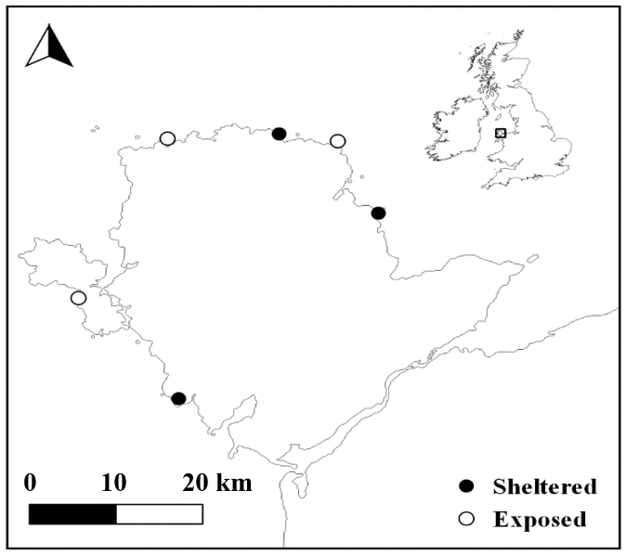

Figure 1.1 Map of study sites across the Isle of Anglesey, Wales, UK. Open circles = Exposed sites, closed circles = sheltered sites.

Site selection and field experiment
My thesis is split into an initial investigation using Nucella directly collected from the six sites in Figure 1.1 and then the following three investigation utilise offspring of Nucella from the same six sites reared under laboratory conditions. For my initial investigation into the potential impacts of predation risk on the oxygen consumption rates of vulnerable and invulnerable Nucella from wave-exposed and wave-sheltered populations, I initially took measurements in the field and then used the same individuals in a laboratory experiment. Oxygen consumption rates of field collected Nucella were conducted within 30 mins of collection, providing an approximation of how Nucella respiration would respond to risk under natural conditions. Field collected Nucella were then fed and housed in a laboratory for one month before measuring oxygen consumption again as well as measuring changes in movement of Nucella exposed to crab effluent and filtered sea water. In the case of the field experiment and all subsequent laboratory experiments crab effluent was created in the same way. In total 8-10 large male crabs (mean carapace length ± SD, 56.6 ± 4.8 mm) were placed into 20 L of filtered and aerated water for 1 hour.

Laboratory reared Nucella
As stated earlier the second set of experiments were conducted using laboratory bred Nucella from each of the six sites. The last three chapters in this thesis investigate the influence of the developmental experience of predation risk (i.e. that occurring throughout the development of offspring) and the parental habitat (wave-exposure) on different traits in Nucella. I manipulated the temporal pattern of risk experienced by Nucella offspring throughout their development by exposing them to one of three predation risk treatment: a no risk treatment, a constant risk treatment and a variable risk treatment. Although detailed methodologies exist in each chapter, as an overview, I will describe how I bred and manipulated the risk experienced by Nucella offspring, providing the animals I used in my last three chapters. In chapter 3, I analysed the influence of these factors on the energy budget and growth of Nucella offspring; In Chapter 4, I looked at their effects on the short-term escape behaviour of Nucella offspring; and finally In Chapter 5, I investigated the influence of the developmental experience of risk on the foraging behaviour of offspring from a wave-exposed and a wave-sheltered population.
Adult Nucella (approx. 150) were collected in February 2017 from the six sites (Fig. 1.1) and placed into site specific tanks, on a 12:12 light dark cycle, with water temperatures that reflected local ambient seawater temperatures. Nucella are internal fertilisers and produce egg capsules (10s per female) contained 10-30 fertilised embryos and 100s of nurse eggs (Pechenik et al. 1984) which they attach to moist rocky overhangs and crevices (Crothers 1985). As hatchling emerge as fully formed snails and do not move great distances throughout their lives, there is little migration between populations (Rolán et al. 2004, Dingemanse et al. 2007, Carro et al. 2012). Nucella breeding peaks in March around the coast of North Wales (Crothers 1985, Morton 2009), when snails form large reproductive aggregations. Under laboratory conditions, Nucella formed breeding aggregations in February and egg capsules were deposited by Nucella from all 6 sites within a 2-week period in mid-March. Egg capsules from each of the six sites were randomly assigned to a no risk, a variable risk or a constant risk regime resulting in a total of 18 treatment combinations (n = 6 mesocosm replicates per treatment combination). Using a scalpel blade, egg capsules were carefully removed, and 8 egg capsules were randomly assigned to one of three risk regimes. Hatchlings were initially provided with rocks, covered in newly recruited barnacles, and then subsequently with larger barnacles as they grew in size. In addition to food, the rocks provided a refuge throughout the 8-month rearing process. Risk exposure was based on the addition, to individual mesocosms, of a perforated crab pot which housed a large male crab (mean carapace length ± SD, 56.6 ± 4.8 mm). Housing crabs in such pots allowed the free dispersion of kairomones without allowing predators direct access to Nucella. Under the no-risk regime crab pots remained empty, whereas under the constant risk regime crabs were present throughout the experiment. For the variable risk regime, crabs were added and removed from the crab pot every three or four days, resulting in Nucella in this regime being exposed to risk for 50% of the time. Nucella offspring were therefore reared under these three risk regimes from the egg capsule phase and throughout the initial 8 months of development.

Thesis Outline
In Chapter 2, I address the potential relationship between local predation pressure and prey vulnerability on prey metabolic rate and antipredator behaviour responses. I measured the oxygen consumption rate of prey at size refuge and therefore no longer susceptible to direct predation, in order to investigate the potential for the indirect effects of predation to persist in these size classes. I used Nucella from three wave-exposed and three wave-sheltered populations to investigate if differences in crab densities at each habitat may influence the metabolic response of vulnerable and invulnerable Nucella. The same individuals were then used in a laboratory investigation one month later, measuring both oxygen consumption rates and movement in response to Carcinus effluent.
Karythis S, Cornwell T, Gimenez L, McCarthy ID, Whiteley NM, Jenkins SR, (2020). Prey vulnerability and predation pressure shape predator-induced stress responses and antipredator behaviour. Animal Behaviour

In Chapter 3, I investigate the potential influence of the experience of risk throughout development and parental habitat on the growth and long-term energetics of Nucella. Using laboratory bred Nucella, I calculated and compared the growth as well as the energetic budget (using the Cellular Energy Allocation technique) of offspring reared under three different risk regimes.
Chapter 4 focused on comparing the short-term behavioural responses of Nucella from wave-exposed and wave-sheltered parents bred under different risk regimes. The aim was to investigate the potential for either parental experience of risk or that experienced by the individual throughout development on the antipredator behaviour adopted. This was achieved by using Nucella offspring in series of behavioural assays using crab effluent and filtered seawater and comparing the behavioural outcomes.
Finally, in Chapter 5 I compared the foraging behaviour of Nucella offspring from a wave-exposed and a wave-sheltered population under different temporal patterns of risk. The aim of this experiment was to investigate how differences in the patterns of risk experience during development may affect the foraging behaviour under predictable and unpredictable risk of Nucella offspring.

Prey vulnerability and predation pressure shape predator-induced changes in O₂ consumption and antipredator behaviour
CHAPTER TWO

Prey vulnerability and predation pressure shape predator-induced changes in O₂ consumption and antipredator behaviour

Abstract
Predators regulate prey abundance (direct predation) as well as influencing their metabolism and behaviour (indirect effects) through the perception of risk. Anti-predator traits are informed by individual experience of risk, which may vary over environmental gradients and through ontogeny. As prey grow in size, individual vulnerability generally diminishes, and the reduction in individual vulnerability with ontogenetic growth can potentially lead to size refugia, ultimately nullifying the impacts of direct predation. Despite the ecological importance of the indirect effects of predation and the disproportionate influence that larger individuals have on ecological level processes, there has been little focus on the potential indirect effects of predation risk on invulnerable prey. Using a combination of field and laboratory experiments, we measured the changes in routine oxygen consumption of vulnerable and invulnerable size classes of the intertidal snail Nucella lapillus, exposed to effluent from its crab predator Carcinus maenas. To test the potential influence of prior experience of predation risk, measurements were conducted on populations naturally exposed to different levels of predation pressure. Field results showed that only invulnerable snails modified their routine oxygen consumption in the presence of risk, and this occurred across all populations. Oxygen consumption rates in the laboratory however, contradicted the pattern, with only vulnerable prey responding to the perception of risk. Metabolic responses of both vulnerable and invulnerable prey under field and laboratory conditions are discussed in the context of asset protection and prey energetic state. Observations of snail behaviour in the laboratory showed that dogwhelks from sheltered shores, where predatory risk is higher, exhibited a higher propensity to exhibit anti-predatory behaviour. Importantly our findings provide evidence that the indirect effects of predators remain influential even after prey are no longer susceptible to direct predation and add to the growing body of evidence highlighting the ecological importance of indirect predation.

Introduction
In many species, exposure to a predatory cue elicits a series of coordinated, adaptive physiological responses, which influence antipredator behaviour (Hawlena et al. 2011, Van Dievel et al. 2016) and may come at an energetic cost (Kamenos et al. 2006, Slos and Stoks 2008, Hawlena and Schmitz 2010a). Such physiological and behavioural responses, as well as promoting prey survival, lead to localised reductions in foraging rates or changes in habitat use that can cause trophic cascades with lasting effects on local population densities and community structure (Schmitz et al. 1997, 2004, Werner and Peacor 2003, Trussell et al. 2004). The energetic costs of predator-induced stress responses have been suggested as potential explanations for reductions in prey fitness, and consequently changes in prey demography (Boonstra et al. 1998, Creel et al. 2007, Preisser et al. 2007, Slos and Stoks 2008), ecosystem nutrient dynamics (Hawlena and Schmitz 2010a), energy flow through trophic levels (Matassa and Trussell 2014) and may possibly account for food chain length in some systems (Trussell et al. 2006b).
The threat of predation varies both temporally and spatially at the individual and population level (Lima and Dill 1990, Lima and Bednekoff 1999). Natural variation in ambient predation pressure among populations has led to the evolution of adaptive physiological and behavioural responses to predation, which may be adjusted by local conditions (Holopainen et al. 1997, Handelsman et al. 2013, Donelan and Trussell 2018a). For example, the resting metabolic rate (MR) of tadpoles (Rana temporaria) exposed to short-term risk increases, leading to an enhanced ability to escape predators. However, with longer exposure MR rates drop, showing acclimation to predator risk by reducing energetic demands which may underpin risk-averse behaviour whilst foraging (Steiner and Van Buskirk 2009). This individual experience of local predation pressure can also inform the subsequent generation, through epigenetic programming (Jablonka and Raz 2009, Love et al. 2013). This trait is particularly important for direct developing offspring, whose experience of risk is likely to strongly correlate with that of their parents (Dixon and Agarwala 1999, Poethke et al. 2010). For instance, offspring dispersal (a predator avoidance trait) in the lizard Zootoca vivipara, increases as a consequence of maternal predator-related stress, decreasing the potential predation pressure experienced by offspring during the most vulnerable stages of development (Bestion et al. 2014). In this way, parental input and individual experience combine to produce more suitable adaptive ecotypes (Giesing et al. 2011, Donelan and Trussell 2015) with natural selection acting to reinforce local adaptations (Mäkinen et al. 2008, Guerra-Varela et al. 2009).
At the level of the individual, several factors including learned behaviours and ontogenetic somatic growth can result in a change in the suite of predators that threaten prey and, in many cases, result in a reduction in overall predation pressure (Paradis et al. 1996, Scharf et al. 2000). Larvae of the three-spine stickleback (Gasterosteus aculeatus), use predator size relative to their own as a measure of predation risk and modify their foraging behaviour accordingly, thus optimizing energy intake whilst minimising the risk of being eaten (Bishop and Brown 1992). This type of threat-sensitive behaviour is further enhanced when prey are able to adjust their behaviour relative to their encounter rates with different predators (Rochette et al. 1999). Legault & Himmelman (1993) showed that this kind of threat-sensitive behaviour exists in several marine invertebrate prey, but that correlations between encounter rates and antipredator behaviour vary between species.
Ontogenetic somatic growth can be an escape strategy in and of itself, with many prey species able to grow to size refugia and escape direct predation completely (Chase 1999). Little is known regarding the way in which prey that have reached a size refuge respond to the threat of predation (Werner et al. 1983, Lundvall et al. 1999), although links between size related vulnerability and antipredator behaviour have been shown in certain aquatic gastropods (Rochette and Himmelman 1996, DeWitt et al. 1999). In their study into the potential for the aquatic snail, Physa gyrina, to express behavioural compensation for morphological vulnerability to a crayfish predator (Orconectes rusticus), DeWitt et al (1999) showed that larger less vulnerable snails demonstrate reduced levels of antipredator behaviour. Considering the disproportionate impact larger individuals have on demography and resources (Paine 1976, Etter 1989), it is perhaps surprising that little interest has been shown in the indirect effects predators have on prey that have reached size refugia.
The purpose of this study was to investigate how differences in prey size and hence vulnerability to direct predation affects the physiological and antipredator response in prey. In addition, we examined how these effects were modified by prior experience of predation risk, based on habitat (sheltered or exposed shores). We used a widely adopted intertidal predator-prey system and implemented a series of field and laboratory experiments, to examine both physiological and behavioural responses of vulnerable and invulnerable prey to predation risk.

Materials and Methods

Predator prey system
The green shore crab Carcinus maenas is an important predator of the dogwhelk Nucella lapillus (hereafter referred to as Nucella). Both species are found extensively across the North Atlantic and co-occur along a gradient of wave exposure (Crothers 1985). Nucella reaches a size refuge from crab predation at 27mm shell length (Hughes and Elner 1979). As with many gastropod species, Nucella are able to assess predation risk through the detection of differences in concentration of kairomones, waterborne chemical cues inadvertently released by predators (Vadas et al. 1994, Edgell 2010, Matassa and Trussell 2011). Nucella use differences in the concentration of these chemicals to assess the proximity of a predator (Freeman and Hamer 2009, Large et al. 2011) and therefore are influenced by local hydrodynamic conditions (Freeman and Hamer 2009, Large et al. 2011). For example, in high flow, wave-exposed environments, characterised by an elevated degree of mixing, the homogenisation of the olfactory seascape created by predatory kairomones, affects the chemoreceptive ability of prey (Zimmer and Butman 2000, Weissburg et al. 2003, Large et al. 2011). Large et al (2011), showed that antipredator behaviour in Nucella lapillus is strongly influenced by hydrodynamic mixing and that Nucella chemoreception ability is reduced in very slow or fast flowing turbulent water. They argue that on exposed shores, due to the homogenisation of different concentrations of chemical cues, Nucella are unable to perceive predation risk. Wave action also directly impacts the densities of crabs, with wave exposure being negatively correlated with crab densities (Hughes & Elner, 1979; Large & Smee, 2013; Menge, 1983; Rochette, Smee, & Trussell, 2011). Hence populations of Nucella can experience varying levels of predation risk depending on local wave action regimes (Menge 1976, Freeman and Hamer 2009, Large et al. 2011, Tyler et al. 2014). The effects of wave action combined with inherent differences in predator densities result in the formation of distinct ecotypes of Nucella, with plasticity present in both morphological and behavioural antipredator traits (Crothers 1983, Rolán et al. 2004, Guerra-Varela et al. 2009, Large and Smee 2013).

Site selection and predator numbers
Our field study was conducted at six sites, 3 wave-exposed and 3 wave-sheltered, around the coasts of Anglesey, North Wales, UK (Fig. 2.1). Sites were initially selected as wave-sheltered or wave-exposed based on community structure (Ballantine 1961) and later exposure was calculated using the map-based method to estimate mean wave fetch for each site (Burrows et al. 2008a). In order to estimate differences in crab abundance, baited crab traps (60 x 40 x 35 cm, with 500g of fish) were used at each of the 6 sites. For each site, crab numbers per trap were counted on three consecutive days. A single baited crab trap was placed in the midzone and left for two complete tidal cycles, sampled and then redeployed a further two times, each time deploying ~30 m along the shore. This allowed us to average crab numbers across the three days for each site to provide a mean crab number per trap per site.

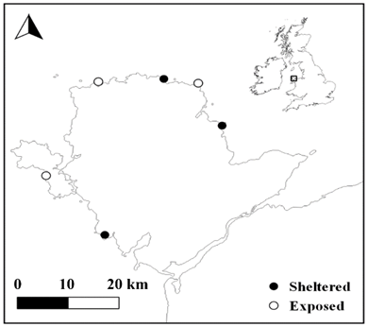

Figure 2.1 Map of study sites across the Isle of Anglesey, Wales, UK. Open circles = Exposed sites, closed circles = sheltered sites.

Field measurements
We compared field oxygen consumption rates of two size classes of Nucella from exposed (low predator abundance) and sheltered (high predator abundance) shores with and without predator cue. Small Nucella, considered vulnerable to predation (N = 7 at each site, mean shell length 14.6 ± SD 1.3 mm) and large, considered invulnerable (N = 7 at each site, mean shell length 29.0 ± SD 1.6 mm) were collected from the same tidal height to control for any unknown shore-level size gradients (Elner and Hughes 1978). Field measurements were conducted between 11.00 and 17.00 on 4-8 October 2017, apart from one sheltered shore which had to be completed during the next tidal cycle (17 October 2017) due to adverse weather conditions. Animals were collected before being exposed to air, as the tide was receding, and subsequently were kept submerged to avoid any potential impacts on oxygen consumption rates (Stickle et al. 1985, McMahon 1988). Care was taken not to select individuals that were actively feeding. Individual Nucella were carefully placed into closed system respirometers (70 x 70 x 50 mm) containing fully aerated filtered seawater to determine oxygen consumption rates. All water used in field measurements was sourced from the laboratories at the School of Ocean Sciences, Bangor University, Menai Bridge, Wales. Changes in water oxygen partial pressure (PO₂) were measured using an optical fluorescence technique (PreSense, Fibox 4 trace, Fiber optic Trace Oxygen Meter). Each respirometer was equipped with a single oxygen sensor spot (PreSense) located on the inside of the lid, which allowed for non-intrusive measurement of seawater PO₂ levels at regular intervals. The seawater was filtered (0.45 μm) to reduce contaminating effects of biological activity from microbes and algae, and two controls consisting of respirometers without snails were included during each trial (N=16). Controls for filtered sea water and crab effluent were used to assess any background (microbial) oxygen consumption rates and this was then subtracted from all other measurements in that trial. Sea surface temperature was measured at each site at the beginning of each experiment and respirometers were placed into temperature-controlled water baths to ensure that in situ temperatures were maintained throughout the period of oxygen consumption measurement (mean 14.18 ± SD 0.06 oC across all sites) to prevent temperature-related changes in metabolic rates (Dahlhoff et al. 2008).
Preliminary trials showed that rates of oxygen consumption were initially elevated when Nucella were first placed in the respirometers due to handling stress, but levels fell over the next 25 minutes as snails settled in the respirometers. Over the next 45 minutes PO₂ levels fell within the respirometers in a linear fashion which we considered to be routine rates of oxygen consumption as the snails were free to move around within the respirometers. Several studies have shown that exposure to crab effluent influences Nucella behaviour and therefore the use of routine rates of oxygen uptake are more appropriate when determining the natural reaction of Nucella to the detection of a predator (including the effects of movement). Based on these initial observations, individual snails were inserted into their respiration chambers, sealed and left for 25 mins before the initial PO₂ reading was taken. Repeated PO₂ readings were then taken every 5 min for the next 45 min to determine the linear fall in PO₂ over time. Snails therefore spent 70 min in total in their respective respirometers. In each case, care was taken to avoid hypoxia from developing within the respirometers by ensuring that PO₂ levels remained above 17 kPa throughout this period. Rates of oxygen consumption were determined from the drop in PO₂ over 45 min by linear regression, minus the background fall in PO₂ from the respective controls. This value was multiplied by the solubility coefficient for oxygen adjusted for salinity and temperature to give whole-body values in ml O₂/h. Values were corrected to STPD and expressed as umol O₂/h.
Once a baseline oxygen consumption rate had been established for each individual, they were then subjected to the predation risk treatment. Each individual that had been monitored for baseline oxygen consumption was exposed to predation risk by exchanging the water in the respirometer for water treated through exposure to crabs. This ‘predation risk’ water was created in the field by adding 8-10 large male crabs (mean carapace length ± SD, 56.6 ± 4.8 mm) to 20 L of filtered and aerated water for 1 hour. Care was taken to keep Nucella submerged at all times during the water change. Nucella were then allowed a further 25 minutes to acclimatise to the new treatment. Once measurements were complete, all Nucella were marked and returned to the laboratory in order to assess their oxygen consumption rates and behavioural responses to predation risk under controlled laboratory conditions.

Laboratory measurements
Individuals collected from the field were housed in a temperature-controlled aquarium at similar temperatures to those in the field (mean 13.9 ± SD 0.9 ºC) in fully aerated, recirculated, natural seawater for one month prior to running the second experiment. Nucella were not exposed to predation risk during this period. They were fed mussels and barnacles ad libitum and then starved for 48 hours prior to taking oxygen consumption measurements, in order to standardise digestive state (Matassa and Trussell 2014). Laboratory measurements followed the same protocol as the field experiment with routine oxygen consumption rates being established prior to measuring them under predation risk conditions. Water temperature was maintained at the respective in situ temperatures. After 25 minutes acclimatisation, oxygen consumption rates were measured every 5 minutes for 45 minutes. As with the field experiment, the same individuals were then exposed to crab effluent and their oxygen consumption rates were measured.
To determine whether the two size classes of Nucella demonstrate typical antipredator responses (cessation of movement, Freeman, Dernbach, Marcos, & Koob, 2014; Vadas et al., 1994), Nucella were observed for 20s every 5 minutes, over a total period of 45 mins, and their precise location noted on a diagram of the respirometer following the approach of Large et al. (2011). Care was taken not to cast a shadow over the respiration chambers to reduce any potential impacts on Nucella behaviour. As the exact movement of individuals between 5-minute increments could not be known, we used the shortest possible distance between two consecutive increments for our calculations. By combining the distance travelled between all increments, we were able to estimate the total distance travelled during the experiment.

Statistical analysis
As the focus of this study was on comparing the effect of predation risk on oxygen consumption rates of vulnerable and invulnerable prey and not directly on the effects of size, analysis was conducted on whole animal rates of oxygen consumption (Packard and Boardman 1999, Hayes 2001, Dahlhoff et al. 2008). To assess the potential impact of predation risk on the oxygen consumption rates of vulnerable and invulnerable prey both in the field and in the laboratory, we used a model selection approach using Gamma distributed Generalized Linear Mixed Models (GLMMs). In both analyses, we used whole animal oxygen consumption rates as a response variable and wave-exposure (exposed and sheltered), Nucella vulnerability (vulnerable and invulnerable) and predation risk treatment (No predator cue and predator cue) as fully crossed fixed effects. Log transformed total length was used as a covariate to account for any potential size related differences within the size ranges selected. We considered site as being nested within wave-exposure and Nucella ID as a repeated measure (both treated as random effects). We also performed a GLMM with Nucella movement as a response variable using the same fixed, nested and repeated terms effects as in previous analyses. The movement results showed over-dispersion and were therefore analysed using a negative binomial GLMM. We used the glmm.TMB package to analyse movement results (Brooks et al. 2017).
All GLMMs were constructed and compared in R 3.5.0 (R Core Team 2013) using the lme4 package (Bates et al. 2015). Backward model selection was achieved using the drop1 function and models with the lowest AIC were selected (Bolker et al. 2008). When interaction terms were significant at the α = 0.05 level, Tukey post hoc tests were carried out using the emmeans package (Lenth et al. 2004).

Results

Field results
Exposure calculations (measured as average wave fetch per site) using the Burrows et al. (2008) map-based method concurred with our assessment of exposure with sheltered and exposed shores having a mean wave fetch of 17.89 km (± 7.77 SD) and 49.55 km (± 10.09 SD) respectively. These values agree with Burrows et al. (2008) assessment of wave-sheltered and wave-exposed shores which they defined as being 20-40 km and 40-60 km respectively. There was a significant effect of wave exposure on crab numbers per trap (ANOVA: F_{1,11} = 7.42, P = 0.016, Table 2.1), with wave-exposed sites having an average of 0.89 ± 0.42 crabs per trap compared with wave-sheltered sites which had an average of 41.22 ± 5.81 crabs per trap (Fig. 2.2). The combination of wave exposure effects on the perception of kairomones and the stark difference in predator densities indicate that Nucella at each exposure were exposed to different levels of predation risk.
Table 2.1 Wave fetch indices for exposed and sheltered sites using the Burrows et al., 2008 map based method using 32 angular sectors and mean crab number per trap per site.

Site Wave exposure Mean Fetch (km) Mean Crab Number (± SE)
Moelfre Sheltered 11.71 54.66 (10.7)
Porth Cwefan Sheltered 26.62 45.66 (4.48)
Bull Bay Sheltered 15.37 23.33 (3.17)
Point Lynas Exposed 55.10 0.00 (0.00)
Cemlyn Bay Exposed 55.64 1.33 (0.88)
Trearddur Bay Exposed 37.89 1.33 (0.88)
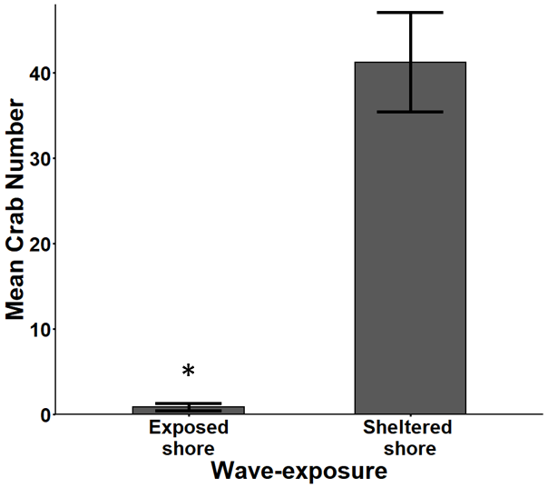

Figure 2.2 Mean number (± SE) C. maenas caught per trap for exposed and sheltered shores, t-test was used to compare means. Significant differences are indicated using (*) at  < 0.01.

The addition of Nucella shell length to all models tested had no impact on the AIC calculated and it was therefore not included in further analysis. Model selection results for our field and laboratory measurements are summarised in Table 2.2. Background respiration rates were 0.52 µmol O₂/h across treatments. Oxygen consumption rates of vulnerable Nucella (mean 3.60 µmol O₂/h, SE = 0.25) were lower than those of invulnerable individuals (mean = 16.65 µmol/l/h, SE = 0.85) across all exposure gradients and treatments (gamma distributed GLMM: N = 65, χ²₁ = 66.12, P < 0.001, Fig. 2.3). GLMM analysis showed that the two size classes of Nucella reacted differently when exposed to crab effluent (gamma distributed GLMM: N = 65, χ²₁ = 8.85, P = 0.003). Further post hoc analysis showed that in the presence of predation risk, invulnerable Nucella reduced their respiration rates by 36.2%, (Table 2.3, Tukey pairwise comparison: P < 0.001), whereas vulnerable individuals showed a slight non-significant increase in oxygen consumption rates of 6.01% (Table 2.3, Tukey pairwise comparison: P = 0.914). This pattern was consistent across both exposure levels (gamma distributed GLMM: N = 65, χ²₁ = 0.45, P = 0.49, Fig. 2.3).
Table 2.2 Field and laboratory model selection scores results for the potential influence of predation risk on wave exposed and wave sheltered population of dogwhelks (Nucella lapillus).
Terms removed df Field Laboratory Movement

3-way factorial 11 700.52 619.47 1478.19
2-way interaction E*T*S 10 700.52 617.67 1476.61
T:S 9 706.07 619.47 1486.37
E:S 9 696.98 629.18 1478.99
E:T 9 696.98 615.74 1475.10*
Single 2-way interaction E:S + T:S 8 704.20 627.26 1485.34
E:T + T:S 8 705.28 629.54 1488.90
E:T + E:S 8 696.58* 616.86* 1478.19
Fixed terms E:T + E:S + T:S 7 703.37 627.60 1487.41
T 6 717.00 643.29 1500.16
S 6 766.94 688.82 1485.59
E 6 701.87 627.26 1490.31
Single Fixed terms T + S 5 785.58 704.94 1499.03
E + S 5 715.65 642.90 1503.99
E + T 5 765.00 687.03 1488.46
Random Factor Site 10 699.21 617.67 1476.19

Best Model Field = Risk Treat*Size, Laboratory = Risk Treat*Size,
Movement = Risk Treat*Size + Wave-Exposure* Size
Abbreviations: E = Wave-Exposure, T = Risk Treatment, S = Size (vulnerability). Models selected using generalised linear square models and Akaike Information Criteria (AICc) for all dependent variables. Selected models are highlighted in bold with an (*).

Laboratory results
Overall laboratory background respiration rates contributed in control respirometers were 0.30 µmol/O₂/h. As with the field results, in the laboratory, invulnerable Nucella had higher oxygen consumption rates than vulnerable individuals (gamma distributed GLMM: N = 65, χ²₁ = 61.48, P < 0.001). However, under laboratory conditions although there was an interaction between treatment and size (gamma distributed GLMM: N = 65, χ²₁ = 12.73, P < 0.001), it was vulnerable Nucella that showed a reduction in respiration rates by 26.8% under predator risk (Table 2.3, Tukey pairwise comparison: P < 0.001), whereas respiration of invulnerable individuals did not differ between treatments (Fig. 2.4, Tukey pairwise comparison: P = 0.64). Once again, differences between size classes were the same irrespective of exposure level (gamma distributed GLMM: N = 65, χ²₁ = 1.66, p = 0.169).
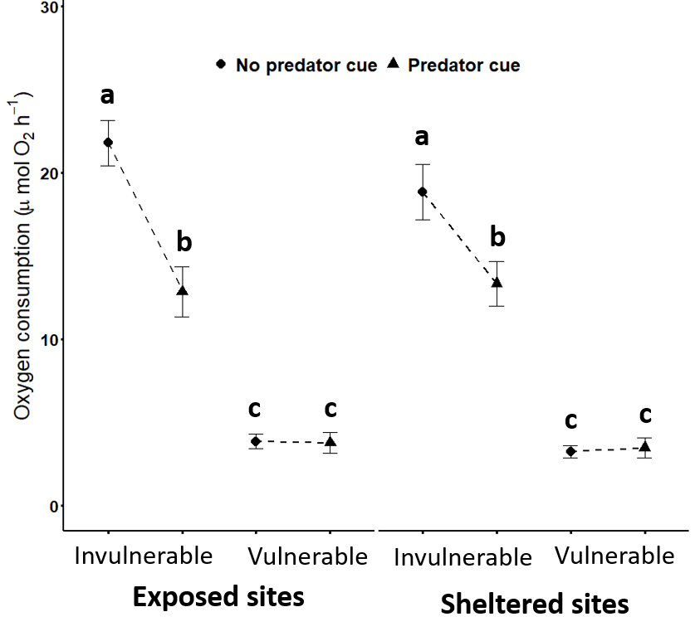

Figure 2.3 Field oxygen consumption rates of vulnerable and invulnerable dogwhelks (Nucella lapillus) from sheltered and exposed shores in filtered seawater (No Predator Cue) and under predation risk (Predator Cue). Letters indicate results from the Post hoc Tukey’s HSD and bars represent ± SE among sites.

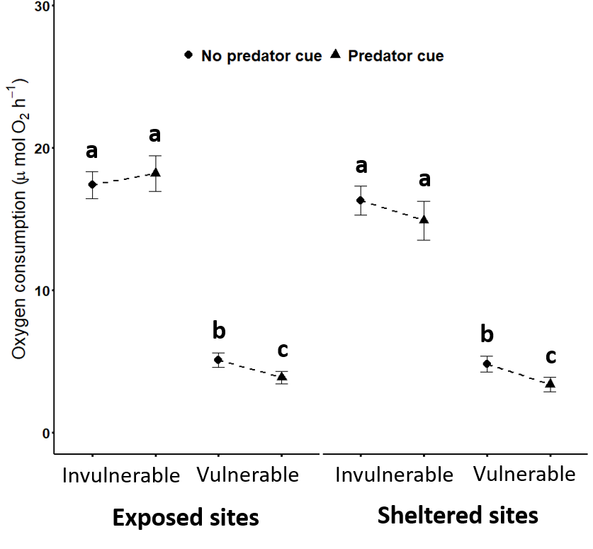

Figure 2.4 Laboratory oxygen consumption rates of vulnerable and invulnerable dogwhelks (Nucella lapillus) from sheltered and exposed shores in filtered seawater (No Predator Cue) and under predation risk (Predator Cue). Letters indicate results from the Post hoc Tukey’s HSD and bars represent ± SE among sites.

Laboratory behavioural responses
The detection of a predatory cue affected the behaviour of Nucella, and its impact was influenced by both prey vulnerability as well as wave-exposure level (Fig. 2.5). Overall, vulnerable Nucella reduced their movement in the presence of a predatory cue, whereas invulnerable Nucella did not show a reduction (negative binomial GLMM: N = 65, χ²₁ = 11.84, P < 0.001). Post hoc testing revealed that both size classes moved similar distances in filtered sea water (Fig. 2.5) but, in crab effluent vulnerable Nucella reduced their movement (Table 2.3, Tukey pairwise comparison: P < 0.001), whereas invulnerable individuals did not (Table 2.3, Tukey pairwise comparison: P = 0.715). Under predation risk conditions, there was an overall effect of wave-exposure on Nucella behaviour (Fig. 2.6, negative binomial GLMM: N = 65, χ²₁ = 4.92, P = 0.03). Nucella from sheltered shores, naturally exposed to higher ambient levels of predation risk reduced their movement when exposed to crab effluent (Table 2.3, Tukey pairwise comparison: P <0.001), whereas Nucella from wave-exposed shores remained active (Table 2.3, Tukey pairwise comparison: P = 0.157).
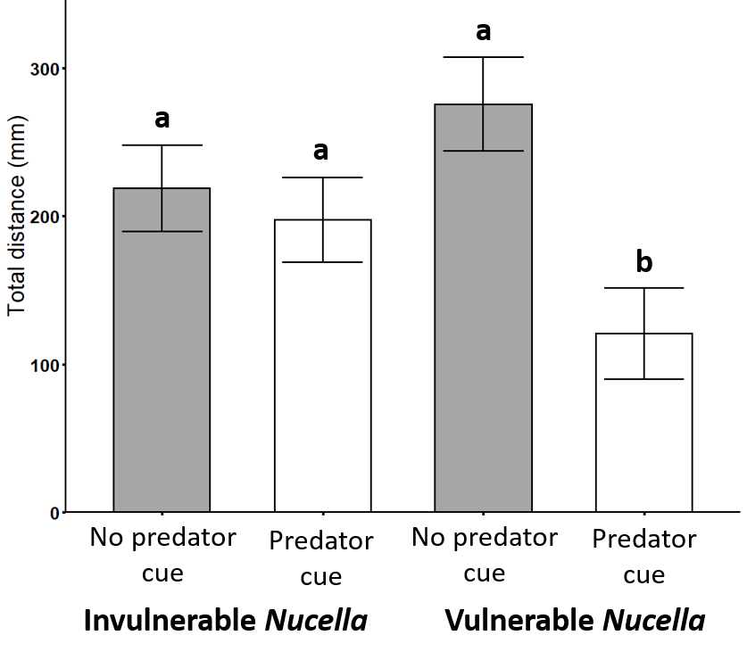

Figure 2.5 Movement of A) vulnerable and B) invulnerable dogwhelks (Nucella lapillus) from sheltered and exposed shores in filtered seawater (black bars) and under predation risk (grey bars). Letters indicate results from the Post hoc Tukey’s HSD. Bars represent ± SE among sites.
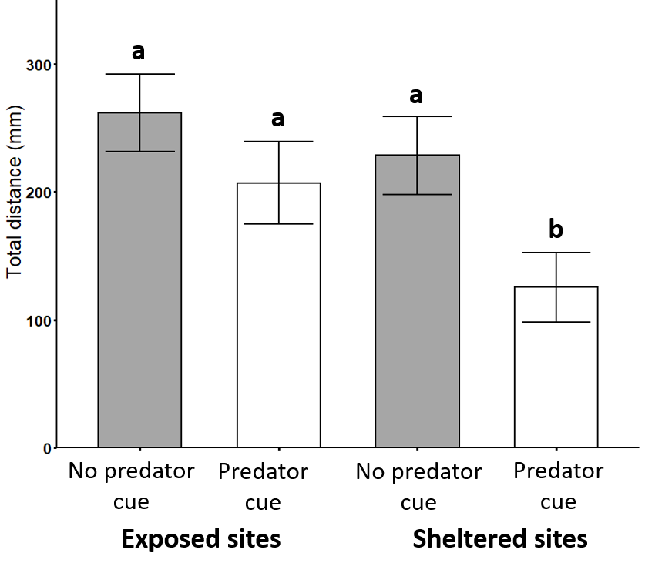

Figure 2.6 Combined movement of all sizes classes of dogwhelks (Nucella lapillus) from sheltered and exposed shores in filtered seawater (grey bars) and under predation risk (white bars). Letters indicate results from the Post hoc Tukey’s HSD. Bars represent ± SE among sites.

Discussion
Short-term metabolic responses of invertebrate prey to predation risk and the resulting antipredator behaviour are not well understood (Canero and Hermitte 2014, Mitchell et al. 2017), and the influence of individual vulnerability even less so (DeWitt et al. 1999). Exposing Nucella to a predatory cue affected their routine MR as well as their antipredator behaviour, but each response was influenced differently by individual vulnerability and wave-exposure. When vulnerable and invulnerable Nucella were exposed to a predatory cue in the field, moments after being collected, it was the invulnerable size class which reduced its oxygen consumption rate, as opposed to vulnerable ones. It is important to note that Nucella were not tethered while in the respiration chamber as our intention was to capture the total oxygen consumption related to the detection and subsequent short-term response to predation risk. Therefore, our results do not allow us to distinguish between a potential physiological response to predation risk and the metabolic cost of the resulting behavioural response. Changes in oxygen consumption rates are therefore a combination of stress induced changes in metabolic rate as well as behavioural changes. Notwithstanding, our results clearly indicate that predation risk may still influence prey which are otherwise safe from direct predation by specific predators. In addition, through making comparisons of oxygen consumption in the field, in individuals extracted directly from natural conditions, with those maintained in the laboratory, we also show important differences in response. Our results and particularly the differences between the field and laboratory observations are explained in relation to size related risk taking as well as through potential changes in Nucella physiological and energetic state.

Oxygen consumption in vulnerable Nucella
When vulnerable Nucella were exposed to a predatory cue in the field, there was no change in oxygen consumption when compared to respiration in filtered sea water alone. Previous laboratory based studies show a cessation of movement in the presence of a predatory cue (Vadas et al. 1994, Large and Smee 2010). However, our field-based results, when framed from the perspective of foraging-risk trade-off, may be explained by Clark’s Asset Protection Principle (APP, Clark, 1994). The APP asserts that foraging decisions relate to the relative amount an individual stands to lose or gain from foraging at a particular time. The APP argues that for a given amount of energy to be gained from foraging at a specific time, smaller individuals have less to lose (less already invested in growth) and proportionally more to gain, than a larger individual. In this context, smaller individuals should forage under risky conditions if the potential energy gain is high enough. In essence, it is more favourable for smaller prey to forage during risky periods compared to larger individuals. Thus, vulnerable Nucella under predation risk conditions are likely to continue to search for food due to the high fitness gains, resulting in similar levels of oxygen consumption between our two treatments.
In the laboratory, where Nucella were fed ad libitum and did not experience risk cues or wave action for one month, oxygen consumption responses to risk differed to those in the field. Vulnerable Nucella reduced their routine metabolic rate as well as their movement when exposed to a predatory cue. These seemingly contradictory patterns between field and laboratory results may be explained in the context of the Risk Allocation Hypothesis (RAH). The RAH rests on the inextricable link between current energy reserves and decision making under risky conditions, meaning that behavioural changes are not a result of momentary trade-offs, but rather as forming part of an overarching foraging strategy (Mangel and Clark 1986, Lima and Dill 1990, Burrows and Hughes 1991a, Lima and Bednekoff 1999). In essence, low energy reserves force prey to forage irrespective of risk, whereas when energy reserves are high, prey are able to wait out risky periods in order to forage during more favourable ones (Lima and Dill 1990, Lima and Bednekoff 1999). One of the important predictions of the RAH is that if prey experience prolonged periods of safety interspersed with short high risk periods, then prey should stop foraging during the high risk periods (Lima 1998b). In the laboratory, Nucella experienced “safe” conditions, where they were able to increase energy reserves. Thus, when faced with predatory risk they reduced activity as predicted by the RAH which in turn was reflected in a reduction in oxygen consumption. When Matassa and Trussell (2014) tested the response of starved and satiated Nucella in the laboratory they found patterns which corroborate our field-lab comparisons. Satiated animals did not forage during risky periods whereas starved individuals were forced to forage even under high risk conditions.

Oxygen consumption in invulnerable Nucella
Although vulnerable Nucella reacted predictably to predation risk in terms of the RAH, the pattern seen in the invulnerable adults was less clear. Under field conditions, invulnerable Nucella reduced their oxygen consumption rate in response to a predatory cue. Large invulnerable Nucella are much more likely than small vulnerable individuals to have sufficient energy reserves to be able to reduce activity in the presence of increased risk (Feare 1970). Thus, a reduction in oxygen consumption in the field may be a consequence of a reduction in movement. Although the exact mechanism underpinning this reduction in oxygen consumption is beyond the scope of this investigation (stress response and movement), these observations are important in showing that Carcinus is still able to affect Nucella even after they have reached a size refuge. This pattern changed after Nucella had been housed under “safe” conditions in the laboratory. When tested again in the laboratory, where we expected a similar pattern to that seen in the field (with satiated individuals reducing their respiration as well as their movement), there was no reduction in oxygen consumption or movement under predation risk condition. Clearly the complexity of behavioural and physiological changes in laboratory housed Nucella at size refuge warrants further study, as these size classes have a disproportionate influence on population dynamics.

Antipredator behaviour
Antipredator behaviour was only assessed in the laboratory, and not in the field. Our observations showed an interesting influence of wave exposure (and hence prior experience of predatory threat) on the propensity for Nucella to adopt an antipredator behaviour. Wave-sheltered populations (which naturally experience higher predation risk) showed higher levels of antipredator behaviour (cessation of movement) than their wave-exposed counterparts. At the population level, comparisons of the effects of sympatric and allopatric predators on the behaviour of prey have shown that the influence of local ambient predation pressure informs antipredator behaviours (Rochette et al. 1997, 1999, Aschaffenburg 2008, Large and Smee 2013). In comparisons of antipredator behaviour of the common whelk (Buccinum undatum), from populations naturally exposed to different suites of predators, Rochette and Himmelman (1996) found that individuals adopt more appropriate antipredator behaviour to sympatric predators than allopatric ones. In Nucella investigations of wave-exposure effects on behaviour are conflicting. Large and Smee (2013) found that crabs caused a reduction in Nucella movement in both wave-sheltered and wave-exposed populations. By contrast, and in accordance with our own work, Freeman et al. (2014) showed lower levels of antipredator behaviour in more predator naïve populations from exposed shores.

Potential ecological importance
The changes in behavioural and physiological traits of prey can have potentially cascading effects on the rest of the biological community. A predator’s influence on community dynamics is not limited to their regulation of prey densities (Density-Mediated Indirect Interactions - DMIIs), but also through their influence on prey physiological and behavioural traits (Trait-Mediated Indirect Interactions - TMIIs). Investigations into the potential strength of DMIIs compared to TMIIs between Carcinus and Nucella have shown that direct predation and predation risk exert similar influence on the community dynamics of this rocky shore food chain (Trussell et al. 2006a). Our results indicate that this may in fact be an underestimation of the importance of TMIIs as previous studies have only used small size classes of Nucella that have lower foraging rates than individuals at size refuge used in this study (Dunkin and Hughes 1984). The persistence of the indirect effects of Carcinus on Nucella even after a size refuge has been reached will mean that TMIIs persist for longer than DMIIs, increasing their ecological importance. The greater impact larger individuals have on resources combined with the protracted temporal scale at which prey are influenced by predation risk, may result in a considerable underestimation of the overall impacts predators have on an ecosystem.

Conclusions
Our results provide insight into the effects of predators on prey of differing vulnerability and the potential for antipredator behaviours to be influenced by local environmental factors (wave exposure and hence presumed influence of predation risk). Importantly we have shown that the influence of a predator may be more far reaching than originally thought, as they are able to affect oxygen consumption of prey even after they are no longer susceptible to direct predation. Our contrasting results from field and laboratory experiments show clearly that understanding of prey state (e.g. physiological/energetic condition which is likely to change dependent on handling and husbandry) is critical in generating a holistic understanding of predator prey responses (e.g. Matassa & Trussell, 2014). Finally, although not consistent across all responses, we found an effect of wave exposure on antipredator behaviour (cessation of movement) indicating an effect of prior experience of predation risk. Further studies into the potential for predators to indirectly influence prey which are not at risk of direct predation will enable us to better appreciate the overall influence predators have on the ecosystem they inhabit.

 |  |  | Contrast |  |  |  |  |  | Combination
Experiment | Model |  | Factor |  | Levels |  |  |  | Vulnerability | Estimate | Z ratio | P
Field O₂ Consumption | O₂ con ~ Vulnerability + Risk Treatment + Wave-exposure +  Vulnerability * Risk Treatment +  (1|Site) + (1 | Nucella ID) |  | Risk Treatment |  | No  Predator | vs. | Predator |  | Vulnerable | -0.0608 | -0.609 | 0.914
 |  |  |  |  |  |  |  |  | Invulnerable | -0.4573 | -5.290 | <0.001
Laboratory O₂ Consumption | O₂ con ~ Vulnerability + Risk Treatment + Wave-exposure +  Vulnerability * Risk Treatment +  (1|Site) + (1 | Nucella ID) |  | Risk Treatment |  | No  Predator | vs. | Predator |  | Vulnerable | -0.3379 | -5.883 | <0.001
 |  |  |  |  |  |  |  |  | Invulnerable | -0.0555 | -1.094 | 0.644
Laboratory Movement Analysis | Movement ~ Vulnerability + Risk Treatment + Wave-exposure +  Vulnerability * Risk Treatment +  Wave-exposure * Risk Treatment +  (1|Site) + (1 | Nucella ID) |  | Risk Treatment |  | No  Predator | vs. | Predator |  | Vulnerable | -1.6137 | -5.052 | <0.001
 |  |  |  |  |  |  |  |  | Invulnerable | -0.2426 | -0.984 | 0.715
 |  |  | Risk Treatment |  | No Predator | vs. | Predator |  | Wave- Exposure
 |  |  |  |  |  |  |  |  | Sheltered | -1.3559 | -4.401 | <0.001
 |  |  |  |  |  |  |  |  | Exposed | -0.5004 | -1.982 | 0.157
Table 2.3 Post hoc Tukey’s HSD test results for significant interactions from GLMMs conducted on field and laboratory experiments. Statistically significant models (p = 0.001) are in bold

Parental effects and individual experience of predation risk informs growth and the energy budget of prey Parental effects and individual experience of

CHAPTER THREE

Parental effects and individual experience of
predation risk informs growth and the energy budget of prey

Abstract
Predation risk influences how prey acquire and use energy, impacting energy reserves and growth, with potential implications for ecosystem functions. Prey must respond to both small-scale fluctuations in predation risk as well as adapting to larger-scale differences in the predation pressure experienced by separate populations. In many cases these larger-scale environmentally driven differences in predation risk can have a profound effect on the amount of energy prey invest in antipredator defences relative to that invested in growth. Furthermore, as the predation pressure faced by prey may be closely correlated with that of their parents, many prey species can influence the antipredator responses of their offspring through parental effects. Comparing the responses of prey to risk in various contexts will help us develop a deeper understanding of the full impact of predators on prey life history and community dynamics. I reared the offspring generation of intertidal gastropods (Nucella lapillus), from populations naturally exposed to different predation pressure, under different temporal patterns of risk throughout development. The shell length, relative investment in defensive structures (body Vs shell tissue) and long-term energetics of offspring were then analysed to determine the influence of parental habitat and developmental experience of risk. My results showed that shell length was influenced by parental habitat and developmental experience of risk, however Nucella from both populations allocated more resources to shell tissue relative to soft body tissue in response to the amount of time they spent under risky conditions. Although the overall the energetic budget of Nucella, was not influenced by developmental risk or parental habitat, analysis revealed that they play important roles in the proportion of energy stored as protein, carbohydrate and lipid. Our results highlight the impacts of individual experience of risk on growth, allocation of resources to defensive structures and the energetic budget of Nucella as well as the potential influence parental experience can have through parental effects.

Introduction
The fear of being eaten profoundly influences prey behaviour, physiology, morphology and life history (Werner et al. 1983, Lima et al. 1985, Trussell et al. 2003, Hawlena and Schmitz 2010b). Predator-induced increases in metabolic costs and reductions in foraging are common observations in a number of taxa leading to subsequent impacts on growth (Dill 1987, Lima and Dill 1990). However more recently studies have begun to show that risk can have more profound effects on prey energetics. For short-term exposure to predation risk, prey are able to rely on previously acquired energy reserves, but in some predator-prey systems extended exposure to risk has been shown to impact the body stoichiometry of prey (Van Dievel et al. 2016, 2019a, Tigreros et al. 2018). Predation risk has been shown, in some instances, to influence the amount of energy stored as protein, carbohydrate and lipids which can influence future foraging predation risk trade-offs (Tigreros et al. 2018). The long-term exposure of the damselfly Enallagma cyathigerum, to predatory cues results in changes to the C:N ratio of body tisues (Van Dievel et al. 2016) which can influence nutrient cycling and ultimately affect the level of production (Van Dievel et al. 2019a). As the risk posed by predators can modulate the acquisition and utilisation of energy (Trussell et al. 2006b, Thaler et al. 2012, Van Dievel et al. 2016), how prey balance their energy budgets with their experience of risk will affect their overall lifetime fitness (Lima and Bednekoff 1999, Ferrari et al. 2009, Trussell et al. 2011) as well as impacting ecosystem functions (Trussell et al. 2006a, 2017, Hawlena and Zaguri 2016, Van Dievel et al. 2016).
While the threat of predation is often examined through relatively simple experiments which consider risk as either present or absent, such studies are prone to exaggerate or neglect the indirect effects of predation risk (Ferrari and Chivers 2009, Trussell et al. 2011). In nature, environmental conditions change, predators move and prey increase in body size; therefore, predation risk is neither constant nor predictable, thus perception of risk can vary through time in a complex manner (Lima and Bednekoff 1999, Sih et al. 2000, Ferrari et al. 2008b). Initially theoretical, and increasingly empirical studies are showing that manipulations of temporal patterns of risk, provide a more realistic test of the effects of predation risk on prey (Lima and Bednekoff 1999, Ferrari et al. 2008b, 2009). Furthermore, recent investigations have also shown that individual variation in behaviour is also driven by environmental and temporal pattern of risk (Cornwell et al. 2019, Jolles et al. 2020). Specifically, time of day (Ferrari et al. 2008a), frequency (Sih and McCarthy 2002, Ferrari et al. 2008b), predictability (Trussell et al. 2011, Matassa and Trussell 2014), as well as the relative duration of exposure to predation risk (Van Dievel et al. 2016) have all been shown to elicit different responses in prey. For example, tadpoles (Rana sylvatica) reduce their movement under risky conditions, but the magnitude of this antipredator response is sensitive to the time of day, as well as the level of perceived threat (Ferrari et al. 2008a, Ferrari and Chivers 2009). Similarly, energy acquisition (foraging rates) and anti-predator escape behaviours in the freshwater snail, Physa acuta, appear to be directly influenced by fluctuating patterns of predation risk from predatory crayfish (Procambarus spp, Kain & McCoy, 2016). Thus, further highlighting the potential importance of experimental manipulations examining temporal patterns of risk, which may provide more reliable estimates of risk response in prey organisms.
Although individual experience of risk will undoubtably have a profound influence on the acquisition and utilisation of energy in prey, in many systems experience of risk of one generation can also influence the antipredator traits of subsequent ones (Mousseau and Fox 1998, Agrawal et al. 1999). Chronic parental exposure to predation risk can reduce the number and quality of offspring (Mcghee et al. 2012) and modify fitness through changes in behaviour (Storm and Lima 2010, Mcghee et al. 2012, O’Brien et al. 2017) and their physiological responses to predation risk (Donelan and Trussell 2018a, 2018b, 2019). For example, offspring of gravid female field crickets (Gryllus pennsylvanicus) previously exposed to cues from the wolf spider Hogna helluo, exhibit elevated antipredator responses compared with offspring of unexposed females (Storm and Lima 2010). These results revealed higher survival rates in parentally informed offspring than the corresponding uninformed juvenile crickets and were later confirmed in field populations, with local predation pressure by wolf spiders correlating with antipredator responses in field crickets. In addition, this type of parental effect can be seen in the post-consumptive processes in some prey species. Donelan and Trussell (2018b) have shown, for example, that parental experience with risk can influence the long-term growth efficiency of the intertidal snail, Nucella lapillus. Parental pairs of snails exposed to predation risk produce offspring with higher growth efficiencies than those of unexposed parents (Donelan and Trussell 2018b). It is, therefore, important to appreciate the potential influence that parental experience may have on the behaviour and physiology of their offspring when exposed to predators.
Here we address the question of how experience of risk by offspring may be modified by parental experience and how those experiences affect the growth and long-term energetics of offspring. Using an intertidal (dogwhelk - crab) predator-prey system, we combine parental experience of risk with manipulations of developmental experience (i.e. that occurring throughout the development of offspring). In considering how parental experience can influence life-history traits of distinct populations, it is necessary to consider the experiences of individuals at larger temporal and spatial scales. Variability in predation risk tends to decrease over larger spatial scales (Luttbeg and Sih 2004, Hammond et al. 2007), as differences in environmental conditions between populations begin to play a larger role in species interactions (Paine 1976, Menge 1978b, Menge et al. 1987, Menge and Olson 1990, Moody and Aronson 2007). For instance, in intertidal habitats, as abiotic factors become more extreme, mobile predators become less abundant and efficient, and hence the overall predation pressure experienced by prey is lower (Moody and Aronson 2007, Freeman and Hamer 2009). In the rocky intertidal, predation pressure by crabs (Carcinus maenas; hereafter Carcinus) on dogwhelk (Nucella lapillus; hereafter Nucella) is higher in sheltered shores as compared to those exposed to wave action (Hughes and Elner 1979, Large and Smee 2013, Karythis et al. 2020). We therefore collected adult dogwhelks from populations occurring in wave-exposed and wave-sheltered shores and allowed them to breed in the laboratory. After measuring their size of emergence, offspring were then exposed to both predictable and unpredictable patterns of predation risk throughout their development. We then analysed and compared the growth (shell length, body size and relative commitment of resources to defence) and energetic budget (energy reserves and energy consumption) of our offspring generation of Nucella reared under three risk levels (no risk, constant risk and variable risk). Energetic budgets were compared using the Cellular Energy Allocation (CEA) technique (i.e. a ratio of energy reserves and energy usage, De Coen and Janssen 1997) which provides a measure of the cellular energy budget of Nucella. It was anticipated that the size at which Nucella offspring emerged would differ for wave-exposed and wave-sheltered offspring (Donelan and Trussell 2018a) and that their growth will be negatively affected by predation risk experienced during development (Trussell et al. 2006b). Finally, we expected that exposure to predation risk during development would influence the energetic budget of Nucella, resulting in decreases in the CEA (Tigreros et al. 2018, Van Dievel et al. 2019b).

Methods

Study System and general approach
The intertidal gastropod Nucella lapillus and its crab predator Carcinus maenas co-occur in rocky shores along a gradient of wave-exposure across northern Europe (Crothers 1985) and have been used extensively in the study of the indirect effects of predation on prey (Vadas et al. 1994, Trussell et al. 2002, 2017, Aschaffenburg 2008, Matassa and Trussell 2014). Previous findings have shown that once Nucella detects Carcinus, they reduce movement (Vadas et al. 1994), suspend foraging (Matassa and Trussell 2014) and increase their use of refuges (Matassa et al. 2016). Prolonged exposure to Carcinus results in predator-induced morphological changes (Hughes and Elner 1979, Appleton and Palmer 1988), as well as negatively impacting post-consumptive efficiencies as well (Trussell et al. 2006b, 2011). Moreover, Carcinus can have sustained influence on the behaviour and physiology of Nucella even after a brief exposure during their early stages of development (Pascoal et al. 2012b, Donelan and Trussell 2018a, 2019).
We used Nucella from two distinct intertidal environments; wave-exposed and wave-sheltered shores (Fig. 3.1), where it is expected that individuals are exposed to two different predatory regimes. It is well established that Nucella respond to local hydrodynamic regimes and differences in the intensity of crab predation through investment in morphological defences, mainly through changes in the rate of deposition of shell material (Appleton and Palmer 1988, Palmer 1990). Crab density and activity is reduced at sites of high wave-exposure (Hughes and Elner 1979, Menge 1983, Robinson et al. 2011, Large and Smee 2013). In addition kairomone plumes inadvertently released by Carcinus are homogenised throughout the water column in exposed environments reducing their reliability as predator cues (Weissburg et al. 2002a). Thus, Nucella are likely to perceive a reduction in ambient predation pressure as wave-exposure increases (Large and Smee 2013; Donelan and Trussell 2019; Karythis et al. 2020). Nucella collected from three wave-exposed and three wave-sheltered shores were allowed to breed naturally in laboratory mesocosms under no predatory risk. We then explored how the progeny of these individuals (from the egg capsule stage) responded to different temporal patterns of risk. Offspring of wave-exposed and wave-sheltered populations were reared under three predator risk regimes; no risk, constant risk and variable risk. After eight months (just prior to reaching reproductive maturity, Crothers 1985) individuals across all treatments were measured to determine impacts on growth. They were then frozen (-80°C ) prior to analysis of cellular energy budgets.

Nucella collection and breeding
Animals were collected in December 2017 from sites around the coast of Anglesey, North Wales, UK (Fig. 3.1). Previous work has demonstrated clear differences in wave exposure based on average wave fetch (Burrows et al. 2008a) between exposed and sheltered sites. This difference in exposure to wave action has been shown to result in very clear differences in crab abundance and hence predation pressure at the selected sites (Karythis et al. 2020). Observed crab abundances based on intertidal traps were 40 times lower at wave exposed (0.89 ± 1.27 SD crabs per trap) compared with wave sheltered sites (41.22 ± 17.43 SD crabs per trap).
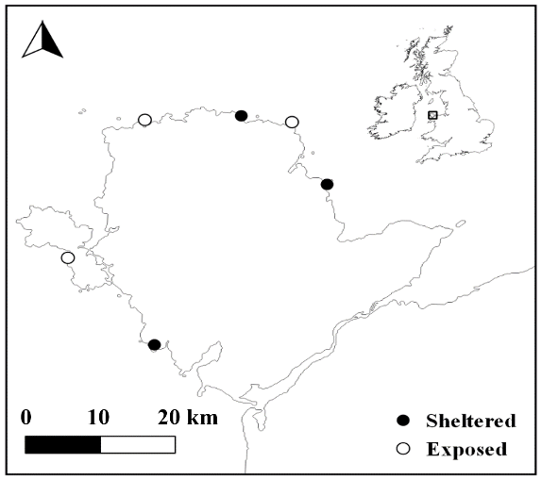

Figure 3.1 Map of study sites across the Isle of Anglesey, Wales, UK. Open circles = Exposed sites, closed circles = sheltered sites.
Nucella breed throughout the year, but peaks in early spring in North Wales (Crothers 1985, Morton 2009). They are internal fertilisers and reproduce by forming breeding aggregations. Egg capsules clutches are then deposited (100s per aggregation) in crevices and on the underside of rocks, with each egg capsule containing between 5-30 fertilised embryos (Pechenik et al. 1984). Unsexed adult Nucella (150 – 200 individual) were collected from each site, placed in site-specific breeding tanks (transparent plastic 1 x 1 x 0.6 m tubs) and provided with barnacle covered rocks as a food source ad libitum for a period of 4 months (Dec 2017-March 2018). In March 2018, over a 2-week period Nucella from all 6 sites formed breeding aggregations and deposited egg masses on the walls of the tanks and the undersides of rocks. Egg capsules were carefully removed from the tanks using a scalpel and 8 capsules were transferred to each replicate mesocosms where they were exposed to different predation risk regimes. Egg capsules were checked every two days and upon emergence (~ six weeks), a subsample of hatchlings were used to estimate offspring emergence size of each treatment combination. Offspring were provided with food and refuge, i.e. with rocks covered in newly recruited barnacles, followed by progressively larger barnacles as they grew, and held under the various treatments for eight months. Due to the large numbers and the diminutive size of hatchlings the monitoring of mortality rates was unfeasible. Tanks were housed in a temperature-controlled room, in a flow through system reflecting ambient water temperatures and on a 12:12 light dark cycle.

Risk Manipulation
Risk was manipulated by placing a large male crab (mean carapace length ± SD = 56.6 ± 4.8 mm) into a perforated “crab pot” (500 ml), that was then placed in each mesocosm. For the no risk regime, crab pots remained empty for the entire eight-month period. Crab pots for the constant risk treatment contained a crab for the entirety of the experiment, with crabs being used for a maximum of four days before being replaced. In the variable risk regime, Nucella were exposed to a predatory cue for 50% of the time with a crab being added or removed from the crab pot every three or four days. The combination of offspring from 6 shores (3 wave-exposed and 3 wave-sheltered) and 3 predator treatments resulted in 18 treatment combinations (n = 6 replicates for each treatment combination).

Data collection

Growth
Within two days of hatching, images were captured and used to measure the maximum shell length (±0.01 mm) of hatchlings as an estimate of size at emergence (ImageJ image analysis, Abramoff et al. 2004). A total of 422 hatchlings were measured across all treatment combinations, although sampling between treatments was not even (wave-exposed = 165, wave-sheltered = 262, see table S1 for n per treatment combination). At the end of the experiment the shell lengths of individuals (total n = 830) were measured again using vernier calipers (±0.1 mm). However, although previously used as a proxy for growth in other gastropods (Trussell et al. 2017), total shell length has been shown to be a poor predictor of tissue growth in Nucella lapillus (Palmer 1990, Pascoal et al. 2012a), as shell shapes and thickness vary greatly depending on local biotic and abiotic conditions. We therefore compared the tissue and shell mass of a subsample of Nucella from each treatment combination. Comparisons could then be made of shell mass per unit tissue mass which provides a reliable index for the relative commitment of resources to shell defence (Palmer 1990). Wet body weight and shell weight were measured by carefully cracking and removing Nucella shells, blotting dry before weighing the shell and tissue separately (±0.001 g).

Energetic state analysis
To determine the energy budgets of Nucella offspring, we used the Cellular Energy Allocation (CEA) technique. This assay has been used previously to investigate seasonal and environmentally driven changes in energy reserves as well as to test the effects of long-term exposure to abiotic (Beyer et al. 2013, De Troch et al. 2013, Van Dievel et al. 2019b) and biotic factors (De Troch et al. 2013) including predation (Tigreros et al. 2018, Van Dievel et al. 2019b). CEA analysis was conducted on whole-animal samples and is defined as the ratio of energy reserves available (E_{a}, measured as the combined energy stored in total proteins, lipids and carbohydrates) to energy consumption (E_{c}, determined through the activity of the Electron Transport System in the mitochondria). Bioassays followed the protocol used by De Coen & Janssen (1997) with slight modifications described below.
Owing to the small body size of Nucella and the amount of tissue needed for the complete CEA analysis, samples consisted of the whole-body homogenates of two Nucella individuals combined. The original 6 replicate mesocosms of each treatment combination were therefore aggregated into 3 pairs at random and only Nucella from pairs of mesocosms were combined. Frozen snails were homogenised in liquid nitrogen using a pestle and mortar resulting in a well-mixed fine powder. Each homogenate combination was then split into a total of 12 subsamples (10-20 mg) and triplicates were used in each of the four subsequent biochemical assays.
In brief, protein content of the sub-samples was determined by using a micro-modification of the Pierce BCA Protein Assay (Thermo Scientific). Total lipid content was measured using a modified sulpho-phospho-vanillin (SPV) assay, originally described by Bligh and Dyer (1959) and modified for microplates (Torres et al. 2007) against cholesterol as a standard. Finally, total carbohydrate content was determined using a modified (Leyva et al. 2008) anthrone-sulphuric acid assay (Roe 1954) for marine invertebrates using glycogen as a standard.
To estimate the Energy consumption (Ec) or cellular respiration rates, we measured the activity of the electron transport system (ETS) using the methodology provided by Owens and King (1975) and modified by Smolders (2004). An extinction coefficient of 15,900 M⁻¹ cm⁻¹ was used to determine the amount of formazan produced during the ETS reaction. Formazan was subsequently converted into Ec, assuming that for every 2 μmol of formazan formed, 1 μmol of O₂ was consumed (De Coen and Janssen 1997). The quantity of O₂ consumed was subsequently converted into energy equivalents using the oxyenthalpic equivalents for an average mixture of protein, carbohydrate and lipids of 480 kJ/mol O₂ (Gnaiger 1983). Individual energy reserve fractions were then converted to their energetic equivalents using their combustion energy values (Gnaiger, 1983): protein 24,000 mJ mg⁻¹, lipid 39,500 mJ mg⁻¹, and glycogen 17,500 mJ mg⁻¹. Total available energy (E_{a}) was calculated by adding the three energy fractions and energy consumption (E_{c}) was estimated as ETS activity. Cellular respiration rate was calculated as the ratio of available energy to energy consumption (E_{a}/E_{c}), which reflects the energy status of an organism at the cellular level.

Data Analysis
We tested the influence of developmental experience of predation risk and parental habitat (wave-exposed vs wave-sheltered) on emergence size, growth as well as the energy budget of Nucella after eight months. Nucella growth was split into three response variables: shell length, tissue mass and tissue mass per unit shell mass. The latter two variables were log transformed prior to analysis. Energy budgets were analysed by comparing the energy fractions of proteins, lipids and carbohydrates, the total energy available, energy consumption (ETS activity) and the resulting CEA of the offspring generation. Parental habitat and developmental experience of risk were fully crossed fixed factors, and site (i.e. a specific wave-exposed or wave-shelter shore) was nested within the parental habitat. To account for potential unequal variances between treatment combinations, we used the REML-weighted variance estimates developed by Zuur et al. (2009). Once the variance structure was identified, it was used throughout the rest of the model selection process. We used backward model selection, by removing terms from the full model and selecting the most parsimonious model with the lowest AIC score. All analyses were constructed in R 3.5.0 (<www.r-project.org>, Studio 2012) using the lme4 package (Bates et al. 2013). When interaction terms were significant at the α = 0.05 level, the lsmeans package was used to conduct Tukey post hoc tests (Lenth 2016).

Results
Analysis of the images of hatchlings revealed no influence of parental habitat or developmental experience of risk on the size at emergence of Nucella (lm, F= 1.75, p = 0.17, Fig. 3.2). However, parental habitat and developmental experience of risk influenced the final total shell length of Nucella (lm, F= 8.68, p <0.001, Fig. 3.3). In both wave-sheltered and wave-exposed offspring the no risk treatment resulted in greater final total shell lengths than under constant risk. However, the variable risk treatment resulted in growth rates equivalent to no risk in exposed shore offspring but equivalent to constant risk in the sheltered shore (Fig. 3.3 A). Nucella log-tissue mass did not vary between treatments, with only Nucella from wave-exposed parents reared under the constant risk treatment showing significant reductions in tissue mass (Fig. 3.3 B). Finally, the relative investment in shell and tissue (shell mass per unit tissue mass) by Nucella differed depending on the developmental experience of risk (lm, F= 8.68, p <0.001). As the experience of risk increased (no risk < variable risk < constant risk), log-shell mass in Nucella increased relative to log-tissue mass (Fig. 3.3 C), demonstrating an increase in the relative investment in shell defence.

Sheltered shore
Exposed shore
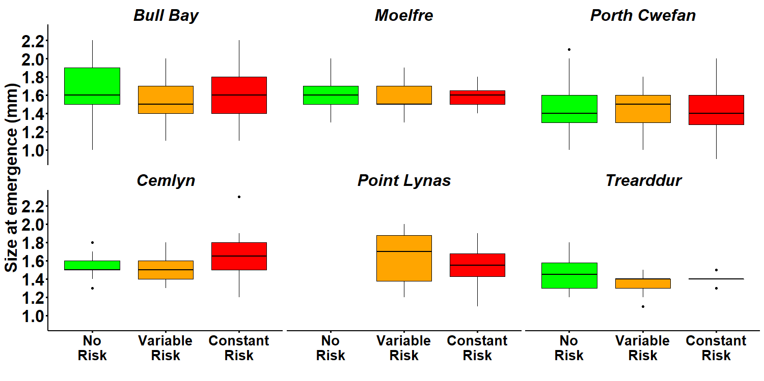
N.D.

Figure 3.2 Emergence size (maximum shell length) of Nucella hatchlings from wave-exposed and wave-protected sites reared no risk (green), variable risk (orange) and constant risk (red) treatments. Boxplots represent medians with 95% confidence intervals. ND = No Data

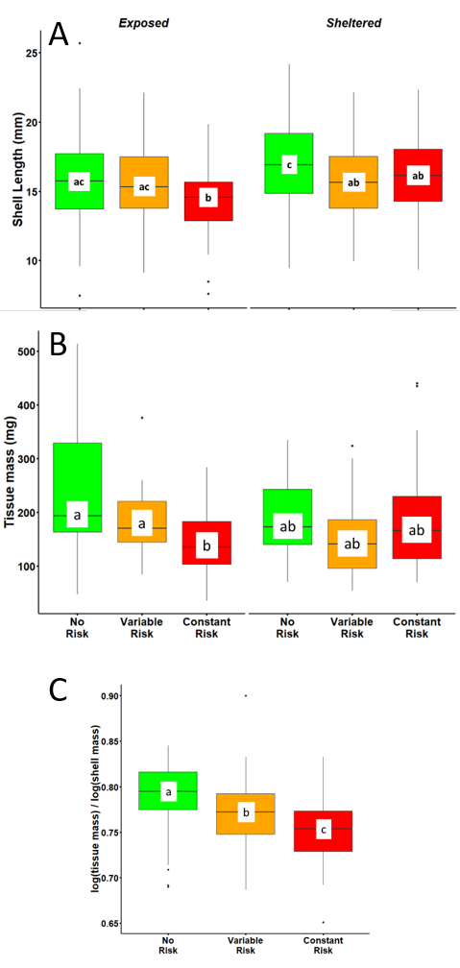

Figure 3.3 a) Shell length b) tissue mass and c) shell mass per unit tissue mass of the offspring generation of dogwhelks (Nucella lapillus) from wave-exposed and wave-protected sites reared no risk (green), variable risk (orange) and constant risk (red) treatments. Values are means ±SE. Different letters indicate significant differences (Tukey’s HSD, α=0.05).
Analysis of the effects of parental habitat and developmental experience of risk revealed different responses for each of the three energy reserve fractions: protein, lipid and carbohydrate. For protein content there was a significant interaction between parental habitat and developmental experience of risk (Table 3.1, Fig. 3.4 A). Total protein content was 12% higher in the constant risk treatment for wave-exposed offspring than in the other two treatments, but wave-sheltered offspring showed a different pattern, with total protein energy reserves highest in the no risk treatment (Fig. 3.4 A). Lipid energy reserves were not affected by developmental experience of risk but there was a significant effect of parental habitat (F= 23.37, p < 0.01); across all developmental risk treatments wave-exposed Nucella had 29% less energy stored as lipids compared to wave-sheltered offspring (Fig. 3.4 B). Finally, carbohydrate energy reserves showed a significant main effect of developmental risk, which was consistent across wave-exposed and wave-sheltered populations (Table 3.1). The highest carbohydrate energy reserves were found in Nucella reared under the no risk treatment, with those in the variable risk and constant risk treatments recording 12% and 14% less energy stored as carbohydrate, respectively (Fig. 3.4 C).
Across all treatments, the highest contribution to total energy availability of Nucella came from proteins (53%), followed by lipids (31%) and finally carbohydrates (16%). When all the energy fractions were combined into total energy reserves i.e. E_{a}, there was no effect of risk treatment (Table 1), but a clear significant effect of parental population (lm, F= 21.39, p = 0.009, Fig 5 A). Nucella from wave-exposed populations had 12.5% lower overall energy availability than offspring from wave-sheltered populations. Analysis of the electron transport system revealed no difference in the energy consumption (E_{c}) of Nucella across all treatment combinations (Table 1, Fig 5 B). Despite differences in Nucella E_{a} between treatments, CEA analysis showed no differences in the cellular energy budgets of Nucella between treatments, although wave-exposed parents tended (lm, F= 6.25, p = 0.066, Fig 5 A) to produce offspring with a lower CEA than their wave-sheltered counterparts (Fig 5 C). On closer inspection, results showed that both Nucella ETS and CEA were affected by developmental experience of risk, but responses differed at the site level (Fig.6). Contradictory patterns of ETS and CEA between sites nested within each parental habitat resulted in no overall effect of developmental risk treatment.

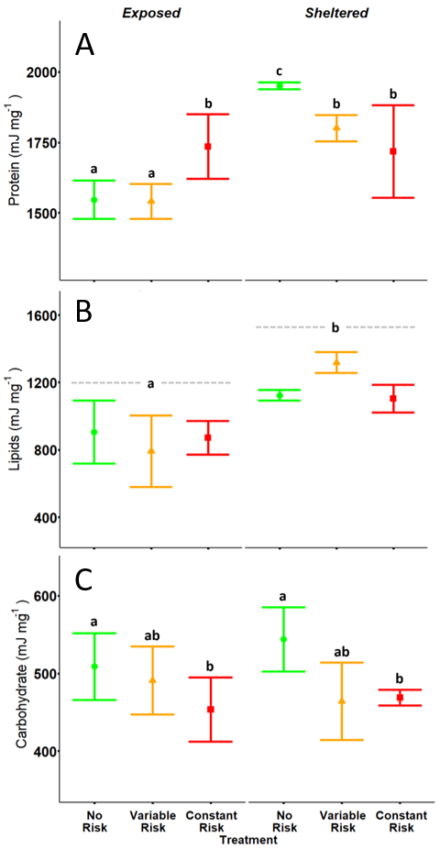

Figure 3.4 The energy equivalents of total (A) Protein, (B) Lipids and (C) Carbohydrate of dogwhelk (Nucella lapillus) offspring from wave-exposed and wave-protected parents reared under no risk (green circles), variable risk (orange triangles) and constant risk (red squares) treatments. Values are means ±SE. Different letters indicate significant differences (Tukey’s HSD, α=0.053).
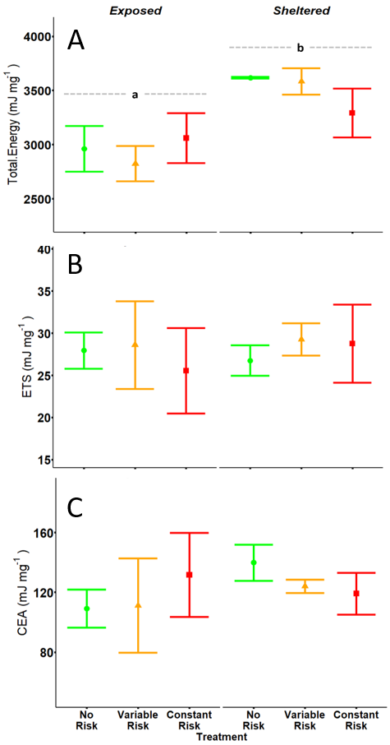

Figure 3.5 Cellular energy budgets including the components: (A) total energy available (Ea); (B) total energy consumption (Ec); and (C) CEA of dogwhelk offspring (Nucella lapillus) from wave-exposed and wave-protected parents reared under no risk (green circles), variable risk (orange triangles) and constant risk (red squares) treatments. Values are means ±SE. Different letters indicate significant differences (Tukey’s HSD, α=0.05).

Table 3.1 Summary of full model results from GLMs of protein reserves, lipid reserves, carbohydrate reserves, total energy, electron transport system (ETS) activity, the cellular energy allocation (CEA), shell length (SL), tissue mass (TM) and SL:TM of wave-exposed and wave-sheltered offspring of Nucella lapillus reared under different risk treatments.
Response variable Effect Df F P
Size at emergence Parental habitat 1 0.59 0.484
Develop risk 2 1.87 0.156
Ph x Dr 2 1.95 0.144
Error 421 2352.51

Protein reserves Parental habitat 1 11.47 0.028
Develop risk 2 1.70 0.190
Ph x Dr 2 5.83 0.005
Error 62 6479.45

Lipid Reserves Parental habitat 1 24.13 0.008
Develop risk 2 0.017 0.983
Ph x Dr 2 1.84 0.169
Error 62 806.35

Carbohydrate Parental habitat 1 0.030 0.871
reserves Develop risk 2 3.2963 0.045
Ph x Dr 2 0.471 0.627
Error 62 1520.175

Total Energy Parental habitat 1 21.39 0.009
Develop risk 2 0.776 0.465
Ph x Dr 2 3.100 0.054
Error 62 4481.10

ETS Parental habitat 1 0.0277 0.876
Develop risk 2 0.138 0.871
Ph x Dr 2 0.3814 0.685
Error 62 995.53

CEA Parental habitat 1 0.0154 0.307
Develop risk 2 0.065 0.938
Ph x Dr 2 1.356 0.267
Error 62 860.53

Shell length Parental habitat 1 3.89 0.119
Develop risk 2 16.37 <0.001
Ph x Dr 2 8.68 <0.001
Error 819 2601.03

Tissue mass Parental habitat 1 0.151 0.717
Develop risk 2 4.458 <0.013
Ph x Dr 2 5.35 <0.006
Error 153 4286.55

Tissue: Shell Parental habitat 1 2.04 0.227
Develop risk 2 20.88 <0.001
Ph x Dr 2 2.61 <0.077
Error 153 42706.9

Results may vary slightly after model selection, but the significance of any factors or factor combinations remains unchanged. Statistically significant effects (α = 0.05) are in bold. Discussion
As expected, predation risk influenced the growth and energetic budget of the offspring generation of Nucella, but its effect was strongly influenced by parental habitat. Contrary to our expectations, Nucella offspring from both wave-exposed habitats emerged from their egg capsules at the same size. This indicated that any differences in shell growth recorded at the end of the eight-month exposures are not attributed to initial differences in size of offspring. Nucella shell length at the end of the investigation was affected by both parental habitat and developmental risk, although differences in Nucella tissue were only present in wave-exposed Nucella reared under constant risk. Interestingly, however, our results clearly show that Nucella allocated resources to tissue growth and shell deposition in accordance with the developmental risk they experienced. The ratio of tissue mass to shell mass of Nucella was highest in the no risk treatment, lowest in the constant risk treatment and intermediate ratios were recorded in the variable risk treatment, indicating an increase in commitment of resources to defence (shell deposition, Palmer 1990; Pascoal et al. 2012b) potentially related the amount of time Nucella are exposed to predatory cues. Energy consumption (ETS activity) and overall energy budget (CEA) remained the same across all treatment combinations, with only wave-sheltered offspring showing a trend (p = 0.066) in having higher CEA than that of wave-exposed Nucella; mainly driven by differences in the total energy availability in Nucella from each parental habitat. Predation risk did however, impact individual energetic fractions of offspring. Proteins levels for wave-exposed and wave-sheltered offspring were influenced by developmental risk, although this was not reflected in total energy availability, despite proteins accounting for half the energy reserves in Nucella. Possible differences in carbohydrate and lipid levels between treatments may have obscured the influence of developmental risk in Nucella total energy availability. Overall, our results demonstrate that parental effects can combine with individual experience of risk, to influence energy budgets and define important growth metrics of offspring from wave-exposed and wave-protected populations of Nucella.
All Nucella hatchlings emerged at the same size, irrespective of parental habitat or the risk they were exposed to while still in the egg capsule. Previous findings have shown that egg capsules collected from wave-exposed shores contain smaller and more numerous hatchlings than their wave-sheltered counterparts (Etter 1989, Donelan and Trussell 2019). These conflicting results may highlight the important role played by predation risk just prior to breeding, as in the current study Nucella reproduced under no risk and in relatively benign laboratory conditions. Despite no differences in initial shell size (size at emergence), Nucella final shell length was influenced by the pattern of predation risk they experience during development, with offspring from the two parental habitats responding differently. Although as with previous studies (Palmer 1990, Bourdeau 2010, Pascoal et al. 2012a) there was a negative effect of predation risk on shell length of both wave-exposed and wave-sheltered populations, shell lengths in the variable treatment responded differently for each parental habitat. Offspring of low predation pressure wave-exposed parents reared under the variable risk treatment had shell lengths similar to those exposed to no risk. On the other hand, offspring of high predation pressure populations in the variable risk treatment reach shell lengths comparable to those reared under constant risk. In each case it would seem that when Nucella are exposed to variable (and potentially unpredictable) predation risk, they attain shell lengths that are influenced by parental experience of local predation pressure levels. Furthermore, although it is unclear whether these threat-sensitive adaptive responses are achieved through behavioural or physiological compensation, or a combination of both, results show that growth in Nucella may be influenced by parental effects (Etter 1996, Beckerman et al. 2007, Thaler et al. 2012).
The influence of predation risk on the comparative rate of shell deposition and tissue growth is well-documented in Nucella lapillus (Palmer 1990, Pascoal et al. 2012a). In the current study, Nucella tissue growth remained relatively constant for all treatments, with only significant reductions in tissue mass recorded for wave-exposed Nucella reared under constant risk. However, comparisons of the shell mass per unit tissue mass clearly show that relative shell deposition in Nucella may be threat sensitive. Relative shell deposition of both parental habitats was higher when Nucella were exposed to risk than for predator naïve offspring. While these results confirm previous findings (Palmer 1990, Trussell and Nicklin 2002, Bourdeau 2010), results of our variable risk treatment also reveal new insights into the influence of predation risk on the commitment of resources to defence in Nucella. Offspring exposed to variable risk allocated an intermediate amount of resources into shell deposition compared to those in the no risk and constant risk treatments. It is not yet clear whether increases in shell deposition in gastropods are a direct result of the chemical cues released by crabs or as a result of reductions in foraging under elevated predation risk conditions (Trussell and Nicklin 2002, Trussell et al. 2003, Brookes and Rochette 2007, Bourdeau 2010, Pascoal et al. 2012a). Although our results are unable to shed more light on this issue, they do indicate that there is a temporal link between the amount of time spent under risky conditions and the relative amount invested in shell defences.
Predation risk influenced energetic budget of Nucella, with responses of offspring effected by parental habitat. Energy consumption (E_{c}) results showed that ETS activity was the same for all Nucella offspring, indicating that the energy demands at the cellular level did not differ for offspring irrespective of treatment combination. This finding contrasts with those of previous studies showing that predation risk is able to alter the energy consumption of prey (Huuskonen et al. 1997, Steiner and Van Buskirk 2009, Hawlena and Schmitz 2010b, Barry and Syal 2013), including that of Nucella (Karythis et al. 2020). However, despite no significant overall impact on E_{c}, predation risk did influence the E_{c} of offspring, but responses were different at the site level. Contradictory patterns between sites nested in the same habitat may have obscured the treatment effects. The metabolism (energy consumption) of intertidal invertebrates can be influenced by food availability (Shick et al. 1988), thermal stress (Tomanek and Somero 1999, Sanford 2002) as well as wave driven mechanical stress (Donovan and Taylor 2008), therefore, different metabolic responses to predation risk at site level may not be so remarkable. Despite results indicating an influence of parental habitat on the total energy available (E_{a}) to Nucella, contradictory patterns in E_{c} also resulted in similar overall CEA results of Nucella offspring. Therefore, despite the impacts on E_{a}, cellular energy budgets were unaffected by offspring experiences of risk or parental habitat. E_{a} was lower for wave-exposed offspring than for sheltered-shore Nucella and was mainly driven by differences in protein and lipid reserves. Further examination of the energy fractions of E_{a}, however, did reveal some interesting differences, with potential implications for individual fitness discussed below. Our results indicate that Nucella from both wave-exposed and sheltered populations respond and adapt their growth and cellular energy budgets to different temporal patterns of predation risk, but responses may vary between sites.
The predatory risk regime Nucella offspring were exposed throughout their development influenced how Nucella utilised individual energetic fractions, but its effect differed depending on parental habitat. The two most energetically important fractions, protein and lipids, were both influenced by parental habitat. Previous studies have shown that these two energy reserves play important roles in the life history of Nucella (Stickle 1975, Etter 1989) and this may help explain the adaptive potential for parental effects to play a role in their utilisation. For instance, Nucella spp. utilise protein catabolism to respond to their energetic demands (Stickle 1975), with a closely related species Nucella lamellosa using energy stored as proteins to provide up to 85% of the energy they require during periods of fasting (Stickle and Bayne 1982). Lipids on the other hand play a pivotal role in the reproductive strategy of Nucella, with most of the energy invested in egg production coming from lipid reserves (Etter 1989). These habitat differences in lipid reserves may reflect the ability of parental experience to influence the different reproductive strategies of populations at each wave exposure (Crothers 1974, Etter 1989). As wave-exposed Nucella produce four times more offspring than individuals on wave sheltered shores (Etter 1989), parental effects on the utilisation of lipids will ultimately affect the reproductive success of their progeny. Only carbohydrate energetic reserves were not influenced by parental habitat, with levels responding negatively to the amount of time Nucella spent under risk during development (Fig. 3C). As carbohydrates accounted for just 16% of energy reserves in Nucella and generally serve as a dynamic energetic reserve used in many prey, the lack of a parental habitat effect is to be expected. Although necessarily speculative, due to the complex nature of energy use in Nucella (Stickle and Bayne 1982, 1987, Chu et al. 2014), our results indicate that parental experience in Nucella is able to inform offspring of how best to utilise different energetic reserves in relation to the probable conditions they may encounter.

Parental and individual experience of predation risk informs short-term antipredator responses in the dogwhelk, Nucella lapillus.
CHAPTER FOUR

Parental and individual experience of predation risk informs short-term antipredator responses in the dogwhelk, Nucella lapillus.

Abstract
How prey respond to the detection of a predator will ultimately affect their chances of survival. Many behavioural antipredator responses of prey are plastic, enabling prey to learn from previous experience increasing their chance of surviving future encounters. Furthermore, when the risk experienced by parents is predictive of that faced by their offspring, many prey can influence the antipredator traits of their offspring, through parental effects. The dogwhelk Nucella lapillus inhabits rocky intertidal sites along a wave-exposure gradient which in turn controls local abundances of the crab predator, Carcinus maenas, resulting in populations being subject to different predation pressure. In this study I exposed the offspring generation of wave-exposed and wave-sheltered dogwhelks to different patterns of risk throughout development and then investigated their short-term responses to crab effluent. As expected, dogwhelks were less likely to move when exposed to a predatory cue, although the risk experienced throughout development and parental habitat did not influence this response. We found no impacts of parental habitat or development risk on the distance dogwhelks travelled or on the likelihood of choosing a refuge. However, the pattern of risk experienced throughout development did influence the frequency with which Nucella crawled above the water line rather than hiding under a hard substrate refuge. The overall similarity in the response of Nucella offspring from wave-exposed and wave-sheltered parents, may reflect habitat specific behavioural constraints brought about by contrasting biotic and abiotic factors. These findings suggest that it is important to appreciate the dynamic nature of antipredator responses if we are to understand the impacts predators have on prey and their ecosystem.

Introduction
The responses of prey to the threat of predation have a profound implications for prey fitness. Along with morphological defences, prey utilise avoidance and escape behaviours to evade predators, which can typically include shifts in speed and direction, as well as changes of microhabitats and the use of refuges (Chivers and Smith 1998, Wirsing et al. 2010, Hawlena et al. 2011, Donelan et al. 2017). In marine gastropods both morphological and behavioural responses to the risk of predation are common. Apart from the ubiquitous development of more robust shells to better withstand crushing by predators (Hughes and Elner 1979, Appleton and Palmer 1988, Trussell and Nicklin 2002, Edgell and Neufeld 2008), many gastropods also respond behaviourally to the detection of predators, by reducing activity and seeking the safety of a refuge (Fairweather 1988, Donelan et al. 2017). To enable prey to respond to changes in predation risk many antipredator responses are plastic, allowing for previous experiences of predation risk to inform future behaviour (Mery and Burns 2010). For example, when juvenile whelks (Buccinum undatum) were initially exposed to cues from the predatory asteroid Leptasterias polaris they showed weak antipredator responses, with no whelks adopting foot contortion, the strongest antipredator response to asteroids (Rochette et al. 1998). However, after a short exposure (30 minutes) to predatory cues over four consecutive days, an increase in the overall intensity of antipredator response was observed with foot contortions seen in 25% of responses. Slight changes in individual behaviours can have significant impacts on predator-prey dynamics (e.g. vertical distribution of gastropods in response to predation risk, Phillips, 1976) and hence have important effects on community-level processes.
The intertidal dogwhelk Nucella lapillus (hereafter Nucella), has been used extensively to investigate the influence of predation risk on the antipredator traits of prey (Trussell et al. 2006b, Johnston et al. 2012, Large and Smee 2013). Nucella detect chemical cues from the green shore crab Carcinus maenas which enhance both morphological (Hughes and Elner 1979) and behavioural (Vadas et al. 1994) antipredator traits in response. In addition to developing thicker shells when exposed to crab kairomones several studies have shown, that Nucella also alter their activity under risky conditions (Large and Smee 2010, 2013, Large et al. 2011, 2012). For example, when Large and Smee (2010) exposed Nucella to crab effluent their activity (mean number of movements) was reduced by up to 40% when compared with controls. As with other gastropods, in addition to reducing activity, Nucella also change their use of microhabitats to hide from predators. In response to risk, Nucella are not only more likely to seek refuge out of the water (Vadas et al. 1994), but will also choose the safety of a rock refuge more often as well (Feare 1971, Burrows and Hughes 1989, Matassa et al. 2016). However, reductions in activity and the increased use of refugia by Nucella in response to risk can also be affected by the risk experienced by their parents. Donelan and Trussell (2015) exposed parental couples of Nucella to predatory crab cues for 10 weeks and then tested the antipredator responses of the resulting offspring. They showed that exposure of parental couples to risk reduced the sensitivity of offspring to predation risk. By increasing the amount of time, the offspring spent in risky habitats, they increased the number of barnacles consumed which resulted in increased growth from predator exposed parents. Moreover, in a later study the same authors exposed Nucella to predation risk while they were still in the egg capsule, resulting in hatchlings from some populations emerging at smaller sizes and with higher growth efficiencies than for predator-naïve hatchlings (Donelan and Trussell 2019). These studies indicate that understanding the drivers of how and why prey respond to predation risk differently in different contexts can be complex.
Predictable environmental differences have a major impact on the interaction between predators and prey (Menge 1976, 2000). This has been demonstrated in Nucella across gradients of wave action. As wave action increases on rocky shores, predatory crab abundance declines (Hughes and Elner 1979, Large and Smee 2013, Karythis et al. 2020) and hunting and handling efficiency is reduced (Robinson et al. 2011). The combined effect is a reduction in the levels of predation pressure on wave-exposed populations (Menge et al. 1987, Large and Smee 2013). Such differences in localised predation pressure, apart from being reflected in the shape and thickness of Nucella shells (Pascoal et al. 2012a, 2012b), have implications for their antipredator behaviour as well. For example, Large and Smee (2013) tested the short-term responses of Nucella from both wave-exposed and wave-protected sites, and observed that although all Nucella showed behavioural responses (reduction in movements) to the presence of predatory crab cues, the response was more intense in individuals from sheltered shores where predator abundances are higher. This difference in the behavioural response of Nucella from exposed and sheltered populations are not universal however, with several studies indicating that the two populations respond equally to the presence of a predatory crab cue (Palmer 1990, Freeman et al. 2014, Dernbach and Freeman 2015). A greater understanding of how prey from high and low predation pressure habitats respond to predation risk is necessary in order to fully appreciate the ecological importance of predation risk.
In this study we investigated the influence of parental experience of risk (through the use of adults sourced from populations differing in predation pressure) and developmental experience of risk (through rearing offspring under different risk regimes) on the short-term behavioural response of Nucella. We first reared the offspring generation of Nucella from different parental habitats (wave-exposed and wave-sheltered populations) under three developmental risk regimes and then conducted a short-term behavioural assay to see how they responded to a predatory cue from the crab Carcinus maenas. Nucella were reared under no risk, constant risk and variable risk conditions. Despite the predictable differences in predation pressure between wave-exposed and wave-sheltered sites, the predation risk faced by prey in each habitat is not constant but instead varies spatially and temporally (Feare 1970, Brown et al. 1999, Lima and Bednekoff 1999, Gallagher et al. 2017). Therefore, rearing Nucella under variable risk should provide a more reasonable insight into the development of antipredator traits. Short-term behavioural assays were conducted by adding crab effluent or filtered seawater to an experimental mesocosm and then assessing the propensity of offspring to express antipredator behaviours. We initially recorded if Nucella moved or remained still in response to the addition of a predatory cue, and for those that moved, measured the distance covered. Finally, we recorded if Nucella chose to seek refuge in response to a predatory cue as well as determining the type of refuge selected.

Methods

Nucella collection and breeding
Adult Nucella were collected in December 2017 from three wave-exposed and three wave-sheltered sites, located around the coast of Anglesey, North Wales, UK (Fig.4.1). The selected sheltered and exposed sites show clear differences in their wave exposure level (Karythis et al. 2020) based on their average wave fetch (Burrows, Harvey, & Robb, 2008). In addition, previous work has shown that these sites also differ in their crab abundances (Karythis et al. 2020), with the selected wave-sheltered sites recording crab abundances as much as 40 times higher (41.22 ± 17.43 SD crabs per trap) than those recorded at exposed sites (0.89 ± 1.27 SD crabs per trap). Once collected, Nucella (n=200) were placed into site-specific tanks, on a 12:12 light dark cycle. Water temperatures reflected local ambient seawater temperatures and Nucella were provided with barnacle-covered rocks as food ad libitum. Nucella breeding peaks in March around the coast of North Wales (Crothers 1985, Morton 2009), when snails form large reproductive aggregations (100s of individuals) and lay egg capsules in crevices and under rocks. Egg capsules contain an average of 30 fertilized embryos which are accompanied by hundreds of nurse eggs (Pechenik et al. 1984). Under laboratory conditions, Nucella formed breeding aggregations in February and egg capsules were deposited by Nucella from all 6 sites within a 2-week period in mid-March.

Risk Regimes
Egg capsules from each of the six sites were randomly assigned to a no risk, a variable risk or a constant risk regime resulting in a total of 18 treatment combinations (n = 6 mesocosm replicates per treatment combination). Using a scalpel blade, egg capsules were carefully removed, and 8 egg capsules were randomly assigned to one of the three risk regimes. Hatchlings were initially provided with rocks, covered in newly-recruited barnacles, and then subsequently with larger barnacles as they grew in size. In addition to food, the rocks provided a refuge throughout the rearing period. Behavioural assays were conducted after an 8 month rearing period, when snails were not yet sexually mature (Hughes et al. 1992) but still remaining vulnerable to crab predation (Hughes and Elner 1979), as these factors may have influenced behavioural responses (Clark 1994, Karythis et al. 2020). Risk exposure was manipulated by the addition, to individual mesocosms, of a perforated crab pot which housed a large male crab (mean carapace length ± SD, 56.6 ± 4.8 mm). Housing crabs in such pots allowed the free dispersion of kairomones without allowing predators direct access to Nucella. Under the no risk regime crab pots remained empty, whereas under the constant risk regime crabs were present throughout the experiment. For the variable risk regime, crabs were added and removed from the crab pot every three or four days, resulting in Nucella in this regime being exposed to risk for 50% of the time. In the variable and constant risk treatments, crabs were held in the crab pots for a maximum of 4 days and only used once before being released.

Figure 4.1 Map of study sites across the Isle of Anglesey, Wales, UK. Open circles = Exposed sites, closed circles = sheltered sites.

Behavioural assay
To assess the influence of parental habitat and developmental experience of risk on the short-term antipredator behavioural responses of Nucella, we conducted a series of behavioural assays in the presence and absence of a predatory cue. A total of 108 Nucella (6 for each treatment combination) from wave-exposed and sheltered sites, reared under the three risk regimes were starved for two days prior to beginning the behavioural assays. Individual Nucella were placed in the centre of an experimental mesocosm (30 x 20 x 10 cm) with a rock refuge at one end and allowed to acclimatise for five minutes. After acclimatisation, the predator treatment was introduced to the experimental mesocosm by adding 500 ml of filtered seawater (control) or crab effluent. The predator treatment was introduced to the same area of the mesocosm each time and was non-directional. Crab effluent was prepared by adding 8-10 large male crabs to 20 l of aerated seawater for one hour.
Following introduction of the predator treatment, an initial observation was taken to record whether Nucella chose to move or to remain still. The exact position of Nucella within the mesocosm was then recorded every three minutes for a total of 21 minutes. This was then used to calculate a proxy for the total distance moved, by measuring the distance between each successive position. Nucella were then left for a further 30 minutes before their final position was recorded. Final position was recorded as: in the water (unsafe), in the rock refuge (safe) and out of the water (Air refuge, safe). After each assay, animals were returned to their original mesocosms where exposure to the long-term risk regime (developmental risk) continued. Assays were repeated on the same individual a total of ten times over consecutive days: 5 in filtered seawater and 5 in crab effluence. The order in which individuals were exposed to crab effluent or controls was selected at random. Nucella were not fed throughout the experimental period and therefore we included trial day in our analysis to account for the effects of increases in hunger.

Data Analysis
Data was analysed using R 3.5.0 (Studio 2012) using the lme4 package (Bates et al. 2013). Using the backward selection of GLM models, we tested the influence of parental habitat (wave-exposed and wave-sheltered), developmental experience of risk, predator treatment and their interaction on the short-term decision making of Nucella. Behaviour was assessed by considering four response variables: i) initial response (moved or not moved), ii) distance travelled, iii) final position (safe or unsafe) and iv) refuge type (rock or air). In addition to the four response variables, we used Nucella ID, trial day and experimental mesocosm as random factors, and site as a nested term within parental habitat. Backwards model selection was employed to determine the most parsimonious model with the lowest AIC, by removing terms from the full model. Any interactions which were found to be significant were then analysed using the Tukey post hoc test (lsmeans package Lenth, 2016).

Results
In total 1080 behavioural assays were conducted, and they showed that exposure to a predatory cue in our short-term experiment affected Nucella responses. Nucella were less likely to move when exposed to crab effluent than when exposed to filtered seawater (Fig. 4.2, binomial GLM, F = 7.08, p < 0.001). Model selection revealed that the likelihood of moving was not affected by parental habitat or by developmental experience of risk (Table 4.1). Despite predator treatment influencing the decision of Nucella to move, once the decision was taken the total distance travelled was the same across all treatment combinations (Table 1, Fig. 4.3).

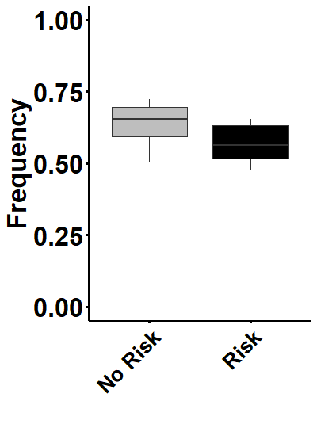

Figure. 4.2 Frequency with which individual Nucella lapillus moved in response to the addition of filtered seawater (No risk) and effluent from the green shore crab, Carcinus maenas (Risk). Boxes indicate the 25th and 75th percentiles (whiskers 1.5 x interquartile range) and the median (horizontal line within each box. All individual (n=108) were exposed to control and predator conditions 5 times each.
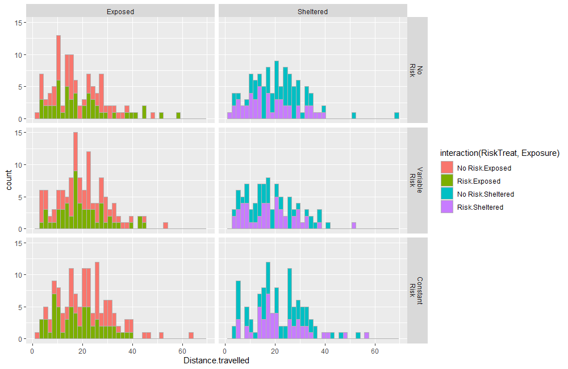

Figure. 4.3 Distance travelled by Nucella lapillus in response to the addition of filtered seawater (No risk) and effluent from the green shore crab (Risk). All individual (n=108) were exposed to control and predator conditions 5 times each.

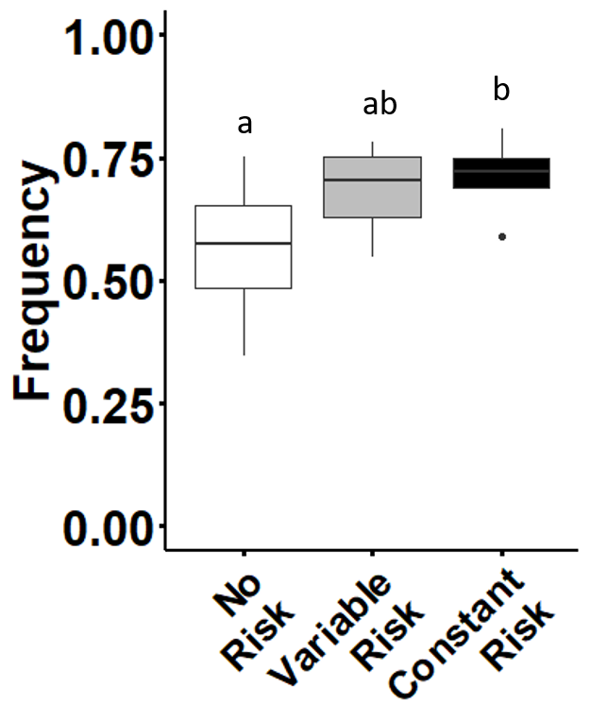

Figure. 4.4 Frequency with which individual Nucella lapillus chose to move above the waterline depending on the developmental exposure to risk. . Boxes indicate the 25th and 75th percentiles (whiskers 1.5 x interquartile range) and the median (horizontal line within each box. All individual (n=108) were exposed to control and predator conditions 5 times each. Letters indicate results from the Post hoc Tukey’s HSD.

Of all the instances (60.67 % of all trials) in which Nucella moved from their initial position, in 88 % of cases, snails chose the safety of a refuge as their final position rather than remaining in the open and exposed to a potential attack. None of the factors tested here influenced the choice of Nucella to seek safety (Table 4.1). However, further analysis into the types of refuge selected by Nucella, revealed that the risk regime they were exposed to throughout development impacted their choice of refuge (Fig. 4.4). Nucella reared under constant risk were more likely to choose to move out of the water (73 % frequency), than those reared under no risk conditions (54% frequency, Tukey’s pairwise comparison: p = 0.019). Nucella reared in the variable risk treatment selected to crawl above the waterline at a frequency intermediate between no risk and constant risk (Fig. 4.4).

Table 4.1 Behavioural assay model selection scores for wave-exposed and wave-sheltered population of dogwhelks (Nucella lapillus), reared under no risk, variable risk and constant risk conditions exposed to crab effluent from the green shore crab or filtered seawater.
Terms removed df Moved Distance Safe Refuge
Not Moved Travelled Not Safe Out

3-way 16 1322.077 4969.775 1320.536 911.6078
2-way A*B*C 14 1320.906 4972.473 1316.714 908.7896
A:B 13 1320.239 4970.555 1314.722 911.0364
B:C 12 1318.472 4970.182 1315.020 905.6681
A:C 12 1319.170 4969.707 1313.826 909.0082
Single 2-way A:B + B:C 11 1317.755 4968.280 1313.026 908.1236
A:C + A:B 11 1318.462 4967.796 1311.836 911.2840
A:C + B:C 10 1316.815 4967.357 1312.190 905.8400
Fixed A:B + A:C + B:C 9 1316.059 4965.466 1310.199 908.1842
C 7 1313.033* 4963.112 1309.788 912.1668
B 8 1320.540 4965.311 1308.345 906.6639
A 8 1317.384 4963.467 1310.699 907.5606
Single Fixed B + C 6 1317.608 4962.989 1307.978 910.5472
A + C 6 1314.378 4961.117 1310.305 911.6489
A + B 7 1321.784 4963.312 1308.836 906.0211*
Null 5 1318.876 4960.997* 1308.486* 910.0149
Best model A + B Null Null C
Abbreviations: A = Parental habitat, B = Predator Treatment, C = Developmental exposure to risk. Models selected using generalised linear square models and Akaike Information Criteria (AICc) for all dependent variables. Selected models are highlighted in bold.

Discussion
Our results show that Nucella respond behaviourally to the presence of a predatory cue from C. maenas, but the risk experienced by parents (parental habitat) and of offspring throughout development had little impact on prey response. When compared to filtered seawater, Nucella offspring from both wave-exposed and wave-sheltered populations moved less when exposed to crab effluent, irrespective of the risk experienced during development. Overall, our results reveal no effect of parental habitat or development risk on the distance travelled or the likelihood of choosing the safety of a refuge. These findings agree with those of previous studies indicating that embryonic exposure to risk (while in the egg capsule) has no effect on whether Nucella chose to seek a refuge (Donelan and Trussell 2018b). However, analysis of the choice of refuge selected by Nucella offspring revealed that developmental experience of risk did have an effect on the type of refuge they chose. Nucella were more likely to select to crawl above the waterline if they had been exposed to continuous risk throughout development than when reared under the no risk or variable risk treatments. These findings indicate that the behavioural antipredator responses of Nucella to predator cues from Carcinus, are influenced by current risk and that experienced throughout development, with parental habitat having little influence on the behavioural responses tested here.
Nucella offspring from both parental habitats were less likely to move when they were exposed to predation risk than when under control conditions and this was not influenced by developmental experience of risk. These results broadly agree with previous behavioural assays conducted on Nucella that have also shown a decrease in activity levels in response to predation risk (Vadas et al. 1994, Donelan et al. 2017). For example, Vadas et al. (1994) exposed Nucella to cues from Carcinus and found similar reduction in the proportion of Nucella that moved from their initial position, as in the current study. Since our experiment was designed to encourage Nucella to move in order to shelter from predation risk, rather than starting from within a refuge (as was the case in Vadas et al., 1994), the decision to remain in their original position or move to a refuge is likely to be a crucial one (Burrows and Hughes 1989, Sih and Kats 1991, Sih and McCarthy 2002). One potential explanation may be that as Nucella spend 50 – 80% of their time in refuges and only leave them in order to forage before returning to digest their food in safety (Burrows and Hughes 1991b, Donelan et al. 2017), remaining inactive after the detection of a predator will most likely result in remaining in the safety of a refuge. The decision to remain inactive may therefore be adaptive, as in most cases remaining inactive will decrease their exposure to predation and increases their chance of survival (Burrows and Hughes 1991b, Sih and Kats 1991, Sih and McCarthy 2002). However, as the introduction of predation risk to the experimental tanks in the behavioural assays represented a pulse of risk, our results may be more representative of Nucella’s adaptive response to such pulses of risk. The adaptive response of prey to pulses of predation risk depends on the availability and proximity of refuges, as a lack of suitable refuges may mean that increased inactivity may reduce prey conspicuousness and therefore the chances of being attacked (Sih and Kats 1991, Sih and McCarthy 2002). As has been previously demonstrated with salamander larvae (Ambystoma barbourin, Sih & Kats, 1991), Nucella may be “freezing” as an adaptive response to a lack of (or at least a lack of awareness of) suitable refuges. Although distinguishing between these two possible explanations is beyond the scope of this study, results indicate that the initial positions (inside or outside of refuge) as well as the availability of refuges could potentially impact the antipredator responses of Nucella.
Across all treatments, where Nucella makes the initial decision to move, in the vast majority of cases (88%) individuals choose the safety of a refuge (air and rock) over remaining in a vulnerable area of the tank. Previous investigators have argued that due to the difference in the speed of Carcinus and Nucella, the snails have “relatively little behavioural capacity to escape green crab predators once detected” (Donelan and Trussell 2019). The inherent difference in speed between predator and prey in this context, would place greater pressure on Nucella to adopt avoidance behaviours to evade a predator before they are detected themselves. As avoiding detection or reducing vulnerability to direct predation through the increased use of a refuge is highly context dependent (i.e. distance to suitable refuge), therefore Nucella are forced to continue seeking a refuge until they are safe. Intriguingly, we found that the distance travelled once Nucella chose to move and seek a refuge was the same regardless of parental habitat or the predation risk experienced during development. Nucella naturally face a range of adverse biological and environmental factors which may compel them to seek a refuge (Freeman and Hamer 2009). As remaining out of a refuge increases the chance of predation (Vadas et al. 1994, Donelan et al. 2017), desiccation (Etter, 1988) or dislodgement (Gosselin and Bourget 1989, Hughes and Taylor 1997), for individuals in both wave-exposed and wave-sheltered populations finding a safe refuge is of vital importance. Indeed, previous studies have argued that each habitat has its own dominant constraint on Nucella behaviour, with predation risk and wave-action being the primary mortality forces on wave-sheltered and wave-exposed shores respectively (Burrows and Hughes 1989, Freeman and Hamer 2009).
Perception of risk through development had an impact on the type of refuge selected by Nucella. Overall, the more time spend under predation risk throughout development, resulted in Nucella increasingly choosing to escape to the air refuge rather than selecting to hide in the rock refuge. Nucella reared under no risk conditions selected the air and rock refuge at approximately the same frequency, with individuals reared under constant risk selecting the air refuge almost three quarters of the time. The reasons for this distinction in refuge use based on the developmental experience of risk are unclear. One possible explanation is the potential for Nucella to have become habituated to Carcinus kairomones during exposure during development and thus produce an enhanced response. Such differences in the kairomone threshold required to induce antipredator traits have been previously highlighted in the closely related species Nucella lamellosa (Edgell 2010). N. lamellosa exposed to crab kairomones for 30 days, produce thicker shells when they are later exposed to dilute (50%) crab effluent, whereas unconditioned Nucella showed no response to such low concentrations of kairomones. Despite the reasons remaining elusive, our results show that Nucella’s choice of refuge can be influenced by individual long-term experience of risk. As the behaviour of individuals combine to have community level impacts, understanding the factors which affect the short-term behavioural responses of prey to the detection of a predator remains a key focus of community ecology.

Parental effect and individual experience of predation risk informs the foraging behaviour of a wave-exposed and a wave-sheltered population of Nucella lapillus.
CHAPTER FIVE

Parental effect and individual experience of predation risk informs the foraging behaviour of a wave-exposed and a wave-sheltered population of
Nucella lapillus.

Abstract
The impact of predation risk on the foraging behaviour of prey is profound. With prey relying on their energy reserves while remaining in the safety of a refuge between foraging bouts, the decision to forage in one instance will impact future foraging/predation risk trade-offs by influencing the energy reserves of prey. As these trade-offs form part of a larger foraging strategy, prey are also able to learn from previous experience and therefore the overall foraging strategy of prey can be influenced by past experience of risk. Apart from predation risk, wave-action places constraints on the foraging behaviour of intertidal gastropods, with many only able to forage under favourable conditions. I investigated the influence of the pattern of risk experienced by a wave-exposed and a wave-sheltered population of the intertidal dogwhelk, Nucella lapillus. I first reared offspring from these two populations under constant and unpredictable risk using effluent from the crab, Carcinus maenas, and then analysed their foraging behaviour under different predator treatments. My results showed that the foraging behaviour of Nucella offspring from each of the two sites was affected differently depending on their developmental experience of risk. Overall, the foraging behaviour of the sheltered shore population was unaffected by either developmental risk or predator treatment. In contrast offspring of the wave-exposed population changed their foraging behaviour as well as their likelihood to utilise refuges, although no changes were recorded in the number or the average size of the barnacles consumed. As only represented by a single wave-exposed and a single wave-sheltered population, no firm conclusion as to the influence of parental habitat can be drawn based on these results. Despite this, my results indicate that the pattern of risk experienced throughout development may impact the foraging strategy of Nucella offspring, although this may be dependent on physical/biotic conditions as indicated by the clear differences between the populations drawn from different wave exposures.

Introduction
Predation risk has been identified as a strong driver of the foraging behaviour of many intertidal invertebrates (Menge, 1978; Trussell, Ewanchuk, & Bertness, 2003; Trussell, Matassa, & Ewanchuk, 2017). In most cases finding and consuming resources comes at the expense of reductions in vigilance and antipredator behaviour, resulting in trade-offs between resource acquisition and predator avoidance (Dill, 1987; Lima & Dill, 1990). For intertidal gastropods, such as the common dogwhelk Nucella lapillus (hereafter Nucella), for example, foraging generally requires individuals to leave a refuge in search of food in more exposed areas (Donelan et al. 2017), where they are more likely to encounter the predatory crab, Carcinus maenas (hereafter Carcinus, Burrows & Hughes, 1989). However, permanently remaining in a refuge is not an option irrespective of the levels of risk, as animals need to acquire a minimum amount of energy to survive (Lima and Bednekoff 1999). Prey are therefore forced to forage as their energy reserves begin to decline. For example, starved Nucella are 2.6 times more likely to forage than satiated individuals (Matassa & Trussell, 2014) when under risky conditions. Furthermore, since the choice of whether or not to forage is influenced by an individuals’ digestive and energetic state (Burrows and Hughes 1991a, Lima and Bednekoff 1999), the decision to forage will impact current energy reserves, and in turn affect future foraging decisions. As a result, prey must assess and respond to current levels of risk based on their previous experience, and the likelihood of starvation if a foraging opportunity is overlooked (Lima and Bednekoff 1999).
As with most intertidal organisms, Nucella have adapted to a range of environmental conditions, which can influence predator/prey interactions, and ultimately shape their foraging behaviour (Feare 1970, 1971, Crothers 1985). In the case of Nucella, as crabs are detected via chemical cues transported in the water column, changes in flow speeds and turbulence influence their transport and ultimately affect how Nucella perceive risk (Weissburg et al. 2002b, Large et al. 2011). For instance, when the antipredator responses of Nucella exposed to crab kairomones were tested under different flow velocities, Nucella only responded at intermediate flow rates, with no responses recorded in either low or high flow conditions (Large, Smee, & Trussell, 2011). Although on small temporal and spatial scales abiotic factors are likely to fluctuate, when such factors are viewed over larger spatial and temporal scales they become more predictable (Ballantine 1961, Underwood and Chapman 1996, Burrows et al. 2008a). With wave exposure being a function of the average wave fetch of each site, wave-action differences between sites are one of the most predictable and influential abiotic factors faced by intertidal species (Burrows, Harvey, & Robb, 2008). In addition to affecting predator detection, wave action also influences the abundance of predators (Hughes and Elner 1979). As well as increasing the likelihood of being dislodged, increases in flow speed have been shown to decrease the foraging time and overall hunting efficiency of crab predators (Robinson, Smee, & Trussell, 2011; Hughes & Elner, 1979; Yamada & Boulding, 1996). Therefore persistent differences in wave exposure between sites result in differences in both predation pressure as well as its influences on community dynamics (Ballantine 1961, Menge 1976). At wave-sheltered sites where wave action is consistently low, predator numbers are high and predation pressure plays an important role in community dynamics (Menge and Olson 1990). On the other hand, in wave-exposed sites it is the physiological stress placed on animals by the harsher environmental conditions that drives ecological processes (Hughes and Taylor 1997, Freeman and Hamer 2009).
These longer-term differences between wave-exposed and wave-sheltered sites have been shown to influence the foraging behaviour of Nucella. In one instance, Freeman and Hamer, (2009) showed that Nucella from wave-sheltered sites almost halved the number of mussels they consumed under predation risk, whereas exposed shore individuals showed no difference in foraging rates between risk treatment and controls. The authors argue that any differences seen in the foraging rates of Nucella, would likely relate to interpopulation differences in their experience of predation risk. Further support for the important influence of prior experience on how Nucella respond to predation risk come from a study by Large and Smee (2013) in the Gulf of Maine, where both Nucella and Carcinus are an invasive species. The study compared the foraging behaviour of Nucella from sites where they had an established history with Carcinus, with that of Nucella from areas that had yet to be invaded. They found that only Nucella from wave-sheltered sites that had an established history with Carcinus reduced their foraging rates in the presence of risk. These investigations highlight potential differences in the predation risk responses of Nucella according to the likelihood of encountering or detecting Carcinus in their natural environments.
Adaptive antipredator responses, however, are not necessarily restricted to a single generation, but in some cases, parents are able to influence their offspring’s antipredator traits, through adaptive parental effects (Marshall and Uller 2007). These transgenerational effects were first recorded in Nucella in relation to the heritability of shell morphology, between exposed and sheltered shores. Pascoal et al., (2012) showed that laboratory reared Nucella retained their parental shell morphologies, but that differences diminished with subsequent generations. Other studies have shown the ability of Nucella to inform the behaviour of their offspring (Donelan and Trussell 2018b, 2019). When parental couples of Nucella were exposed to predation risk, they produced offspring that were 30% more likely to utilise refuges when exposed to predatory cues, compared to responses of offspring from risk naïve parents (Donelan and Trussell 2018b). In this way, Nucella (as is the case with many other prey species) are able to prepare the subsequent generation for the potential biotic and abiotic conditions they may face.
The aim of this chapter is to investigate the foraging activity of offspring of Nucella from two populations naturally exposed to different predation pressure, reared under different predation risk. First, a wave-exposed and a wave-sheltered population of Nucella were bred in the laboratory under a no risk, a constant risk and a variable risk regime throughout their development. After approx. 8 months Nucella were then used in a 17-day foraging experiment, where they were assigned to one of three predator treatments: no predator, constant predator and variable predator. Firstly, I investigated the behavioural impacts of different temporal patterns of predation risk on the likelihood of Nucella to forage or to seek the safety of a refuge. I also counted the number of barnacles consumed throughout the experience and calculated the average size of barnacle consumed.

Methods

Site selection and Nucella Breeding
Approximately 200 adult Nucella were collected from two rocky intertidal sites on the coast of Anglesey in December 2018. These sites differed in their exposure to wave action, as described in detail in chapter 1. The first, Cemlyn bay is a wave-exposed site, with an average wave fetch index of 55.64 and as with many wave-exposed sites, is dominated by a barnacle zone. The second site, Porth Cwyfan is a wave-sheltered site dominated by macro algal cover (mainly fucus species) and has an average wave fetch index of 26.62. In addition to their wave fetch, both these sites also differ in crab abundances, with the wave-sheltered shore having 45.66 (± 4.48 SE) crabs per trap compared to the wave-exposed site where crab abundance is 1.33 (± 0.88 SE) crabs per trap. See chapter 1 for a detailed description of the methods used to estimate crab abundances at these sites. The combination of the differences in wave-action (mixing) and crab abundances results in Nucella at these sites being subjected to different levels of predation pressure (Leonard et al. 1998, Smee et al. 2010, Large et al. 2011, Large and Smee 2013).
After Nucella were collected from each site they were transported to the Nuffield laboratories, Bangor University, Menai Bridge, where breeding and the foraging study took place. Animals from each site were held in separate site-specific breeding tanks, where they were provided with barnacle covered rocks as food ad libitum, in water mirroring local ambient sea temperature on a 12:12h light:dark cycle. Nucella are internal fertilisers and produce egg capsules (10s per female) which they attach to moist rocky overhangs and crevices (Crothers 1985). Each egg capsule contained 10-30 fertilised embryos and 100s of nurse eggs used to nourish the developing embryos (Pechenik et al. 1984). Around the coast of Anglesey, Nucella normally form breeding aggregations in January and February each year and then deposit their egg capsules in spring (March – April, Crothers, 1985; Morton, 2009). In the laboratory, Nucella from both the exposed and the sheltered site formed breeding aggregations in February and deposited their egg capsules within a two-week period in mid-March. Once deposited, egg capsules were carefully removed with the aid of a scalpel blade and 8 randomly selected egg capsules were transferred into separate mesocosms where they were exposed to different risk regimes throughout their development (See risk regimes below). Exposure to the different risk regimes began while Nucella were still in the embryonic stage, as previous work has shown that exposure to cues from Carcinus while still in the egg capsule influenced several pre- and post-consumptive processes in Nucella (Donelan and Trussell 2019). Once hatched, juvenile Nucella were provided with barnacles covered rocks, providing simultaneous food and refuge. Juvenile Nucella were fed newly recruited barnacles followed by adult barnacles once large enough to consume them.

Risk Regimes
In order to test the effects of individual experience of risk on the foraging activity of Nucella, offspring of field collected animals were reared under three developmental risk regimes. Firstly, offspring assigned to the no risk regime, were not exposed to a predator at any point of their development. Nucella reared in the constant risk regime, however, were exposed to a predatory cue throughout their development. Finally, animals reared in the variable risk regime, were exposed to crab effluent 50% of the time. The 50% treatment in the variable risk regime was achieved by adding or removing predatory cues every 3 or 4 days. Crab cues were introduced to each mesocosm by adding and removing a large male crab (mean carapace length ± SD, 56.6 ± 4.8 mm), housed in a perforated “crab pot”. These perforated crab pots allowed kairomones to diffuse into the mesocosm but did not allow crabs to attack dogwhelks directly. Nucella were exposed to the risk regimes for a total of 8 months prior to the foraging experiment described below.

Foraging experiment
Offspring of Nucella from a wave-exposed and a wave-sheltered site reared under the three long-term risk regimes were used to assess how exposure to risk during development influenced the foraging behaviour and growth. Prior to beginning the foraging experiment all Nucella were starved for seven days to standardise their digestive state (Matassa and Trussell 2014). After the starvation period, tagged pairs of Nucella reared under the same risk regime were transferred to foraging mesocosms (300 mm x 200 mm x 100 mm) where they were subsequently exposed to one of three short-term predator treatments. Predator treatment manipulation was once again achieved by adding and removing crabs from crab pots as described in the Risk Regime section above. Over the 17-day experiment I exposed Nucella to a no predator treatment, a constant predator treatment or a variable predator treatment and their foraging behaviour was monitored (Table 5.1). Once again, Nucella in the no predator treatment were not exposed to a predatory cue throughout the foraging experiment, whereas animals in the constant risk treatment were continually exposed to a predatory cue for the entirety of the experiment. Finally, in the variable predator treatment animals were exposed to crab effluent 75% of the time, by manipulating the risk as shown in the schematic below (Table 1). It was decided to set the variable predator treatment at 75% exposure to predation risk, as more time spent under risky conditions would force prey to decide to forage during risky periods, rather than simply foraging during safe periods (Matassa and Trussell 2014). The experiment could not be monitored on day 14 (25th December 2018) as the university buildings were inaccessible, and therefore it was omitted from the final analysis. Overall, offspring from each of the two sites were reared under the three risk regimes and then exposed to three predator treatments resulting in 18 treatment combinations. Table 5.2 provides a breakdown of the level of replication of each treatment combination, as this was defined by the numbers of offspring produced during the breeding.

Table 5.1 Schematic of the pattern of exposure of Nucella to the three different short-term predator treatments. Red indicates the presence of crab in the crab pot and white identifies predator free days.
Treatment | 1 | 2 | 3 | 4 | 5 | 6 | 7 | 8 | 9 | 10 | 11 | 12 | 13 | 14 | 15 | 16 | 17
No
Predator
Variable Predator
Constant Predator

Table 5.2 Breakdown of the level of replication (number of mesocosms) for the 18 treatment combinations used in the foraging experiment.
Risk Regime | Predator treatment | Wave-exposed site | Wave-sheltered site
No Risk | No Predator | 5 | 5
No Risk | Variable Predator | 4 | 4
No Risk | Constant Predator | 5 | 4
Variable Risk | No Predator | 5 | 6
Variable Risk | Variable Predator | 5 | 5
Variable Risk | Constant Predator | 6 | 6
Constant Risk | No Predator | 6 | 6
Constant Risk | Variable Predator | 6 | 5
Constant Risk | Constant Predator | 6 | 6

Barnacle covered rocks were added to each of the foraging mesocosms to provide pairs of Nucella with a foraging opportunity as well as a refuge to hide in. Barnacles were scraped off the undersides of rocks to ensure only the tops of the rocks had barnacles attached to them, as determining if an individual is foraging or not while in a refuge is challenging (Matassa and Trussell 2014). Foraging activity was recorded every 24 hours for the 17-day duration of the experiment (except on day 14) before any changes to risk in the variable predator treatment were conducted. Nucella were classified as “foraging”, if they were on top of a barnacle for 20s or “Safe” if they were in a “rock refuge” or an “air refuge” (crawled above the water line). Although our definition of foraging is somewhat crude, it is impossible to determine if Nucella are actively foraging without disturbing them (Matassa and Trussell 2014). Rocks were photographed before and after the experiment, to enable an estimate of the numbers of barnacles consumed as well as the average size of the barnacle consumed in each mesocosm. Control rocks (no predatory cue) were placed in empty mesocosms (n= 6) and did not experience any mortality over 17-day experiment. Average barnacle size for each mesocosm was calculated by measuring the opercular opening of 5 – 10 consumed barnacles, depending on how many barnacles were consumed in each mesocosm.

Data Analysis
All data was analysed using the lme4 package (Bates et al. 2013) in R 3.5.0 (<www.r-project.org>, R-Studio, 2012). As only a single wave-exposed and wave-sheltered site was used in this experiment, all variables tested were analysed separately for each site. For each site, I analysed the potential influence which developmental exposure to risk and the short-term predator treatment had on the (i) foraging behaviour, (ii) refuge use, (iii) the number of barnacles consumed and (iv) the average size of the barnacle consumed by the offspring generation of Nucella. To analyse both foraging behaviour and refuge use, I divided the number of observations during which Nucella were foraging or utilising a refuge, by the total number of observations. The resulting frequencies were then used in the analysis. The total number of barnacles consumed in each mesocosm was divided by two to calculate the per capita number of barnacles consumed before being analysed. I used a Levene’s test to test for homogeneity of variance utilising the car package (Fox and Weisberg 2019). As all variables had equal variances, they were then analysed using linear mixed-effects models with developmental exposure to risk and predator treatment as fully crossed fixed factors and mesocosm as a random factor. Where interactions were found to be significant, Tukey’s post hoc tests were used, utilising the lsmeans package (Lenth 2016).

Results
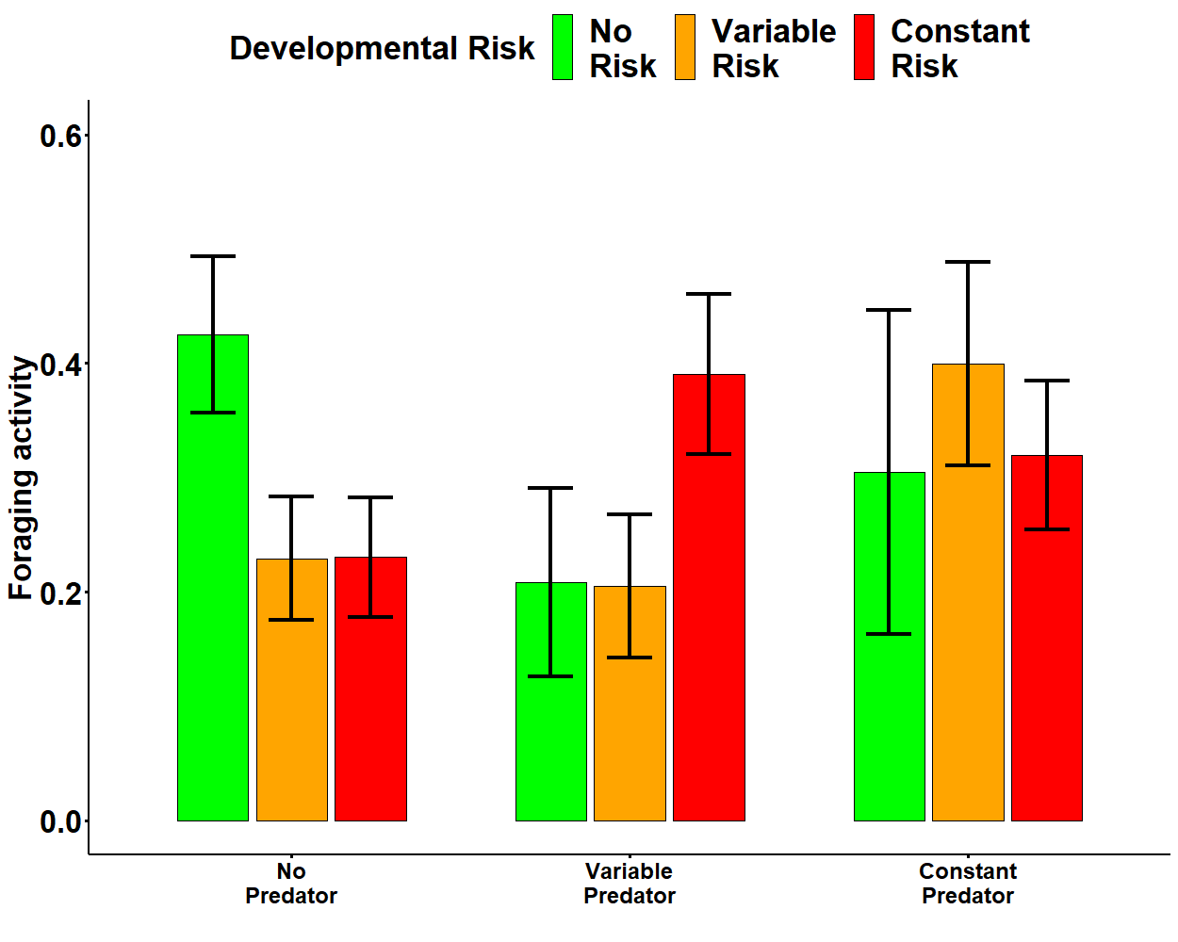
Sheltered Shore

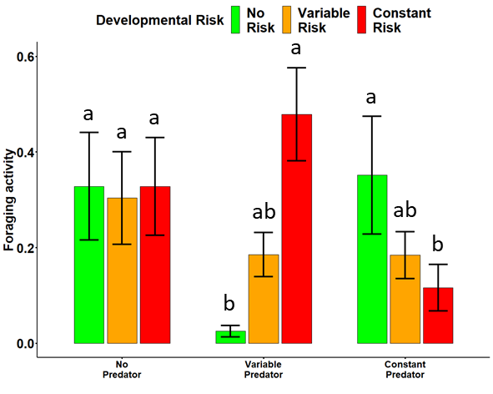
Exposed Shore

Figure 5.1 The average foraging activity (proportion of snails foraging) of the offspring generation of a) wave-sheltered b) wave-exposed Nucella reared under no risk (green), variable risk (orange) and constant risk (red) treatments. Values are means ±SE. Different letters indicate significant differences (Tukey’s HSD, α=0.05).
There was a distinct difference in how threat of predation affected the behaviour of Nucella from sheltered and exposed shores. Overall, the foraging behaviour of offspring of the wave-sheltered population was not influenced by either the risk experienced throughout development or the short-term predator treatments they were exposed to during the foraging experiment (Fig. 5.1 A, Table 5.3). In contrast both of these types of predatory threat affected offspring from the wave-exposed population. Analysis of the foraging activity of offspring of the wave-exposed population, revealed an interaction between the developmental experience of risk and predator treatment (lm, F_{1,32} = 4.93, p = 0.003). Nucella reared under the three risk regimes had similar foraging frequencies when not exposed to risk (Fig. 5.1 B) during the foraging experiment. Tukey post-hoc testing revealed Nucella in the variable predator treatment that were reared under no risk conditions foraged less (Tukey pairwise comparison: p = 0.003), than those reared under a variable and constant risk treatment. Moreover, Nucella in the constant predator treatment, foraged less frequently (Tukey pairwise comparison: p = 0.05), if they were reared under constant risk than if they experienced no risk or variable risk during development (Fig. 5.1 B).
Similarly, to Nucella foraging behaviour, my analysis revealed that refuge use in wave-sheltered offspring was unaffected by any of the treatment combinations (Fig 5.2 A, Table 5.3). Refuge use in wave-exposed Nucella was influenced by the combined effect of both developmental risk and predator treatment (lm, F_{1,32} = 5.89, p > 0.001). Nucella reared under no risk conditions throughout development, selected the safety of a refuge more frequently when exposed to variable risk than when there was no risk (Tukey pairwise comparison: p = 0.003) or when the risk was constant (Tukey pairwise comparison: p = 0.001).
Nucella offspring of both populations consumed the same number of barnacles per mesocosm as well as consuming the same average size barnacle across all treatment combinations (Fig. 5.3 and 5.4). Overall, wave-exposed offspring consumed 26% fewer barnacles (mean 8.55 ± 4.90 SD), that were on average 16% smaller (mean 2.175 mm ± 0.373 SD) compared to those consumed by wave-sheltered counterparts (mean number of barnacles consumed 11.68 ± 6.55 SD, average barnacle size 2.59 mm ± 0.378 SD). However, although not significant, analysis revealed that the average size of barnacle consumed by wave-sheltered offspring tended to be affected by the predator treatment they were exposed to (lm, F_{1,32} = 3.08, p = 0.058), with Nucella consuming the largest barnacles when exposed to the variable treatment, followed by no predator treatment and then finally the smallest barnacles were consumed in the constant predator treatment.

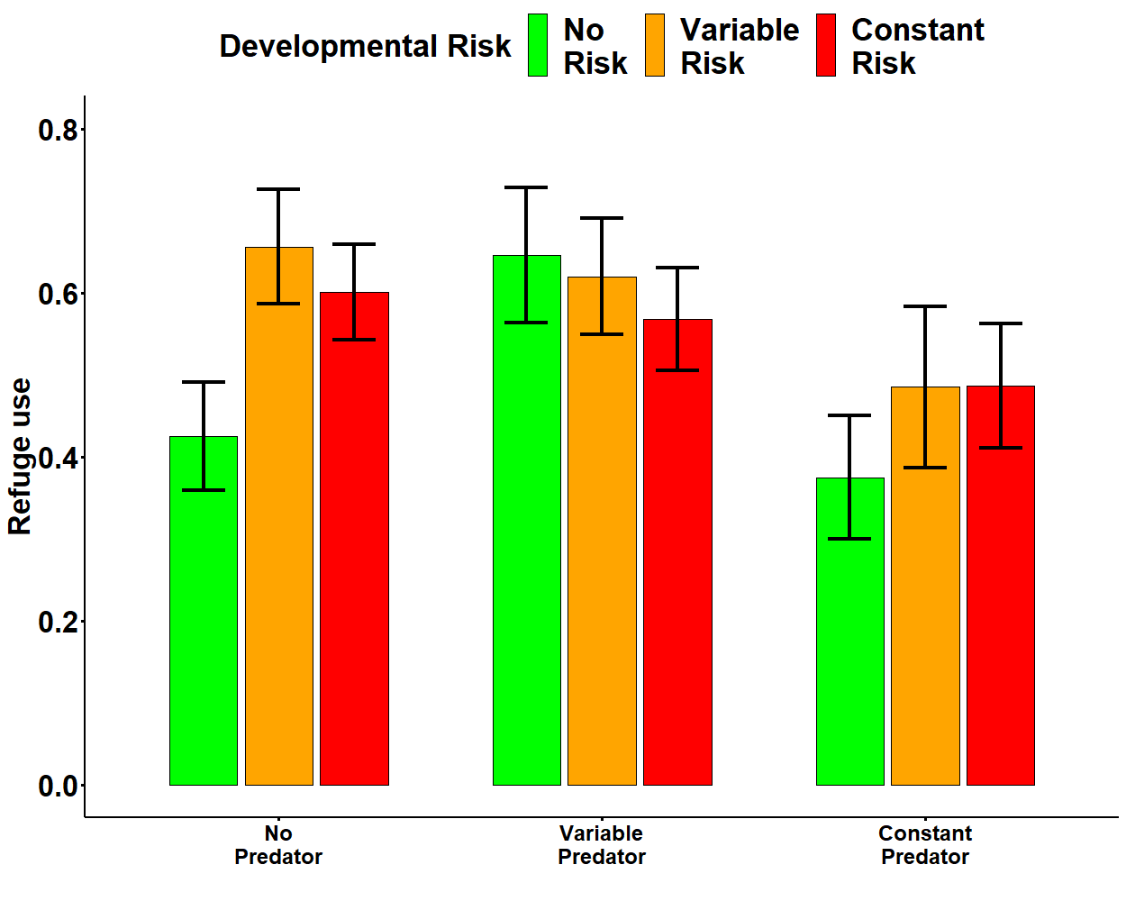
Sheltered Shore

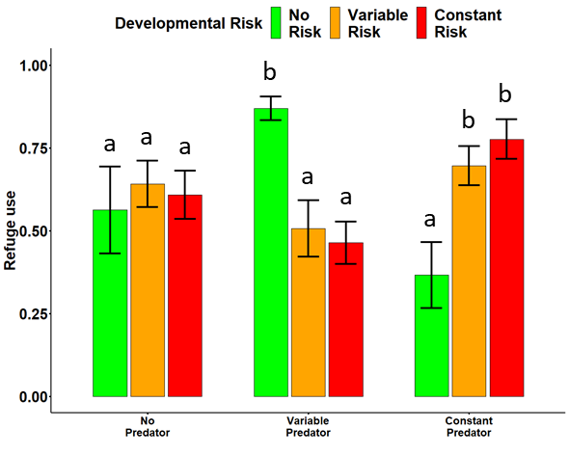
Exposed Shore

Figure 5.2 The average foraging activity (proportion of snails foraging) of the offspring generation of a) wave-sheltered b) wave-exposed Nucella reared under different long-term risk regimes. Values are means ±SE. Different letters indicate significant differences (Tukey’s HSD, α=0.05).

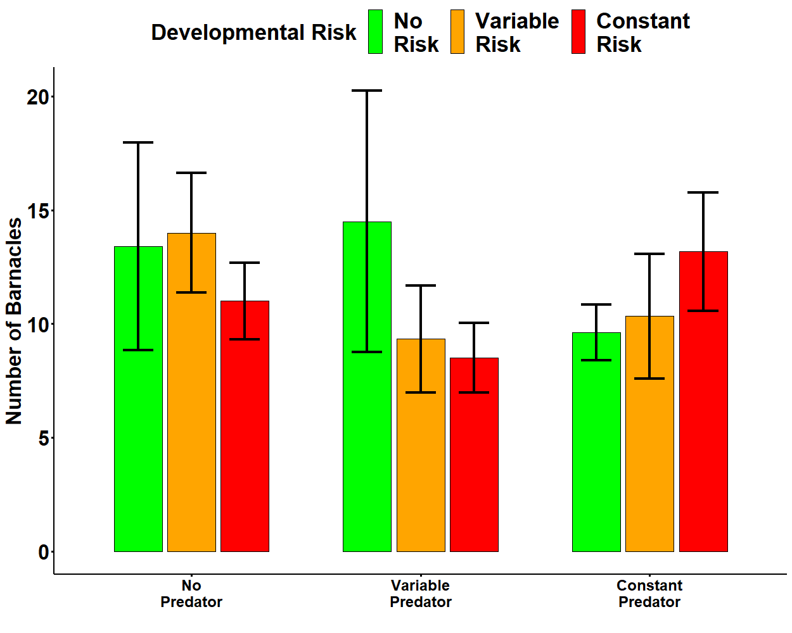
Sheltered Shore

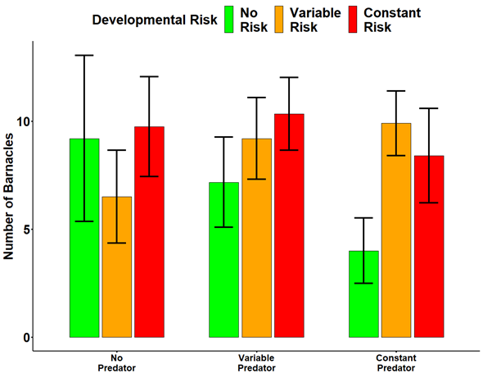
Exposed Shore

Figure 5.3 Average number of barnacles consumed by the offspring generation of a) wave-sheltered b) wave-exposed Nucella reared under different long-term risk regimes. Values are means ±SE. Different letters indicate significant differences (Tukey’s HSD, α=0.05).

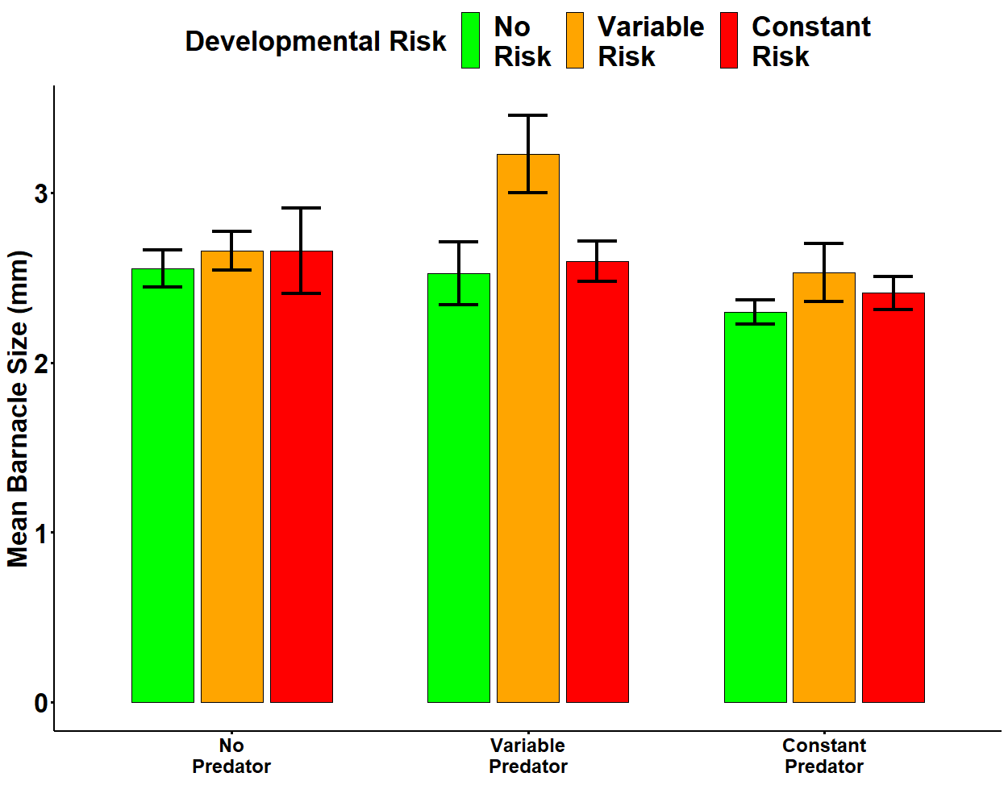
Sheltered Shore

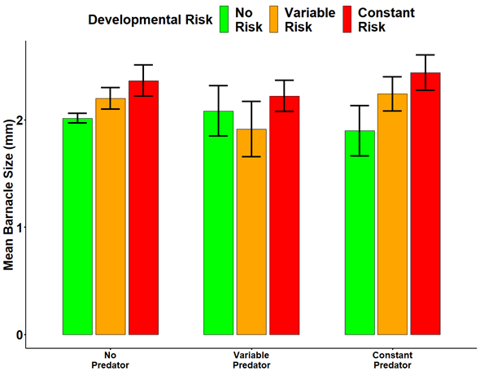
Exposed Shore

Figure 5.4 Mean barnacle size consumed by offspring generation of a) wave-sheltered b) wave-exposed Nucella reared under different long-term risk regimes. Values are means ±SE. Different letters indicate significant differences (Tukey’s HSD, α=0.05).

Table 5.3 Summary of full linear mixed model results of foraging activity, refuge use, number of barnacles consumed, average size of barnacle consumed, and total amount of energy consumed by offspring from a wave-exposed and a wave-sheltered population of Nucella lapillus reared under different risk treatments.
Response variable Effect Df F P
Sheltered shore Nucella
Foraging Activity Develop risk 2 0.281 0.756
Predator Treatment 2 1.032 0.365
Pt x Dr 4 1.468 0.229
Error 49 105.9

Refuge use Develop risk 2 0.85 0.433
Predator Treatment 2 2.43 0.101
Pt x Dr 4 1.00 0.418
Error 49 325.04

Barnacles consumed Develop risk 2 0.19 0.829
Predator Treatment 2 0.39 0.681
Pt x Dr 4 0.744 0.568
Error 38 325.04

Av. Barnacle size Develop risk 2 2.02 0.146
Predator Treatment 2 3.08 0.058*
Pt x Dr 4 0.65 0.634
Error 38 4.73
Exposed shore Nucella
Foraging Activity Develop risk 2 0.584 0.562
Predator Treatment 2 2.06 0.141
Pt x Dr 4 4.93 0.003
Error 46 77.55

Refuge use Develop risk 2 0.05 0.953
Predator Treatment 2 0.45 0.642
Pt x Dr 4 5.89 > 0.001
Error 46 452.82

Barnacles consumed Develop risk 2 0.94 0.400
Predator Treatment 2 0.29 0.749
Pt x Dr 4 0.824 0.519
Error 34 864.38

Av. Barnacle size Develop risk 2 1.19 0.317
Predator Treatment 2 0.46 0.637
Pt x Dr 4 0.913 0.913
Error 34 560.34

Statistically significant models (α = 0.05) are in bold and marginally significant (> 0.06) results are indicated with a (*).

Discussion
Overall, my results revealed that the foraging behaviour of Nucella offspring from the wave-sheltered populations was not affected by developmental experience of risk or predator treatment, whereas foraging in offspring of the wave-exposed population was influenced by a combination of current and previous exposure to risk. It is important to acknowledge, that although my results show clear differences between the offspring of the two populations tested here, as only a single population of each wave exposure was used in this study, conclusions cannot be ascribed to differences in wave-exposure. Offspring of the wave-exposed population reduced their foraging activity under risky conditions as well as selecting the safety of a refuge more frequently when exposed to a predatory cue. In both of these cases responses were different depending on the developmental experience of risk Nucella were reared in. The foraging activity of offspring of the wave-exposed population when no predatory cue was present were the same irrespective of developmental experience of risk, indicating that developmental exposure of risk did not impact foraging activity during safe periods. However, when Nucella were exposed to either variable or constant risk, they responded differently. When foraging under the variable predator treatment, Nucella offspring foraged less frequently if they were predator naïve (reared under no risk during development) and more frequently when constantly exposed to predation risk during development. However, when foraging under constant predator treatment, predator naïve offspring (those reared in the no risk regime) foraged more frequently than those exposed to a constant risk throughout development. The differences in foraging activity between each predator treatment can also be seen in the refuge use of offspring of the wave-exposed population. As analysis of the frequency of refuge use revealed the opposite pattern to that seen in foraging, it indicates that when Nucella were not foraging they were generally utilising refuges. Finally, in contrast to what I expected based on previous studies (Vadas et al. 1994, Trussell et al. 2011, Matassa and Trussell 2014) the number of barnacles consumed by Nucella offspring was not influenced by exposure to risk while foraging, although our results showed a trend for wave-sheltered Nucella to choose smaller barnacles on average when under constant risk.
In contrast with previous results (Freeman and Hamer 2009, Freeman et al. 2014, Dernbach and Freeman 2015), only Nucella offspring from the wave-exposed population altered their foraging behaviour in response to predation risk, whereas the foraging behaviour of offspring of the wave-sheltered population was unaffected by risk. This result is surprising as previous experience of predation risk has been shown to be an important driver in the foraging behaviour of Nucella as well as many other prey species (Freeman et al. 2014). Similarly, results of the use of refuges by Nucella followed the opposite pattern of that seen in my foraging results, but once again were counter to what I expected based on previous findings (Donelan and Trussell 2015). My analysis did reveal that foraging and refuge uses behaviour of wave-exposed offspring was different according to the risk they experienced throughout development. Firstly, offspring of wave-exposed Nucella reared under the three risk regimes foraged and utilised refuges at the same frequency when exposed to no risk. This result indicates that when under no risk, the foraging and refuge use behaviour of Nucella from this population was unaffected by the risk they were exposed to throughout development (Donelan and Trussell 2018b). However, both these behaviours differed when Nucella were exposed to a level of risk. When risk was unpredictable (variable predator treatment), predator naïve offspring foraged less frequently and utilised refuges more often than offspring that had previous experience of predatory cues (variable risk and constant development exposure to risk). However, when forced to make foraging and refuge use decisions under constant risk, predator naïve Nucella foraged more frequently and used a refuge less frequently than did offspring exposed to a predator (both variable and constant risk treatments). These results seem to suggest that previous experience of predation risk during development influences how Nucella respond to current levels of risk. When risk is unpredictable, predator naïve Nucella respond strongly, by reducing their foraging activity and increasing their use of refuges, whereas when risk is constant, the same predator naïve Nucella are seemingly able to overcome the influence of the predatory cues and forage at levels similar to those under seen under the no predator treatment.
Nucella offspring from the two populations consumed the same number of barnacles irrespective of developmental exposure to risk or predator treatment. Several previous studies have shown that Nucella consume fewer barnacles when exposed to predatory cues (Trussell et al. 2006b, Matassa and Trussell 2011, Matassa et al. 2016) a pattern that was not seem in my results. However, my results showed that, overall wave-exposed Nucella consumed fewer and smaller barnacles than those consumed by the wave-sheltered population. These results do confirm earlier studies which have shown that exposed shore Nucella tend to consume fewer and smaller barnacles than do Nucella from more wave-protected sites in the field (Menge 1978b) and under laboratory conditions (Trussell et al. 2006b, Dernbach and Freeman 2015). In one instance, Palmer (1990) showed that Nucella exposed to crab kairomones reduced the number of barnacles they consumed by up to 75% depending on the level of risk they were exposed to. The lack of a difference in the number of barnacles consumed under risk in the current study when compared to results from previous investigations may be due to Nucella in the current study being reared under laboratory condition, whereas previous studies have been conducted on field collected animals (Trussell et al. 2006b, Matassa and Trussell 2014).
Analysis of the size of barnacle consumed by Nucella in this experiment did not reveal any significant interaction between developmental experience of risk and predator treatment, although some interesting patterns did emerge. Firstly, as stated earlier, offspring of the wave-exposed population of Nucella selected smaller barnacles across all treatment combinations than wave-sheltered offspring. Secondly, my results showed a strong trend (p = 0.056), that although not significant, does follow similar trends as other predators of reducing the size of prey being consumed when under risky conditions. However, this trend was only present for wave-sheltered offspring. It is important to restate that Nucella generally have to leave the safety of a refuge in order to forage and are therefore naturally more exposed to abiotic and biotic factors. In the case of wave-exposed Nucella consuming smaller barnacles than wave-sheltered snails, previous authors have argued that the reduction in handling time gained by choosing smaller prey, also reduced the amount of time they are exposed to wave-action (Burrows and Hughes 1991b). Moreover, Nucella on wave-sheltered shores tend to be more exposed to predation risk while foraging (Menge 1978a), especially as resources are depleted near to refuges quickly and they are therefore forced to venture into more risky areas to forage (Donelan et al. 2017). As Nucella from wave-sheltered populations are subjected to higher levels of predation pressure, potential changes to the handling times of prey will reduce the amount of time they are out of a refuge and increase their chances of survival. This trend should, however, be viewed cautiously, as previous studies have shown that Nucella prey selection remains constant irrespective of the level of risk perceived, although these results refer to the selection of mussel prey rather than barnacles (Quinn et al. 2012).

General Discussion

CHAPTER SIX

General Discussion

General overview
The impacts that predators have on prey and the ecological systems they inhabit are indisputable, but appreciation of the indirect effects of predation risk is only recently becoming apparent (Lima 1998b, Lima and Bednekoff 1999, Duffy 2003, Bednekoff and Lima 2011). Recent advances in the investigation of these indirect effects have shown them to be context dependant in many instances, with both biotic and abiotic interactions adding to their complexity (Bartley et al. 2019). With the influence of past experience, prey state, differences in the temporal pattern of risk experienced, refuge quality as well as the potential for parental effects to guide antipredator traits in prey, there have been increased calls for investigations to test the expression of different antipredator responses under different contexts (Lima and Bednekoff 1999, Ferrari and Chivers 2009, Matassa and Trussell 2014, Ferrari et al. 2015). This thesis therefore aimed to test the antipredator responses of an intertidal dogwhelk under different predation risk scenarios, focusing on the risk experienced throughout development and the potential for parental effects to affect responses. The results presented above, demonstrate the potential predator-induced changes in metabolism, in the long-term energy budget and relative investment in somatic growth and defensive morphologies, the impacts on escape and avoidance behaviour and finally on the foraging strategy of Nucella. Although the results presented in this thesis undoubtably illustrate the impacts predation risk plays in the life history of Nucella, it also adds to the growing literature highlighting the profound role predators play in the lives of prey more generally. Changes to the accumulation of energy, its short- and long-term storage and utilisation as well as the relative investments in growth and defensive morphologies highlighted here can impact prey demography and cause wider reaching ecological impacts through cascade effects (Trussell et al. 2003, 2006b, 2017). Although not directly tested in this thesis, the mechanisms which underpin the antipredator response in prey highlighted here, may also be useful in understanding the importance that predators play on community dynamics and ecosystem functioning (Stoks et al. 2005, Hawlena and Schmitz 2010b). As future global climate change increases the pressure on already depleted populations of predators, it is important to understand the mechanisms that underpin species interactions, if we are to accurately predict and respond to such changes (Bartley et al. 2019).

Pervasive impacts of predation risk
Despite the recognition of an organism’s body-size as one of the most important driving forces in ecological interactions (De Roos et al. 2003), few studies have attempted to incorporate differences in body size into investigations of the indirect effects of predation risk (Rochette and Himmelman 1996, Rochette et al. 1999). Moreover, as increases in body size may constitute an animals natural defence against direct predations (Hughes and Elner 1979, Chase 1999), it is surprising that more studies have not tested the indirect effects of predation on prey at a size refuge. In Chapter 2, I demonstrated that Nucella which had grown to a size refuge, reduced the amount of oxygen they consumed when exposed to predation risk in the field. These results provide the first insight into the pervasive nature of the indirect effect of risk in this predator-prey system, and their potential ability to persist even after pressure from direct predation has dissipated. Studies into the responses of prey with differing vulnerabilities to direct predation, although rare, have highlighted both behavioural (Rochette et al. 1996) and foraging (Rochette and Himmelman 1996) differences between the different size classes. Therefore, further investigations into other aspects of antipredator responses in Nucella, may help us better appreciate the impacts of risk on these larger size classes.
Investigations into the influence of predation risk on prey at a size refuge will also be important for explaining the large-scale impacts of predation risk, as these size classes disproportionately influence ecological level processes (De Roos et al. 2003). For example, large individuals have higher foraging rates (Hughes and Dunkin 1984, Matassa et al. 2016), and hence any impacts on the foraging of these larger size classes will have implications for prey demography and community dynamics. Without testing whether the indirect effect of risk persists into these size classes, animals at a size refuge are considered to have escaped the influence of predation. However, results such as the ones presented here show that more attention should be paid to the potential of the indirect effects of predation risk to continue to affect these ecologically important size classes.
In many systems, the relative importance of indirect effects as a result of direct predation (DMIIs) or brought through changes to the traits of prey (TMIIs), are still debated. For Nucella, previous studies have shown that despite their seemingly transitory nature, TMIIs have an equal or larger impact on ecological systems than DMIIs (Trussell et al. 2004, 2006a, 2017). Importantly, insights into the relative strength of DMIIs and TMIIs come from manipulative experiments that alter predator and prey densities and measure the resulting changes in the abundance of prey resources. In all cases, only prey that remained vulnerable to direct predation were used, presumably to guarantee that the indirect effects of predation risk would influence their expression of antipredator behaviours. As results presented here show, individuals at size refuge remain affected by predation risk and combined with the increases seen in barnacle consumption with larger body sizes (Matassa et al. 2016), indicates that the relative importance of TMIIs in this system may have been underestimated. Considerations of this type are important as they help us better understand how predators influence community dynamics through manipulations of their abundances or modifications of individual antipredator traits.

The fluctuating nature of predation risk
The risk posed by predators is neither constant nor predictable, with daily changes in abiotic factors and the movements of both predators and prey, influencing the risk perceived by prey. As such, investigations into the indirect effects of predation risk should attempt to incorporate an element of unpredictability in their design in order to create treatments that best represent the risk experienced by prey in nature. Such studies have shown, for example, that predator-induced chances in growth efficiencies are not linear, but instead may be lower when risk is unpredictable rather than when it is constantly present (Trussell et al. 2011). They have also highlighted the importance that pattern of risk have on prey foraging strategy (Matassa and Trussell 2014), predator avoidance (Ferrari and Chivers 2009). However, short-term investigations into the antipredator responses of prey, where prey are exposed to risk for a matter of hours or days may not allow enough time for the expression of compensatory mechanisms (Thaler et al. 2012, Van Dievel et al. 2016). Prey are able to develop behavioural and physiological compensatory mechanism to help them ameliorate some of the negative impacts of predation risk in one instance and defer them to when the risk has subsided. Examples such as that provided by the tobacco hornworm caterpillar, Manduca sexta, which is able to postpone predator-induced inefficiencies in the assimilation of consumed energy to a period when the risk of being consumed subsides (Thaler et al. 2012). Results from Chapters 3, 4 and 5 have further highlighted the importance of incorporating an unpredictable risk treatment in long-term investigations into the antipredator responses of prey. For example, in previous investigations which consider risk as either present or absent Nucella attain smaller shell lengths under constant risk than when exposed to no risk conditions, a pattern that was repeated in the current study. However, the incorporation of a variable risk treatment revealed that when risk was unpredictable Nucella, grew differently depending on parental habitat.

Potential climate driven changes
The impacts of climate changes are undoubtedly the most pressing challenge facing ecologists today. The potential for these accelerated changes to affect individual life histories, inter- and intraspecific interactions as well as potential catastrophic effects on ecosystem functioning must be identified and evaluated. Our ability to predict the effects of climate change on ecological communities, rests on our understanding of how environmental conditions influence the interaction of physical processes and species interactions. The net impact of large-scale environmental change on community structure, will therefore depend on how prey respond to both abiotic changes as well as how these influence the interaction of one species with another. Large scale changes such as the increased spread of invasive species, ocean acidification, increases in metabolic demands of ectotherms are predicted to follow global increases in temperature.
More specifically, with regard to intertidal invertebrate interactions, increases in ocean acidification will impact both predators and prey. It could impede the formation and robustness of gastropod shells (Coleman et al. 2014), as well as potentially weakening the attacking capabilities of some predators for example, by reducing the strength of crab claws (Landes and Zimmer 2012). Moreover potential increases in the metabolism of prey brought about by higher temperatures may outpace the increases in foraging speeds, resulting in overall reductions in growth (Iles 2014). Finally, the nature of predator-prey interactions may be affected through changes to the chemical cues themselves as well as changes to the medium through which they are transmitted. However, even closely related species may respond differently to large-scale environmental changes (Coleman et al. 2014), highlighting the importance of understanding the mechanisms which underpin the responses on organism. We must therefore aim to better understand the forces that drive community structure and influence ecosystems function if we are to best respond to environmental change.

References
References

Adamo, S. A., and J. L. Baker. 2011. Conserved features of chronic stress across phyla: The effects of long-term stress on behavior and the concentration of the neurohormone octopamine in the cricket, Gryllus texensis. Hormones and Behavior 60:478–483.
Agrawal, A. A., C. Laforsch, and R. Tollrian. 1999. Transgenerational induction of defences in animals and plants. Nature 401:60–63.
Angell, J. R. 1915. Bodily changes in pain, hunger, fear and rage; An account of recent researches into the function of emotional excitement. Page Science. 2nd edition. New York: Harper & Row, New York.
Appleton, R. D., and A. R. Palmer. 1988. Water-borne stimuli released by predatory crabs and damaged prey induce more predator-resistant shells in a marine gastropod. Evolution 85:4387–4391.
Aschaffenburg, M. D. 2008. Different crab species influence feeding of the snail Nucella lapillus through trait-mediated indirect interactions. Marine Ecology 29:348–353.
Ballantine, W. J. 1961. A biologically-defined exposure scale for the comparative description of rocky shores. Field Studies 1:1–19.
Barry, M. J., and S. Syal. 2013. Metabolic responses of tadpoles to chemical predation cues. Hydrobiologia 700:267–276.
Bartley, T. J., K. S. McCann, C. Bieg, K. Cazelles, M. Granados, M. M. Guzzo, A. S. MacDougall, T. D. Tunney, and B. C. McMeans. 2019. Food web rewiring in a changing world. Nature Ecology and Evolution 3:345–354.
Bates, D., M. Mächler, B. Bolker, and S. Walker. 2015. Fitting linear mixed-effects models using lme4. Journal of Statistical Software 67:1–48.
Bates, D., M. Maechler, B. Bolker, and S. Walker. 2013. lme4: Linear mixed-effects models using Eigen and S4. Journal of Statistical Software 67:1–48.
Beaty, L. E., J. D. Wormington, B. J. Kensinger, S. R. Goeppner, K. D. Gustafson, K. N. Bayley, and B. Luttbeg. 2016. Shaped by the past, acting in the present: transgenerational plasticity of anti-predatory traits. Oikos 125:1570–1576.
Beauchamp, G. 2015. Animal Vigilance: Monitoring Predators and Competitors. Page (G. Beauchamp, Ed.). Academic Press.
Beckerman, A. P., M. Uriarte, and O. J. Schmitz. 1997. Experimental evidence for a behavior-mediated trophic cascade in a terrestrial food chain (herbivore-mediated effectspredationold field food chainsgrasshoppers). Proceedings of the National Academy of Sciences 94:10735–10738.
Beckerman, A. P., K. Wieski, and D. J. Baird. 2007. Behavioural versus physiological mediation of life history under predation risk. Oecologia 152:335–343.
Bednekoff, P. A., and S. L. Lima. 2011. Risk Allocation Is a General Phenomenon: A Reply to Beauchamp and Ruxton. The American Naturalist 177:147–151.
Bestion, E., A. Teyssier, F. Aubret, J. Clobert, and J. Cote. 2014. Maternal exposure to predator scents: Offspring phenotypic adjustment and dispersal. Proceedings of the Royal Society B: Biological Sciences 281:20140701.
Beyer, J., N. Aarab, A. H. Tandberg, A. Ingvarsdottir, S. Bamber, J. F. Børseth, L. Camus, and R. Velvin. 2013. Environmental harm assessment of a wastewater discharge from Hammerfest LNG: A study with biomarkers in mussels (Mytilus sp.) and Atlantic cod (Gadus morhua). Marine Pollution Bulletin 69:28–37.
Bishop, T. D., and J. A. Brown. 1992. Threat-sensitive foraging by larval threespine sticklebacks (Gasterosteus aculeatus). Behavioral Ecology and Sociobiology 31:133–138.
Bligh, E.G. and Dyer, W. J. 1959. A rapid method of total lipid extraction and purification. Canadian Journal of Biochemistry and Physiology 37:911–917.
Bolker, B. M., M. E. Brooks, C. J. Clark, S. W. Geange, J. R. Poulsen, M. H. H. Stevens, and J. S. S. White. 2008. Generalized linear mixed models: a practical guide for ecology and evolution. Trends in Ecology and Evolution 24:127–135.
Boonstra, R. 2013. Reality as the leading cause of stress: Rethinking the impact of chronic stress in nature. Functional Ecology 27:11–23.
Boonstra, R., D. Hik, G. R. Singleton, and A. Tinnikov. 1998. The impact of predator‐induced stress on the snowshoe hare cycle. Ecology Monographs 79:371–394.
Bourdeau, P. E. 2010. An inducible morphological defence is a passive by-product of behaviour in a marine snail. Proceedings of the Royal Society B: Biological Sciences 277:455–462.
Bourdeau, P. E., and F. Johansson. 2012. Predator-induced morphological defences as by-products of prey behaviour: A review and prospectus. Oikos 121:1175–1190.
Brookes, J. I., and R. Rochette. 2007. Mechanism of a plastic phenotypic response: Predator-induced shell thickening in the intertidal gastropod Littorina obtusata. Journal of Evolutionary Biology 20:1015–1027.
Brooks, M. E., K. Kristensen, K. J. van Benthem, A. Magnusson, C. W. Berg, A. Nielsen, H. J. Skaug, M. Maechler, and B. M. Bolker. 2017. glmmTMB Balances speed and flexibility among packages for Zero-inflated Generalized Linear Mixed Modeling. The R Journal 9:378–400.
Brown, J. S., J. W. Laundre, and M. Gurung. 1999. The ecology of fear: optimal foraging, game theory, and trophic interactions. Journal of Mammalogy 80:385–399.
Burrows, M. T., R. Harvey, and L. Robb. 2008a. Wave exposure indices from digital coastlines and the prediction of rocky shore community structure. Marine Ecology Progress Series 353:1–12.
Burrows, M. T., and R. N. Hughes. 1989. Natural foraging of the dogwhelk, Nucella lapillus (Linnaeus); the weather and whether to feed. Journal of Molluscan Studies 55:285–295.
Burrows, M. T., and R. N. Hughes. 1991a. Optimal foraging decisions by dogwhelks, Nucella lapillus (L) - influences of mortality risk and rate-constrained digestion. Functional Ecology 5:461–475.
Burrows, M. T., and R. N. Hughes. 1991b. Variation in foraging behaviour among individuals and populations of dogwhelks, Nucella lapillus: natural constraints on energy intake. Journal of Animal Ecology 60:497–514.
Canero, E. M., and G. Hermitte. 2014. New evidence on an old question: Is the “fight or flight” stage present in the cardiac and respiratory regulation of decapod crustaceans? Journal of Physiology Paris 108:174–186.
Carpenter, S. R., J. F. Kitchell, and J. R. Hodgson. 1985. Cascading trophic interactions and lake productivity. BioScience 35:634–639.
Carro, B., M. Quintela, J. M. Ruiz, and R. Barreiro. 2012. AFLPs reveal different population genetic structure under contrasting environments in the marine snail Nucella lapillus L. PLoS ONE 7.
Chase, J. M. 1999. Food web effects of prey size refugia: variable interactions and alternative stable equilibria. The American Naturalist 154:559–570.
Chivers, D. P., and R. J. F. Smith. 1998. Chemical alarm signalling in aquatic predator-prey systems: a review and prospectus. Ecoscience 5:338–352.
Chu, N. D., L. P. Miller, S. T. Kaluziak, G. C. Trussell, and S. V. Vollmer. 2014. Thermal stress and predation risk trigger distinct transcriptomic responses in the intertidal snail Nucella lapillus. Molecular Ecology 23:6104–6113.
Clark, C. W. 1994. Antipredator behavior and the asset-protection principle. Behavioral Ecology 5:159–170.
Clinchy, M., M. J. Sheriff, and L. Y. Zanette. 2013. Predator-induced stress and the ecology of fear. Functional Ecology 27:56–65.
Clinchy, M., L. Zanette, R. Boonstra, J. C. Wingfield, and J. N. M. Smith. 2004. Balancing food and predator pressure induces chronic stress in songbirds. Proceedings of the Royal Society B: Biological Sciences 271:2473–2479.
De Coen, W., and C. R. Janssen. 1997. The use of biomarkers in Daphnia magna toxicity testing. IV.Cellular Energy Allocation: a new methodology to assess the energy budget of toxicant-stressed Daphnia populations. Journal of Aquatic Ecosystem Stress and Recovery 6:43–55.
De Coen, W. M., and C. R. Janssen. 2003. The missing biomarker link: Relationships between effects on the cellular energy allocation biomarker of toxicant-stressed Daphnia magna and corresponding population characteristics. Environmental Toxicology and Chemistry 22:1632–1641.
Coleman, D. W., M. Byrne, and A. R. Davis. 2014. Molluscs on acid: Gastropod shell repair and strength in acidifying oceans. Marine Ecology Progress Series 509:203–211.
Connell, J. H. 1961a. Effects of competition, predation by Thais lapillus, and other factors on natural populations of the barnacle Balanus balanoides. Ecological Monographs 31:61–104.
Connell, J. H. 1961b. The influence of interspecific competition and other factors on the distribution of the barnacle Chthamalus Stellatus. Ecology 42:710–723.
Cooke, S. J., J. Steinmetz, J. F. Degner, E. C. Grant, and D. P. Philipp. 2003. Metabolic fright responses of different-sized largemouth bass (Micropterus salmoides) to two avian predators show variations in nonlethal energetic costs. Canadian Journal of Zoology 81:699–709.
Cooper, W. E., and D. T. Blumstein. 2015. Escaping From Predators: An Integrative View of Escape Decisions. Page (W. E. Cooper and D. T. Blumstein, Eds.). Cambridge University Press.
Cornwell, T. O., I. D. McCarthy, C. R. A. Snyder, and P. A. Biro. 2019. The influence of environmental gradients on individual behaviour: Individual plasticity is consistent across risk and temperature gradients. Journal of Animal Ecology 88:511–520.
Crane, A. L., and M. C. O. Ferrari. 2015. Minnows trust conspecifics more than themselves when faced with conflicting information about predation risk. Animal Behaviour 100:184–190.
Creel, S., D. Christianson, S. Liley, and J. A. Winnie. 2007. Predation risk affects reproductive physiology and demography of elk. Science 315:960.
Creel, S., J. A. Winnie, and D. Christianson. 2009. Glucocorticoid stress hormones and the effect of predation risk on elk reproduction. Proceedings of the National Academy of Sciences 106:12388–12393.
Crothers, J. 1974. Variation in the Shell of the Dog-Whelk, Nucella Lapillus. Field Studies 4:39–60.
Crothers, J. H. 1983. Variation in dog‐whelk shells in relation to wave action and crab predation. Biological Journal of the Linnean Society 20:85–102.
Crothers, J. H. 1985. Dog-whelks: An introduction to the biology of Nucella lapillus (L.). Field Studies 6:291–360.
Dahlhoff, E. P., J. H. Stillman, and B. A. Menge. 2008. Physiological community ecology: variation in metabolic activity of ecologically important rocky intertidal invertebrates along environmental gradients. Integrative and Comparative Biology 42:862–871.
Dernbach, E. M., and A. S. Freeman. 2015. Foraging preference of whelks Nucella lapillus is robust to influences of wave exposure and predator cues. Marine Ecology Progress Series 540:135–144.
DeWitt, T. J., A. Sih, and J. A. Hucko. 1999. Trait competition and cospecialization in a freshwater snail: size, shape and antipredator behaviour. Animal Behaviour 58:397–407.
Díaz-Gil, C., J. Alós, P. Arechavala-Lopez, M. Palmer, I. Riera-Batle, A. Grau, and I. A. Catalán. 2020. Reversible morphological changes in a juvenile marine fish after exposure to predatory alarm cues. Royal Society Open Science 7.
Van Dievel, M., L. Janssens, and R. Stoks. 2016. Short- and long-term behavioural, physiological and stoichiometric responses to predation risk indicate chronic stress and compensatory mechanisms. Oecologia 181:347–357.
Van Dievel, M., L. Janssens, and R. Stoks. 2019a. Effects of pesticide exposure and predation risk on nutrient cycling and primary production. Science of the Total Environment:135880.
Van Dievel, M., L. Janssens, and R. Stoks. 2019b. Additive bioenergetic responses to a pesticide and predation risk in an aquatic insect. Aquatic Toxicology 212:205–213.
Dill, L. M. 1987. Animal decision making and its ecological consequences: the future of aquatic ecology and behaviour. Canadian Journal of Zoology 65:803–811.
Dingemanse, N. J., J. Wright, A. J. N. Kazem, D. K. Thomas, R. Hickling, and N. Dawnay. 2007. Behavioural syndromes differ predictably between 12 populations of three-spined stickleback. Journal of Animal Ecology 76:1128–1138.
Dixon, A. F. G., and B. K. Agarwala. 1999. Ladybird-induced life-history changes in aphids. Proceedings of the Royal Society B: Biological Sciences 266:1549–1553.
Donelan, S. C., J. H. Grabowski, and G. C. Trussell. 2017. Refuge quality impacts the strength of nonconsumptive effects on prey. Ecology 98:403–411.
Donelan, S. C., and G. C. Trussell. 2015. Parental effects enhance risk tolerance and performance in offspring. Ecology 96:2049–2055.
Donelan, S. C., and G. C. Trussell. 2018a. Synergistic effects of parental and embryonic exposure to predation risk on prey offspring size at emergence. Ecology 99:68–78.
Donelan, S. C., and G. C. Trussell. 2018b. Parental and embryonic experiences with predation risk affect prey offspring behaviour and performance. Proceedings of the Royal Society B: Biological Sciences 285.
Donelan, S. C., and G. C. Trussell. 2019. The effects of embryonic experience with predation risk vary across a wave exposure gradient. Ecosphere 10.
Donovan, D. A., and H. H. Taylor. 2008. Metabolic consequences of living in a wave-swept environment: Effects of simulated wave forces on oxygen consumption, heart rate, and activity of the shell adductor muscle of the abalone Haliotis iris. Journal of Experimental Marine Biology and Ecology 354:231–240.
Duffy, J. E. 2003. Biodiversity loss, trophic skew and ecosystem functioning. Ecology Letters 6:680–687.
Dunkin, S. D. B., and R. N. Hughes. 1984. Behavioural components of prey-selection by dogwhelks, Nucella lapillus (L.), feeding on barnacles, Semibalanus balanoides (L.), in the laboratory. Journal of Experimental Marine Biology and Ecology 79:91–103.
Edgell, T. C. 2010. Past predation risk induces an intertidal whelk (Nucella lamellosa) to respond to more dilute concentrations of its predator’s scent. Marine Biology 157:215–219.
Edgell, T. C., and C. J. Neufeld. 2008. Experimental evidence for latent developmental plasticity: Intertidal whelks respond to a native but not an introduced predator. Biology Letters 4:385–387.
Elner, R. W., and R. N. Hughes. 1978. Energy maximization in the diet of the shore crab, Carcinus maenas. Journal of Animal Ecology 47:103–116.
Etter, R. J. 1988. Physiological stress and color polymorphism in the intertidal snail Nucella lapillus. Evolution 42:660–680.
Etter, R. J. 1989. Life-History variation in the intertidal snail Nucella lapillus across a wave-exposure gradient. Ecology 70:1857–1876.
Etter, R. J. 1996. The effect of wave action, prey type, and foraging time on growth of the predatory snail Nucella lapillus (L.). Journal of Experimental Marine Biology and Ecology 196:341–356.
Fairweather, P. G. 1988. Movements of intertidal whelks (Morula marginalba and Thais orbta) in relation to availability of prey and shelter. Marine Biology 100:63–68.
Feare, C. J. 1970. Aspects of the ecology of an exposed shore population of dogwhelks Nucella Lapillus (L.). Oecologia 5:1–18.
Feare, C. J. 1971. The adaptive significance of aggregation behaviour in the dogwhelk Nucella lapillus (L.). Oecologia 7:117–126.
Ferrari, M. C. O., and D. P. Chivers. 2009. Temporal variability, threat sensitivity and conflicting information about the nature of risk: understanding the dynamics of tadpole antipredator behaviour. Animal Behaviour 78:11–16.
Ferrari, M. C. O., A. L. Crane, G. E. Brown, and D. P. Chivers. 2015. Getting ready for invasions: Can background level of risk predict the ability of naïve prey to survive novel predators? Scientific Reports 5:8309.
Ferrari, M. C. O., F. Messier, and D. P. Chivers. 2008a. Larval amphibians learn to match antipredator response intensity to temporal patterns of risk. Behavioral Ecology 19:980–983.
Ferrari, M. C. O., A. C. Rive, C. J. MacNaughton, G. E. Brown, and D. P. Chivers. 2008b. Fixed vs. random temporal predictability of predation risk: An extension of the risk allocation hypothesis. Ethology 114:238–244.
Ferrari, M. C. O., A. Sih, and D. P. Chivers. 2009. The paradox of risk allocation: a review and prospectus. Animal Behaviour 78:579–585.
Fox, J., and S. Weisberg. 2019. An R companion to applied regression. Page (J. Fox and S. Weisberg, Eds.). Third. Sage.
Freeman, A. S., E. Dernbach, C. Marcos, and E. Koob. 2014. Biogeographic contrast of Nucella lapillus responses to Carcinus maenas. Journal of Experimental Marine Biology and Ecology 452:1–8.
Freeman, A. S., and C. E. Hamer. 2009. The persistent effect of wave exposure on TMIIs and crab predation in Nucella lapillus. Journal of Experimental Marine Biology and Ecology 372:58–63.
Freymiller, G. A., M. D. Whitford, T. E. Higham, and R. W. Clark. 2017. Recent interactions with snakes enhance escape performance of desert kangaroo rats (Rodentia: Heteromyidae) during simulated attacks. Biological Journal of the Linnean Society 122:651–660.
Gallagher, A. J., S. Creel, R. P. Wilson, and S. J. Cooke. 2017. Energy Landscapes and the Landscape of Fear. Trends in Ecology and Evolution 32:88–96.
Gibbs, P. E. 1993. Phenotypic changes in the progeny of Nucella lapillus (gastropoda) transplanted from an exposed shore to sheltered inlets. Journal of Molluscan Studies 59:187–194.
Giesing, E. R., C. D. Suski, R. E. Warner, and A. M. Bell. 2011. Female sticklebacks transfer information via eggs: Effects of maternal experience with predators on offspring. Proceedings of the Royal Society B: Biological Sciences 278:1753–1759.
Gnaiger, E. 1983. Calculations of energetic and biochemical equivalents of respiratory oxygen consumption. Pages 337–345 in E. Gnaiger and H. Forstner, editors. Polarographic Oxygen Sensors,Aquatic and Physiological Applications. Springer Verlag, Berlin.
Gosselin, L. A., and E. Bourget. 1989. The Performance of an Intertidal Predator Thais lapillus, in Relation to Structural Heterogeneity. The Journal of Animal Ecology 58:287.
Guerra-Varela, J., I. Colson, T. Backeljau, K. Breugelmans, R. N. Hughes, and E. Rolán-Alvarez. 2009. The evolutionary mechanism maintaining shell shape and molecular differentiation between two ecotypes of the dogwhelk Nucella lapillus. Evolutionary Ecology 23:261–280.
Hammond, J. I., B. Luttbeg, and A. Sih. 2007. Predator and prey space use: Dragonflies and tadpoles in an interactive game. Ecology 88:1525–1535.
Handelsman, C. A., E. D. Broder, C. M. Dalton, E. W. Ruell, C. A. Myrick, D. N. Reznick, and C. K. Ghalambor. 2013. Predator-induced phenotypic plasticity in metabolism and rate of growth: Rapid adaptation to a novel environment. Integrative and Comparative Biology 53:975–988.
Hawlena, D., H. Kress, E. R. Dufresne, and O. J. Schmitz. 2011. Grasshoppers alter jumping biomechanics to enhance escape performance under chronic risk of spider predation. Functional Ecology 25:279–288.
Hawlena, D., and V. Pérez-Mellado. 2009. Change your diet or die: Predator-induced shifts in insectivorous lizard feeding ecology. Oecologia 161:411–419.
Hawlena, D., and O. J. Schmitz. 2010a. Herbivore physiological response to predation risk and implications for ecosystem nutrient dynamics. Proceedings of the National Academy of Sciences 107:15503–15507.
Hawlena, D., and O. J. Schmitz. 2010b. Physiological stress as a fundamental mechanism linking predation to ecosystem functioning. The American Naturalist 176:537–556.
Hawlena, D., and M. Zaguri. 2016. Fear and below-ground food-webs. Soil Biology and Biochemistry 102:26–28.
Hay, M. E. 2009. Marine chemical ecology: chemical signals and cues structure marine populations, communities, and ecosystems. Annual Review of Marine Science 1:154–156.
Hayes, J. P. 2001. Mass-specific and whole-animal metabolism are not the same concept. Physiological and Biochemical Zoology 74:147–150.
Heller, J. 1976. The effects of exposure and predation on the shell of two British winkles. Journal of Zoology 179:201–213.
Hertz, P. E., R. B. Huey, and E. Nevo. 1982. Fight versus flight: Body temperature influences defensive responses of lizards. Animal Behaviour 30.
Holopainen, I. J., J. Aho, M. Vornanen, and H. Huuskonen. 1997. Phenotypic plasticity and predator effects on morphology and physiology of crucian carp in nature and in the laboratory. Journal of Fish Biology 50:781–798.
Hughes, R. N. 1972. Annual production of two Nova Scotian populations of Nucella lapillus (L.). Oecologia 8:356–370.
Hughes, R. N., M. T. Burrows, and S. E. B. Rogers. 1992. Ontogenetic changes in foraging behaviour of the dogwhelk Nucella lapillus (L.). Journal of Experimental Marine Biology and Ecology 155:199–212.
Hughes, R. N., G. Chelazzi, and F. Rovero. 1999. Effect of experience on predatory behaviour of dogwhelks. Animal Behaviour 57:1241–1249.
Hughes, R. N., and S. D. B. Dunkin. 1984. Behavioural components of prey selection by dogwhelks, Nucella lapillus (L.), feeding on mussels, Mytilus edulis L., in the laboratory. Journal of Experimental Marine Biology and Ecology 77:45–68.
Hughes, R. N., and R. W. Elner. 1979. Tactics of a predator, Carcinus maenas, and morphological responses of the prey, Nucella lapillus. Journal of Animal Ecology 48:65–78.
Hughes, R. N., and M. J. Taylor. 1997. Genotype-environment interaction expressed in the foraging behaviour of dogwhelks, Nucella lapillus (L.), under simulated environmental hazard. Proceedings of the Royal Society B: Biological Sciences 264:417–422.
Huuskonen, H., H. Huuskonen, J. Karjalainen, and J. Karjalainen. 1997. Predator-induced respiratory responses in juveniles of vendace. Time 49:265–269.
Iles, A. C. 2014. Toward predicting community-level effects of climate: Relative temperature scaling of metabolic and ingestion rates. Ecology 95:2657–2668.
Jablonka, E., and G. Raz. 2009. Transgenerational Epigenetic Inheritance: Prevalence, mechanisms, and implications for the study of heredity and evolution. The Quarterly Review of Biology 84:131–176.
Johnson, M. P., R. N. Hughes, M. T. Burrows, and S. J. Hawkins. 1998. Beyond the predation halo: Small scale gradients in barnacle populations affected by the relative refuge value of crevices. Journal of Experimental Marine Biology and Ecology 231:163–170.
Johnston, B. R., M. Molis, and R. A. Scrosati. 2012. Predator chemical cues affect prey feeding activity differently in juveniles and adults. Canadian Journal of Zoology 90:128–132.
Jolles, J. W., A. J. King, and S. S. Killen. 2020. The role of individual heterogeneity in collective animal behaviour. Trends in Ecology and Evolution 35:278–291.
Kain, M. P., and M. W. McCoy. 2016. Anti-predator behavioral variation among Physa acuta in response to temporally fluctuating predation risk by Procambarus. Behavioural Processes 133:15–23.
Kamenos, N. A., P. Calosi, and P. G. Moore. 2006. Substratum-mediated heart rate responses of an invertebrate to predation threat. Animal Behaviour 71:809–813.
Karythis, S. P., T. Cornwell, S. Jenkins, L. Giménez, I. Mccarthy, and N. M. Whiteley. 2020. Prey vulnerability and predation pressure shape predator-induced changes in O2 consumption and antipredator behaviour. Animal Behaviour 167.
LaBarbera, M. 1989. Analyzing body size as a factor in ecology and evolution. Annual Review of Ecology and Systematics 20:97–117.
Landes, A., and M. Zimmer. 2012. Acidification and warming affect both a calcifying predator and prey, but not their interaction. Marine Ecology Progress Series 450:1–10.
Large, S. I., and D. L. Smee. 2010. Type and nature of cues used by Nucella lapillus to evaluate predation risk. Journal of Experimental Marine Biology and Ecology 396:10–17.
Large, S. I., and D. L. Smee. 2013. Biogeographic variation in behavioral and morphological responses to predation risk. Oecologia 171:961–969.
Large, S. I., D. L. Smee, and G. C. Trussell. 2011. Environmental conditions influence the frequency of prey responses to predation risk. Marine Ecology Progress Series 422:41–49.
Large, S., P. Torres, and D. Smee. 2012. Behavior and morphology of Nucella lapillus influenced by predator type and predator diet. Aquatic Biology 16:189–196.
Laurila, A., J. Kujasalo, and E. Ranta. 1998. Predator-induced changes in life history in two anuran tadpoles: effects of predator diet. Oikos 83:307.
Legault, J., and C. Himmelman. 1993. Relation between escape behaviour of benthic marine invertebrates and the risk of predation. Journal of Experimental Marine Biology and Ecology 170:55–74.
Lenth, R. 2016. Least-Squares Means: The {R} Package {lsmeans}. Journal of Statistical Software 69:1–33.
Lenth, R., H. Singmann, J. Love, P. Buerkner, and M. Herve. 2004. ‘emmeans’: Estimated marginal means, aka least-squares means.
Leonard, G. H., J. M. Levine, P. R. Schmidt, and M. D. Bertness. 1998. Flow-driven variation in intertidal community structure in a Maine estuary. Ecology 79:1395.
Leyva, A., A. Quintana, M. Sánchez, E. N. Rodríguez, J. Cremata, and J. C. Sánchez. 2008. Rapid and sensitive anthrone-sulfuric acid assay in microplate format to quantify carbohydrate in biopharmaceutical products: Method development and validation. Biologicals 36:134–141.
Lima, S. L. 1988. Initiation and termination of daily feeding in dark-eyed funcos : Influences of predation risk and energy reserves. Oikos 53:3–11.
Lima, S. L. 1995. Back to the basics of anti-predatory vigilance: the group-size effect. Animal Behaviour 49:11–20.
Lima, S. L. 1998a. Nonlethal effects in the ecology of predator-prey interactions. BioScience 48:25–34.
Lima, S. L. 1998b. Stress and decision making under the risk of predation: recent developments from behavioral reproductive, and ecological perspectives. Advances in the Study of Behavior 27:258–289.
Lima, S. L., and P. A. Bednekoff. 1999. Temporal variation in danger drives antipredator behavior: The Predation Risk Allocation Hypothesis. The American Naturalist 153:649–659.
Lima, S. L., and L. M. Dill. 1990. Behavioral decision made under the risk of predation: a review and prospectus. Canadian Journal of Zoology 68:619–640.
Lima, S. L., T. J. Valone, and T. Caraco. 1985. Foraging-efficiency-predation-risk trade-off in the grey squirrel. Animal Behaviour 33:155–165.
Lively, C. M. 1986a. Predator-induced shell dimorphism in the acorn barnacle Chthamalus anisopoma. Evolution 40:232.
Lively, C. M. 1986b. Competition, comparative life histories, and maintenance of shell dimorphism in a barnacle. Ecology 67:858–864.
Love, O. P., P. O. Mcgowan, and M. J. Sheriff. 2013. Maternal adversity and ecological stressors in natural populations: The role of stress axis programming in individuals, with implications for populations and communities. Functional Ecology 27:81–92.
Lundvall, D., R. Svanbäck, L. Persson, and P. Byström. 1999. Size-dependent predation in piscivores: Interactions between predator foraging and prey avoidance abilities. Canadian Journal of Fisheries and Aquatic Sciences 56:1285–1292.
Luttbeg, B., L. Rowe, and M. Mangel. 2003. Prey state and experimental design affect relative size of trait- and density-mediated indirect effects. Ecology 84:1140–1150.
Luttbeg, B., and A. Sih. 2004. Predator and prey habitat selection games: The effects of how prey balance foraging and predation risk. Israel Journal of Zoology 50:233–254.
Mäkinen, T., M. Panova, K. Johannesson, A. Tatarenkov, C. Appelqvist, and C. André. 2008. Genetic differentiation on multiple spatial scales in an ecotype-forming marine snail with limited dispersal: Littorina saxatilis. Biological Journal of the Linnean Society 94:31–40.
Mangel, M., and C. Clark. 1986. Towards a Unified Foraging Theory. Ecology 67:1127–1138.
Mappes, J., T. Mappes, and T. Lappalainen. 1997. Unequal maternal investment in offspring quality in relation to predation risk. Evolutionary Ecology 11:237–243.
Marshall, D. J., and T. Uller. 2007. When is a maternal effect adaptive? Oikos 116:1957–1963.
Matassa, C. M., S. C. Donelan, B. Luttbeg, and G. C. Trussell. 2016. Resource levels and prey state influence antipredator behavior and the strength of nonconsumptive predator effects. Oikos 125:1478–1488.
Matassa, C. M., and G. C. Trussell. 2011. Landscape of fear influences the relative importance of consumptive and nonconsumptive predator effects. Ecology 92:2258–2266.
Matassa, C. M., and G. C. Trussell. 2014. Prey state shapes the effects of temporal variation in predation risk. Proceedings of the Royal Society B 281.
Maziarz, M., C. Piggott, and M. Burgess. 2018. Predator recognition and differential behavioural responses of adult wood warblers Phylloscopus sibilatrix. Acta Ethologica 21:13–20.
Mcghee, K. E., L. M. Pintor, E. L. Suhr, and A. M. Bell. 2012. Maternal exposure to predation risk decreases offspring antipredator behaviour and survival in threespined stickleback. Functional Ecology 26:932–940.
McMahon, R. F. 1988. Respiratory response to periodic emergence in intertidal molluscs. American Zoologist 28:97–114.
McPeek, M. A. 2004. The growth/predation risk trade‐off: So what is the mechanism? The American Naturalist 163:E88–E111.
McPeek, M. a, M. Grace, and J. M. L. Richardson. 2001. Physiological and behavioral responses to predators shape the growth / predation risk trade-off in damselflies. Ecology 82:1535–1545.
Menge, B. A. 1976. Organization of the New England rocky intertidal community: role of predation, competition, and temporal heterogeneity. Ecological Monographs 46:355–393.
Menge, B. A. 1978a. Predation intensity in a rocky intertidal community: Relationship between predator foraging activity and environmental harshness. Oecologia 34:1–16.
Menge, B. A. 1978b. Predation intensity in a rocky intertidal community - Relation between predator foraging activity and environmental harshness. Oecologia 34:1–16.
Menge, B. A. 1983. Components of predation intensity in the low zone of the New England rock intertidal zone. Oecologia 58:141–155.
Menge, B. A. 2000. Top-down and bottom-up community regulation in marine rocky intertidal habitats. Journal of experimental marine biology and ecology 250:257–289.
Menge, B. A., and A. M. Olson. 1990. Role of scale and environmental factors in regulation of community structure. Trends in Ecology and Evolution 5:52–57.
Menge, B. A., J. P. Sunderland, and J. P. Sutherland. 1987. Community regulation: variation in disturbance, competition, and predation in relation to environmental stress and recruitment. The American Naturalist 130:730–757.
Mery, F., and J. G. Burns. 2010. Behavioural plasticity: An interaction between evolution and experience. Evolutionary Ecology 24:571–583.
Mitchell, M. D., K. R. Bairos-Novak, and M. C. O. Ferrari. 2017. Mechanisms underlying the control of responses to predator odours in aquatic prey. The Journal of Experimental Biology 220:1937–1946.
Moody, R. M., and R. B. Aronson. 2007. Trophic heterogeneity in salt marshes of the northern Gulf of Mexico. Marine Ecology Progress Series 331:49–65.
Morgan, M. J. 1988. The effect of hunger, shoal size and the presence of a predator on shoal cohesiveness in bluntnose minnows, Pimephales notatus Rafinesque. Journal of Fish Biology 32:963–971.
Morton, B. 2009. Recovery from imposex by a population of the dogwhelk, Nucella lapillus (Gastropoda: Caenogastropoda), on the southeastern coast of England since May 2004: A 52-month study. Marine Pollution Bulletin 58:1530–1538.
Mousseau, T. A., and H. Dingle. 1991. Maternal effects in insect life histories. Annual review of entomology. Vol. 36:511–534.
Mousseau, T. A., and C. W. Fox. 1998. The adaptive significance of maternal effects. Trends in Ecology and Evolution 13:403–407.
Munck, A., P. M. Guyre, and N. J. Holbrooke. 1984. Physiological functions of glucocorticoids in stress and their relation to pharmacological actions: Introduction and background. Endocrine Reviews 5:25–44.
Murua, J., M. T. Burrows, R. N. Hughes, S. J. Hawkins, R. C. Thompson, and S. R. Jenkins. 2014. Phenotypic variation in shell form in the intertidal acorn barnacle Chthamalus montagui: distribution, response to predators and life history trade-offs. Marine Biology 161:2609–2619.
Navarro, C., F. De Lope, A. Marzal, and A. P. Møller. 2004. Predation risk, host immune response, and parasitism. Behavioral Ecology 15:629–635.
Nevitt, G. A., R. R. Veit, and P. Karelva. 1995. Dimethyl sulphide as a foraging cue for seabirds. Letters to Nature 376.
O’Brien, C. E., C. Jozet-Alves, N. Mezrai, C. Bellanger, A. S. Darmaillacq, and L. Dickel. 2017. Maternal and embryonic stress influence offspring behavior in the cuttlefish Sepia officinalis. Frontiers in Physiology 8.
Owens, T. G., and F. D. King. 1975. The measurement of respiratory electron-transport-system activity in marine zooplankton. Marine Biology 30:27–36.
Packard, G. C., and T. J. Boardman. 1999. The use of percentages and size-specific indices to normalize physiological data for variation in body size: Wasted time, wasted effort? Comparative Biochemistry and Physiology - A Molecular and Integrative Physiology 122:37–44.
Paine, R. T. 1966. Food Web Complexity and Species Diversity. The American Naturalist 100:65–75.
Paine, R. T. 1969. The Pisaster-Tegula Interaction: Prey patches, predator food preference, and intertidal community structure. Ecology 50:950–961.
Paine, R. T. 1974a. Experimental studies on the relationship between a dominant competitor and its principal predator. Oecologia 15:93–120.
Paine, R. T. 1974b. Intertidal community structure - Experimental studies on the relationship between a dominant competitor and its principal predator. Oecologia 15:93–120.
Paine, R. T. 1976. Size-limited predation: An observational and experimental approach with the Mytilus-Pisaster interaction. Ecology 57:858–873.
Palmer, A. R. 1990. Effect of crab effluent and scent of damaged conspecifics on feeding, growth, and shell morphology of the Atlantic dogwhelk Nucella lapillus (L.). Hydrobiologia 193:155–182.
Paradis, A. R., P. Pepin, and J. A. Brown. 1996. Vulnerability of fish eggs and larvae to predation: review of the influence of the relative size of prey and predator. Canadian Journal of Fisheries and Aquatic Sciences 53:1226–1235.
Pascoal, S., G. Carvalho, S. Creer, S. Mendo, and R. Hughes. 2012a. Plastic and heritable variation in shell thickness of the intertidal gastropod Nucella lapillus associated with risks of crab predation and wave action, and sexual maturation. PLoS ONE 7.
Pascoal, S., G. Carvalho, S. Creer, J. Rock, K. Kawaii, S. Mendo, and R. Hughes. 2012b. Plastic and heritable components of phenotypic variation in Nucella lapillus: An assessment using reciprocal transplant and common garden experiments. PLoS ONE 7.
Peacor, S. D., and E. E. Werner. 2014. Trait-mediated indirect interactions in a simple aquatic food web. Ecology 78:1146–1156.
Pechenik, J. A., S. C. Chang, and A. Lord. 1984. Encapsulated development of the marine prosobranch gastropod Nucella lapillus. Marine Biology 78:223–229.
Pessarrodona, A., J. Boada, J. F. Pagès, R. Arthur, and T. Alcoverro. 2019. Consumptive and non‐consumptive effects of predators vary with the ontogeny of their prey. Ecology 0:e02649.
Phillips, D. W. 1976. The effect of a species-specific avoidance response to predatory starfish on the intertidal distribution of two gastropods. Oecologia 23:83–94.
Poethke, H. J., W. W. Weisser, and T. Hovestadt. 2010. Predator‐induced dispersal and the evolution of conditional dispersal in correlated environments. The American Naturalist 175:577–586.
Powell, G. V. N. 1974. Experimental analysis of the social value of flocking by starlings (Sturnus vulgaris) in relation to predation and foraging. Animal Behaviour 22:501–505.
Preisser, E. L., J. L. Orrock, and O. J. Schmitz. 2007. Predator hunting mode and habitat domain alter nonconsumptive effects in predator-prey interactions. Ecology 88:2744–2751.
Quinn, B. K., M. R. Boudreau, and D. J. Hamilton. 2012. Inter- and intraspecific interactions among green crabs (Carcinus maenas) and whelks (Nucella lapillus) foraging on blue mussels (Mytilus edulis). Journal of Experimental Marine Biology and Ecology 412:117–125.
R Core Team. 2013. R: a language and environment for statistical computing. R Foundation for Statistical Computing.
Raimondi, P. T., S. E. Forde, L. F. Delph, and C. M. Lively. 2000. Processes structuring communities: evidence for trait-mediated indirect effects through induced polymorphisms. Oikos 91:353–361.
Robinson, E. M., D. L. Smee, and G. C. Trussell. 2011. Green crab (Carcinus maenas) foraging efficiency reduced by fast flows. PLoS ONE 6:1–8.
Rochette, R., D. J. Arsenault, B. Justome, and J. H. Himmelman. 1998. Chemically-mediated predator-recognition learning in a marine gastropod. Ecoscience 5:353–360.
Rochette, R., L. M. Dill, and J. H. Himmelman. 1997. A field test of threat sensitivity in a marine gastropod. Animal Behaviour 54:1053–1062.
Rochette, R., J. F. Hamel, and J. H. Himmelman. 1994. Foraging strategy of the asteroid Leptasterias polaris - Role of prey odors, current and feeding status. Marine Ecology Progress Series 106:93–100.
Rochette, R., and J. H. Himmelman. 1996. Does vulnerability influence trade-offs made by whelks between predation risk and feeding opportunities? Animal Behaviour 52:783–794.
Rochette, R., M.-J. Maltais, L. M. Dill, and J. H. Himmelman. 1999. Interpopulation and context-related differences in responses of a marine gastropod to predation risk. Animal Behaviour 57:977–987.
Rochette, R., J. N. McNeil, and J. H. Himmelman. 1996. Inter- and intra-population variations in the response of the whelk Buccinum undatum to the predatory asteroid Leptasterias polaris. Marine Ecology Progress Series 142:193–201.
Rochette, R., S. Morissette, and J. H. Himmelman. 1995. A flexible response to a major predator provides the whelk <i>Buccinum undatum L. with nutritional gains. Journal of Experimental Marine Biology and Ecology 185:167–180.
Roe, R. H. 1954. The determionation of sugar in blood and spinal fluid with anthrone reagent. Journal of Biological Chemistry 212:335–343.
Rolán, E., J. Guerra-Varela, I. Colson, R. Hughes, and E. Rolan-Alvarez. 2004. Morphological and Genetic analysis of two sympatric morphs of the dogwhelk Nucella lapillus (Gastropoda:Muricidae) from Galicia (Northwestern Spain). Journal of Molluscan Studies 70:179–185.
De Roos, A. M., L. Persson, and E. McCauley. 2003. The influence of size-dependent life-history traits on the structure and dynamics of populations and communities. Ecology Letters 6:473–487.
Rovero, F., R. Hughes, and G. Chelazzi. 1999. Cardiac and behavioural responses of mussels to risk of predation by dogwhelks. Animal behaviour 58:707–714.
Sanford, E. 2002. Water temperature, predation, and the neglected role of physiological rate effects in rocky intertidal communities. Integrative and Comparative Biology 42:881–891.
Santini, G., G. A. Williams, and G. Chelazzi. 2000. Assessment of factors affecting heart rate of the limpet Patella vulgata on the natural shore. Marine Biology 137:291–296.
Sapolsky, R. M., L. M. Romero, and A. U. Munck. 2000. How do glucocorticoids influence stress responses? Integrating permissive, suppressive, stimulatory, and preparative actions. Endocrine Reviews 21:55–89.
Scharf, F. S., F. Juanes, and R. A. Rountree. 2000. Predator size - prey size relationships of marine fish predators : interspecific variation and effects of ontogeny and body size on trophic-niche breadth. Marine Ecology Progress Series 208:229–248.
Schmitz, O. J., A. P. Beckerman, and K. M. O’Brien. 1997. Behaviorally Mediated Trophic Cascades : Effects of predation risk on food web interactions. Ecology 78:1388–1399.
Schmitz, O. J., V. Krivan, and O. Ovadia. 2004. Trophic cascades: The primacy of trait-mediated indirect interactions. Ecology Letters 7:153–163.
Sheriff, M. J., C. J. Krebs, R. Boonstra, M. J. Sheriff, C. J. Krebs, and R. Boonstra. 2010. The ghosts of predators past : population cycles and the role of maternal programming under. Ecology 91:2983–2994.
Shick, J. M., J. Widdows, and E. Gnaiger. 1988. Calorimetric studies of behavior, metabolism and energetics of sessile intertidal animals. Integrative and Comparative Biology 28:161–181.
Sih, A., and L. B. Kats. 1991. Effects of refuge availability on the responses of salamander larvae to chemical cues from predatory green sunfish. Animal Behaviour 42:330–332.
Sih, A., and T. M. McCarthy. 2002. Prey responses to pulses of risk and safety: testing the risk allocation hypothesis. Animal Behaviour 63:437–443.
Sih, A., J. W. Petranka, and L. B. Kats. 1988. The dynamics of prey refuge use : A model and tests with sunfish and salamander larvae. The American Naturalist 132:463–483.
Sih, A., R. Ziemba, and K. C. Harding. 2000. New insights on how temporal variation in predation risk shapes prey behavior. Trends in Ecology and Evolution 15:3–4.
Silva, A. C., S. J. Hawkins, K. R. Clarke, D. M. Boaventura, and R. C. Thompson. 2010. Preferential feeding by the crab Necora puber on differing sizes of the intertidal limpet Patella vulgata. Marine Ecology Progress Series 416:179–188.
Slos, S., and R. Stoks. 2008. Predation risk induces stress proteins and reduces antioxidant defense. Functional Ecology 22:637–642.
Smee, D. L., M. C. Ferner, and M. J. Weissburg. 2010. Hydrodynamic sensory stressors produce nonlinear predation patterns. Ecology 91:1391–1400.
Steiner, U. K., and J. Van Buskirk. 2009. Predator-induced changes in metabolism cannot explain the growth/predation risk tradeoff. PLoS ONE 4:2–5.
Stickle, W. B. 1975. The reproductive physiology of the intertidal prosobranch Thais lamellosa (Gmelin). II. Seasonal changes in biochemical composition. The Biological bulletin 148:448–460.
Stickle, W. B., and B. L. Bayne. 1982. Effects of temperature and salinity on oxygen consumption and nitrogen excretion in Thais (Nucella) lapillus (L.). Journal of Experimental Marine Biology and Ecology 58:1–17.
Stickle, W. B., and B. L. Bayne. 1987. Energetics of the muricid gastropod Thai (Nucella) lapillus. Journal of Experimental Biology and Ecology 107:263–278.
Stickle, W. B., M. N. Moore, and B. L. Bayne. 1985. Effects of temperature, salinity and aerial exposure on predation and lysosomal stability of the dogwhelk Thais (Nucella) lapillus (L.). Journal of Experimental Marine Biology and Ecology 93:235–258.
Stoks, R., M. De Block, and M. A. McPeek. 2005. Alternative growth and energy storage responses to mortality threats in damselflies. Ecology Letters 8:1307–1316.
Storm, J. J., and S. L. Lima. 2010. Mothers forewarn offspring about predators: A transgenerational maternal effect on behavior. American Naturalist 175:382–390.
Studio, R. 2012. R Studio: integrated development environment for R.
Thaler, J. S., S. H. McArt, and I. Kaplan. 2012. Compensatory mechanisms for ameliorating the fundamental trade-off between predator avoidance and foraging. Proceedings of the National Academy of Sciences 109:12075–12080.
Tigreros, N., R. H. Norris, E. H. Wang, and J. S. Thaler. 2017. Maternally induced intraclutch cannibalism: an adaptive response to predation risk? Ecology Letters 20:487–494.
Tigreros, N., E. H. Wang, and J. S. Thaler. 2018. Prey nutritional state drives divergent behavioural and physiological responses to predation risk. Functional Ecology 32:982–989.
Tomanek, L., and G. N. Somero. 1999. Evolutionary and acclimation-induced variation in the heat-shock responses of congeneric marine snails (genus Tegula) from different thermal habitats: Implications for limits of thermotolerance and biogeography. Journal of Experimental Biology 202:2925–2936.
Torres, G., L. Giménez, and K. Anger. 2007. Effects of osmotic stress on crustacean larval growth and protein and lipid levels are related to life-histories: The genus Armases as a model. Comparative Biochemistry and Physiology - B Biochemistry and Molecular Biology 148:209–224.
De Troch, M., J. T. Reubens, E. Heirman, S. Degraer, and M. Vincx. 2013. Energy profiling of demersal fish: A case-study in wind farm artificial reefs. Marine Environmental Research 92:224–233.
Trussell, G. C. 1996. Phenotypic Plasticity in an intertidal snail: the role of a common crab predator. Evolution 50:448–454.
Trussell, G. C. 2000. Predator-induced plasticity and morphological trade-offs in latitudinally separated populations of Littorina obtusata. Evolutionary Ecology Research 2:803–822.
Trussell, G. C., P. J. Ewanchuk, and M. D. Bertness. 2002. Field evidence of trait-mdeiated indirect interactions in a rocky intertidal food web. Ecol. Letters 5:241–245.
Trussell, G. C., P. J. Ewanchuk, and M. D. Bertness. 2003. Trait-Mediated effects in rocky intertidal food chains : Predator risk cues alter prey feeding rates. Ecological Society of America 84:629–640.
Trussell, G. C., P. J. Ewanchuk, M. D. Bertness, and B. R. Silliman. 2004. Trophic cascades in rocky shore tide pools: Distinguishing lethal and nonlethal effects. Oecologia 139:427–432.
Trussell, G. C., P. J. Ewanchuk, and C. M. Matassa. 2006a. Habitat effects on the relative importance of trait- and density-mediated indirect interactions. Ecology Letters 9:1245–1252.
Trussell, G. C., P. J. Ewanchuk, and C. M. Matassa. 2006b. The fear of being eaten reduces energy transfer in a simple food chain. Ecology 87:2979–2984.
Trussell, G. C., P. J. Ewanchuk, and C. M. Matassa. 2008. Resource identity modifies the influence of predation risk on ecosystem function. Ecology 89:2798–2807.
Trussell, G. C., C. M. Matassa, and P. J. Ewanchuk. 2017. Moving beyond linear food chains: Trait-mediated indirect interactions in a rocky intertidal food web. Proceedings of the Royal Society B: Biological Sciences 284:20162590.
Trussell, G. C., C. M. Matassa, and B. Luttbeg. 2011. The effects of variable predation risk on foraging and growth: Less risk is not necessarily better. Ecology 92:1799–1806.
Trussell, G. C., and M. O. Nicklin. 2002. Cue sensitivity, inducible defense, and trade-offs in a marine snail. Ecology 83:1635–1647.
Tyler, C. L., E. S. S. Stafford, and L. R. R. Leighton. 2014. The utility of wax replicas as a measure of crab attack frequency in the rocky intertidal. Journal of the Marine Biological Association of the United Kingdom 95:361–369.
Underwood, A. J., and M. G. Chapman. 1996. Scales of spatial patterns of distribution of intertidal invertebrates. Oecologia 107:212–224.
Vadas, R. L., M. T. Burrows, and R. N. Hughes. 1994. Foraging strategies of dogwhelks, Nucella lapillus (L.): interacting effects of age, diet and chemical cues to the threat of predation. Oecologia 100:439–450.
Vanni, M. J., and D. L. Findlay. 1990. Trophic cascades and phytoplankton community structure. Ecology 71:921–937.
Vermeij, G. J. 1982. Phenotypic evolution in a poorly dispersing snail after arrival of a predator.
Viant, M. R. 2007. Metabolomics of aquatic organisms: The new “omics” on the block. Marine Ecology Progress Series 332:301–306.
Volterra, V. 1928. Variations and fluctuations of the number of individuals in animal species living together. ICES Journal of Marine Science 3:3–51.
Weiss, L. C. 2019. Sensory ecology of predator-induced phenotypic plasticity. Frontiers in Behavioral Neuroscience 12:1–12.
Weissburg, M. J., D. B. Dusenbery, H. Ishida, J. Janata, T. Keller, P. J. W. Roberts, and D. R. Webster. 2002a. A multidisciplinary study of spatial and temporal scales containing information in turbulent chemical plume tracking. Environmental Fluid Mechanics 2:65–94.
Weissburg, M. J., M. C. Ferner, D. P. Pisut, and D. L. Smee. 2002b. Ecological consequences of chemically mediated prey perception. Journal of Chemical Ecology 28:1953–1970.
Weissburg, M. J., C. P. James, D. L. Smee, and D. R. Webster. 2003. Fluid mechanics produces conflicting, constraints during olfactory navigation of blue crabs, Callinectes sapidus. Journal of Experimental Biology 206:171–180.
Weissburg, M. J., and R. K. Zimmer-Faust. 1993. Life and death in moving fluids: hydrodynamic effects on chemosensory- mediated predation. Ecology 74:1428–1443.
Werner, E. E. 1974. The Fish Size, Prey Size, Handling Time Relation in Several Sunfishes and Some Implications. Journal of the Fisheries Research Board of Canada 31:1531–1536.
Werner, E. E., J. F. Gilliam, D. J. Hall, G. G. Mittelbach, J. F. Gilliam, and G. G. Mittelbach. 1983. An experimental test of the effects of predation risk on habitat use in fish. Ecology 64:1540–1548.
Werner, E. E., and S. D. Peacor. 2003. A review of trait-mediated indirect interactions in ecological communities. Ecology 84:363–397.
Wirsing, A. J., K. E. Cameron, and M. R. Heithaus. 2010. Spatial responses to predators vary with prey escape mode. Animal Behaviour 79:531–537.
Witman. 1985. Refuges, biological disturbance, and rocky subtidal community structure in New England. Ecological Monographs 55:421–445.
Yamada, S. B., and E. G. Boulding. 1996. The role of highly mobile crab predators in the intertidal zonation of their gastropod prey. Journal of Experimental Marine Biology and Ecology 204:59–83.
Ydenberg, R. C., and L. M. Dill. 1986. The Economics of Fleeing from Predators. Advances in the Study of Behavior 16:229–249.
Zimmer, R. K., and C. A. Butman. 2000. Chemical signaling processes in marine environment. The Biological Bulletin 198:168–187.
Zuur, A. F., E. N. Ieno, A. Saveliev, N. Walker, and G. M. Smith. 2009. Mixed effects models and extensions in ecology. Springer, New York.

