Author post-print, published article available at: http://doi.org/10.1111/aje.12931
Title (61 characters):
Like a bat out of hell; bats roosting in pit-latrine cesspits
Running Title (38 characters):
bat day roosts in pit-latrine cesspits
Authors:
Leejiah J. Dorward
l.dorward@bangor.ac.uk
Department of Zoology, University of Oxford, Oxford, UK
School of Natural Sciences, Bangor University, Bangor, UK
ORCID ID: https://orcid.org/0000-0001-7756-8989
Adam Stein
Adamcarstenstein@gmail.com
Arizona State University - Polytechnic Campus, Applied Biological Sciences, Mesa, Arizona, USA
Charlotte Searle
charlotte.searle@zoo.ox.ac.uk
Wildlife Conservation Research Unit, Department of Zoology, Recanati-Kaplan Centre, University of Oxford, Oxford, UK
Keywords:
toilet, latrine, cesspit, temperature, Tanzania, Cardioderma cor, Nycteris
Day roosts are a vital aspect of bat ecology, providing protection from the elements and predators, as well as opportunities for social interactions, all of which influence bat survival rates and reproductive success (Kunz, 1982). As such roost availability and quality influences the abundance and distribution of bat species, and the destruction of roost sites is an important factor in bat population declines (Evelyn et al. 2004; Kunz, 1982). Bats have been recorded roosting in an array of natural sites and structures, including caves, crevices, tree cavities, among tree foliage, and in self-constructed “leaf-tents”. Human structures often offer conditions similar to those found in natural roosts and as a result many bat species partly, dominantly or exclusively roost in human constructions (Kunz, 1982; Russo & Ancillotto, 2015). As habitat loss and landuse change leads to the continuing destruction of natural roosting sites improving our understanding of the characteristics of suitable roost sites in human-modified landscapes is vital for the ongoing study and conservation of bat species.
A fact of life at a research station situated near Ruaha National Park in Tanzania is the bats roosting within the camp’s pit latrines. These bats are frequently disturbed by (and in turn disturb) the movements of the camp’s human residents when they can be seen and heard flying inside the toilets’ cesspits. The bats roost at the top of the cesspit’s walls or on the underside of the latrine slab (a wooden and concrete construction forming the cess-pit’s ceiling and toilet building’s floor) (Figure 1a and Figure 2), accessing the roost via the same route as the rest of the cess-pits contents – the toilet’s drop hole (Figure 1b).
The camp is located east of Ruaha National Park in Tanzania at -7.74647, 35.13694 at an altitude of 936 masl. The surrounding habitat is grazed dryland Acacia-Commiphora scrub, maize-based subsistence agriculture, and sections of riverine woodland. During the period bats were surveyed the camp contained 7 pit-latrines of similar construction (Figure 2), ranging in age from several years to a few weeks. The authors’ were resident at the camp for periods totalling 17 months between October 2015 and December 2018, throughout this period bats were frequently seen inside a number of the camp’s pit latrines and seen flying in and out of the latrine’s drop holes.
Alongside the incidental sightings recorded between October 2015 and December 2018, three roost surveys were carried out between 28th January and 22nd February 2017. Surveys were conducted during the day with all toilets in camp surveyed and all roosting bats recorded. Two survey methods were used; firstly, a remotely triggered camera and flash inserted through the latrine’s drop hole, allowing photographs to be taken covering the entire ceiling and upper wall of the cesspit, thus photographing all roosting bats present (Figure 1A). Secondly, a mirror and torch attached to an angled pole inserted through the drop hole to conduct visual counts of roosting bats. Temperature loggers (Lascar EL-CC-1, IP67) were used to investigate differences in the thermal environment between cesspits and other potential roost sites. Single loggers were placed under one of the toilet floor slabs where bats roost and under the thatched ceiling of the same toilet. The loggers recorded the temperature at 10-minute intervals for 76 days from 13th September 2018 to 28th November 2018.
The total number of bats recorded across each of the 7 toilets was relatively constant, ranging from 31-35 individuals across the 3 surveys. In each survey, a single heart-nosed bat (Cardioderma cor) was recorded with all other individuals identified as Slit-faced bats (Nycteris sp.). Identifying the Nycteris bats to species level was not possible from the sightings and photos obtained.
Numbers of Nycteris bats recorded in each toilet was quite variable. No bats were recorded in the newest toilet, which was only a few weeks old during the first survey. Among older toilets, there was high variation in roosting numbers with one of the oldest toilets in camp recording a single bat during one survey, while another well-established toilet recorded between 9-13 Nycteris individuals during all 3 surveys. Other toilets displayed high variation in numbers of bats, with two toilets recording between 1 - 12 and 3 - 11 individuals respectively, implying low roosting site fidelity for these Nycteris bats at the individual toilet level. In contrast, one C. cor was recorded in the same toilet during each survey, implying higher site fidelity if we assume a single individual.
A paired t-test shows a significant difference in temperatures between the cesspit and toilet ceiling (t = 11.9, df = 11087, p < 0.001), with the cesspit (x̄ = 27.3 ± 0.9°C) 0.5°C higher on average than the ceiling (x̄ = 26.8 ± 4.9°C). Cesspit temperatures were also more stable (Figure 3), with a paired t-test showing a significant 13.6°C difference in average daily temperature range between cesspit (x̄ = 2.1 ± 0.5°C) and ceiling (x̄ = 15.6 ± 2.0°C) (t = -71.0, df = 76, p < 0.001).
Anecdotal evidence from communities around the camp suggests bats use of pit-latrines is not widespread. However, domestic pit-latrines in the landscape have different construction to those at the camp, with shallower pits, narrower drop holes, and floors made of timber poles and earth. Colleagues who have worked across rural locations in Tanzania have encountered bats in other pit-latrines of a similar construction to those in the camp (J. Francis & S. Sankeni pers comms.).
While usage of human-made structures by bats is widely known (Russo & Ancillotto, 2015), we have only found a single record of bats roosting in the cesspit of a latrine; Kaňuch et al. (2015), which reported numerous C. cor roosting in a cesspit in Ethiopia. C. cor and Nycteris are known to roost in caves, as well as buildings and hollow trees (Csada, 1996; Kaňuch et al., 2015; Kingdon, 2015; Vaughan, 1976), which provide similar conditions to latrine cesspits. Human-structures may not just replace natural roost sites but have characteristics that make them more suitable for bat roosts (Lausen & Barclay, 2006; Russo & Ancillotto, 2015) and we hypothesise cesspits offer advantages over other roost sites that outweigh their unsavoury characteristics. A small vertical entrance restricts predator access, with snakes the only predator likely to be able to enter the space. The latrines contain large invertebrate prey populations supported by decomposing organic matter. Our temperature data shows that as a subterranean environment, temperatures are more stable than comparable roosts in tree cavities or buildings, and decomposing organic matter raises the temperature above that of other potential roost sites. Thermal conditions play an important role in the choice of day roosts, with thermal preferences differing by species and reproductive status and age (Chruszcz & Barclay, 2002; Kunz, 1982). Stable, elevated thermal conditions could be especially important for C. cor in this area as it is south of the species’ known geographical range, and within 4 masl of the upper limit of its known altitudinal range (Monadjem et al. 2017; Vaughan, 1976), therefore potentially near the lower limit of the species’ thermal tolerance. While the range expansion of C. cor presented here may result from low survey effort, it presents the possibility that characteristics of this roost site helps the species persist outside of its normal thermal conditions, a process hypothesised to contribute to the range expansion of other bat species (Ancillotto et al., 2018; Russo & Ancillotto, 2015).
Pit-latrines and other human-structures may offer suitable roosting sites in landscapes where availability of roosting sites is naturally low, or where availability of natural roosting sites, such as large trees, are decreasing as land is cleared to make way for agriculture and other human activities (Evelyn et al., 2004; Russo & Ancillotto, 2015). The between and within pit-latrine variability in roosting numbers at the study site and lack of roosting bats in other pit-latrines in the landscape suggests pit-latrines are not all equal in their suitability as roosting sites. Further study into the impacts of pit-latrine construction, human usage and micro-climate on their suitability as roost sites would improve our understanding of the role pit-latrines and other human-structures play in replacing or supplementing naturally available roost sites.
Acknowledgements
We would like to thank Dr. Bruce Patterson for help with species identification, and members of the Ruaha Carnivore Project for their patience while we stuck things down their toilets. We would also like to thank TAWIRI and COSTECH for their permissions to conduct this research under the following research permits 2015-232-NA-2015-283, 2017-78-NA-2015-283, 2018-368-NA-2018-107.
All data analysis and plotting done in R and Rstudio (R Core Team, 2018).
Data availability statement
Temperature data availabile at https://doi.org/10.6084/m9.figshare.13140440.v1 (Dorward, 2020)
Conflict of Interest
The authors have no conflicts of interest to declare.
Literature Cited
Ancillotto, L., Budinski, I., Nardone, V., Di Salvo, I., Della Corte, M., Bosso, L., Conti, C., & Russo, D. (2018). What is driving range expansion in a common bat? Hints from thermoregulation and habitat selection. Behavioural Processes, 157, 540–546. doi:10.1016/j.beproc.2018.06.002
Chruszcz, B. J., & Barclay, R. M. R. (2002). Thermoregulatory ecology of a solitary bat, Myotis evotis, roosting in rock crevices. Functional Ecology, 16, 18–26. doi:10.1046/j.0269-8463.2001.00602.x
Csada, R.. 1996. Cardioderma cor. Mammalian Species, 519, 1–4. doi:10.2307/3504163
Dorward, L.J. (2020). Like a bat out of hell; bats roosting in pit-latrine cesspits (Data). Figshare. doi:10.6084/m9.figshare.13140440.v1.
Evelyn, M. J., Stiles, D. A., & Young, R. A. (2004). Conservation of bats in suburban landscapes: Roost selection by Myotis yumanensis in a residential area in California. Biological Conservation, 115(3), 463–473. doi:10.1016/S0006-3207(03)00163-0
Kaňuch, P., Aghová, T., Meheretu, Y., Šumbera, R., & Bryja, J. (2015). New discoveries on the ecology and echolocation of the heart-nosed bat Cardioderma cor with a contribution to the phylogeny of Megadermatidae. African Zoology, 50, 53-57. doi:10.1080/15627020.2015.1021711
Kingdon, J. (2015). The Kingdon field guide to African mammals. Bloomsbury Publishing.
Kunz, T. H. (Ed.). 1982. Roosting ecology of bats. Springer.
Lausen, C. L., & Barclay, R. M. R. (2006). Benefits of Living in a Building: Big Brown Bats (Eptesicus Fuscus) in Rocks Versus Buildings. Journal of Mammalogy, 87, 362–370. doi:10.1644/05-MAMM-A-127R1.1
Monadjem, A., Bergmans, W., Mickleburgh, S., & Hutson, A. M. (2017). Cardioderma cor. The IUCN Red List of Threatened Species 2017: e.T3859A22136371. Retrieved June 4, 2019, from https://www.iucnredlist.org/species/3859/22136371
R Core Team (2018). R: A language and environment for statistical computing. R Foundation for Statistical Computing, Vienna, Austria. URL https://www.R-project.org/.
Russo, D., & Ancillotto, L. (2015). Sensitivity of bats to urbanization: A review. Mammalian Biology, 80, 205–212. doi:10.1016/j.mambio.2014.10.003
Vaughan, T. A. (1976). Nocturnal behavuour of the African false vampire bat (Cardioderma cor). Journal of Mammalogy, 57, 227–248. doi:10.2307/1379685
Figure legends
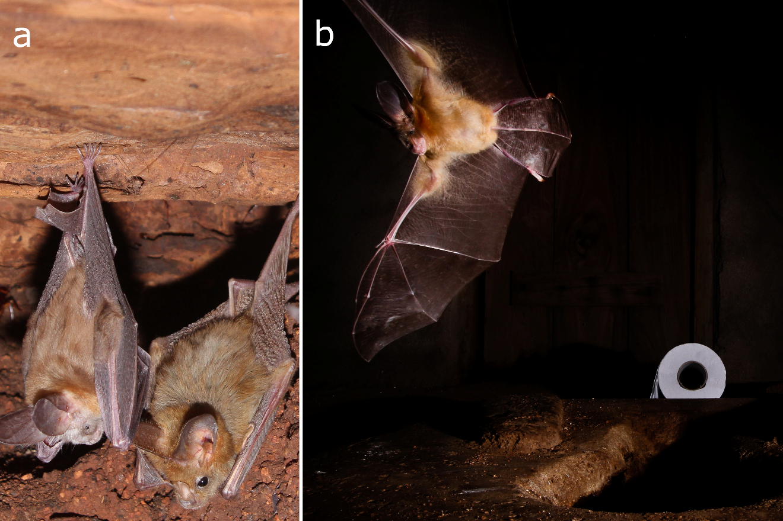
Figure 1. a) Nycteris sp. and Cardioderma cor roosting at the top of a cess-pit. b) Nycteris sp. leaving cesspit in the evening via the toilet's drop-hole. Picture taken using an infra-red beam to remotely trigger a camera.

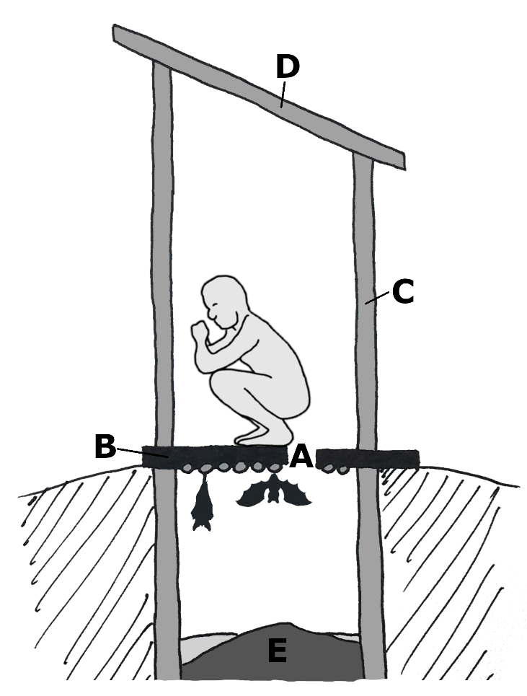
Figure 2. Standard design for all latrines in camp. A. Drop-hole. B. Floor slab and ceiling of cesspit, concrete supported by wooden beams. C. Wall materials made from brick, tightly bound bamboo canes or woven reed mats. D. Roofs made from corregated iron or grass thatch. E. Rotting organic matter.

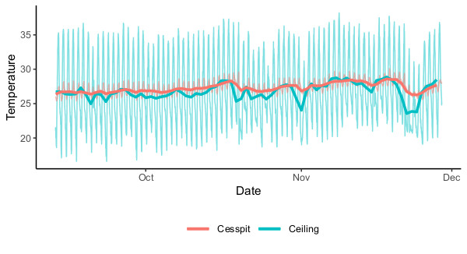
Figure 3. Temperatures recorded in the cesspit and ceiling of one toilet from 13th September 2018 to 28th November 2018. Thin lines denote the temperature recorded at 10 minute intervals and thicker lines the daily average temperatures.

Corresponding Author

