A global evaluation of the effectiveness of voluntary REDD+ projects at reducing deforestation and degradation in the moist tropics
Alejandro Guizar Coutiño, Julia P.G. Jones, Andrew Balmford, Rachel Carmenta, David A. Coomes

Abstract
Reducing Emissions from Deforestation and forest Degradation (REDD+) projects aim to contribute to climate change mitigation by protecting and enhancing carbon stocks in tropical forests, but there are no systematic global evaluations of their impact. Using a new data set for tropical humid forests, we used a standardised evaluation approach to quantify the performance of a representative sample of 40 voluntary REDD+ certified under the Verified Carbon Standard, located in nine countries. In the first five years of implementation, deforestation within project areas was reduced by 47% (95% CI = 24-68%) compared with matched counterfactual pixels, while degradation rates were 58% lower (95% CI = 49-63%). Reductions were small in absolute terms but greater in sites located in high deforestation settings, and did not appear to be substantially undermined by leakage activities in forested areas within 10-km of project boundaries. At COP26 the international community renewed its commitment to tackling tropical deforestation as a nature-based solution to climate change. Our results indicate that incentivising forest conservation through voluntary site-based projects can slow tropical deforestation; they also highlight the particular importance of targeting financing to areas at greater risk of deforestation.

Introduction
Rapid decarbonisation of economies is essential to avert the worst impacts of human-induced climate change but protecting natural ecosystems and the carbon they store is also necessary (Griscom et al. 2017; Seddon et al. 2020). Conserving tropical forests could contribute significantly to achieving net zero emission targets that are needed to limit global warming to below 2 °C in the coming decades (Goldstein et al. 2020). If delivered at scale, keeping carbon stored in forests by avoiding deforestation and forest degradation could be one of the most effective nature-based climate solutions (Griscom et al. 2020). Given that tropical forest ecosystems support the majority of terrestrial biodiversity (Lewis et al. 2015; Barlow et al. 2018), slowing the loss of these vital habitats would also have substantial co-benefits for biodiversity (Di Marco et al. 2018; Watson et al. 2018), particularly if REDD+ helps to conserve threatened forests (Murray et al. 2015). The 26th Conference of the Parties of the United Nations Framework Convention on Climate Change (COP26) saw leaders of over 100 counties, containing over 85% of the world’s forests, make a commitment to bring deforestation and degradation to an end by 2030 through the Glasgow Leaders’ Declaration on Forests and Land Use (UNFCCC 2021), backed by almost USD 20 billion of investments from public and private funds. There is justified scepticism from the international conservation community about the likely realization of this commitment, as previous international commitments have failed to deliver, including most recently the New York Declaration on Forests, which aimed to halve deforestation by 2021 (NYDF Assessment Partners 2020).
Reducing Emissions from Deforestation and Degradation (REDD+) is a multilateral framework for achieving climate change mitigation goals by fostering forest conservation, sustainable management of forests, and enhancement of forest carbon stocks (Agrawal et al. 2011). REDD+ has sought to reduce deforestation and forest degradation by creating financial and institutional mechanisms to deliver genuine emission reductions while benefitting local livelihoods and biodiversity (Holloway & Giandomenico 2009; Agrawal et al. 2011). Around 50 countries have ongoing REDD+ programmes at various stages of development, and more than 350 REDD+ projects have been initiated to date (Simonet et al. 2020). These are likely to vary in effectiveness, for a variety of reasons: they are exposed to different drivers of deforestation and forest degradation (Simonet et al. 2020), have differing social objectives (Sills et al. 2014; Carmenta et al. 2020), engage in different activities to reduce deforestation, and operate under varying degrees of conditionality (Wunder et al. 2018). In practice, REDD+ project implementation has faced many difficulties (Duchelle et al. 2018; Milne et al. 2019). Nevertheless, if the world is going to meet its renewed commitments to protect tropical forests it is important to learn from REDD+ initiatives to date.
Recent studies have evaluated the impact of REDD+ and similar interventions on tropical deforestation. Randomised control trials in Africa have revealed that paying households to reduce deforestation was effective (Jayachandran et al. 2017), while unconditional payments were not (Wilebore et al. 2019). Similarly, a study of REDD+ interventions along Brazil’s Trans-Amazon Highway reported a 50% reduction of deforestation rate compared with matched control sites (Simonet et al. 2019), whereas two other studies of Amazonian REDD+ projects concluded that voluntary REDD+ projects had little impact (West et al. 2020). Deforestation rates in Guyana remained below expected levels while a Norway-supported jurisdictional REDD+ program was active (Roopsind et al. 2019). Given this heterogeneity in results it seems timely to quantify impacts across a large sample of REDD+ projects. To address this gap, here we apply a standardised approach to examine how far site-based REDD+ projects have slowed deforestation across a global sample of projects.
Specifically, we quantified the impact of site-based REDD+ projects on deforestation and forest degradation by examining projects certified by the Verified Carbon Standards (VCS) developed by Verra, one of the leading accreditation registries for voluntary REDD+ projects (Donofrio et al. 2019). We used a new dataset that tracks annual rates of deforestation and forest “degradation” (defined as short-term disturbances detected through changes in the optical properties of forest canopies, which cease to be visible as canopy greenness recovers but may nevertheless correspond to significant biomass loss) across the moist tropics at ~30-m resolution (Vancutsem et al. 2021). We estimated effect sizes by comparing rates of deforestation and degradation after projects were implemented with matched control pixels. Our analysis covers all VCS projects in the humid tropics for which project location maps were provided by Verra, sufficiently long time-series of satellite imagery were available, and appropriate counterfactuals could be identified. We compared REDD+ project areas with matched pixels in the wider landscape, with and without the inclusion of areas included in protected areas (see Appendix S5). Matching pixels in this way provides a “quasi-experimental” analysis of the effectiveness of REDD+, by eliminating from our analyses, to the best of our ability, confounding factors that might have influenced deforestation rates. Leakage, which occurs when deforestation activities in project areas are shifted elsewhere upon project implementation - is a widely acknowledged risk of REDD+ and other forest-based interventions (Pfaff & Robalino 2017). We also evaluated evidence of local leakage by estimating changes in forest loss in forest patches within10-km immediately outside project boundaries (Ewers & Rodrigues 2008). Additionally, we explored how REDD+ effectiveness varies with deforestation threat, defined as the background deforestation rate in the host country during the implementation period, and whether effectiveness varied through time.

Methods

Selection of an initial set of REDD+ projects
REDD+ projects earn carbon credits for independently verified emission reductions relative to a business-as-usual scenario (e.g., an estimation of emissions in the absence of the project); these reductions may arise by avoiding deforestation, reducing degradation or increasing forest cover through reforestation activities. We selected REDD+ sites listed in the VCS database, currently the largest registry for voluntary REDD+ projects (Donofrio et al. 2019), and one of the only registries that had boundary data on REDD+ projects publicly available at the time of the study. Between January and March 2019, we gathered project design documents, validation reports and geospatial datasets depicting project area boundaries from the VCS registry (http://www.vcsprojectdatabase.org). Our analysis focused exclusively on projects categorised as “Reducing Deforestation and Degradation” and established in the tropics (Africa, South-East Asia, Latin America and Oceania) of which 81 were found. We contacted project proponents and the VCS registry to request source boundary files if project boundary maps were not available. For the 71 projects for which we were able to obtain boundary files, we normalised overlapping polygons so that each overlap was contained by a unique geometry and re-projected the database to a Mollweide equal-area projection (Bingham et al. 2019).
The VCS methodology constrained how we could analyse the effects of the projects. Specifically, the avoided deforestation protocols require that a project’s spatial extent (i.e. its “accounting zone”) comprises a parcel of land that has maintained 100% forest cover for at least 10 years prior to the project starting date. Thus, any deforested areas adjacent to, or within, REDD+ boundaries were systematically excluded from the project area boundaries provided to VCS for monitoring, reporting and verification purposes (Shoch et al. 2011). We had no choice other than to adopt a similar approach, defining our basic unit of analysis as a pixel that was observed to have remained as undisturbed forest from 1990 until the project starting year. This meant we could not employ a difference-in-difference approach to isolate the effect of a project because deforestation in the project area was, by definition, zero prior to project commencement. Nevertheless, after-only analysis is widely used to evaluate the impacts of conservation interventions on environmental outcomes including deforestation (Rasolofoson et al. 2015; Eklund et al. 2016; Geldmann et al. 2019).
We diverged from VCS protocols in the approach used to estimate project additionality. Under VCS, a project must select a counterfactual area of forest that has similar deforestation threats to the project area. We instead adopted a pixel-based matching approach, which lead to us having pixels scattered over many sites, instead of a single area. A benefit of this approach is that it ensures that the control set of pixels are exposed to the same geographic drivers of deforestation as the pixels in the REDD+ project sites (Schleicher et al. 2019).

Yearly maps of forest cover, deforestation and forest degradation
Annual maps of forest cover, deforestation and forest degradation were taken from the recently published Tropical Moist Forests (TMF) database (Vancutsem et al. 2021), which was derived from time-series of multispectral imagery collected by Landsat, with pixels of about 30 m resolution. This database provides a long-term characterisation of forest disturbances, on an annual basis from 1990 to 2019. We focused our analyses on quantifying temporal changes between three forest classes as defined by Vancutsem et al.: (a) the undisturbed class, which represents closed evergreen or semi-evergreen forest areas that have not been disturbed over the entire period examined; (b) the degraded class, which represents existing or regrowing evergreen or semi-evergreen forest that has been temporarily disturbed (visible for up to 2.5 years), due to anthropogenic causes such as selective logging or from causes such as wind storms or fires and (c) the deforested class, representing long-term forest disturbances (> 2.5 years) and the complete removal of forest cover. Forest degradation is commonly defined as a loss of productivity and a reduction of forest biomass due to anthropogenic and natural causes (Thompson et al. 2013). However, forest degradation in the TMF database refers to events that substantially but temporarily alter pixel spectral characteristics; these may include sub-pixel changes such as the opening of small logging roads, and the majority (64%) have a duration of less than six months (Vancutsem et al. 2021). Such disturbances may be associated with significant loss of forest carbon stocks and yet appear transient in optical imagery because canopies rapidly regain greenness; hence what appear as short-term disturbance events in the optical imagery may have enduring impacts in carbon stocks and forest structure (Rappaport et al. 2018). However, the relationship between degradation events as characterised in Vancutsem et al. and biomass loss has yet to be quantified.

The 71 REDD+ sites for which we had boundary maps were established in moist and seasonally dry tropical biomes, but as the TMF database does not monitor drier regions, we limited our analysis to sites that were densely forests, i.e., had at least 80% forest cover at the project start date, bringing the total down to 54 projects. Furthermore, since our estimation approach involves analysing forest cover change over a period of at least five years after project implementation (see Impacts of REDD+ projects on deforestation and forest degradation rates) we excluded three projects that had been active for a shorter period. We also excluded one site that started operations before the year 2000 (since this is prior to the operationalisation of REDD+), leaving us with 50 projects with which to search for counterfactual observations for comparison (see Matching).

Sampling design within project areas and surrounding landscapes
We used a pixel sampling approach to characterise project areas (i.e., treatment areas) and the regions where these were located, from which we identified control groups to evaluate treatment effects. Pixels in the treatment areas were sampled by creating a regular pattern of sampling points, each separated by 250 meters, within the boundaries of REDD+ projects, using the project boundary files. To generate observations from which we generated control pixels by matching (see below), a large number of pixels (up to seven times the number in the project area) located within the same country and biome as treatment pixels were sampled at random. We retained pixels if they remained undisturbed for at least 10 years prior to the project starting date (i.e., mirroring the VCS methodology for project areas). Following this approach, all the control and treatment pixels used in our analyses had zero deforestation and degradation rates in the ten years up to project implementation.
To account for local leakage effects in our design, we defined 10-km buffers around the REDD+ interventions (i.e., leakage belts) from which we did not sample pixels for matching. Leakage belts were adjusted to 1) exclude any overlaps with protected areas and other nearby REDD+ projects, and 2) exclude any overlap between buffer zones of REDD+ projects that were close together (n=7) (Appendix S6). We then assessed the extent to which leakage activities took place (e.g., significant differences in deforestation rates) by examining deforestation patterns before and after project implementation within leakage belts (see Quantifying local leakage).

Matching
We performed statistical matching to identify sets of control pixels for each project area that were similar in observable confounders associated with forest loss, thus ensuring that selected controls were exposed to the same drivers of deforestation as project area pixels. To implement a standardised method, we sought a single set of covariates across the full set of sites, acknowledging that drivers of deforestation vary across the countries included in this study (Curtis et al. 2018). We collected pixel-level data on socio-demographic and biophysical characteristics that are typically associated with deforestation (Angelsen & Kaimowitz 2001; Busch & Ferretti-Gallon 2017): elevation and slope (Jarvis et al. 2008), distance to the nearest urban centre in 2015 (Weiss et al. 2018) and distance to forest edge (Laurance et al. 2011). To account for temporal changes in distance to forest edge, we constructed annual time-series of the mean distance to the nearest deforested pixels based on the TMF map. For each sampled pixel, we calculated the distance to the closest pixel that had changed its status from undisturbed to deforested, or from degraded to deforested, during the observed year (for 2000-2019). We then produced a rolling average estimate of the mean distance to the closest deforested pixel in the previous five years, for the period 2005-2019.
Matching was performed with the R MatchIt package (Ho et al. 2011), measuring the similarity between treatment and control pixels using the Mahalanobis distance metric (Legendre & Legendre 1988), which has been shown to result in balanced comparison groups when the number of matching covariates is relatively low (Stuart 2010). We performed 1:1 nearest-neighbour matching with replacement using elevation, slope, mean distance to population centres and mean distance to deforested areas over the five years prior to project commencement (see Appendix S7). We exact-matched on country and terrestrial biome as defined by Dinerstein et al. (2017), and for 10 sites which intersected more than one terrestrial biome (for example, broadleaf forests and mangroves) we subdivided REDD+ sites to generate sets from the same biome to match against controls. By matching within the same tropical moist forests in the same biomes and countries we ensured comparability of bioclimatic conditions for agricultural development. We considered an absolute standardised mean difference of <0.25 between treated and control samples across all covariates as acceptable (Stuart 2010). Only those REDD+ projects that met this criterion for at least 90% of pixels (across all subgroups) were included in further analyses. Ten sites were dropped after matching as these were not matched across all covariates (see Fig. 1, Appendix S14). To evaluate whether the resulting subset of 40 sites was representative of the environmental conditions found in the original set of 71 sites, we ran a logistic regression to predict the probability of being included in this analysis as a function of accessibility, distance to deforestation by project staring date, elevation, Human Development Index (HDI) and project area size. If environmental conditions in the filtered dataset were different from those in the original dataset, we would expect significant effects in the model (having applied a Bonferroni correction for multiple comparisons). Furthermore, we ran a post-hoc analysis of the importance of the covariates we used for matching confirmed that they did indeed predict forest loss, with the final parsimonious model describing a moderate proportion of the observed variation in deforestation across the examined landscapes (Nagelkerke’s r² 0.47) (Appendix S1).
Selecting an appropriate control to evaluate the impact of conservation interventions can be complicated by the presence of other interventions occurring in the examined landscapes (Schleicher et al. 2019). To account for the presence of protected areas we ran a separate set of analyses in which we excluded pixels located within protected area polygons (see Appendix S5), based on the World Database on Protected Areas (UNEP-WCMC & IUCN 2019). We standardised the protected area database by removing areas categorised as “not designated” or “inscribed”, as well as UNESCO Biosphere Reserves (Bingham et al. 2019) and reprojected the geometries to a Mollweide equal-area projection.

Impacts of REDD+ projects on deforestation and forest degradation rates
Annual deforestation and forest degradation rates were calculated for each REDD+ site and its control pixels. To do this, we built a time series of annual rates of deforestation events spanning 2001 to 2019, for all our groups of treatment and matched control pixels. We then estimated annual deforestation rates within a REDD+ project area as: $r_{t}=Δp_{t}/p_{d}$ , where $Δp_{t}$ is the total number of pixels deforested in year $t$ and $p_{d}$ is the number of forested pixels at the start of that project. Annual deforestation rates within control pixels were calculated the same way. We then calculated degradation rates using the same approach in control and treatment sites. Although the TMF database does not differentiate between natural and anthropogenic disturbances, we argue that disturbance by natural causes is similarly prevalent in treated and control sets because of our matching approach, and so our analyses are focussed on disturbance by human activities (i.e. degradation). These time-series provided the information needed to calculate annual deforestation and forest degradation rates from the project starting date for up to 10 years after implementation (where enough data was available).
Absolute differences in deforestation and forest degradation rates between treatments and controls were calculated as ${\overline{r}}_{t}-{\overline{r}}_{c}$for each REDD+ site, where $\overline{r}$ refers to the mean deforestation rate within the first five years of implementation, and the t and c subscripts refer to treatment and control groups, respectively. We used the 40 site-level estimates to derive the global mean change in deforestation and estimated 95% confidence intervals by non-parametric bootstrapping. The same approach was used to calculate site-level differences and global mean change in forest degradation rates. Note that, although we did not incorporate spatial autocorrelation into our analyses of effect sizes, we did reduce autocorrelation in our datasets by taking a systematic sample of pixels within treated areas (each 30 m pixel separated by 250 m), and by drawing random candidate control pixels from other areas of tropical moist forest within the same country and terrestrial biome (excluding leakage belts), prior to matching. Subsequent analyses to evaluate changes in effect size over time were performed with subsets of sites with enough observations to estimate the treatment effect after eight and ten years of implementation, where we used all the temporal observations available at each time subset to estimate the treatment effect.
Site-level proportional differences in forest disturbances were calculated by dividing the mean disturbance rate (e.g. deforestation or forest degradation) at treated sites within the first five years of implementation, by the mean disturbance rate at control groups over the same period, i.e. $\frac{{\overline{r}}_{t}}{{\overline{r}}_{c}}$. The overall mean in deforestation and forest degradation across the 40 sites was calculated to estimate the proportional reduction in disturbance rates associated with REDD+ projects globally; 95% confidence intervals were estimated by bootstrapping.

Effectiveness of REDD+ in relation to background deforestation rates
Given that the sampled REDD+ projects were located in countries and periods with different rates of deforestation, we explored how the REDD+ treatment effect varied with background deforestation. Background deforestation rates was estimated from the mean rates of tropical moist forests loss for the country in which a project was located, during the first five years of project operation (Appendix S8). These rates were used to classify projects into “high threat” and “low threat” categories depending on whether the rates were above or below the mean annual deforestation rate observed across the humid tropics over the last three decades, (i.e. 0.57% yr⁻¹) (Vancutsem et al. 2021). To determine changes in annual forest loss rates between high and low deforestation groups, we grouped site-level mean differences and derived group-level mean estimates with 95% confidence intervals by bootstrapping. We further conducted a Wilcoxon’s rank-sum test to compare differences in reductions between high and low threat groups. To determine threat level proportional differences between treatment and controls, we grouped site-level proportional changes and high and low deforestation groups and derived mean estimates with 95% confidence intervals by bootstrapping. We repeated the same analyses to derive absolute and proportional changes in forest degradation between high and low deforestation groups.

Quantifying local leakage
We evaluated local leakage by testing whether there was a change in annual deforestation rates in the 10-km leakage belts (e.g. buffer zones), following project implementation. Annual deforestation rates within leakage belts were estimated by dividing the area deforested for each year (for 1991-2019), by the extent of undisturbed forests in 1990. We extracted five years of data before and after projects started and tested whether there was an increase in rate following implementation using site-level bootstrapped t-tests. We examined whether leakage grew worse or lessened over time by performing bootstrapped t-tests on subsets of sites with enough observations to examine changes over periods of eight and ten years before and after project implementation.

Results

Project selection
The 40 REDD+ projects selected for this study, following a systematic filtering of the initial database, were located in nine countries and together encompassed 8.38 million ha of humid tropical forest, with a median area of 92,353 ha (interquartile range IQR = 46,192 to 190,660 ha). Thirty-three were in the Americas, five in Africa, one in Asia and one in Oceania (Fig. 1); note that several projects in Africa and Asia were excluded because they were situated in dry forest and savanna regions into which the TMF deforestation maps do not extend. Although the analysed sites represented a subset of the 71 projects initially obtained from the VCS database examination, they were similar to the wider sample in most characteristics but were significantly closer to populated centres (Appendix S17). This suggests that our analysis may be indicative of the performance of REDD+ projects in sites that are more exposed to deforestation (e.g. due to the expansion of infrastructure or agricultural activities; Busch & Ferretti-Gallon 2017).
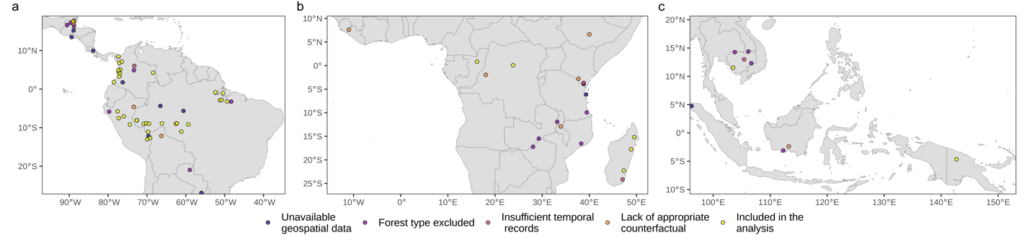
Figure 1: Location of the REDD+ projects included in the analysis. Of 81 tropical REDD+ projects certified by VCS by 2018, 10 did not provide detailed maps of project locations (blue dots), 17 had less than 80% evergreen forest cover at the start of projects (purple), 4 had been operating for fewer than five years or had commenced before the year 2000, and 10 could not be matched with appropriate control pixels (orange), leaving 40 projects in the final dataset (yellow). Panels show projects located in the Americas (a), Africa (b), and Asia and Oceania (c).

The average effectiveness of REDD+ projects
REDD+ project implementation was associated with reductions in both deforestation and forest degradation over their first five years of operation, compared to matched control pixels in the wider landscape (Fig. 2). Reductions in deforestation rates were observed in 34 sites, with small increases observed in six sites (Fig. 2 a), amounting to a mean reduction of 0.22% yr⁻¹ (95% CI= 0.13-0.36% yr⁻¹; Fig. 2 b) compared to the matched controls’ mean deforestation rates of 0.36% yr⁻¹ (95% CI= 0.25-0.55% yr⁻¹). To put this in perspective, the mean deforestation rate in the moist tropics between 1990 and 2019 was 0.57% per year (Vancutsem et al. 2021). Reductions in degradation rates were observed in 33 sites, but small increases were observed in seven sites and increased deforestation was observed in four of these (Fig. 2 c). Estimates amounted to a mean reduction of 0.41% yr⁻¹ (CI= 0.24-0.65% yr⁻¹) when compared with to the matched controls’ mean degradation rates of 0.80% yr⁻¹ (95% CI= 0.60-1% yr⁻¹); we lack a pan-tropical degradation rate to compare with this figure. Expressing these absolute reductions in the rate of deforestation or degradation as relative reductions (i.e., as a percentage of rates observed in controls), we found that REDD+ projects reduced deforestation by 47% (CI = 24-68%) and degradation by 58% (CI = 49-63%) in the first five years (Fig. 3). These annual reductions in deforestation rates amounted to a total of 66,754 ha of avoided forest loss and the annual reduction in degradation amounted to 116,910 ha of avoided forest degradation across all 40 project sites within the first five years of project implementation, which equates to ~0.8% and ~ 1.4%, respectively, of the combined area of these REDD+ projects. Rates of deforestation and degradation were closely correlated among projects (Spearman’s rho= 0.82, p<0.0001; Appendix S9), with degradation occurring at roughly twice the rate of deforestation.
When examining the subset of projects that had been operating for at least eight and ten years (n=24 and 14, respectively) we found no evidence of varying effect sizes through time, as we observed similar estimates of reductions in deforestation (Fig. 3 a) and degradation (Fig. 3 c) throughout these periods. Moreover, estimates of avoided deforestation and forest degradation were hardly affected by whether we included or excluded protected areas from our matching analyses. (Appendix S2-S4), with mean reductions of 0.30% yr⁻¹ (CI= 0.18-0.47% yr⁻¹) in deforestation rates and 0.49% yr⁻¹ (CI= 0.30-0.74% yr⁻¹) in degradation rates relative to matched controls pixels outside protected areas.
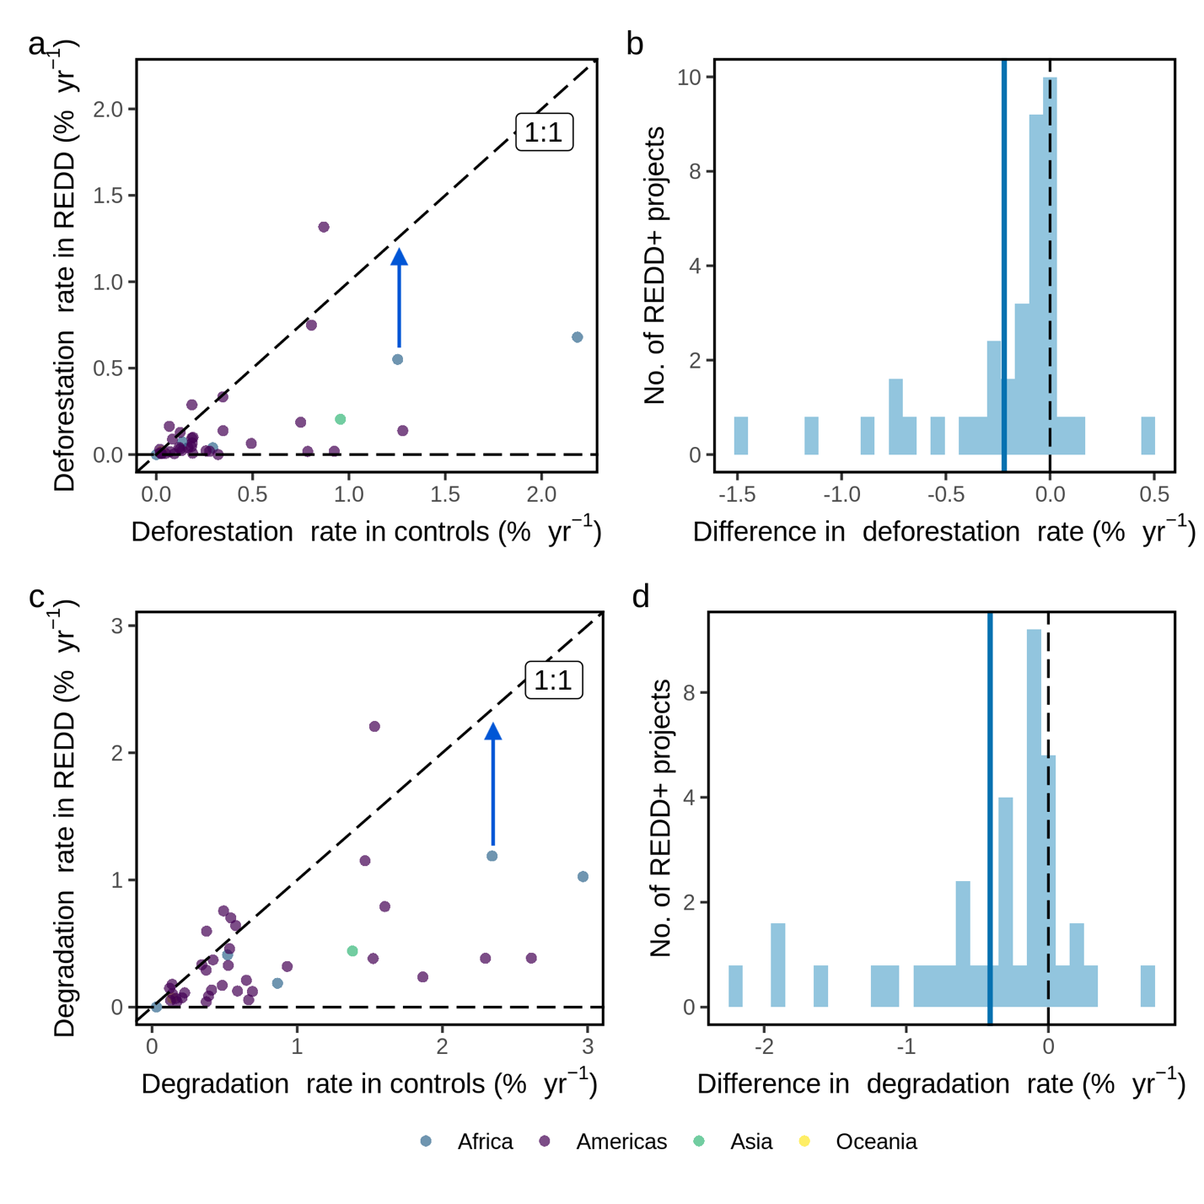
Figure 2: Changes in deforestation and degradation rates resulting from REDD+ projects over their first five years of operation. (a) and (c) scatterplots of deforestation and degradation rates in REDD+ projects versus matched control pixels; with the change in deforestation or degradation resulting from a project is given by the vertical distance between the datapoint and the diagonal 1:1 line (blue arrows); (b) and (d) histograms of the differences in deforestation and degradation rates (relative to controls), with the mean shown as a blue line and vertical dashed lines over the zero threshold.
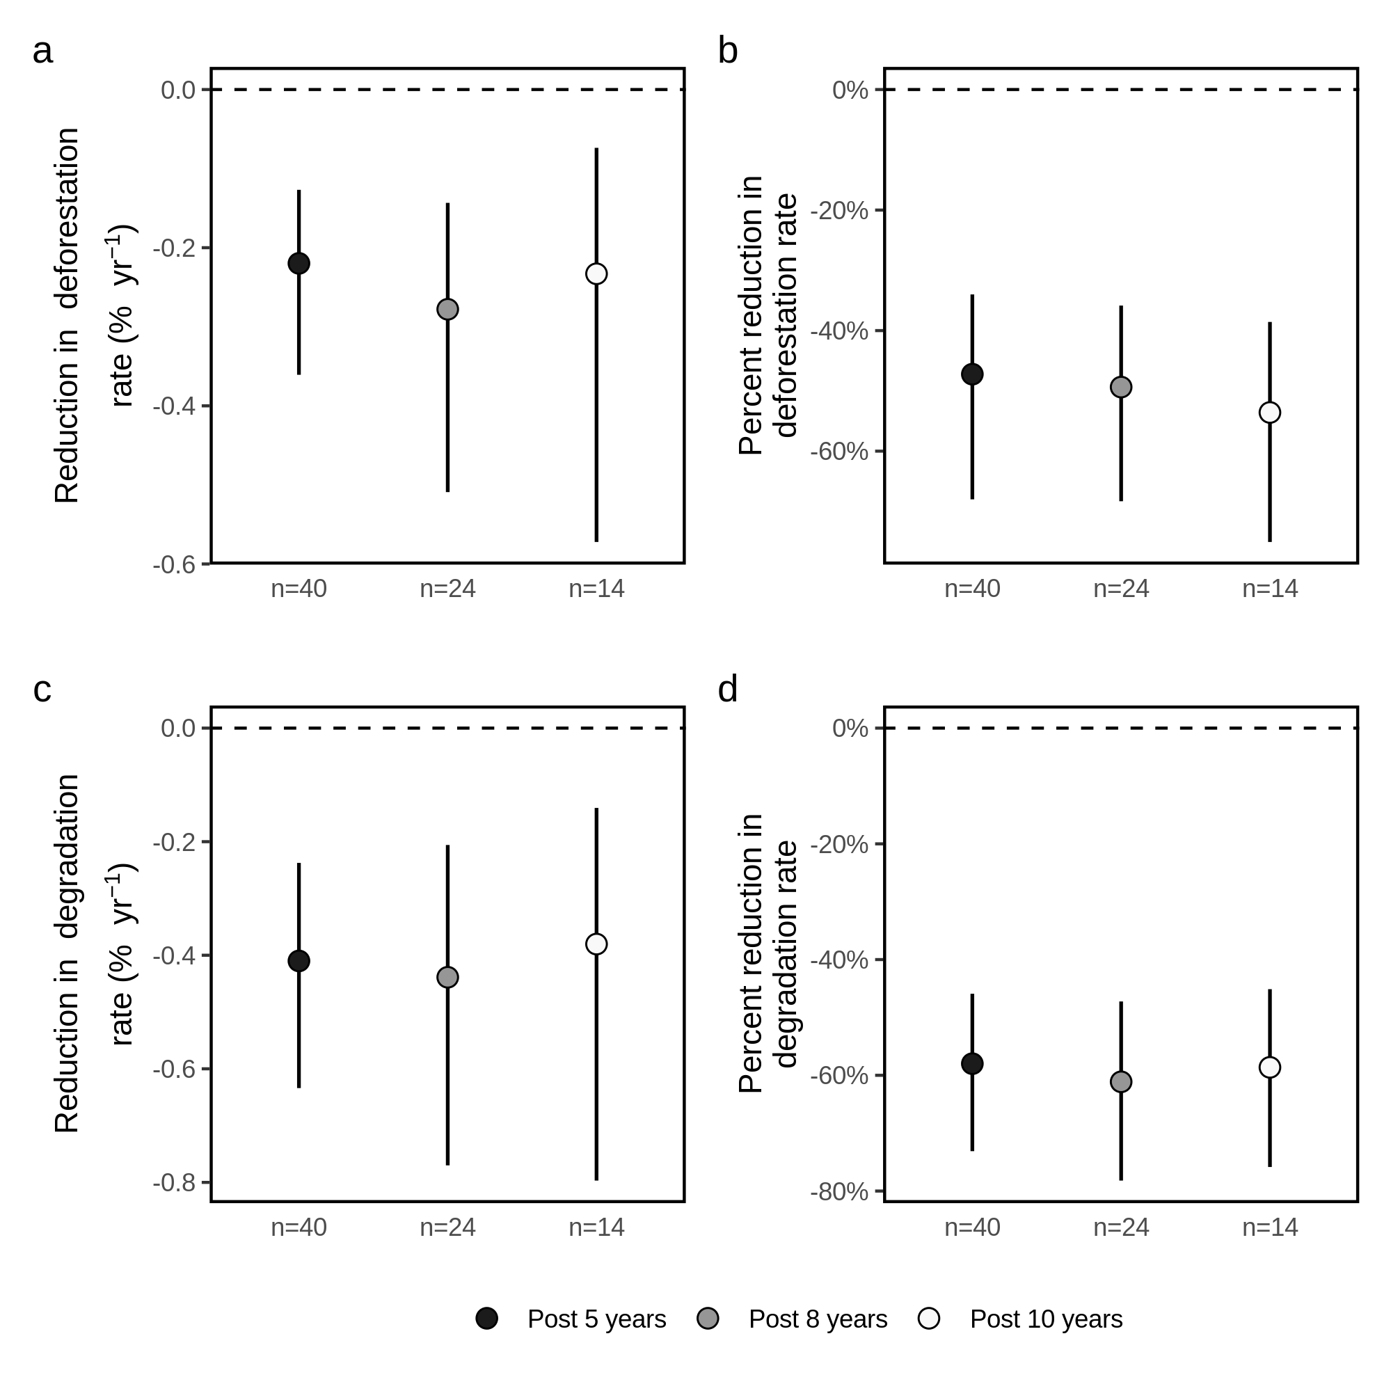
Figure 3: Avoided deforestation and degradation associated with 40 REDD+ projects, for three post implementation periods. (a) and (c) reductions in annual deforestation and degradation rates (means, with 95% confidence intervals); (b) and (d) percent reductions in deforestation and degradation rates (means, with 95% confidence intervals).

Variation in REDD+ effectiveness in relation to background deforestation rates
We observed a moderate correlation between country-level background deforestation rates and reductions in deforestation (Spearman’s rho= 0.42, p=0.006; Fig. 4 b) and reductions in forest degradation (Spearman’s rho= 0.39, p=0.013; Appendix S10). REDD+ projects in the low threat group showed small reductions in deforestation (mean= 0.16% yr⁻¹; CI = 0.07-0.28% y⁻¹) and degradation (mean= 0.33% yr⁻¹; CI = 0.16-0.58% yr⁻¹) rates. Substantially greater effect sizes were observed for the seven projects in the high threat group: deforestation was reduced by 0.52% yr⁻¹ (CI = 0.25-1.0% yr⁻¹) and degradation by 0.79% yr⁻¹ (CI = 0.42 - 1.32% yr⁻¹) (Fig. 4 c). We calculate that 49,197 ha of forest saved by REDD+ projects were in regions of high threat (i.e. 74% of the total saved) even though these forests only represented 20.5% of the total area of the 40 projects investigated. Therefore, in the high threat group, ~2.9% of the area of REDD+ projects were saved over the first five years. When measuring relative reductions in forest disturbances, we observed larger effect sizes in low threat groups compared to high threat groups, with mean reductions in deforestation of 52% (95% CI= 36% to 76%) and 25% (95% CI= 13% to 39%), and mean reductions in degradation of 61% (95% CI= 47% to 79%) and 43% (95% CI= 33% to 60%), in the low and high threat groups, respectively (Fig. 4 d).
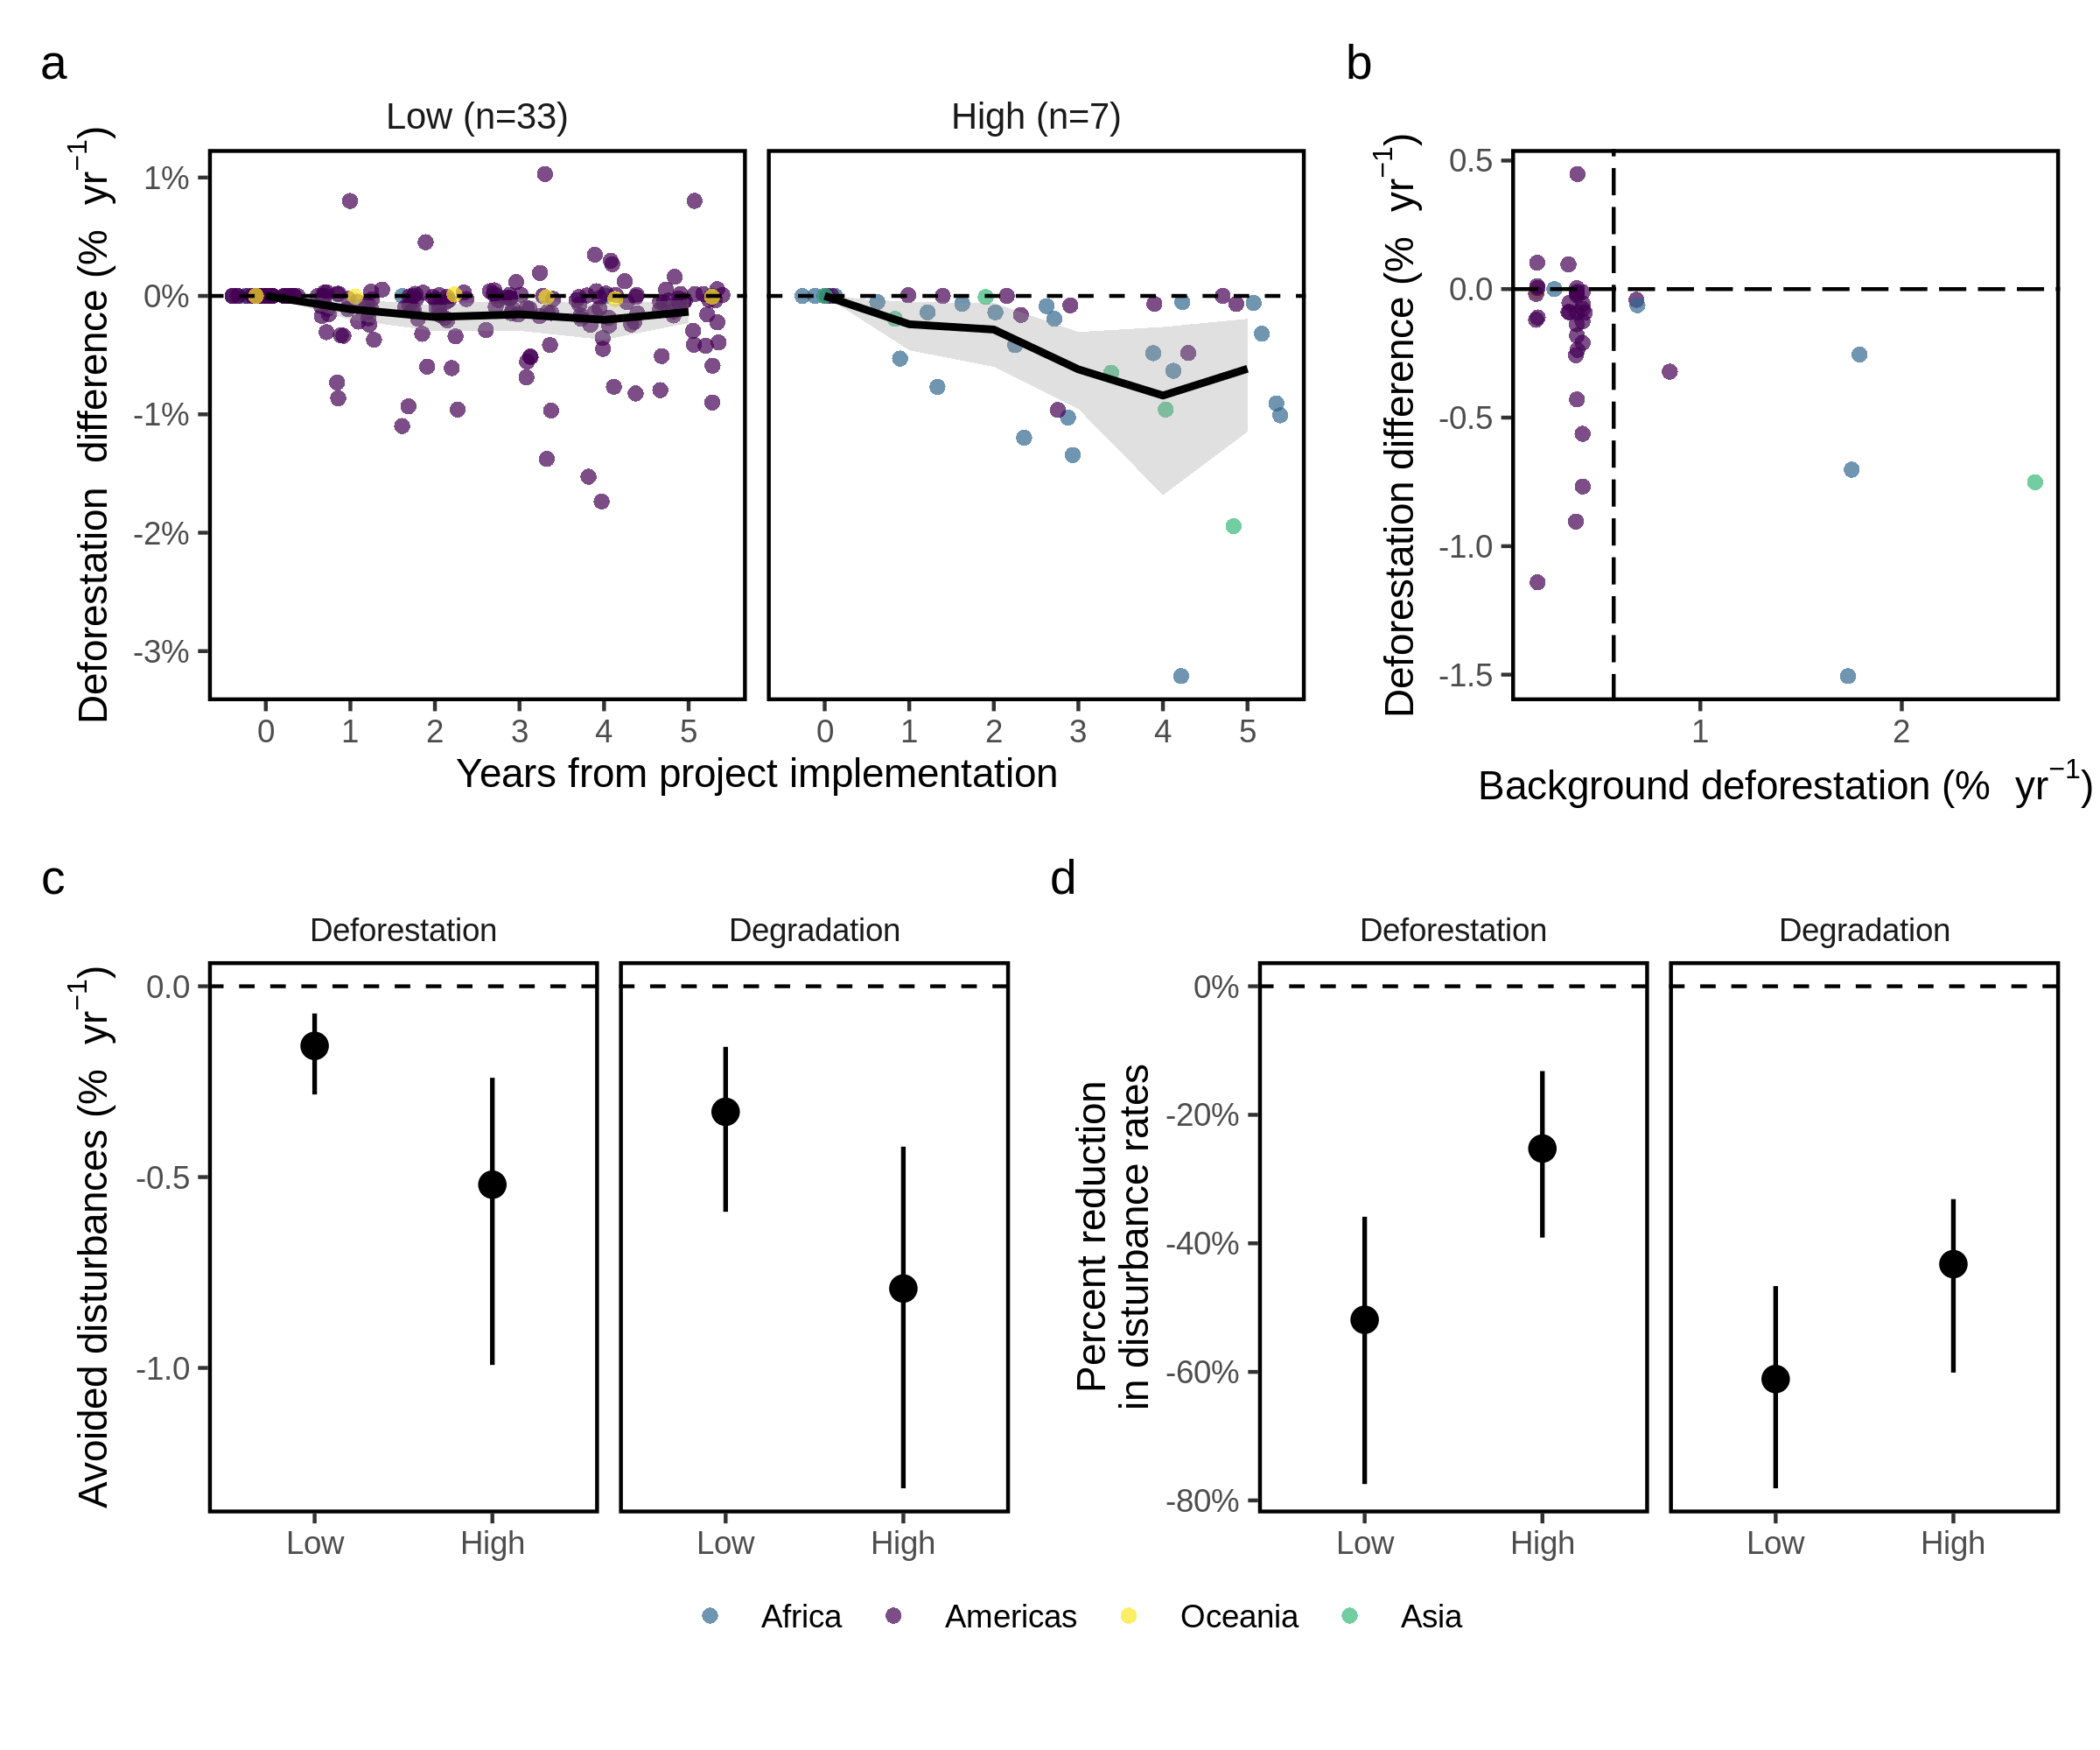
Figure 4: REDD+ project effectiveness in relation to background deforestation rates, for 40 sites in humid tropical forests. (a) annual differences in deforestation (with jitter; % yr⁻¹) between project areas and matched controls over five years after project implementation, with a black line showing the mean annual differences and 95% CI shaded in grey; (b) mean differences in deforestation rates (% yr⁻¹) against country-level background deforestation rates within the humid tropics (calculated for the project implementation period), with a vertical line showing the pan-tropical mean rate of deforestation (0.57% yr⁻¹); (c) mean differences in deforestation and degradation rates within regions categorised as having low (< 0.57% yr⁻¹) or high (> 0.57% yr⁻¹) deforestation rates, based on the average deforestation rate across the entire humid tropics; (d) mean percent reductions in deforestation and degradation rates relative to controls, within regions of high and low deforestation rate. The 95% CIs displayed at a, c and d were estimated using non-parametric bootstrapping.

Evidence of local leakage
Our tests provide no evidence of systematic local leakage of deforestation activities from project areas within the 10-km leakage belts, following project implementation. Within five years of project implementation, three sites had higher rates of deforestation in the leakage belts after project implementation, while two sites had lower rates (bootstrapped t-tests, p < 0.05; Fig. 5). When examining the variation in leakage effects on subset of projects that had been operating for at least eight years, we found one project with higher rates of deforestation, while four sites showed a reduction in deforestation (Appendix S11 a). We found no changes in deforestation rates relative to leakage belts for the subset of projects that had been operating for at least 10 years (Appendix S11 b).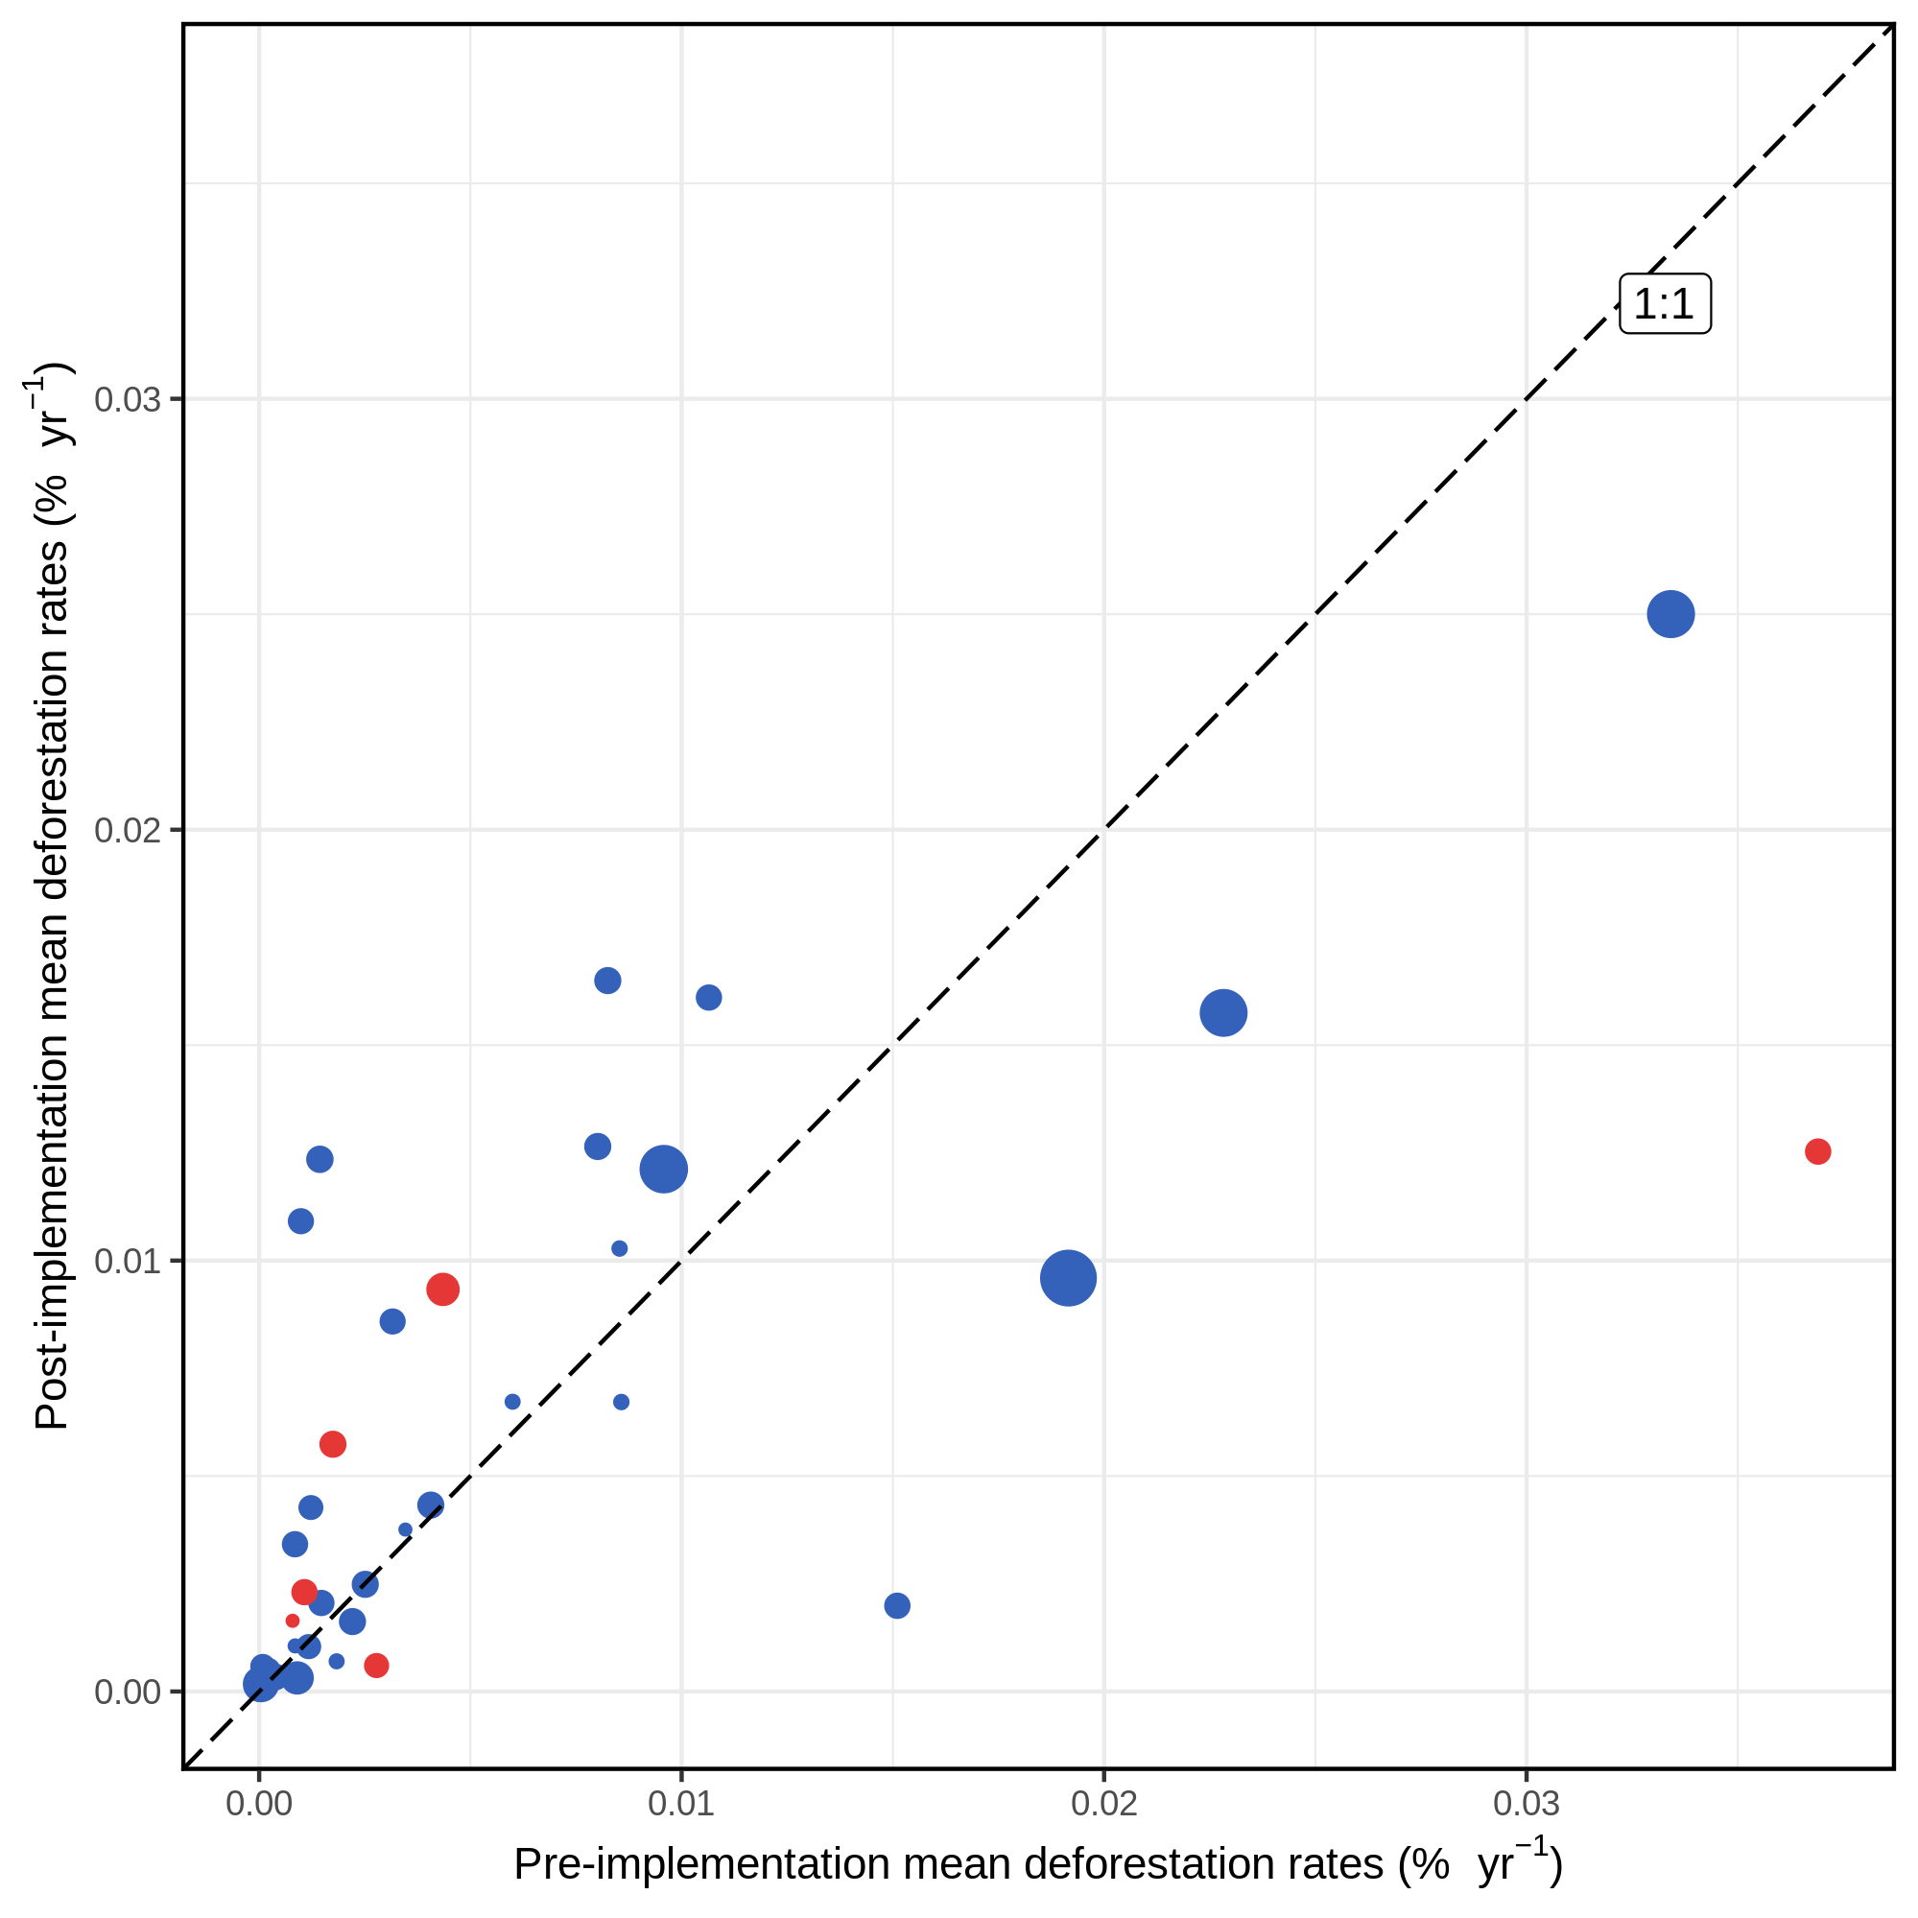
Figure 5: Evidence of deforestation leakage. Filled circles depict the mean rates of deforestation (% yr⁻¹) in the 10-km leakage belt in the five years before (x-axis), and after (y-axis) the commencement of projects. Red circles indicate differences in the post-implementation deforestation rates relative to the pre-implementation period (bootstrapped t-tests, p < 0.05), while blue circles indicate differences were not statistically significant. Circle sizes were scaled to reflect the background deforestation rates observed at the host country within the first 5 years of project implementation.

Discussion
Across 40 voluntary REDD+ projects in nine countries, on average REDD+ interventions reduced deforestation and degradation relative to control pixels over the first five years of operation. REDD+ projects achieved greater reductions in deforestation and forest degradation where the threat of deforestation was greatest. We also find consistent reductions in deforestation and forest degradation when comparing the effectiveness of REDD+ relative to matched pixels outside protected areas. The absolute reductions in these rates were modest in most projects, but in relative terms both rates were roughly halved by the projects we investigated. REDD+ projects did not always deliver reductions in deforestation and degradation: deforestation increased at six sites and forest degradation increased at seven sites, with four sites showing an increase in both deforestation and degradation. Although effect sizes were close to zero for the majority of these sites, our results illustrate the challenges of REDD+ implementation.
To the best of our knowledge, this is the first study that has used remotely sensed degradation and deforestation data to test whether voluntary REDD+ projects are effective at reducing small-scale temporary disturbances, alongside long-term deforestation, across a sample of geographically dispersed projects that differ in deforestation drivers and social objectives. Protecting and restoring natural forests could be a nature-based climate solution that is cost effective and could have substantial impact, if the many hurdles to implementation can be overcome (Duchelle et al. 2018; Milne et al. 2019; TSVCM 2021). Moreover, avoiding deforestation and forest degradation is paramount for safeguarding biodiversity and can play a role in safeguarding non-carbon ecosystem services such as water regulation and soil productivity (Griscom et al. 2017). This paper provides some room for optimism: despite the many challenges to just and economically sustainable implementation, the initial wave of REDD+ projects have been effective at reducing forest loss. The 66,754 ha of spared forests over the first 5 years is small: indeed, it’s smaller than the median size of the examined REDD+ sites (median = 92,353 ha), and much smaller than a typical protected area. Nevertheless, with pressures on biodiverse tropical forests expected to grow in the future (Laurance et al. 2014; Barlow et al. 2018), the evidence that REDD+ has reduced deforestation and degradation where the threat of deforestation was greatest is particularly important. Moreover, the finding that reductions in deforestation and forest degradation were still evident after excluding protected areas from the matching analyses suggests a positive effect of REDD+ that is additional to that achieved by the protected area network.
Estimating the impact of an intervention, such as REDD+, from observational data is inherently difficult as it relies on estimating what would have happened in the absence of the intervention (Ferraro 2009; Ferraro & Hanauer 2014; Baylis et al. 2016). We have matched our REDD+ and control pixels on appropriate drivers of deforestation, but there will inevitably be unobserved covariates. For example, VCS REDD+ projects have often been implemented in areas where conservation NGOs have been operating for some time (Sunderlin & Sills 2012; Usmani et al. 2018) and are likely associated with certain land tenure conditions (Wunder 2013). This has implications for the selection of appropriate controls and therefore our results. For example, where REDD+ projects are the most recent manifestation of longer-running conservation efforts at sites (Lin et al. 2012; Sunderlin & Sills 2012), it is not possible to say how much reductions in deforestation is due to the REDD+ specifically, given the long-term engagement at these landscapes.
Different methods can be used to derive impacts of forest interventions when temporal observations are available for treatment and control groups, before and after project implementation, such as combining matching with difference-in-differences (Costedoat et al. 2015; Santika et al. 2021), or using synthetic control methods to ensure similar pre-treatment deforestation rates between treatment and control groups (West et al. 2020). We use a simpler approach: matching units with similar modelled deforestation risk without any pre-treatment comparisons (e.g. Rasolofoson et al. 2015; Eklund et al. 2016; Geldmann et al. 2019). While this approach has limitations (Schleicher et al. 2019), it was most appropriate for our context: VCS requires projects, when delimiting their boundaries, to exclude from the accounting area any locations where deforestation has taken place in the 10 years prior to the project start date (Shoch et al. 2011). Therefore, the rates of deforestation in the treatment groups are by definition zero prior to the commencement of projects due to active exclusion of deforested pixels, and thus we applied the same constrains when selecting candidate control observations. For the same reason, while we could have combined matching with difference-in-differences, we are restricted to an after-only analysis because deforestation rates in the before period is zero, for both treatment and control groups. Nevertheless, we account for pre-treatment deforestation rates and related deforestation risks by selecting pixels with similar distance to recent forest clearings, which is a strong predictor of deforestation outcomes in the landscapes we examined.
We found that most Brazilian REDD+ projects had a small, positive impact on deforestation (avoided deforestation observed in 11 out of 12 sites Appendix S12 and S18), while a previous analysis focused specifically on the same sites reported no impact or negative impacts for the majority (West et al. 2020; Supp. Fig. 3). These differences are likely to have arisen from differences in the approaches used to construct and match counterfactual areas, and to calculate effect sizes. We used pixels as our unit of analysis, allowing us to restrict deforestation and degradation estimation to forests that were standing at the time of project implementation (in line with VCS requirements). In contrast, West et al. (2020) used georeferenced property boundaries (held in Brazil's Rural Environmental Registry), to construct synthetic controls; this approach uses a weighted combination of untreated property boundaries so that the mean deforestation rates in treated and counterfactual groups were similar in the lead up to project implementation. Further research into the relative merits of different approaches to evaluating the impacts of conservation interventions on deforestation is required.
Leakage is challenging to quantify as it requires the characterisation of enabling factors, such as labour and market conditions (Pfaff & Robalino 2017), with which to produce a forecast of potential displacements of deforestation activities. While acknowledging the limitations of our approach, by examining statistical differences in deforestation after projects became implemented, we did not observe strong evidence of systematic leakage effects into the buffer zones adjacent to REDD+ projects. However, leakage can occur across countries, through international market adjustments in response to local restrictions (Meyfroidt & Lambin 2009) but is very hard to quantify and was not accounted for in our study.
The importance of slowing tropical deforestation and degradation received much attention at the most recent meeting of the COP26 in Glasgow, but the term REDD+ was hardly used. Perhaps the reduction in the use of the term REDD+ is an example of what Redford et al. (2013) call a ‘conservation fad’; where what was seen as an innovative new idea becomes tainted by disappointment with the challenges of real-world implementation and donors, policy makers and practitioners essentially reinvent the concept with new terminology. However, it is essential to learn from the last decade of REDD+ implementation. REDD+ projects have already provided invaluable lessons on the central role of land tenure in implementation (Larson et al. 2013), the necessity of ensuring that the rural poor do not bear the cost of forest conservation efforts (Duchelle et al. 2018; Poudyal et al. 2018; Skutsch & Turnhout 2020), and the need for effective benefit-sharing systems and appropriate participation in decision-making and governance (Luttrell et al. 2013; Milne et al. 2019). Our study also highlights the need to standardise methodologies for establishing baselines with which to evaluate the effectiveness of forest-based interventions to reduce emissions; a point also made by West et al. (2020). It is currently not possible to establish the aggregate impact of voluntary site-based REDD+ projects because the various methodologies used to forecast emissions reductions are incomparable and produce different baseline scenarios (Wilebore 2015).
As our understanding of the carbon stores in tropical forest ecosystems improves (Dargie et al. 2017), and as we gain further understanding of the feedbacks between tropical deforestation and climate change (Baccini et al. 2017), the case for tropical forests being central to climate change mitigation efforts grows stronger. Our analysis shows promising evidence that site-based REDD+ projects have helped to reduce deforestation, particularly in areas of higher deforestation threat. Yet, emissions reductions in the 40 REDD+ projects analysed represent a tiny fraction of global emissions: in total they amount to about 0.01% of 2018 emissions, or 0.13% of emissions from tropical deforestation in 2013. The need to scale up activities is well-recognised. Jurisdictional REDD+ programs, operating at regional or national scales following UNFCCC REDD+ framework of 2013, may address some of the major challenges faced by site-based REDD+ projects (Duchelle et al. 2019). Most importantly, larger-scale efforts may be better placed to address the fundamental challenge that key drivers of deforestation are embedded in global and domestic supply chains for commodities such as beef, palm oil and soya (Curtis et al. 2018; zu Ermgassen et al. 2020), as well as the expansion of extractive activities such as mining (Davis et al. 2020), so cannot be effectively tackled with site-based interventions alone (Delabre et al. 2020). Encouragingly, there is evidence that jurisdictional programs can deliver results: Guyana’s national-level program reduced deforestation loss by 35% between 2010 and 2015 (Roopsind et al. 2019). Applying the lessons from the last few decades to deliver effective and, crucially, equitable reductions in tropical forest degradation and deforestation will be critical if the Glasgow COP26 climate change objectives are to be met.
Supporting Information
Additional information is available online in the Supporting Information section at the end of the online article. The authors are solely responsible for the content and functionality of these materials. Queries (other than absence of the material) should be directed to the corresponding author.

References
Agrawal A, Nepstad D, Chhatre A. 2011. Reducing Emissions from Deforestation and Forest Degradation. Annu. Rev. Environ. Resour. 36:373–396.
Angelsen A, Kaimowitz D. 2001. Agricultural Technologies and Tropical Deforestation. CABI.
Baccini A, Walker W, Carvalho L, Farina M, Sulla-Menashe D, Houghton RA. 2017. Tropical forests are a net carbon source based on aboveground measurements of gain and loss. Science 358:230–234.
Barlow J et al. 2018. The future of hyperdiverse tropical ecosystems. Nature 559:517–526.
Baylis K, Honey‐Rosés J, Börner J, Corbera E, Ezzine‐de‐Blas D, Ferraro PJ, Lapeyre R, Persson UM, Pfaff A, Wunder S. 2016. Mainstreaming Impact Evaluation in Nature Conservation. Conservation Letters 9:58–64.
Bingham HC et al. 2019. Sixty years of tracking conservation progress using the World Database on Protected Areas. Nature Ecology & Evolution 3:737–743.
Busch J, Ferretti-Gallon K. 2017. What Drives Deforestation and What Stops It? A Meta-Analysis. Review of Environmental Economics and Policy 11:3–23.
Carmenta R, Coomes DA, DeClerck FAJ, Hart AK, Harvey CA, Milder J, Reed J, Vira B, Estrada-Carmona N. 2020. Characterizing and Evaluating Integrated Landscape Initiatives. One Earth 2:174–187.
Costedoat S, Corbera E, Ezzine-de-Blas D, Honey-Rosés J, Baylis K, Castillo-Santiago MA. 2015. How Effective Are Biodiversity Conservation Payments in Mexico? PLOS ONE 10:e0119881.
Curtis PG, Slay CM, Harris NL, Tyukavina A, Hansen MC. 2018. Classifying drivers of global forest loss. Science 361:1108–1111.
Davis KF et al. 2020. Tropical forest loss enhanced by large-scale land acquisitions. Nature Geoscience 13:482–488.
Dargie GC, Lewis SL, Lawson IT, Mitchard ETA, Page SE, Bocko YE, Ifo SA. 2017. Age, extent and carbon storage of the central Congo Basin peatland complex. Nature 542:86–90.
Delabre I, Boyd E, Brockhaus M, Carton W, Krause T, Newell P, Wong GY, Zelli F. 2020. Unearthing the myths of global sustainable forest governance. Global Sustainability 3:e16.
Di Marco M, Watson JEM, Currie DJ, Possingham HP, Venter O. 2018. The extent and predictability of the biodiversity-carbon correlation. Ecol. Lett.
Dinerstein E et al. 2017. An Ecoregion-Based Approach to Protecting Half the Terrestrial Realm. Bioscience 67:534–545.
Donofrio S, Maguire P, Merry W, Zwick S. 2019. Financing Emissions Reductions for the Future: State of the Voluntary Carbon Markets 2019. State of the Voluntary Carbon Markets. Forest Trends’ Ecosystem Marketplace, Washington, DC.
Duchelle AE, de Sassi C, Sills E, Wunder S. 2018. People and communities: Well-being impacts of REDD+ on the ground. Pages 131–141 Transforming REDD+. CIFOR.
Duchelle AE, Seymour F, Brockhaus M, Angelsen A, Larson A, Moira M, Wong GY, Pham TT, Martius C, others. 2019. Forest-based climate mitigation: Lessons from REDD+ implementation. WRI.
Eklund J, Blanchet FG, Nyman J, Rocha R, Virtanen T, Cabeza M. 2016. Contrasting spatial and temporal trends of protected area effectiveness in mitigating deforestation in Madagascar. Biological Conservation 203:290–297.
Ewers RM, Rodrigues ASL. 2008. Estimates of reserve effectiveness are confounded by leakage. Trends in Ecology & Evolution 23:113–116.
Ferraro PJ. 2009. Counterfactual thinking and impact evaluation in environmental policy. New Directions for Evaluation 2009:75–84.
Ferraro PJ, Hanauer MM. 2014. Advances in Measuring the Environmental and Social Impacts of Environmental Programs. Annual Review of Environment and Resources 39:495–517.
Geldmann J, Manica A, Burgess ND, Coad L, Balmford A. 2019. A global-level assessment of the effectiveness of protected areas at resisting anthropogenic pressures. Proc. Natl. Acad. Sci. 116:23209–23215.
Griscom BW et al. 2017. Natural climate solutions. Proc. Natl. Acad. Sci. 114:11645–11650.
Griscom BW et al. 2020. National mitigation potential from natural climate solutions in the tropics. Philosophical Transactions of the Royal Society B: Biological Sciences 375:20190126. Royal Society.
Goldstein A et al. 2020. Protecting irrecoverable carbon in Earth’s ecosystems. Nature Climate Change 10:287–295
Ho D, Imai K, King G, Stuart EA. 2011. MatchIt: Nonparametric Preprocessing for Parametric Causal Inference. Journal of Statistical Software 42:1–28.
Holloway V, Giandomenico E. 2009. The History of REDD Policy. Carbon Planet.
Jarvis A, Reuter HI, Nelson A, Guevara E. 2008. Hole-filled SRTM for the Globe. v4. CGIAR. Available from http://srtm.csi.cgiar.org.
Jayachandran S, de Laat J, Lambin EF, Stanton CY, Audy R, Thomas NE. 2017. Cash for carbon: A randomized trial of payments for ecosystem services to reduce deforestation. Science 357:267–273.
Larson AM et al. 2013. Land tenure and REDD+: The good, the bad and the ugly. Global Environmental Change 23:678–689.
Laurance WF et al. 2011. The fate of Amazonian forest fragments: A 32-year investigation. Biological Conservation 144:56–67.
Laurance WF, Sayer J, Cassman KG. 2014. Agricultural expansion and its impacts on tropical nature. Trends Ecol. Evol. 29:107–116.
Legendre P, Legendre L. 1988. Numerical ecology (2nd Edition), 2nd edition. Elsevier.
Lewis SL, Edwards DP, Galbraith D. 2015. Increasing human dominance of tropical forests. Science 349:827–832.
Lin L, Pattanayak SK, Sills EO, Sunderlin WD. 2012. Site selection for forest carbon projects. Pages 209–230 Analysing REDD+: Challenges and choices. CIFOR, Bogor, Indonesia.
Luttrell C, Loft L, Fernanda Gebara M, Kweka D, Brockhaus M, Angelsen A, Sunderlin W. 2013. Who Should Benefit from REDD+? Rationales and Realities. Ecology and Society 18.
Meyfroidt P, Lambin EF. 2009. Forest transition in Vietnam and displacement of deforestation abroad. Proc. Natl. Acad. Sci. 106:16139–16144.
Milne S, Mahanty S, To P, Dressler W, Kanowski P, Thavat M. 2019. Learning From ‘Actually Existing’ REDD+: A Synthesis of Ethnographic Findings. Conservation & Society 17:84–95.
Murray JP, Grenyer R, Wunder S, Raes N, Jones JPG. 2015. Spatial patterns of carbon, biodiversity, deforestation threat, and REDD+ projects in Indonesia. Conserv. Biol. 29:1434–1445.
NYDF Assessment Partners. 2020. Goal 1 assessment: Striving to end natural forest loss. New York Declaration on Forests Progress Assessment. Climate Focus.
Pfaff A, Robalino J. 2017. Spillovers from Conservation Programs. Annual Review of Resource Economics 9:299–315.
Poudyal M, Jones JPG, Rakotonarivo OS, Hockley N, Gibbons JM, Mandimbiniaina R, Rasoamanana A, Andrianantenaina NS, Ramamonjisoa BS. 2018. Who bears the cost of forest conservation? PeerJ 6:e5106.
Rappaport DI, Morton DC, Longo M, Keller M, Dubayah R, dos-Santos MN. 2018. Quantifying long-term changes in carbon stocks and forest structure from Amazon forest degradation. Environmental Research Letters 13:065013.
Rasolofoson RA, Ferraro PJ, Jenkins CN, Jones JPG. 2015. Effectiveness of Community Forest Management at reducing deforestation in Madagascar. Biological Conservation 184:271–277.
Redford KH, Padoch C, Sunderland T. 2013. Fads, Funding, and Forgetting in Three Decades of Conservation. Conservation Biology 27:437–438.
Roopsind A, Sohngen B, Brandt J. 2019. Evidence that a national REDD+ program reduces tree cover loss and carbon emissions in a high forest cover, low deforestation country. Proc. Natl. Acad. Sci. 116:24492–24499.
Santika T, Wilson KA, Law EA, St John FAV, Carlson KM, Gibbs H, Morgans CL, Ancrenaz M, Meijaard E, Struebig MJ. 2021. Impact of palm oil sustainability certification on village well-being and poverty in Indonesia. Nature Sustainability 4:109–119.
Schleicher J, Eklund J, Barnes MD, Geldmann J, Oldekop JA, Jones JPG. 2019. Statistical matching for conservation science. Conservation Biology 34:538–549.
Seddon N, Chausson A, Berry P, Girardin CAJ, Smith A, Turner B. 2020. Understanding the value and limits of nature-based solutions to climate change and other global challenges. Philosophical Transactions of the Royal Society B: Biological Sciences 375:20190120.
Shoch D, Eaton J, Settelmyer S. 2011. Project developer’s guidebook to VCS REDD methodologies. Version 2.0. Conservation International.
Sills EO, Atmadja SS, de Sassi C, Duchelle AE, Kweka DL, Resosudarmo IAP, Sunderlin WD. 2014. REDD+ on the ground: A case book of subnational initiatives across the globe. CIFOR.
Simonet G et al. 2020. ID-RECCO, International Database on REDD+ projects and programs: Linking Economics, Carbon and Communities. v4. CIFOR. Available from http://www.reddprojectsdatabase.org.
Simonet G, Subervie J, Ezzine-de-Blas D, Cromberg M, Duchelle AE. 2019. Effectiveness of a REDD+ Project in Reducing Deforestation in the Brazilian Amazon. American Journal of Agricultural Economics 101:211–229.
Skutsch M, Turnhout E. 2020. REDD+: If communities are the solution, what is the problem? World Development 130:104942.
Stuart EA. 2010. Matching Methods for Causal Inference: A Review and a Look Forward. Statistical Science 25:1–21.
Sunderlin WD, Sills EO. 2012. REDD+ projects as a hybrid of old and new forest conservation approaches. Pages 177–191 Analysing REDD+: Challenges and choices. CIFOR, Bogor, Indonesia.
Thompson ID, Guariguata MR, Okabe K, Bahamondez C, Nasi R, Heymell V, Sabogal C. 2013. An Operational Framework for Defining and Monitoring Forest Degradation. Ecology and Society 18:20.
TSVCM. 2021. Taskforce on scaling voluntary carbon markets. Institute of International Finance. Available from www.iif.com/Portals/1/Files/TSVCM_Report.pdf.
UNEP-WCMC, IUCN. 2019. Protected Planet: The World Database on Protected Areas (WDPA). Available from www.protectedplanet.net.
UNFCCC. 2021. Glasgow Leaders’ Declaration on Forests and Land Use. Available from https://ukcop26.org/glasgow-leaders-declaration-on-forests-and-land-use/ (accessed January 11, 2022).
Usmani F, Jeuland M, Pattanayak SK. 2018. NGOs and the effectiveness of interventions. UNU-WIDER.
Vancutsem C, Achard F, Pekel J-F, Vieilledent G, Carboni S, Simonetti D, Gallego J, Aragão LEOC, Nasi R. 2021. Long-term (1990–2019) monitoring of forest cover changes in the humid tropics. Science Advances 7:eabe1603.
Watson JEM et al. 2018. The exceptional value of intact forest ecosystems. Nature Ecology & Evolution 2:599–610.
Weiss DJ et al. 2018. A global map of travel time to cities to assess inequalities in accessibility in 2015. Nature 553:333–336.
West TAP, Börner J, Sills EO, Kontoleon A. 2020. Overstated carbon emission reductions from voluntary REDD+ projects in the Brazilian Amazon. Proc. Natl. Acad. Sci. 117.
Wilebore B, Voors M, Bulte EH, Coomes D, Kontoleon A. 2019. Unconditional Transfers and Tropical Forest Conservation: Evidence from a Randomized Control Trial in Sierra Leone. American Journal of Agricultural Economics 101:894–918.
Wilebore RAL. 2015. Valuing forests in tropical landscapes in the context of REDD+. University of Cambridge.
Wunder S. 2013. When payments for environmental services will work for conservation. Conservation Letters 6:230–237.
Wunder S, Brouwer R, Engel S, Ezzine-de-Blas D, Muradian R, Pascual U, Pinto R. 2018. From principles to practice in paying for nature’s services. Nature Sustainability 1:145.
zu Ermgassen E, Godar J, Lathuillière MJ, Löfgren P, Gardner T, Vasconcelos A, Meyfroidt P. 2020. The origin, supply chain, and deforestation risk of Brazil’s beef exports. Proc. Natl. Acad. Sci. 117:31770–31779.

