The “Living Law” 100 years after Eugen Ehrlich. Two Workshops in Paris and Frankfurt

Eugen Ehrlich died in 1922, not even 60 years old, in poverty, from diabetes, which was incurable at the time. Behind the exiled Professor of Roman Law laid a life with highs and lows: rejection by many dominant Austrian/German legal scholars but international acclaim, the satisfaction of being able to demonstrate his approach with empirical fieldwork, and discrimination for political (and likely antisemitic) reasons. Many excellent scholars stood at the cradle of sociology of law, but, with Klaus F. Röhl, it can be said that Ehrlich’s book “Grundlagen der Soziologie des Rechts” (“Foundations of the Sociology of Law” in Moll’s English translation) forms the “foundation document” of our subject discipline (Röhl/Machura 2013, 1117).
In September 2022, two conferences were organized to celebrate Ehrlich’s work, take stock, and assess its relevance for the future. A group of Parisian colleagues (Picture 1) invited academics from the host country, from Japan, Germany, Canada, and the United Kingdom to the Université Paris 1 Panthéon-Sorbonne to discuss Ehrlich‘s work and its possible adaptations and uses today. The symposium titled “L’actualité de la pensée d’Eugen Ehrlich pour les méthodes empiriques du droit” (September 22 and 23, 2022) concentrated on the last two chapters of Ehrlich’s “Grundlegung”, the methods chapters. The presenters covered perspectives from legal history and legal theory (Ralf Seinecke, Frankfurt; Amanda Perry-Kessaris, Kent), sociology of law (including Jean-Baptiste Scherrer, Paris; Alain Pottage, Paris; David Nelken, London; Werner Gephart, Bonn; Garronce Navarro-Ugé, Paris; Yoshiki Kurumisawa, Tokyo; Éveline Serverin, Paris; Michel Coutu, Montreal; Claude Didry, Paris; Marc Hertogh, Groningen, and the writer of thes lines); as well as anthropology (Judith Beyer, Konstanz; Nafay Chaudhury, Cambridge). The symposium was held bilingually, in French and English, and the odd sentence in German was thrown in for good measure. Further colleagues from yet more countries followed the discussion online and asked questions in the chat.
Unfortunately, Ehrlich is almost unknown in France as his works are not translated into French. The organisers of the event are planning to change this and are thinking of, not only publishing papers from the symposium, but also about ways to translate key works of Ehrlich. For sure, publications on Ehrlich are filling many bookshelves, yet the Austrian scholar was typically misunderstood. Ehrlich himself has to be blamed partly, as he was more the creative and polemic essayist and less of a systematic thinker. In addition, the impact of World War One, when Russian troops conquered and lost Czernovitz, his home city, several times, as well as his advancing ill health led to the legal scholar’s inability to finish his publication programme. What we know as the “Grundlegung” was only the first volume in a series of three (Rehbinder 2022, 5). The second volume should have covered Ehrlich’s legal dogmatics, and a third volume his empirical findings in the Bukovina province. Of these, only parts of the second book were published and they demonstrate clearly – countering a common misperception – that Ehrlich did not intend to allow judges to deviate from the legal code. On the contrary, where the legislator has foreseen the conflict and the interests involved in it, the judge was to be strictly bound by the law (Ehrlich 1967, 187). Perhaps, the term “free finding of law” which Ehrlich coined was slated to give a false impression to the uninitiated reader from the start. Only where there is a genuine gap, where the code falls silent, the sociological background knowledge and the observation skills of the judge have their place (Ehrlich 1925, 309-313). This reduces the many meters of publications on Ehrlich to a more manageable few in which the authors take into account the full range of Ehrlich’s theories.
The most prominent sociological concept of Ehrlich must be the “living law”. Yet, as the discussion in Paris (and at the Frankfurt conference) also showed, its meaning remains often unclear. The best way to approach this, is possibly to distinguish two manners of speech in Ehrlich’s sociology of law. When Ehrlich is in rhetorical mode, he uses “living law” to basically sell his ideas, drawing on the contemporary popularity of the expression “living”, but when he writes analytically, he juxtaposes “societal law” and “state law” (Vogl 2003, 161-162, 170). According to Ehrlich, law is either developing outside of the state, with most of the law originating there, or by the state.
The “living law” is simply the law that is actually practiced. And as law is originating mostly in the society as a response to ever-changing social or economic problems, the “living law” tends to be of the non-state variant. Only from time to time, the legislation manages to catch up with societal law (situation t₂ in Figure 1), but soon forces in society (the “associations”) have further developed the law (t₃). According to Ehrlich, state intervention is often to the detriment of the situation, but with its force, the state can at times constrain the use of law (t₄). Yet, it lies in the logic of Ehrlich’s ideas that the state will not be successful for long (t₅). Therefore, depending on the case at hand, the “living law” can or cannot consist of state law. For example, when a state tax system recognises useful business expenses as tax deductible, and thus validates business practice, the state law is like the societal law and as they are like, state law is simultaneously “living law”. At the symposium, Nafay Chaudhury demonstrated that after the ousting of the Taliban in 2001, the newly established Afghan Central Bank had to formally accept, as law, the way in which money traders at the Kabul money market self-organised their business. To continue with the tax example, exporters of technology may start to pay bribes to officials in developing countries and to tax deduct the expenses. Driven by moral concern, politicians may then change the tax law and, with the costs no longer possible to include in the firm’s bookkeeping, the practice may seize (t₄). Yet, after a while, a new “useful” practice is developed, for example, instead of employing the blunt instrument of money handouts, things like lavish PhD scholarships to relatives of decision-makers are offered (t₅), or the company pays for a hospital in a politician’s constituency. As these examples have tried to demonstrate, Ehrlich actually has a dynamic model of how law develops and takes effect, how society’s practices become state law, and how state law reflects back to society. The term “living law” covers this forward and backward.
Yet, all depends on the assumption that there is something like societal “law”. And the root of the famous debate between Kelsen and Ehrlich (reprinted in: Lüderssen 2003) lies exactly here. As David Nelken explained at the Sorbonne conference, it ended with Ehrlich challenging Kelsen to a duel. Had Kelsen agreed, it may have ended badly for him, as fencing was Ehrlich’s hobby. Ehrlich did not want Kelsen to actually take up the challenge, he wanted to make his point. Of course, a duel was forbidden by the penal code, but it was a feature of “living law” at the time, including in academic circles, just the kind of law the existence of which Kelsen stubbornly denied.
Does Ehrlich merit attention for reasons other than the history of sociology of law or of legal history? Separately, Marc Hertogh and I argued that this indeed is the case, partly drawing on studies of legal consciousness linking them to the assumption of Ehrlich that law has a foundation in people’s emotional relation to law. The point was well taken by the audience, familiar with the similar theory of Durkheim, the key author of French sociology.
A week later, in Frankfurt, and with proceedings now in German language, Ehrlich was remembered. The Max Planck-Institute for Legal History and Legal Theory, Department of Multidisciplinary Legal Theory, headed by Marietta Auer, had invited scholars not only from Germany, but from Japan, the UK, Switzerland and Austria. Here, Ralf Seinecke acted as co-organiser, taking a more appreciative view of Ehrlich than the institute director who missed system and clarity in Ehrlich’s oeuvre. From the presenters in Paris, Seinecke and the author of these lines contributed. Personally, I was especially looking forward to the presentation of Stefan Vogl (Kyoto), who apart from Manfred Rehbinder, must be the leading international Ehrlich scholar. This time, Vogl explained the divergent perspectives of Pound and Ehrlich, with both being influenced by the very different legal issues in their societies. Pound misunderstood (or misrepresented?) Ehrlich’s theory in many respects, Vogl argued. Doris Schweitzer (Frankfurt at the Main) showed how Ehrlich was initially received by German sociologists. Most of the presenters and definitely most of the audience at the legal history institute were interested in relating Ehrlich to predecessors and contemporaries among legal scholars. As for the Paris conference, only a selection of contributions will be reported here. Very impressively, emeritus professor Joachim Rückert of the Institute provided a plethora of comments, especially on Ehrlich’s relation to the Historische Rechtsschule in Germany. Nikolaus Linder (Göttingen) illuminated the position of Ehrlich as a scholar of Roman Law. Ehrlich has written little on the subject he was teaching at Czernovitz, but he read the ancient sources from an original perspective that challenged the predominant interpretation at his time. Romanists have forgotten his contribution but in recent years, Ehrlich’s interpretation of Roman Law was vindicated in new publications. A bibliometric study on Ehrlich in the literature was introduced by Christian Boulanger (Frankfurt at the Main). As Boulanger explained, the software is not yet ready to adequately cover especially the German literature, in which footnotes are the predominant form of citation. This said, the available data show different times at which Ehrlich was quoted in different countries. Unlike at the Paris symposium, a vocal minority of the Frankfurt participants expressed passionate opposition against Ehrlich and his work on grounds of a lack of clear systematic argument. This may be a view held particularly by those preferring the legal dogmatic literature and to stand on the firm grounds of the codified law. For sociologists of law and all interested in a fuller picture of legal phenomena, the perspective must include the “non-state law”, however. -- Again, a book with the conference papers is in preparation.
All in all, both conferences reflect a renewed interest in the works of Eugen Ehrlich, its predecessors, contemporary relations, and the fluctuating and selective impact of his work. Although Ehrlich is an important figure, a lot of detail is still missing. For example, we don’t know anything about his years as an Austrian lawyer, waiting to get a paid teaching position. What cases did he deal with? Did they influence the turn his academic interests took towards a sociologically grounded jurisprudence?
Stefan Machura

References
Eugen Ehrlich, Die juristische Logik, 2nd edition, Aalen 1925.
Eugen Ehrlich, Freie Rechtsfindung und freie Rechtswissenschaft, in: Eugen Ehrlich, Recht und Leben, edited by Manfred Rehbinder, Berlin 1967, pp. 170–202.
Eugen Ehrlich, Fundamental Principles of the Sociology of Law, translated by Walter L. Moll, 2nd edition, New Brunswick, NJ 2002.
Klaus Lüderssen (ed.), Rechtssoziologie und Rechtswissenschaft, Baden-Baden 2003.
Manfred Rehbinder, Vorbemerkungen des Herausgebers, in: Eugen Ehrlich, Grundlegung der Soziologie des Rechts, 5th edition, edited by Manfred Rehbinder, Berlin 2022, pp. 5-9.
Klaus F. Röhl and Stefan Machura, 100 Jahre Rechtssoziologie: Eugen Ehrlichs Rechtspluralismus heute. Juristenzeitung 68 (2013), 1117–1128.
Stefan Vogl, Soziale Gesetzgebungspolitik, freie Rechtsfindung und soziologische Rechtswissenschaft bei Eugen Ehrlich, Baden-Baden 2003.
Picture 1: Organising team of the Paris symposium
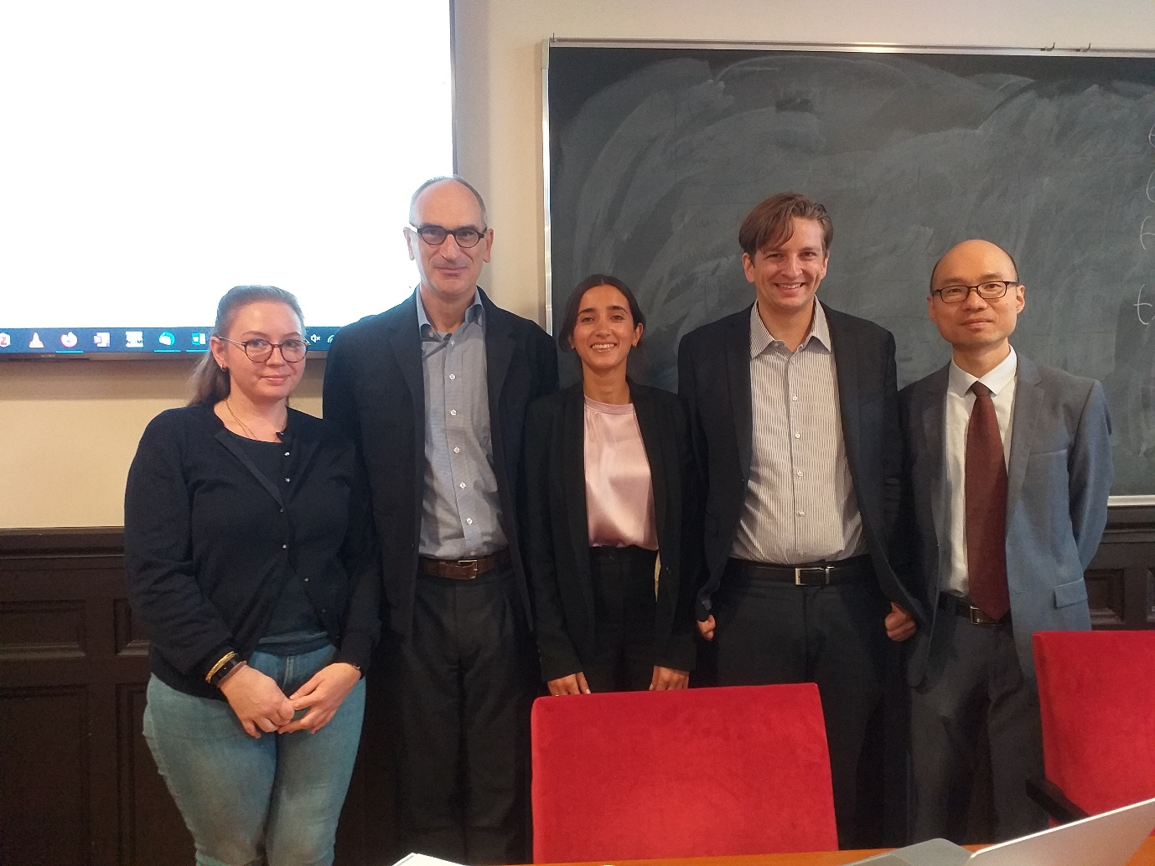
From left to right: Nathalie Sacksick, Pierre Brunet, Clara Gavelli, Jean-Baptiste
Scherrer, Linxin He (photo S. Machura)

Picture 2: Group photo of participants at the Paris symposium
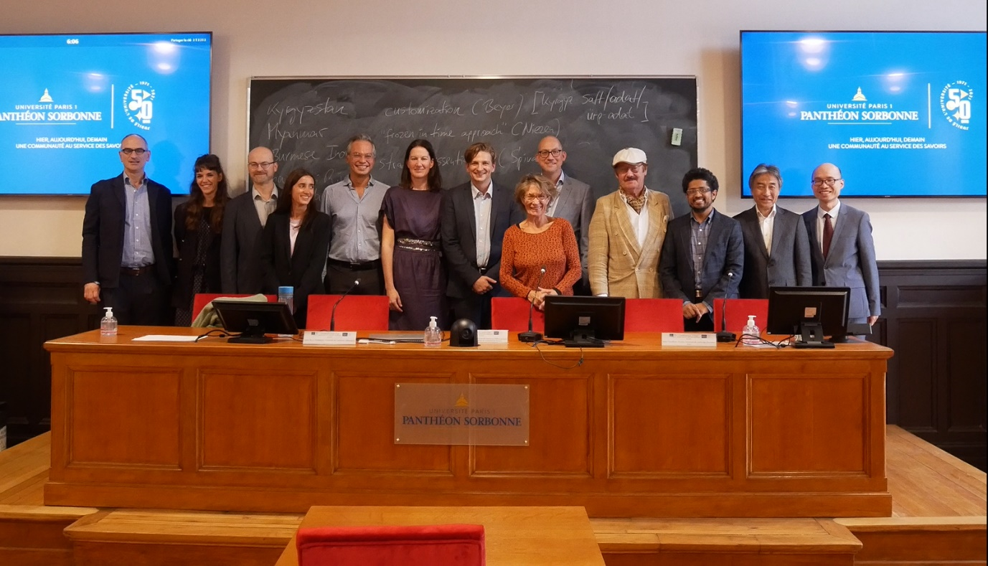

(Printed with kind permission of Y. Kurumisawa)

Figure 1: Living law, societal law and state law according to Ehrlich’s dynamic model

. . .
t₅ |  | ≠
t₄
t₃ |  | ≠
t₂ |  | =
t₁ | Living Law
Timeline | Societal law | Relation | State law

(Source: S. Machura)

