Beauty, Totality, Violent Law

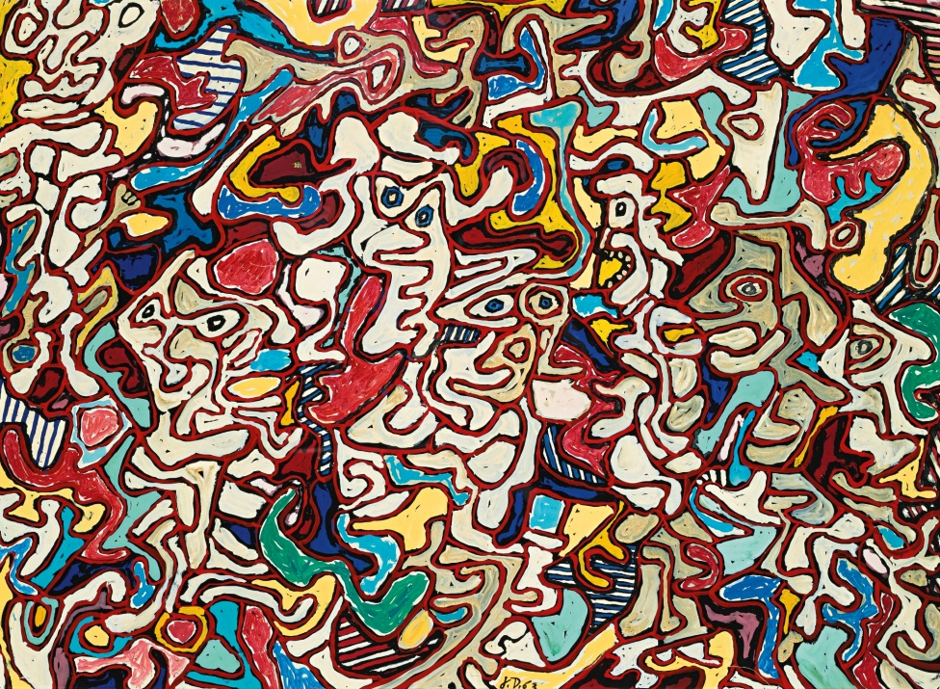
Jean Dubuffet, 1963, Théâtre des Errements III

I remember those heady days before and after the London Summer Riots back in 2011, racing through Hackney to get back to my Clapton sublet, trying to avoid being caught in what was happening on the streets, feeling the blistering energy, the vagrant anger as I traversed zones speedily on two wheels.

I can distinctly recall the feeling of frenetic excitement, at being present during an acute moment of resistance, a flashpoint of property damage and burgeoning violence, where those previously dormant around me now reached forth in a bifurcation of rage and disillusionment. This, from what was evident, was a protest, an outrage against race infused police violence in the killing of Mark Duggan, a reaction to a world of property and exclusion, depleting opportunities and full circle commodity completion.

Equally, what still sits with me today was the treatment of dependent rioters by the lower courts, and ultimately, in the resultant ruling of R v Blackshaw & Others [2011] EWCA Crim 2312, where the crime of ‘riot-related-offending’ was borne, exacerbating sentencing guidelines for those committing petty crimes as a result of complicity in a wider scale riot. This may seem fair enough to some, but in order to understand the Riots in their full historicity, one has to look beyond the superficial disruption caused, the looting and property destruction. All things happen for a reason, and this is where my journey on complexity, entropy, law and aesthetics, properly began.

Moved by the happenings, the riots made me re-think the way law decides who is acceptable and who is unacceptable, whose voice is heard and whose is not, in light of an aesthetic of order and disorder, useless and useful, and I wrote a piece for Law and Critique to reflect this. The scientific measurement for the quantity of disorder in a system (and thus how useless/useful a system is), is entropy. The more entropy there is in a system, the more disorder there is – and yet the more ordered and complex a system becomes too. Imagine a body, the more it ages the more complex and advanced it is, and the more it decays at the same time. Yet, interestingly, a system would be lost without its chaos, as starved of it, there would no change, adaptation, resilience – it would cease to exist.

If you think of it in terms of the Riots, taking place in a country resting its advanced neoliberal capitalism, you could see who the marginalised and apparently chaotic and ‘disordered’ or ‘useless’ might just be. And yet the entropic metaphor gives clarity on those who are deemed useless, as actually fundamental, the heart of a system that functions as a result of their existence and their role. This might seem a functional and almost exploitative one at that, and perhaps sadly it is given Britain’s seething history of dependency and colonialism, and its continued malavalent denial of a disordered past through the irruption of Brexit.

What has this to do with the title, beauty, totality, and violent law? Yesterday, I was listening to a new record by Charlotte Adigéry entitled ‘1,681’, a French artist basing her contents and lyrics on 1.681 as the ‘Golden Ratio’ in maths and aesthetics for proportion, harmony and supposedly how humans ascribe beauty through an ordered collection of aesthetically-pleasing measurements and relations. A poignant rendition that demonstrates how traditional notions of beauty within aesthetics, mathematics and psychology, celebrate the ordered, the total, and denigrate the disordered, and influence what we see as respectable and acceptable, and ultimately the reverse.

And yet who is to say what is beautiful and what is not beautiful? Fundamentally, I would say, the law. Examples such as the Summer Riots clearly demonstrate how the law is moulded around certain (very Western) conceptions of order and disorder, acceptability, civility; a Victorian cover up of all that is unsavoury and uncouth, and yet congenital to the history of the society that we live in. The entropy, metaphor, for me, brings to life the inimical coupling of law and aesthetics as it shapes and manifests law and legal form through deciding what is suitable and insuitable, thus legal and illegal. Going back to the Summer Rioters, this denigration continues as the Court of Appeal recently rejected the Duggan family’s request to quash the lawful killing verdict clearing the police officer who shot Mark Duggan, of any wrongdoing.

It also decides what is art and what is not art. Look at the division in the art world between Outsider Art and the ‘insider’ art establishment – the term outsider troubles me and does so despite self-defined outsider artists saying they are happy with the label. This delimiting of inside/outside recalls the proper and improper that Austrailian jurist Margaret Davies speaks of, where law is defined by relations of those with and those without property, and ultimately the elitist order/disorder dichotomy that law enjoys. The art establishment expects artists to have followed a certain order , both as artists and the art they produce, where a certain trajectory of ‘being an artist’ is fulfilled; but again this is a very Western tunnel-vision of aesthetics, the establishment, what is considered art, just in the same way as what we come to perceive is acceptable through law, is reinforced. Events such as the Summer Riots, demonstrate how sections of society are defined by what they are not, by their very omission and rejection, and the violent exclusionary processes of law and aesthetics combined.

Questioning how our ascribed understandings of what is beautiful, acceptable, can give us invaluable insights into our legal system, the role of aesthetics, how these are interlinked, and ultimately, how we teach this to our lawyers of the future. What entropy specifically can teach us is the similar (and interlinked) problematics attached to methods of categorisation and ascription in law and aesthetics. Disorder is misrepresented as ugly, illegal and reprehensible; and the striving for totality and perfection through order in art and law, is neither possible, nor desirable, given the consequences that we have seen and indeed see today, in totalitarian politics of fascism and racism. It doesn’t matter that you haven’t had the correct training to give you the light and composition expected for a ‘complete’ work of art, because actually, the beauty is the incompleteness. The same for the rioter – you are rioting because of the violence of the order of the system.

How this can assist us in a practical art/law pedagogy of accepting the unacceptable, is to specifically recognise in our teachings of law, that law itself is subject to these aesthetic artifice, and reinforces a given reality as a result. Donna Haraway talks of how we should be ‘making with’, thinking beyond the realities that we have now, and speculating how things might be different, using narrative, making, fabricating. This involves working directly with objects and narratives, aesthetics and politics, to envision new, practical forms of the now (and for our purposes, law). It is only through the task of seeing from the counterpoint, as critical thinkers in law have been doing for many years, that we are able to generate new ways of legal learning and creating. It is through understanding the role of aesthetics in law, as well as the importance of using this within legal teaching methods, that we can even begin to understand the juncture we have arrived at today. I hope that this little excurson into entropy might offer one of those moments of departure.

