The future of ocean renewable energy
  - Simon P. Neillª
  - ªBangor University, School of Ocean Sciences, Menai Bridge, LL59 5AB, UK
  - Email: s.p.neill@bangor.ac.uk

Abstract
The energy supply sector is the largest contributor to global greenhouse gas emissions. The ocean offers many options for reducing greenhouse gas, particularly through the development of renewable energy technologies. However, although the ocean holds vast amounts of energy, it is drastically underdeveloped. In this chapter, the nature and key aspects of these ocean renewable energy options are introduced, including wave and tidal energy, ocean current energy, and Ocean Thermal Energy Conversion (OTEC). Future opportunities in the development of ocean renewable energy are discussed, including innovative materials, novel methods for resource assessments, and co-location of multiple ocean renewable energy technologies.

Keywords: Marine renewable energy, Wave energy, Tidal energy, OTEC, Ocean current energy, Salinity gradient energy, Climate change, Ocean based options

1. Introduction
Established in 1988, the IPCC (Intergovernmental Panel on Climate Change) recently published its Sixth Assessment Report, consisting of three Working Group contributions and a Synthesis Report. The report of Working Group III, published in April 2022, focuses on the mitigation of climate change [1]. The energy supply sector is the largest contributor to global greenhouse gas (GHG) emissions, yet offers a large number of options that could reduce GHG emissions. However, the stabilization of GHG concentrations at low levels will require a fundamental transformation of the energy supply system, including the long-term phase-out of fossil fuel conversion technologies and their substitution by low-GHG alternatives. Of all identified ocean-based options to address climate change (across all sectors), marine renewable energy stands out as having the highest theoretical potential for addressing the main ocean impacts (ocean warming, ocean acidification, sea-level rise), taking advantage of an advanced stage of technology readiness [2].

World electricity production is dominated by fossil fuels. In 2019, 63% of global electricity production was via the combustion of fossil fuels (coal, oil, and natural gas), 10% was nuclear, and 27% renewables (Fig. 1). Of these renewables, these were dominated by hydro (59% of global renewable electricity generation in 2019) and wind energy (19%). Hydropower – which relies on the hydrological cycle – has clear current and future potential in the electricity mix, especially as it is highly dispatchable. However, there is another water-based form of renewable energy conversion that is often overlooked, despite its prevalence and significant global potential – ocean renewable energy. Note that, although wind farms can be sited in the marine environment, offshore wind is not a direct form of ocean renewable energy conversion, and so is not included in this chapter other than discussions on co-location (Section 8.2).

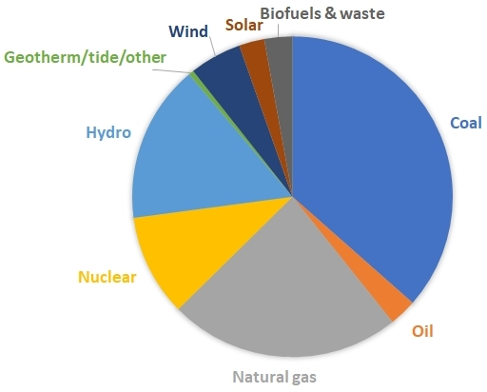
Figure 1: Global electricity generation by fuel type, 2019. Data from the International Energy Agency, https://www.iea.org/data-and-statistics/data-tables/?country=WORLD&energy=Electricity

Ocean renewable energy consists of six forms of energy conversion (Table 1). The global ocean renewable energy resource has been estimated to be around 2 TW – around 70% of the world’s electricity consumption. Around half of this resides in OTEC (1 TW) which, since it requires a large vertical gradient in the temperature of sea water (e.g. at least 20°) is confined to equatorial regions. Since there is little commercial progress (particularly due to the challenges and cost associated with semi-permeable membrane technologies [3]), salinity gradient energy is not considered further in this chapter.

Ocean energy type | Global resource (GW) | Technology types
Wave energy | 100 | Attenuator  Point absorber
OTEC | 1000 | Closed cycle  Open cycle
Ocean current | 500 | Horizontal axis turbine  Kite
Salinity gradient | 50 | Pressure retarded osmosis (PRO)  Reverse electrodialysis (RED)
Tidal range | 100 | Barrage  Lagoon
Tidal stream | 100 | Horizontal axis turbine  Vertical axis turbine
Table 1: Ocean renewable energies, including estimates of the global technical resource and main technology types.

In this chapter, the nature and key aspects of the ocean renewable energy solutions are introduced, and commercial progress highlighted. The chapter concludes with a discussion on the future of ocean renewable energy, including improved observations and modelling, and cost reduction through co-location.

2. Wave energy
Waves are a common occurrence in nature. Although waves in the natural environment occur over a wide range of scales, from capillary waves with periods less than 0.1 s, to trans-tidal waves with periods of over 24 h, the waves that are suitable for wave energy conversion generally have periods of between 1 − 25 s, with corresponding wave lengths of around 5 − 200 m [4].

Waves occur when momentum from the wind field is transferred into the ocean. Locally, for example at the centre of a storm, wind waves are generated, and the energy is characterized by a wide range of wave frequencies. Further from the storm, the waves travel at different speeds depending on their frequency (i.e. they disperse), and the sea may be characterized by a local (wind) component in addition to a swell component that represents energy from the distant storm. Information on the wave energy distribution can be presented in the form of a wave energy spectrum, where the wave energy (related to the amplitude squared) is plotted against each wave frequency (Fig. 2).

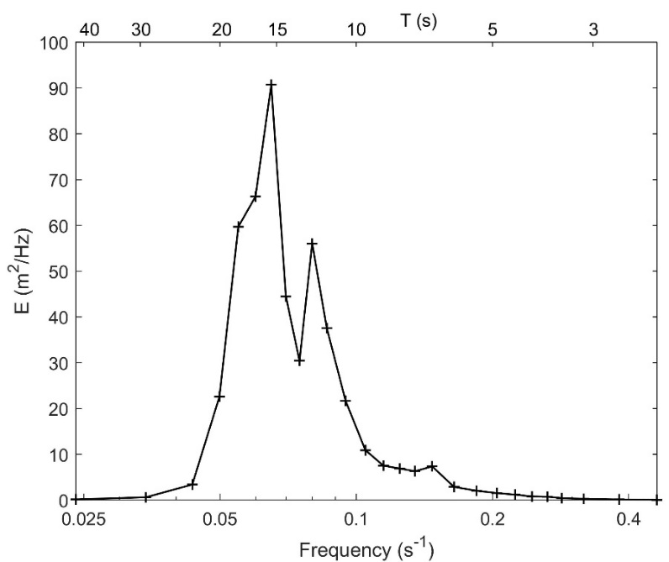
Figure 2: One dimensional wave spectrum from the West of Hebrides wave buoy, west coast of Scotland, 7th January 2023, 15:00. The significant wave height is 6.96 m and the peak wave period is 15.4 s. However, note that the wave spectrum is bi-modal, with a local and swell component. Data from https://www.cefas.co.uk/cefas-data-hub/wavenet/

In addition to frequency, the speed of wave propagation also depends on water depth. The relationship between water depth, wave frequency and wave number is described by the dispersion equation

$$σ^{2}=gk\tanh{(kh)}$$
( 1 )
where $σ=2π/L$ is the angular frequency (T is wave period), g is acceleration due to gravity, h is water depth, and $k=2π/L$ is the wavenumber (L is wave length). As you can see from Eq. 1, provided water depth is not a limiting factor (i.e. in deep water where the water depth is much greater than the wave length), then $\tanh\left(kh\right)=1$ and the phase speed (c) becomes

$$c=\frac{g}{σ}=\frac{gT}{2π}$$
( 2 )
i.e. the phase speed in deep water depends only on the wave period, and hence long period (low frequency) waves propagate faster than short period (high frequency) waves. Therefore, when waves generated at the centre of a storm propagate away from their source, the longer period (longer wave length) waves propagate fastest. For example, if a wave buoy is sited 1000 km from the centre of a storm in the Pacific Ocean, the longer period waves will be detected first. Since wave energy travels at the group velocity (which is half the phase speed in deep water), a 14.8 s wave would take 12 h to arrive at the observation station, whereas a 7.4 s wave would take 24 h – an example of dispersion (Eq. 1). Note that in shallow water, where the wave length is much greater than the water depth, $\tanh\left(kh\right)=kh$ and Eq. 1 simplifies to $c=\sqrt{gh}$ – the same result as a tidal wave (Section 5).

Waves contain equal proportions of potential energy (due to the displacement of the free surface) and kinetic energy (due to wave orbital motion), and the total energy E is

$$E=\frac{{ρgH}^{2}}{8}$$
( 3 )
where H is wave height and ρ is water density. Wave power P (assuming deep water conditions, i.e. where h ≫ L) is

$$P=\frac{ρg^{2}}{64π}H_{s}^{2}T_{e}$$
( 4 )
where H_{s} is the significant wave height (the mean height of the largest one third of waves in a record) and T_{e} is the energy wave period; therefore large amplitude long period waves are the most promising for wave energy conversion.

3. Ocean Thermal Energy Conversion (OTEC)
The temperature of the ocean is fixed at the sea surface by heat exchange with the atmosphere. However, there is a latitudinal variation in the incoming energy from the Sun at the Earth’s surface – for example, the average incoming energy from the Sun is about four times higher at the equator compared to the poles. In contrast, the average infrared radiation heat loss to space is relatively constant with latitude. As a result, there is a net input of heat to the Earth’s surface into the tropical regions, and this is where we find the warmest surface seawater. Heat is subsequently transferred from the tropics to high latitudes by winds and ocean currents.

Cold water is denser than warm water; therefore cold dense water sinks to the bottom of ocean basins, below the warmer surface water. Combined with the wind-driven surface flow (Section 4), the sinking and transport of cold water creates a complex pattern of ocean circulation, often referred to as the ‘global conveyor belt’. Since surface waters are warmer at the tropics, there is a large temperature difference between the surface and deep water at low latitudes (for example >20°C over the uppermost 1000 m – Fig. 3). In contrast, at higher latitudes there is a much lower temperature difference, for example ≈10°C over the uppermost 1000 m at mid-latitudes. It is possible to exploit the large vertical temperature gradient at low latitudes in a process known as Ocean Thermal Energy Conversion (OTEC).

Although warm tropical sea water at ≈25°C is at too low a temperature to boil water (to produce steam and drive a turbine), other working fluids, such as ammonia, have much lower boiling points – therefore a closed cycle OTEC power plant uses ammonia as the ‘working fluid’. This working fluid circulates around a closed loop as shown in Fig. 4. Warm water from the sea surface flows through a heat exchanger, causing the working fluid to boil and vaporize. This vaporized fluid flows through a turbine, which turns a generator that converts the energy into electricity. Upon leaving the turbine, the working fluid needs to be cooled so that it can be reused, otherwise the efficiency of the system would drop significantly. Cold water pumped from the deep ocean flows through a second heat exchanger that cools the working fluid to its original temperature, ready to enter the cycle again. The cold water from the deep ocean, now at a slightly elevated temperature, is discharged into the ocean. The warm water from the ocean surface, at a slightly reduced temperature, is discharged into the upper ocean. An alternative to the closed cycle OTEC power plant is an open cycle power plant, where the sea water itself is used as the working fluid; however such systems are not as actively pursued as closed cycle OTEC [5].

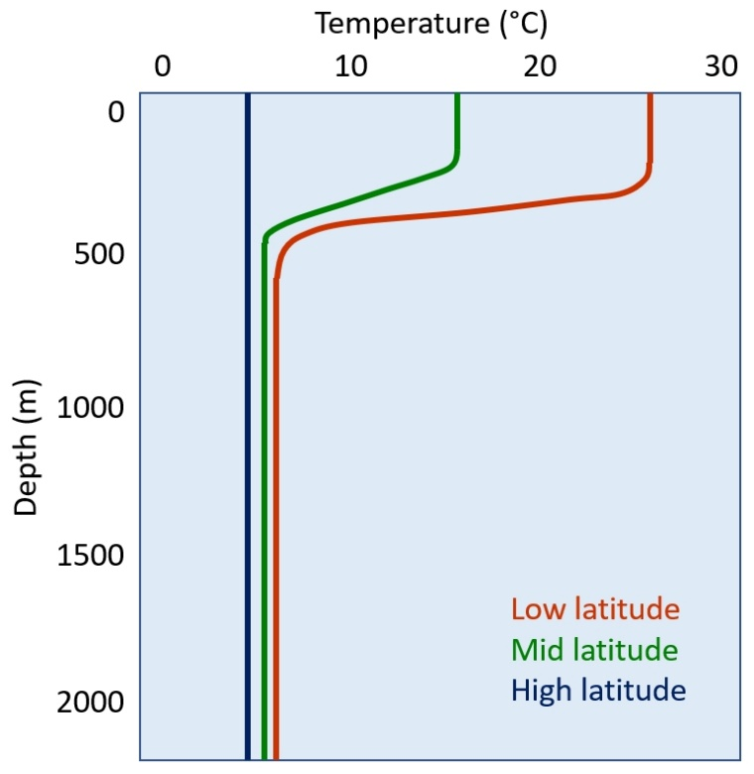
Figure 3: Typical ocean temperature profiles at varying latitudes.

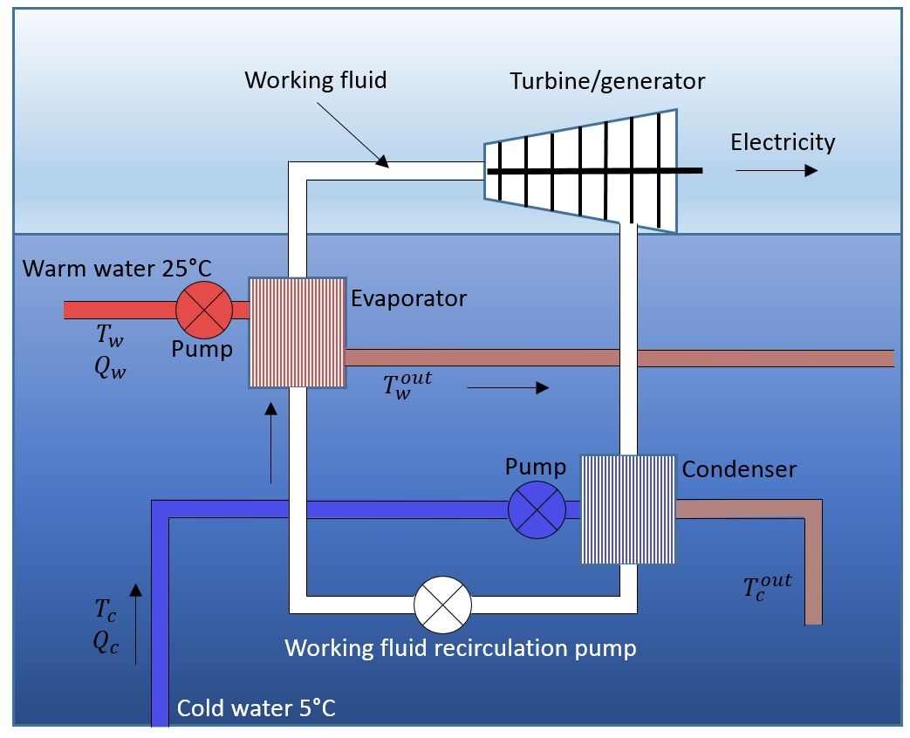
Figure 4: Closed cycle OTEC. Reproduced from Neill and Hashemi [6].

4. Ocean current energy
Winds are a result of uneven solar heating, in combination with the Earth’s rotation. As air moves towards the subtropics (23.5°−35° latitude), it descends over the oceans, creating semi-permanent circulation features known as subtropical highs. In the Northern Hemisphere, for example, these high pressure systems are located over the North Pacific and North Atlantic oceans. Anticyclonic wind systems circulate around these subtropical highs, leading to the westerlies and easterlies (trade winds) that have been exploited in ocean exploration and trading for half a millennium. Friction between the wind field and the ocean surface drives ocean surface currents, and the corresponding ocean gyre systems, with the currents generally concentrated in the upper few hundred metres of the water column.

Surface currents located on the western side of the subtropical gyres, known as western boundary currents, are faster than their eastern boundary counterparts (Fig. 5). One reason for the westward intensification of boundary currents is related to the strengthening of the Coriolis effect with latitude. The Coriolis effect is stronger at the higher latitudes of the westerlies than the lower latitudes of the trade winds. Transport of surface waters toward the western boundary of the ocean basins causes the ocean-surface slope to be steeper on the western side (versus eastern side) of a gyre (in either hemisphere). A steeper ocean-surface slope translates into a faster geostrophic flow on that side of the gyre.

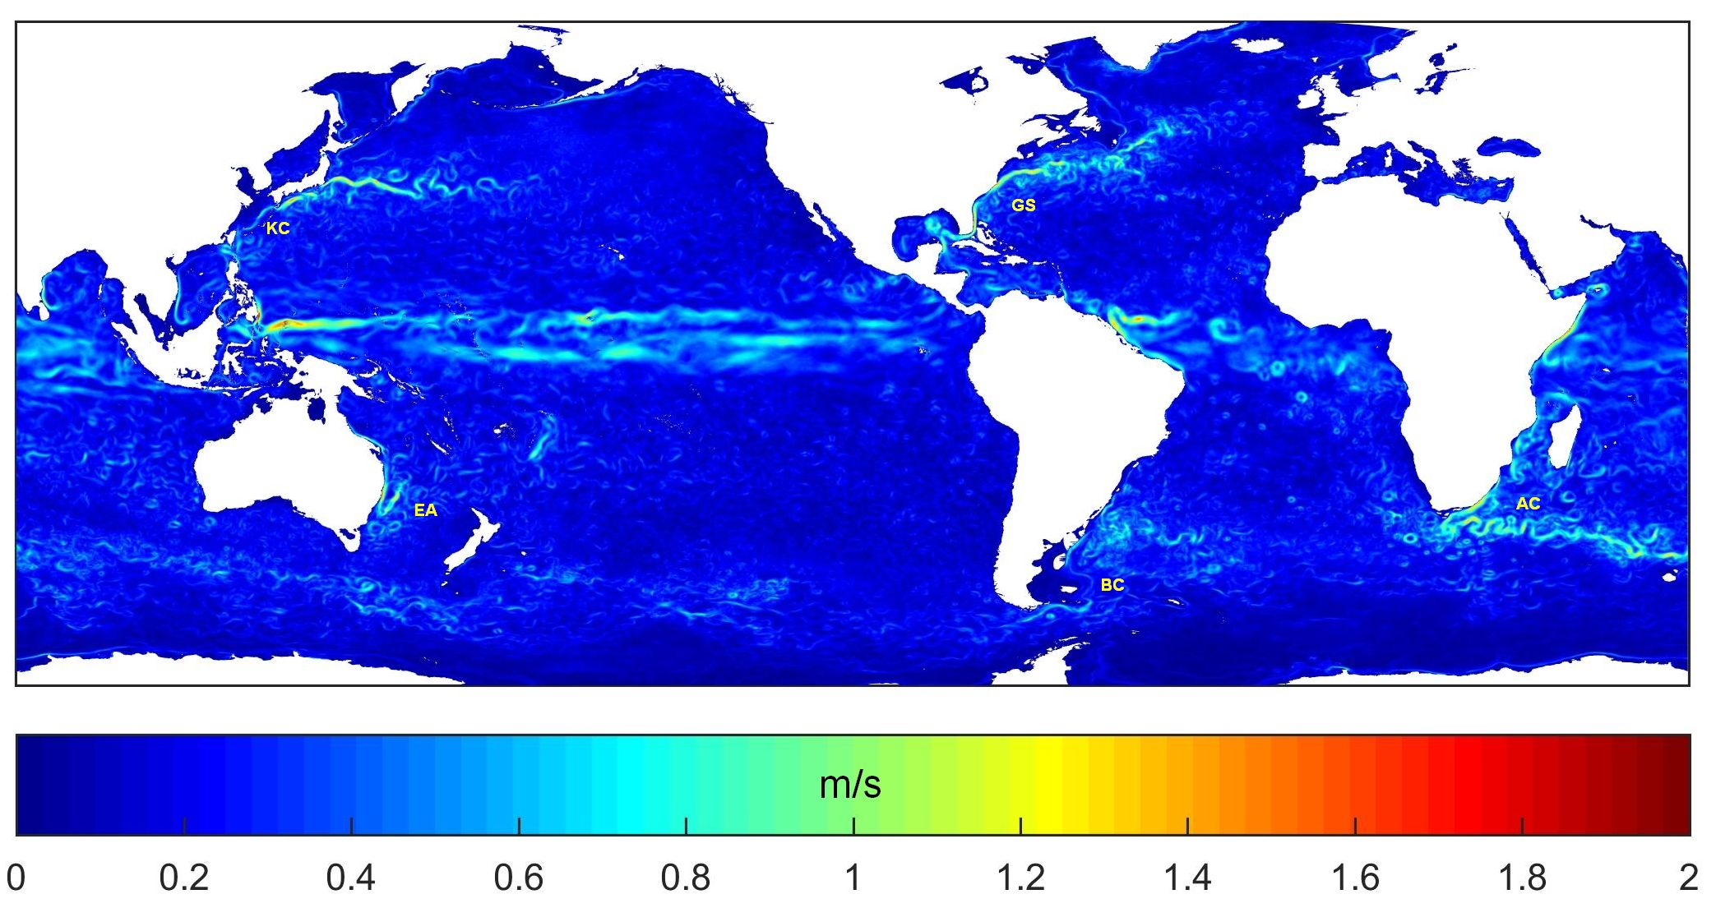
Figure 5: The five main western boundary currents, shown as mean current speed (m/s) in January 2015 at 50 m water depth. From west to east in the plot: KC=Kuroshio Current; EA=East Australia Current; GS=Gulf Stream; BC=Brazil Current; AC=Agulhas Current. Data from HYCOM global reanalysis.

In contrast to the high temporal variability that characterizes the wave energy resource (Section 2), these relatively fast flowing (generally around 1− 1.5 m/s – see Fig. 5) ocean currents are relatively persistent. Since variability is relatively low, western boundary currents could be a fairly reliable ocean renewable energy resource. Further, since ocean currents pass fairly close to land masses (as western boundary currents), for example the Agulhas Current flows along the east coast of Africa, and the Gulf Stream flows through the Straits of Florida (Florida Current), devices that convert the kinetic energy of ocean currents into electricity could be feasible for grid integration. However, the core of the ocean current resource tends to be relatively far from shore (e.g. >20 km) and in relatively deep water (e.g. >500 m) [7], and so extraction of the resource will be expensive and technically challenging. Western boundary currents transport vast volumes of water, for example the Aghulas Current has a mean transport of around 70 Sv (1 Sverdrup = 10⁶ m³/s) [8]. Therefore, from a practical perspective, it is unlikely that extraction, even at significant scale, would affect the resource itself, in contrast, for example, to tidal energy extraction that tends to be focussed in narrow channels (Section 5).

5. Tidal range energy
The physics of tides are complex, involving a discussion of Coriolis and the tide generating forces. Full details are provided in Neill et al. [6], but it is sufficient here to state that due to the coupled Earth-Moon system, in combination with the Earth’s rotation and the Sun’s gravity, we experience tides on Earth. Tides are predominantly semi-diurnal (two tides per day), but in many regions of the Earth the tides are either diurnal (one tide per day) or ‘mixed’ – a combination of semi-diurnal and diurnal tides. The tides also vary over longer timescales, for example a larger tidal range is experienced during spring tides, and a smaller tidal range during neap tides one week later. This represents one of the most important challenges to tidal energy, since most of the energy is available during springs, and very little during neaps, hence significant storage or alternative forms of energy conversion will be required.

The analysis and prediction of tides can be explained by considering a number of tidal constituents – the principal ones are shown in Table 2. In regions that are strongly semi-diurnal, i.e. the majority of the world’s oceans, the M2 tidal constituent on its own represents mean tidal conditions. In contrast, M2 + S2 is a spring tide, and M2 − S2 is a neap tide. The global distribution of M2 tidal amplitudes (Fig. 6) shows that there are a few regions in the world with high tidal range, such as the NW European Shelf Seas, NW Australia, the Patagonian shelf, and regions of Canada (particularly the Bay of Fundy). In these regions, it is possible to convert the potential energy of the tidal range into electricity through the construction of tidal barrages or tidal lagoons [9, 10].

Symbol | Name | Speed (°/h) | Period (h) | Amplitude relative to M2
O1 | Lunar diurnal | 13.94 | 25.82 | 0.26
K1 | Lunisolar diurnal | 15.04 | 23.94 | 0.37
N2 | Larger lunar  elliptic semidiurnal | 28.44 | 12.66 | 0.21
M2 | Principal lunar  semi-diurnal | 28.98 | 12.42 | 1.00
S2 | Principal solar  semi-diurnal | 30.00 | 12.00 | 0.35
Table 2: Some of the most important diurnal and semi-diurnal tidal constituents. The amplitude of each tidal constituent relative to the dominant M2 is calculated using mean amplitudes extracted from TPXO9 global tidal atlas [11] for water depths less than 200 m (representative of shelf sea regions), between latitudes 66.5°S and 66.5°N.

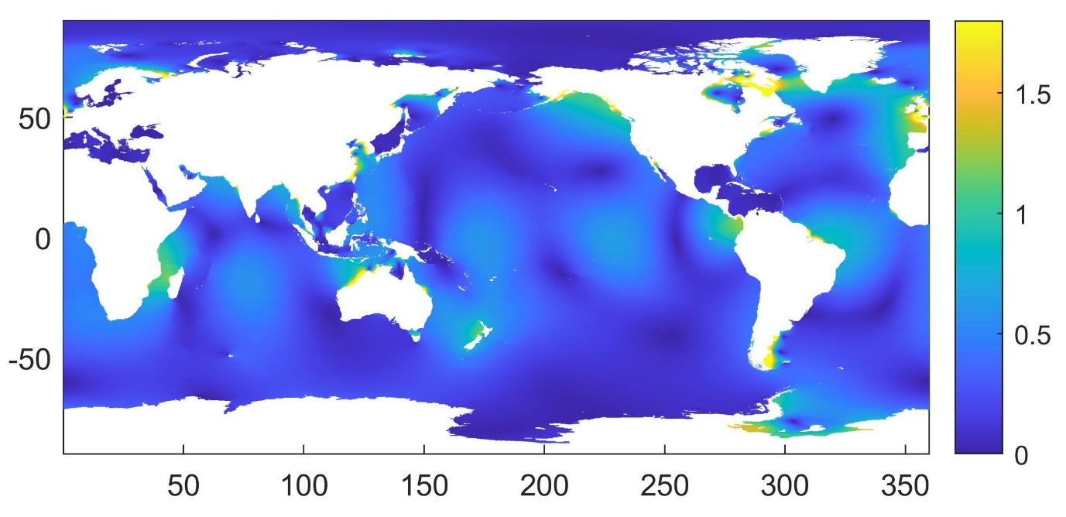
Figure 6: Global distribution of M2 amplitude (m). Figure reproduced from Neill et al. [4].

A tidal range power plant is based on a number of components, the most important of which is the embankment. The embankment, which constitutes the majority of the capital cost of the power plant, is a barrier that is used to impound an area of sea, the filling or release of which is controlled by channelling the flow either through sluice gates (e.g. to transfer water into or out of the enclosed basin) or through turbines (i.e. to generate electricity). There are two main modes of operation of a tidal range power plant, and a third operation mode that is a combination of the other two. For ebb generation, the flooding tide enters the enclosed basin through sluice gates and idling turbines. Once the maximum level inside the lagoon is achieved (i.e. at high water), these gates are closed, until a sufficient head develops on the ebbing tide. Power is subsequently generated by the turbines and generators until a predetermined minimum head difference, when turbines are no longer operating efficiently. For flood generation, the process is reversed to produce electricity during the flood phase of the tidal cycle. Two-way generation is a combination of the two and can be used to reduce variability in the resulting power time series. Two-way generation can also be supplemented by pumping to further reduce variability [12].

6. Tidal stream
In contrast to tidal range, the tides also manifest as tidal currents, and again these are very strong in some regions, such as through tidal channels and around headlands. The kinetic energy can be extracted from these tidal streams using hydrokinetic turbines, analogous to wind energy [13]. Similar to offshore wind, turbines are typically deployed in arrays, increasing system redundancy and resilience. The majority of tidal turbines use rotors to convert the kinetic energy of the flow into mechanical energy, either with the horizontal axis parallel to the flow (horizontal axis turbine) or with the axis perpendicular to the flow (vertical axis turbine). However, there are examples of turbines using other means such as oscillating hydrofoils and underwater kites [14]. Regardless of the specific type of technology being used, all projects require resource assessments to first determine project feasibility, then to design the turbine array layout, and finally to compute the project annual energy production (AEP). The International Electrotechnical Commission (IEC) has published a technical specification for performing tidal stream energy resource assessments for projects at all stages of project development [15].

7. Technology types and commercial progress

7.1. Wave energy
There are numerous wave energy converter (WEC) technologies, but two of the front runners are the wave attenuator and the surface point absorber. An attenuator, an example of which is Pelamis, is a long floating device aligned with the direction of wave propagation. The device converts the energy of waves into electricity by constraining the motion along its length. Since the attenuator is aligned with the direction of wave propagation, it is more suited to environments where the wave direction is relatively consistent, for example in the coastal zone where waves tend to propagate normal to the coastline due to wave refraction. In contrast, a point absorber can convert the energy from waves travelling in multiple directions. These are therefore more suited to environments, likely further offshore, where wave direction is more variable. Other types of WEC, particularly those that are shore-attached, include oscillating water column and overtopping devices [6].

The European Marine Energy Centre (EMEC) was established in Orkney (north of Scotland) in 2003. Although EMEC has now expanded to 13 sites suited to either tidal or wave energy conversion, the full scale wave test site at Billia Croo to the west of Orkney was the first to open for business, and the Pelamis 750, the world’s first grid-connected floating wave energy device, began testing in 2004 [16]. Various iterations of Pelamis, an attenuator device, were subsequently developed and tested, culminating in the P2 device (also rated at 750 kW). Pelamis went into administration in 2014, but managed to deliver over 250 MWh of electricity to the UK grid during its lifetime, along with valuable knowledge acquired through extensive testing. The publicly available power matrix of Pelamis is often used in technical wave energy resource assessments (e.g. [17]).

Early prototype point absorber technologies made use of heaving buoys that reacted against a fixed frame of reference, such as the sea bed. However, this creates difficulties due to the relatively large distance between the sea surface and sea bed, and so most point absorbers now developed are two-body systems, in which energy is converted from the relative motion between two bodies oscillating at different frequencies [18]. The Wavebob, developed in Ireland, converts the relative axial motion between two co-axial axisymmetric buoys into electrical energy through a high pressure oil system. A one-quarter scale device has been tested in Galway Bay, on the west coast of Ireland, but unfortunately the company ceased trading in 2013 due to funding difficulties. Another two-body point absorber is the PowerBuoy, developed by the US-based Ocean Power Technologies. Rated at around 3 kW, the device is targeted more towards creating an uninterruptable power supply, for example to provide power to offshore communication platforms, rather than large-scale grid integration. This is an interesting area of development for wave energy projects and devices, since a much higher levelized cost of energy is more suited to the provision of electricity offshore, which tends to cost an order of magnitude more than domestic electricity [19].

7.2. Ocean Thermal Energy Conversion (OTEC)
Although OTEC is limited to low latitudes, its potential is huge – the International Renewable Energy Agency (IRENA) has estimated that the OTEC resource could be as high as 30 TW [20], and this would make it, by far, the largest of the ocean energy resources. However, despite the resource potential, commercial progress has been modest (Fig. 7). The low economic feasibility of OTEC is related to low energy efficiency, and high consumption of deep-sea cold energy extraction pumps [5]. Although operational plants are around the 100 kW scale, those sites that are currently planned or under development are around the 10 − 20 MW scale.

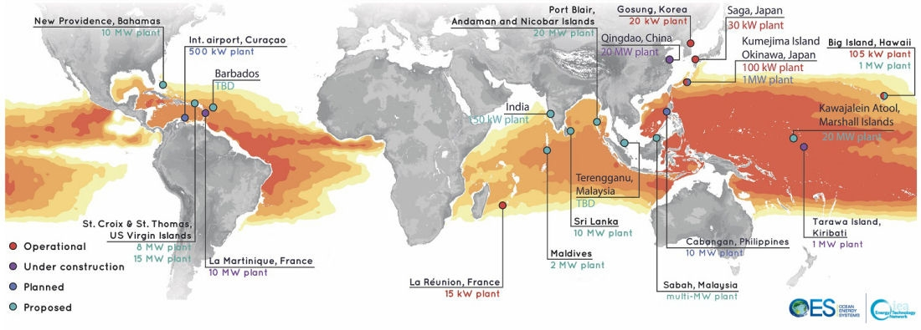
Figure 7: OTEC projects around the world. (Image provided by the OTEC Foundation.)

7.3. Ocean current energy
Globally, the theoretical ocean current energy resource has been estimated as around 0.5 TW [21], with the Florida Current alone representing 20 – 25 GW, which reduces to 1−4 GW if realistic technical constraints are imposed [7]. To put the former Florida Current figure (20−25 GW) into perspective, this is approximately the mean demand for electricity of the state of Florida. To convert the kinetic energy that resides in ocean currents into electricity, turbines would need to be designed with characteristics that can overcome a number of technical challenges. The resource is stronger closer to the water surface (accounting for navigational constraints), but water depths at suitable locations will be 200 − 500 m, and regions with a suitable energy density are relatively far from shore. For the latter constraint, devices will need to be suitably robust to minimize maintenance periods, and for this, in general, simplicity is important. One aspect that will help here is the fact that the ocean currents, in contrast to tidal energy for example, are generally uni-directional, and so neither a yawing mechanism is required, nor turbines where the blades must be designed to extract energy during different phases of a tidal cycle. Clearly in such water depths, the devices must be floating, yet tethered to the sea bed – design criteria that are not uncommon in the tidal energy and offshore wind industries. Several designs for ocean current devices have been proposed, of which three are prominent. Two of these are of the horizontal axis configuration: Aquantis C-Plane and the three-bladed Kuroshio Current prototype [22]. Another design is particularly novel – the Minesto Deep Green ‘kite’, which is tethered to the sea bed, and travels in a figure-of-eight trajectory, increasing the local velocity at the turbine which is on the kite itself. However, apart from some limited prototype testing, there is virtually zero exploitation of the ocean current energy resource to date.

7.4. Tidal range energy
Although it doesn’t necessarily have the greatest potential, by far the greatest globally installed capacity of ocean renewable energy is tidal range. The first tidal range power plant was installed in La Rance (France) in 1966 – a 240 MW power station – and is still operating today [23]. There are five other tidal range power plants throughout the world [9], but no tidal range power plant has been constructed for several decades. However, whereas all existing power plants are barrages, a more contemporary approach is that of the tidal lagoon which only partly impounds a channel or seaway, and so will have lower capital cost and reduced environmental impact. It is likely that the first tidal lagoon will be constructed in the next decade, and a strong contender is Swansea Bay, UK [24].

7.5. Tidal stream energy
In contrast to tidal range, although there has been a lot of activity in the tidal stream sector over the last 20 years, as yet there is minimal installed capacity (around 10 MW globally, compared to 500 MW of installed tidal range capacity). In 2008, the Marine Current Turbine (MCT) dual rotor SeaGen device was connected to the grid in Strangford Lough (Northern Ireland). The device had a rated capacity of 1.2 MW and was decommissioned over the period 2016 − 2018. SeaGen delivered around 12 GWh during its life time, and its successful decommissioning demonstrated the feasibility of commercial tidal stream energy developments at all stages of project life cycles. Currently the largest tidal stream array in operation, the 6 MW Phase 1A MeyGen project in the Pentland Firth (Scotland) consists of four 1.5 MW horizontal axis turbines. Up to October 2022, the project had generated 45 GWh.

8. The future of ocean renewable energy
In general, the wave and tidal stream sectors have suffered a large number of setbacks over the years due to failure, largely associated with a lack of understanding of the resource (which, particularly in the case of wave energy, has led to increased cost). The tidal range sector suffers from high capital cost, in addition to uncertainty in environmental impacts due to the large-scale nature of the power plants (in contrast, tidal stream arrays are smaller and modular). Finally, the OTEC and ocean current areas are again associated with high costs due to working far offshore and, in the case of OTEC, low energy efficiency and the need to pump large volumes of cold water from 1 km depth. Aspects of these challenges are discussed in the following sub-sections.

8.1. Improved observations and modelling
At present, tidal stream and wave energy projects rely on relatively expensive and long-term sea bed moorings (acoustic Doppler current profiler, ADCP) and wave buoy deployments, respectively, to make annual energy yield estimates. In addition to the cost of deploying instruments at sea for long periods of time, such observations are Eulerian (i.e. they focus on a single location), challenging (often ending in failure, for example if the wave buoy is struck by a vessel or if the sea bed mooring becomes buried in sediment preventing recovery), and it is necessary to wait until post-deployment to analyze the data. Alternatives have been proposed including the application of X-Band radar [25], ship-based surveys, and drone-based large-scale particle image velocimetry [26].

The IEC technical specification for tidal energy resource assessment specifies a methodology in which an ADCP should be used to collect 90 days of continuous data at the location of each individual turbine [15]. By combining such internationally accepted methods with novel technologies would put less emphasis on selecting the exact location of each turbine prior to deployment. For example, it could be possible, after 90 days of recording, and perhaps using this data to calibrate or validate a numerical model, that the optimal location could lie several hundred metres away. Lagrangian (drone) or spatial (X-Band radar) methods could be combined with limited ADCP mooring data to establish the optimal location prior to a lengthy/costly/risky longer term deployment [13].

Such field data can be used to validate numerical models of the study region, both for resource assessment and characterization, and also to assess environmental impacts. The environmental impact of an ocean energy scheme is particularly relevant to modelling activities since it is not possible to determine the impacts prior to construction. Therefore models must be as accurate as possible, combing multiple physical processes (e.g. wave-current interaction [27]), considering three-dimensions, and realistically representing device feedback in the models [13, 28].

8.2. Co-location
There are many advantages to co-locating multiple renewable energy technologies at a single location, including cost reduction through shared cabling and foundation systems, and smoothing of the (aggregated) power outputs. It is also possible to co-locate maritime industries at the location of an ocean energy power plant, for example co-locating the power plant with desalination, aquaculture, or a hydrogen generation facility [29]. Such combined industries could make use of surplus energy conversion; for example during the night when there is minimal grid-based demand for electricity, an OTEC power plant could still be producing desalinated water. Further, it is attractive for a less established or high cost renewable energy technology such as wave energy to combine with an established technology such as offshore wind. However, this would depend on the phasing between the wind and waves – an ideal site would have winds and waves uncorrelated or at least out of phase with one another, likely characterized by a location that is dominated by swell waves [30]. It is also possible to strategically site individual site power plants such that their aggregated power output is smoothed at grid level – the most obvious example of this is siting a series of tidal range power plants along a coastline so that they each intercept the tidal wave at a different part of its phase [13].

8.3. Biofouling and novel materials
Marine growth creates many problems for the offshore renewable energy industry. Increased surface roughness due to biofouling and barnacle growth increases the structural drag forces and affects dynamic response [31]. Chemicals present in antifouling coatings are often harmful to marine life, and so efforts are needed to trial novel coatings and reduce toxicity. Due to a requirement to develop projects in regions that are highly energetic (for example large waves and strong tidal currents), ocean energy devices are often located in harsh environments where access is difficult. Corrosion and fatigue degrade structural integrity, and so new materials need to be developed and applied to emerging offshore renewable energy applications [32]. Taking the mature offshore wind energy as an analogue, most of the materials used in wind turbines can be recycled, but one exception is the composite material used in wind turbine blades [33]. Current practice is to condemn decommissioned blades to landfill, but this is unsustainable, and hence there is an urgent need for the entire offshore renewable energy sector to avoid this issue [32].

References
[1] P. Shukla, J. Skea, R. Slade, A. Al Khourdajie, R. van Diemen, D. McCollum, M. Pathak, S. Some, P. Vyas, R. Fradera, M. Belkacemi, A. Hasija, G. Lisboa, S. Luz, J. Malley, Climate Change 2022: Mitigation of Climate Change. Contribution of Working Group III to the Sixth Assessment Report of the Intergovernmental Panel on Climate Change (2022).
[2] J.-P. Gattuso, A. K. Magnan, L. Bopp, W. W. Cheung, C. M. Duarte J. Hinkel, E. Mcleod, F. Micheli, A. Oschlies, P. Williamson, et al., Ocean solutions to address climate change and its effects on marine ecosystems, Frontiers in Marine Science (2018) 337.
[3] T. Withers, S. P. Neill, Salinity gradient power, Comprehensive Renewable Energy 8 (2022) 50–79.
[4] S. P. Neill, Introduction to ocean renewable energy, Comprehensive Renewable Energy 8 (2022) 1–9.
[5] X. Yang, Z. Li, Y. Shen, R. Kuang, Review of studies on enhancing thermal energy grade in the open ocean, Journal of Renewable and Sustainable Energy 14 (6) (2022) 062701.
[6] S. P. Neill, M. R. Hashemi, Fundamentals of ocean renewable energy: generating electricity from the sea, Academic Press, 2018.
[7] K. Haas, X. Yang, V. Neary, B. Gunawan, Ocean current energy resource assessment for the Gulf Stream system: The Florida Current, in: Marine Renewable Energy, Springer, 2017, pp. 217–236.
[8] H. L. Bryden, L. M. Beal, L. M. Duncan, Structure and transport of the Agulhas Current and its temporal variability, Journal of Oceanography 61 (3) (2005) 479–492.
[9] S. P. Neill, A. Angeloudis, P. E. Robins, I. Walkington, S. L. Ward, I. Masters, M. J. Lewis, M. Piano, A. Avdis, M. D. Piggott, et al., Tidal range energy resource and optimization – past perspectives and future challenges, Renewable Energy 127 (2018) 763–778.
[10] V. Marti-Barclay, S. Neill, A. Angeloudis, Tidal range resource of the Patagonian shelf, Renewable Energy (in press) (2023).
[11] G. D. Egbert, S. Y. Erofeeva, Efficient inverse modeling of barotropic ocean tides, Journal of Atmospheric and Oceanic Technology 19 (2) (2002) 183 – 204.
[12] N. Yates, I. Walkington, R. Burrows, J.Wolf, The energy gains realisable through pumping for tidal range energy schemes, Renewable Energy 58 (2013) 79–84.
[13] S. P. Neill, K. A. Haas, J. Thiébot, Z. Yang, A review of tidal energy – resource, feedbacks, and environmental interactions, Journal of Renewable and Sustainable Energy 13 (6) (2021) 062702.
[14] A. Roberts, B. Thomas, P. Sewell, Z. Khan, S. Balmain, J. Gillman, Current tidal power technologies and their suitability for applications in coastal and marine areas, Journal of Ocean Engineering and Marine Energy 2 (2) (2016) 227–245.
[15] International Electrotechnical Commission, TS 62600-201:2015 Marine Energy - Wave, Tidal and Other Water Current Converters - Part 201: Tidal Energy Resource Assessment and Characterization, International Electrotechnical Commission, 2015.
[16] V. M. Barclay, J. Culina, S. P. Neill, Ocean renewable energy test centers, Journal: Comprehensive Renewable Energy (2022) 123–148.
[17] K. Gunn, C. Stock-Williams, Quantifying the global wave power resource, Renewable Energy 44 (2012) 296–304.
[18] F. Antonio, Wave energy utilization: A review of the technologies, Renewable and Sustainable Energy Reviews 14 (3) (2010) 899–918.
[19] A. LiVecchi, A. Copping, D. Jenne, A. Gorton, R. Preus, G. Gill, R. Robichaud, R. Green, S. Geerlofs, S. Gore, et al., Powering the blue economy; exploring opportunities for marine renewable energy in maritime markets, US Department of Energy, Office of Energy Efficiency and Renewable Energy. Washington, DC 207 (2019).
[20] R. Kempener, F. Neumann, Ocean Thermal Energy Conversion, technology brief, IRENA Ocean Energy Technology Brief 1 (2014).
[21] Ocean Energy Council, Ocean current energy, http://www.oceanenergycouncil.com/ocean-energy/ocean-current-energy/, accessed: 09-01-2023 (2018).
[22] K. Shirasawa, K. Tokunaga, H. Iwashita, T. Shintake, Experimental verification of a floating ocean-current turbine with a single rotor for use in Kuroshio currents, Renewable Energy 91 (2016) 189–195.
[23] R. H. Charlier, Forty candles for the Rance River TPP tides provide renewable and sustainable power generation, Renewable and Sustainable Energy Reviews 11 (9) (2007) 2032–2057.
[24] S. Waters, G. Aggidis, A world first: Swansea Bay tidal lagoon in review, Renewable and Sustainable Energy Reviews 56 (2016) 916–921.
[25] T. Harrison, K. M. Thyng, B. Polagye, Comparative evaluation of volumetric current measurements in a tidally dominated coastal setting: A virtual field experiment, Journal of Atmospheric and Oceanic Technology 37 (4) (2020) 533–552.
[26] I. Fairley, B. J. Williamson, J. McIlvenny, N. King, I. Masters, M. Lewis, S. Neill, D. Glasby, D. Coles, B. Powell, et al., Drone-based large-scale particle image velocimetry applied to tidal stream energy resource assessment, Renewable Energy 196 (2022) 839–855.
[27] N. Guillou, G. Chapalain, S. P. Neill, The influence of waves on the tidal kinetic energy resource at a tidal stream energy site, Applied Energy 180 (2016) 402–415.
[28] A. J. G. Brown, S. P. Neill, M. J. Lewis, Tidal energy extraction in three-dimensional ocean models, Renewable Energy 114 (2017) 244–257.
[29] R. J. Cavagnaro, A. E. Copping, R. Green, D. Greene, S. Jenne, D. Rose, D. Overhus, Powering the blue economy: Progress exploring marine renewable energy integration with ocean observations, Marine Technology Society Journal 54 (6) (2020) 114–125.
[30] D. Christie, S. Neill, P. Arnold, Characterizing the wave energy resource of Lanzarote, Canary Islands, Renewable Energy (in press) (2023).
[31] N. Srikanth, Composites towards offshore renewable system needs, Comprehensive Renewable Energy 8 (2022) 221–244.
[32] D. Greaves, S. Jin, P. Wong, D. White, H. Jeffrey, B. Scott, R. Wigg, UK perspective research landscape for offshore renewable energy and its role in delivering Net Zero, Progress in Energy 4 (4) (2022) 042012.
[33] A. Cooperman, A. Eberle, E. Lantz, Wind turbine blade material in the United States: Quantities, costs, and end-of-life options, Resources, Conservation and Recycling 168 (2021) 105439.

https://simecatlantis.com/tidal-stream/meygen/

