Note on correction for the changing date of the field course
The Snowdon field courses were held during the Easter holiday, but as the timing of this varied from year to year, a correction is needed when examining the data for long term trends. It would not be right, for example, to compare a temperature measurement made in April of one year with one made in February of another year.
Averaged values of air and water temperature are likely to vary sinusoidally over the course of a year but, for a relatively short section on the rising part of the curve (the field courses range over about 1/10th of a year in the spring), it may be appropriate to consider the change of temperature with time to be linear. We have checked this with an independent data set (26 years of daily measurements) from Dinorwic quarry, near Snowdon. All observations on each day corresponding to the range of field course dates have been averaged and plotted against day in the figure below.
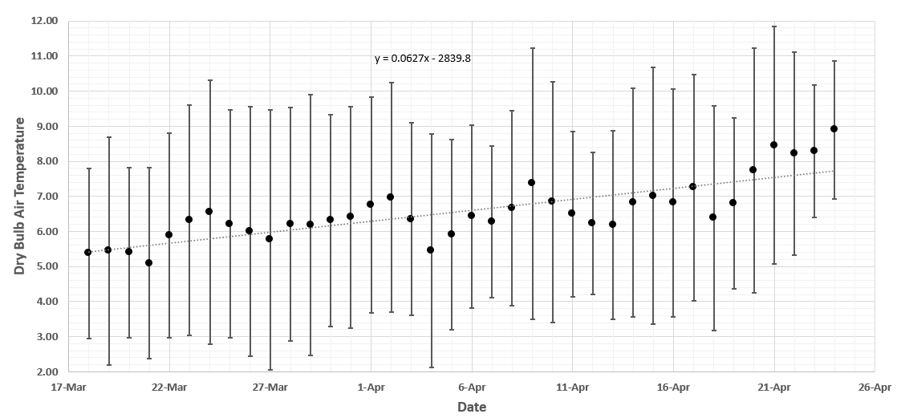
Each point in this figure is an average of 26 years on that particular day and the vertical bars show the standard deviations about the mean A linear fit with a gradient of 0.06 degrees per day is the simplest correction for variation with ‘day of year’ over this period. A linear fit to the variation of temperature with day seems to be a good one over the range of dates of the field course.

