‘In forests of eternal death […] I bring forth from my teeming bosom myriads of flames’:
The Origin of Necropolitics and Visions of Resistance in William Blake’s The Marriage of Heaven and Hell and the Continental Prophecies

Tristan Donal Burke
Bangor University
Introduction

Between 1790 and 1800, while living in Lambeth, just south of the river Thames in London, William Blake (1757-1827) produced a sequence of highly idiosyncratic illuminated works: handmade books combining poetry, visual art, and printing. Known as the “Lambeth Books,” these works respond actively and dynamically to the revolutionary excitement and disruption that was being experienced across the world, and in so doing move between historical event and abstract theory. For Blake, like the French revolutionaries who inspired and disturbed him, this moment appears as a Year Zero, a moment when “the Eternal Hell revives” (3 E34), which is dated in one copy of The Marriage of Heaven and Hell (1792-3) as 1790 (E801). Throughout the Lambeth Books, Blake is particularly interested in the conjunction of specific historical events, shifting forms of sovereignty, possibilities for resistance to sovereign power, and how these developments can(not) be systematized. As Tilottama Rajan observes, in the Lambeth Books, “Blake attempts to arrange world history mythopoeically, or rather to work [out] the system through the materiality of history” (Rajan 1995: 399). However, she argues that this attempt at systematization constantly comes up against its own limits as the trauma of history and the possibilities of resistance produce excesses that cannot be incorporated. Thus, “these texts are caught in the impossibility of their own writing, as a process in which Blake articulates, cancels, and (dis)figures the system that he can produce only in and as its abjected parts” (Rajan 1995: 399).

In this essay, I consider Blake as an artist-theorist of modernity. His attempt to think history, sovereignty, and resistance as system, I argue, finds its counterpart in his exploration of the non-human world, and the human body within it, as an environmental system characterized by decline, disfiguration, degradation, and damage. So, for example, Blake understands the British reaction to the American Revolution in America a Prophecy (1793) in terms of wholesale environmental degradation. In one plate (Figure 1), Blake describes an America engulfed in “grim flames” and ravaged by the “diseases of the earth” (13:9, 15 E56). At the top of the page, a bird of prey pecks at the body of a naked woman, and at the bottom, fish swim around the body of a naked man (13 E56). In the center—which serves as an earth between the images of sky and sea—there is text, a written vision of environmental violence. The relations between sky, sea, and earth here are ambiguous and multifaceted to the point of contradiction. On the one hand, the words establish the connection between ecocide and sovereign power, which seems to be reflected in the images of human death as well as references to a continental conflagration “from north to south” (13:11 E56). On the other hand, as the illustrated bodies turn to carrion, they also suggest the return of some sort of free energy to an environment that is not dominated by the human, which forms the basis of a resistance that both informs human political activity while absorbing and exceeding the human realm. The text itself is concerned with the formation of military blocs: “[t]heir numbers forty millions, must'ring in the eastern sky” (13:16 E56) but the upside-down image of armies forming in the sky draws attention to the lightning and plant-like tendrils that connect the sky and the sea, the fish and the birds. Notably, between the second and third lines, the governors of the American colonies “[shake] their mental chains,” question their ideological entrapment, and surrender to Washington (13:3 E56). As Blake puts it in The Marriage of Heaven and Hell (though it further problematizes the role of sovereign power): “The roaring of lions, the howling of wolves, the raging of the stormy sea, and the destructive sword are portions of eternity too great for the eye of man” (8:27 E36).
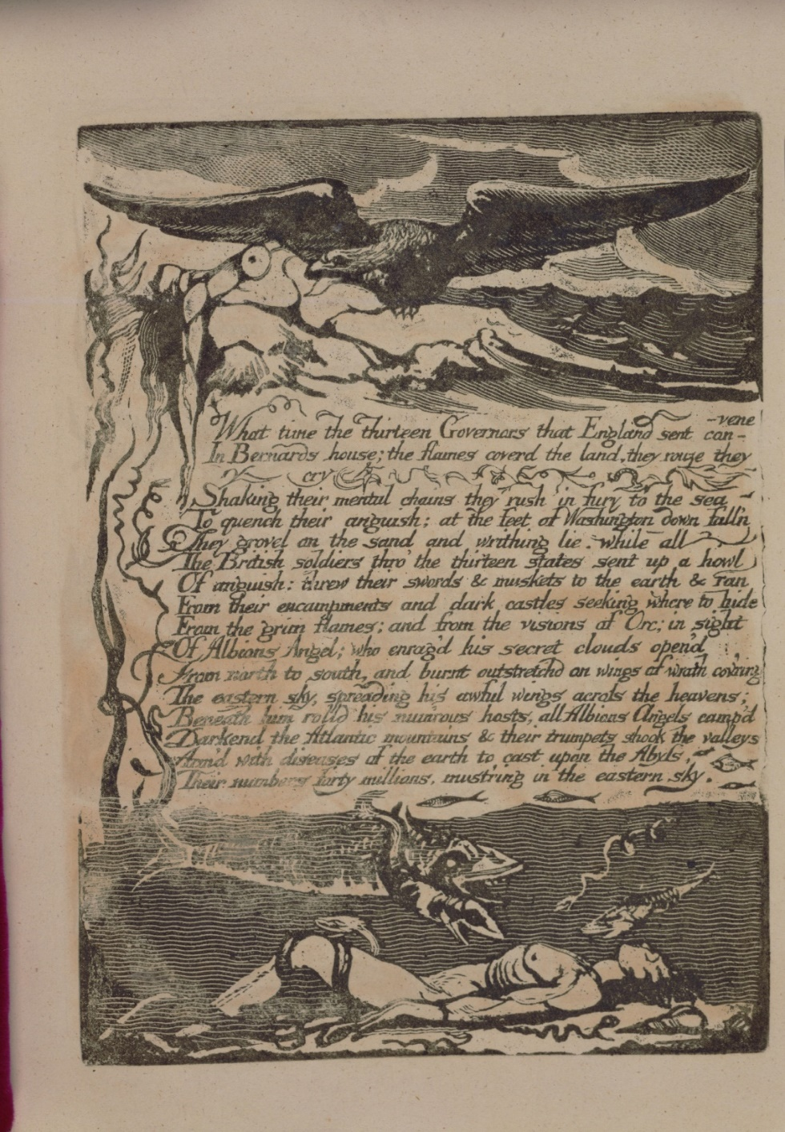
Figure 1. Blake, William (1793). America (Lambeth: Printed by William Blake), Plate 13 [Copy E]. Library of Congress, Rare Book and Special Collections Division - Lessing J. Rosenwald Collection.
As Rajan’s comments and these examples suggest, Blake’s thought cannot be reduced to a single, unambiguous statement. However, these conjunctions between sovereign power and environment in Blake’s work are suggestive for thinking about environmental decline in relation to Achille Mbembe’s recent articulation of necropolitics. Necropolitics is the “generalized instrumentalization of human existence and the material destruction of human bodies and populations” (Mbembe 2019: 68, original emphasis), which for Mbembe is a constitutive feature of modernity that exists in a necessary structural relationship to the self-disciplining subject and the biopolitical organization of life that Foucault identified in liberal democracies. For Mbembe, necropolitics is one form of sovereignty that finds its origin in modernity—in the period immediately preceding and during the French Revolution, the industrial revolution, and the first modern period of colonial expansion. Blake’s work, at the outset of Western modernity proper, is highly attentive to new modes of sovereignty. However, the echoes between Mbembe’s necropolitics and Blake’s work have yet been little noted in the critical literature on Blake’s writing. As such, this article focuses specifically on the group of Blake’s Lambeth Books known as the “Continental Prophecies”: America a Prophecy (1793), Europe a Prophecy (1794), and The Song of Los (1795), the latter of which is composed of two sections, “Africa” and “Asia,” along with references to the contemporaneous The Marriage of Heaven and Hell. These works are particularly concerned with connecting historical events to the theoretical mode Blake calls “prophecy.” Prophecy for Blake is not about telling the future but rather about constructing an image of the world, which can account for both the world and a work’s composition as well as the possibilities that escape that composition. As the prophet Isaiah puts it in The Marriage of Heaven and Hell: “I saw no God, nor heard any, in a finite organical perception; but my senses discover’d the infinite in everything, and as I was then perswaded, & remain confirm’d; that the voice of honest indignation is the voice of God, I cared not for the consequences, but wrote” (12 E38). Prophecy, in the Continental Prophecies, finds its expression in relations established between life and death. In America a Prophecy, for example, Orc—Blake’s mythological personage who embodies the spirit of revolution— is addressed by “the shadowy daughter of Urthona,” who personifies America (1:1 E51). She states that he is “fall’n to give me life in regions of dark death” (2:9 E52) but also that he brings “eternal death” in the pain of revolution (2:17 E52). Death here characterizes the world before revolutionary change, when Orc is “chaind beneath” (1:18 E51). Revolutionary change is, by contrast, associated with life, but as part of its own exercise of power brings death with it. Blake’s art finds an energy in death that has a political force, much like prophecy. As such, these works allow relations to be established between exercises of sovereign power over life and death, the systematic forms these produce, and the spaces of revolution and resistance that emerge from these interstices.

No simple binary system of moral values can be applied to life and death in Blake’s work. In a recent insightful essay, Haram Lee observes that in Blake’s poetry of the late 1790s, especially The Four Zoas (c.1796-1807) composed immediately after the Continental Prophecies, Blake mounts a critique of many of the most famous English radical supporters of the French Revolution, such as Tom Paine and John Thelwall. In Blake’s poem, these radicals are seen to “overemphasiz[e] rational thinking and self-discipline when they idealiz[e] the sovereign individual as the model of the political subject” (Lee 2021: 54). As a result, such thinkers ground their philosophy in a biopolitical instrumentalization of life that reproduces the domination they claim to reject:

Blake depicts specifically how the liberal radicals champion the sovereign individual and instrumental reason in a self-defeating manner: as long as they treat reason merely as a means for the mastery of nature, they reduce the rational subject to a simple living creature, a machine of survival. (Lee 2021: 68)

The result is that these radicals come to resemble Thomas Malthus in their valuation of human life; the individuated, rational subject must exercise self-discipline to control their own forces of life. Lee’s focus is on the constitution and manipulation of life as a political object, but he begins to make a connection to death by observing that “[w]hen the radicals prioritize life and happiness over anything else, for Blake they contribute to reducing human life to natural life, which entails nothing but suffering and death” (Lee 2021: 69). In this paper, I shift the attention from life to death to explore in more detail the close relationship Blake establishes between these two forces, and to suggest that in the face of biopolitical and necropolitical domination, death is also conceived by Blake as a generative force.

I argue that Blake establishes environmental decline as the definitional mode of nature-as-system, and that this is an essential component of necropolitical power. Defining the necropolitics of environmental decline both in terms of the direct exercise of sovereign power, which is ecologically destructive, and the underlying discursive inscription that systematizes nature and allows this exercise to occur, I argue that Blake engages with necropolitical practices of control but connects these to an underlying and foundational systematization of nature, which I also understand as necropolitical. A necropolitical organization of the environment is directly linked, in Blake’s vision, to colonial war, slavery, and Indigenous genocide. However, in line with Mbembe’s theory, Blake also recognizes possibilities for resistance that must, necessarily, emerge from within death itself.

Surprisingly little critical attention has been devoted to Blake’s engagement with nature, and ecocritical literary scholarship—in which the British Romantic period figures so centrally—has been similarly subdued in its discussion of Blake. In what has recently been described as an “extraordinary book” (Morris 2012: 291 fn.2), Kevin Hutchings, a rare outlier working at the intersection of Blake studies and ecocriticism, addresses both omissions. As Hutchings explains: “[a]lthough William Blake’s attitude towards nature is equivocal and contradictory […] it has become a widely accepted critical commonplace that Blake is in fact nature’s poetic adversary.” This is the result of a critical tradition that has “emphasize[d] his idealist suspicion of nature” (Hutchings 2002: 37). Undoubtedly, there are many statements in Blake’s work to support such claims, perhaps most famously in a “Proverb of Hell” in The Marriage of Heaven and Hell: “[w]here man is not nature is barren” (10:68, E38). More examples, Hutchings suggests, can be found in Blake’s marginalia in particular. These “are commonly quoted as rhetorical coups de grâce providing beyond doubt that Blake was unequivocally hostile to the natural world.” However, “[a]ll too often […] Blake’s readers fail to give the annotations the close readings they demand and require” (Hutchings 2002: 38-39). Hutchings’ point here is not that the significance of the marginalia has been overstated, but rather that it has been treated by critics, who have failed to investigate Blake’s characteristic equivocity and ambiguity, as definitive and univocal. For Hutchings, such overly simple readings are a result of the critical dominance of Northrop Frye’s Fearful Symmetry (1947), which sought to establish Blake’s work as forming a systematic, unified, and stable idealist mythology at the expense of readings that championed a more ambiguous, self-contradictory Blake.

As a result of Frye’s influence, “although Blake studies have witnessed profound changes in methodology and viewpoint since the publication of Fearful Symmetry, the view of Blake as nature’s English Romantic adversary has become […] entrenched” (Hutchings 2002: 37-38). This entrenchment has significant political implications, given Blake’s own distrust of reductive or entrenched forms of thinking: “[i]n Blake’s view a ‘holism,’ giving primacy to the whole over the part, is potentially tyrannous, for when parts of a system are considered primarily in terms of their relationship to the greater system or whole, they are necessarily instrumentalized, as their perceived function in the grand scheme of things becomes their most important defining attribute” (Hutchings 2002: 35). In such holistic critical schemas, critics must either idealize nature to force it to conform to the demands of the critical system they impose on Blake, or else they argue that Blake rejects nature to ensure that its stubborn empirical specificity does not threaten the critical system they have imposed.

Blake and Ecocriticism

While Blake studies has historically been dominated by an idealism that rejects nature, the history of ecocriticism, for Hutchings, is a history of the idealization of nature. This tradition has been skeptical of Blake for his purported rejection of nature. Moreover, this ecocritical tradition also rejects revisionist accounts of Blake, which argue that he develops a much more ambiguous, contradictory, or proto-deconstructive philosophy of nature concerned with the discourses and practices of power by which nature is produced as object. Hutchings is particularly critical of Karl Kroeber and Jonathan Bate, who, he argues, dismiss “the potentially important environmental insights of discourse theory” in favor of the “transcendental ‘given[ness]’” of nature, and at the expense of a critical understanding of the “established definitions of nature, the modes of government that produce and support them, their material consequences for biospheric and cultural diversity, and the possibility of formulating a practical, politically-informed theory of socio-ecological transformation” (Hutchings 2002: 9-10, original emphasis).

Clearly, these more naïve ecocritical paradigms have been largely superseded but their history is still significant in a study of this type, in part because of the near-ritualistic invocation of the names Bate and Kroeber in ecocritical work; because of the continuing influence of Bate in broader public discourse on the arts and nature; and because of the echoes of such paradigms in popular ecological thought, which “runs the risk of naively celebrating all initiatives that encourage the perceived enhancement of green and wild spaces, while condemning all actions that seem to oppose such a programme” (Hutchings 2002: 11). Moreover, such uncritical responses find their echo in more sophisticated ecocritical work, which nonetheless fails to critique its own entanglement in discursivity.

I understand discourse and discursivity in the terms set out by Michel Foucault across his work and particularly in The Archaeology of Knowledge. Discursivity is the process by which the dispersed and non-linguistic material world is formed, framed, and organized into the objects of knowledge in language; discursivity “forms objects that are in fact highly dispersed” and “[t]his formation is made possible by a group of relations established between authorities of emergence, delimitation, and specification” (Foucault 2002: 49). Discourses are therefore “practices that systematically form the objects of which they speak” (Foucault 2002: 54). As such, they produce knowledge. However, it is important to stress that discourses are not purely linguistic formations. Discourses bring the material world into language, “but what they do is more than use these signs to designate things” (Foucault 2002: 54). Knowledge in discourse is a form of power because, on the one hand, it organizes the material world and, on the other, because the conditions for this organization are themselves determined by structures through which power is contested: governments, institutions, and social formations (Foucault 2002: 143-146). Discourses, then, are the structures by which the material world (in this case nature) is brought into knowledge and the sites for the contestation of power via this knowledge. As David B. Morris has observed, “[m]uch modern ecocriticism […] directly opposes anthropocentricism—which it rejects in favor of various ‘biocentrisms,’” but in “draw[ing] support from fact-based, materialist, biological sciences and from the rational study of ecosystems” (Morris 2012: 281)—i.e. human-crafted discourses—it relies on the very system of thought it claims to be rejecting. For Morris, Blake’s ambiguity and complexity offer a way to avoid reproducing the rationality of the materialist sciences and taxonomic ordering of nature from the perspective of human domination and instrumentalization.

Blake’s work, then, is particularly effective for critiquing the ways in which nature as given is bound up in discursivity. As Blake puts it in Europe: “[t]hought chang’d the infinite to a serpent […] then all the eternal forests were divided into earths rolling in circles of space” (10:16, 18-19 E63). It is the discursive activity of thought that divides given, pre-discursive nature into “eternal forests” (which themselves can only be known discursively)—into a nature located (and divided) in time and space. For Blake, this process simultaneously instantiates oppressive political power. Discursive, divided nature, for Blake, “overwhelm[s] all except this finite wall of flesh” (10:20 E63)—that is the human, who assumes dominion over it. The result of this human dominion is the erection of “the serpent temple,” which is “form’d” as an “image of infinite / Shut up in finite revolutions” (10:21-22 E63). It is widely accepted that Blake’s “serpent temple” refers to the megalithic structures at Stonehenge and Avebury. As Jason Whittaker explains, Blake draws this image from antiquarian William Stukeley (1687-1765). Stukeley argued in his books Stonehenge: A Temple Restor'd to the British Druids (1740) and Abury: A Temple of the British Druids (1743) that these sites are the remnants of an ancient druidical religion which practiced serpent worship (Whittaker 1999: 117). Whittaker explains that Stukeley saw the serpent temples as part of an ancient patriarchal religion featuring strong parallels with Christianity, and which lent political and religious legitimacy to the British state (Whittaker 1999: 156-160). Like Whittaker, I argue that Blake’s discussion of the serpent temple is a critique of Stukeley (159). The meaning Blake assigns to the serpent temple is that of a religion that produces and frames nature, founding on it forms of political oppression while simultaneously turning it into an unchanging religious fetish that is “shut up in finite revolutions.” Subverting Stukeley’s parallels between his posited ancient druidical religion and the modern British state, Blake suggests that the discursive production, division, and reification of the unchanging objectified nature of a nature religion ultimately results in “God a tyrant crown’d” (10:23 E63), represented on earth by a warmongering “fiery king” (10:2 E63). Blake provides a similar description of this process in The Marriage of Heaven and Hell, where we are told “[t]he ancient Poets animated all sensible objects with Gods or Geniuses, calling them by the names and adorning them with the properties of woods, rivers, mountains, lakes, cities, nations, and what-ever their enlarged & numerous senses could perceive,” but ultimately, “a system was formed, which some took advantage of & enslav’d the vulgar by attempting to realize or abstract the mental deities from their objects; thus began Priesthood” (11 E38). For Blake, the discursivity that produces nature as knowable also points to the danger of framing nature as an object of veneration. The discursivity that renders nature knowable also produces forms of political tyranny concerned with ordering human life just as they order natural life. The serpent temple of nature, described in Europe, structures the cosmos; it is “[p]lac’d in the order of the stars” (10:10 E63) while also structuring and limiting human experience, which is now “barr’d and petrify’d against the infinite” (10:15 E63).

However, for Blake, in Europe, care for infinite nature also requires the process of framing and forming; it need not be tyrannical. In contrast to the infinite limited to finite repetition, Blake posits the possibility of the infinite brought into human knowledge but sustained in the eternal. The infinite implies nature in a pre-discursive state that exceeds human knowledge, but Blake distinguishes between the infinite made finite and the infinite made eternal—accessible to human knowledge, power, and conception while sustaining the unknowable difference and potential of the infinite. While both of these imply a process of discursive framing in order to bring the unknowable into discursive structures, the two approaches have very different political valences. In the “Preludium,” the speaker asks, “who shall bind the infinite with an eternal band?” This imagines a way of framing nature that, rather than reducing it to an unchanging ideal object as the serpent temple does, allows nature to subsist in its infinite and eternal state. For Blake, this infinite and eternal state is required for the care of nature. This process of binding, in contrast to the framing of the serpent temple, preserves the infinite in the eternal rather than perpetuating the flat sameness of the limited ideal object, which is “shut up in finite revolutions.” Maintaining this sense of difference or change within nature offers the possibility that someone may “compass it with swaddling bands” and “cherish it / With milk and honey” (2:13-15 E61). The insoluble doubleness of the danger and necessity of binding and framing infinite nature is typical of Blake’s work. As Hutchings explains:

[i]n much of Blake’s visionary poetry, representations of nature and nature objects embody a sense of doubleness, evincing tensions between what we might see as the poet’s desire to imagine the things of nature in ideal and infinite terms […], and his darker, more sober understanding of their inescapable discursivity. (Hutchings 2002: 14)

Blake’s representation of nature goes beyond a mere recognition and analysis of nature’s entanglement in discursivity towards a theorization, perhaps even a political prescription, for how nature may be cherished and protected from human degradation and instrumentalization, without the process of fixing and fetishization that can give way to tyranny. Blake’s approach chimes with theoretically informed ecocriticism, particularly the work of Timothy Morton. The latter critiques the fetishization of nature in Ecology Without Nature as follows: “[p]utting something called nature on a pedestal and admiring it from afar does for the environment what patriarchy does for the figure of Woman” (Morton 2009: 5). As William Cronon has observed, this attitude is closely related to the construction of nature as wilderness, which produces “untouched” nature as an object purportedly separate from modern human life and fails to consider how humans live in and interact with nature. This is disastrous for those who live in “uninhabited wilderness.” For example, in the United States,

[t]he movement to set aside national parks and wilderness areas followed hard on the heels of the final Indian wars, in which the prior human inhabitants of these areas were rounded up and moved onto reservations. The myth of the wilderness as ‘virgin,’ uninhabited land has always been especially cruel when seen from the perspective of the Indians who had once called that land home. (Cronon 1995: 79)

Moreover, by placing wilderness or “untouched” nature at the heart of environmental activism and conservation efforts, we claim that the wilderness is “true” nature at the expense of critical thought: “to the extent that we live in an urban-industrial civilization but at the same time pretend to ourselves that our real home is in the wilderness, to just that extent we give ourselves permission to evade responsibility for the lives we actually lead” (Cronon 1995: 81). Morton and Cronon’s remarks accord with Blake’s critique of the serpent temple, where religion produces nature as a knowable object and priestcraft provides a prototype for other forms of political dominance, as exemplified in “The Chimney Sweeper” from Songs of Innocence: “God and his Priest and King / Who make up a heaven of our misery” (37:11 E23).

Blake offers a vision of nature more reminiscent of Morton’s concept of the “hyperobject”—“things that are massively distributed in time and space relative to humans,” which escape easy conceptualization but nevertheless demand to be thought, since “they ‘stick’ to beings that are involved with them” (Morton 2013: 1). Similarly, the ungraspable infinity of nature that Blake identifies must be thought, conceptualized, and bound if it is to be cherished.

Blake and the Politics of Life

Approaches that develop notions of difference or the negative in Blake’s thought constitute some of the most interesting recent criticism on Blake. This work has often focused on the relationship between life and non-life in Blake. For example, Saree Makdisi outlines Blake’s philosophy of life as that which “requires us to imagine an alternative understanding of form, and of the relationship of body to form, in such a way that form can become liberating rather than confining” (Makdisi 2003: 282). Similarly, Joel Faflak describes the circulation of non-living affects in Blake’s work (Faflak 2019). In the context of Blake’s ecological politics, Morris has developed an argument for the centrality of a self-contradictory and “dark” ecology of bio-anthropocentricism in The Marriage of Heaven and Hell (Morris 2012). Timothy Morton has also described a “Romantic disaster ecology,” wherein the rhetoric of natural disaster produces disaster. Morton is concerned that the notion of ecological disaster is an oxymoron (Morton 2012: para. 7). By characterizing the ecological crisis of our present as a “disaster,” we create a false separation, typical of Romantic period poetry, between “inside” and a disaster that comes from without (Morton 2012: paras. 5-6), whereas there is an urgent need to situate ourselves within the crisis and to understand it as having greater extension in time and space than that which pertains to our immediate needs: “truly to think what I call the ecological thought […] is to recalibrate what we mean by disaster, such that ecological thinking and practice must entail dropping the imminence of disaster, with its resulting states of exception” (Morton 2012: para. 2). Morton uses Blake to critique this Romantic disaster ecology through a reading of “The Tyger.” Morton argues that “[e]vil […] already haunts the Universe, in the form of an unconscious subjectivity that sees certain phenomena as material embodiments of evil, as if from a great distance” (Morton 2012: para. 25). In this context, environmentalism, for Morton, produces the disaster it attempts to avert, while producing a form of governance over nature that seeks to ensure nature never changes; this is similar to my reading above of what Blake calls the “serpent temple,” a framing of nature that not only establishes dominion over nature but grounds political sovereignty over human life. To think outside framing structures that limit and fix nature, Morton argues, we must think “ecology beyond disaster, [which] means thinking ecology without nature; and even thinking ecology without environmentalism” (Morton 2012: para. 11).

To cultivate nature as the infinite, to celebrate its life, we must approach it from what we might call the ‘wrong side.’ Blake does this in the opening of Europe a Prophecy. On the opening plate, Blake offers a framing narrative for the subsequent text, which is dictated by a fairy. The framing narrative describes the poet-narrator’s encounter with the fairy. The framing narrative begins with the “mocking” (iii:7 E60) song of the fairy. This develops a common idea in Blake’s poetry, that human perception is limited by the conventionality of the five senses: “Five windows light the cavern’d Man” (iii:1 E60). For Blake and the fairy, these senses frame nature and fix what is changing and “infinite” in it, while also facilitating its domination and governance. Thus, through sight, Man “can look. / And see small portions of the eternal world that ever groweth” (iii:3-4 E60). In the fairy’s song, this eternal world’s portions are those that sustain human life; bread and wine are described as a theft which further separates Man from the rest of the world: “[f]or stolen joys are sweet, & bread eaten in secret pleasant” (iii:6 E60). This attitude of human mastery over nature and the instrumentalization of nature is reinforced by the narrator’s response to the fairy’s song. When the fairy stops singing, the narrator “ca[tches] him in [his] hat as boys knock down a butterfly” (iii:9 E60) and demands to know where the song is from and its meaning: “Then tell me, what is the material world, and is it dead?” (iii:13 E60). As with the bread and wine, the fairy is constrained to provide its knowledge for human consumption because it has been placed in a power relation with the human: “Seeing himself in my possession thus he answered me: / My master, I am yours. command me, for I must obey” (iii:11-12 E60).

Nonetheless, the fairy’s song hints at a different relationship between humans and the world that surrounds them. The song refers to the sense by which Man can “himself pass out what time he please” to leave the conventional framing of the body which in turn frames nature, “but he will not” because of the pleasures of power (iii:5 E60). In response to the narrator’s inquiry regarding whether the material world is dead, the fairy offers an education regarding how to relate to nature in a way that both acknowledges the necessity of framing nature in order to flourish (perhaps even acknowledging that power relations will always occur), while also resisting forms of instrumentalization and conventionality. Rather than answering the narrator’s question directly, the fairy offers to write poetry, “a book on leaves of flowers” (iii:14 E60), proffering a different way to frame the relationship between knowledge and nature. Subverting the human use of nature for nourishment as with bread and wine, the fairy instead offers poetry only if the man will “feed me on love-thoughts, & give me now and then / A cup of sparkling poetic fancies” (iii:15-16 E60). Poetry will develop into a vision of world wherein everything will be recognised as valuable in its own right rather than as an object of domination or use; the fairy’s poetry will “shew you all alive / The world, when every particle of dust breathes forth its joy” (iii: 17-18). Crucially, Blake still recognises poetry as a form of human framing and organizing that brings pre-discursive nature into discursivity, with all the power relations and violence this entails as well as the possibilities for mutual flourishing and radical reinvigorations of subjectivity. Poetry in this poem is associated with laughter. The fairy responds to the narrator’s question “what is the material world, and is it dead?” by “laughing” (iii: 13-14 E60) when he offers to write poetry. As part of the narrator’s poetic education in seeing the changing, eternal world, the fairy shows the narrator of the passage “each eternal flower” (iii:20 E60). Strikingly, the fairy “laugh[s] aloud to see [the flowers] whimper because they were pluck’d” (iii: 21 E60). While Blake resists the instrumentalization and exploitation of the natural world, he does not offer here the anodyne platitudes of conservation, but recognizes that any relation would involve forms of violence. Some forms of violence are voraciously exploitative and emphasize possession and separation, while others are seen as part of the constantly changing flux of the eternal. In light of Morton’s theory, this fairy is a truly ecological figure, able to recognize the eternal in nature, its beauty, and its importance to human flourishing, precisely because the fairy has not fetishized nature’s conservation but merely takes joy in its dynamism.

Morton’s argument is not that we should allow environmental decline to occur, but that ecology can only fulfill its promise of a just and sustainable shared world if we think against the discursive practices that instantiate disaster and recognize change as part of ecological flourishing. Blake’s thought is particularly suited to this work because it allows problems, processes, and events to be thought obliquely, from counterintuitive, negative, or “wrong” positions. Indeed, Blake dramatizes the process by which things might be thought from the wrong side or in reverse in the opening of The Marriage of Heaven and Hell, when he explicitly refers to a politics of life and death, environmental decline, and environmental flourishing.

In a reversal of the structure of Paradise Lost, where a prose “argument” is followed by a verse text, Blake’s “The Argument” is in verse and introduces a prose text. “The Argument” describes a “meek” and “just man” who follows a “perilous path.” However, his dangerous journey occurs simultaneously with environmental flourishing: “Roses are planted where thorns grow, / And on the barren heath / Sing the honey bees” (2:6-8 E33). Significantly, this vision of environmental flourishing occurs in “[t]he vale of death” and emerges explicitly from death: “a river, and a spring / On every cliff and tomb; / And on the bleached bones / Red clay brought forth” (2:10-13 E33). This scene of environmental flourishing occurs without human agency, but also influences the discursive world of human activity. It occurs alongside a reversal of ethical roles, and perhaps even causes it. The “[r]ed clay brought forth,” we are told, “Till the villain left the paths of ease” and “drive[s] / The just man into barren climes” (2:13, 15-16 E33), implying that the red clay’s continuing fecundity causes this relocation of ethical roles while, in turn, the red clay’s fecundity is made barren. There is perhaps also a pun on the verb “to till,” which means “to bestow labour and attention, such as ploughing, harrowing, manuring, etc., upon [land] so as to fit it for raising crops; to cultivate” (OED), which is supported by a later repetition of similar images in Blake’s proverb, “[d]rive your cart and your plow over the bones of the dead” (7:2 E35).

Tilling is imagined as a villainous activity, one which organizes and instrumentalizes nature, but it is also made imperative by nature’s own vital potential. The result is that “now” the “just man rages in the wilds” (2:19 E33). We might think of these “wilds” as a given ecology without nature that exists prior to nature’s discursive inscription and/or as a degraded environment that results from this discursive inscription. No longer meek, the just man has become active, perhaps even an activist. He has become a prophet, in Blake’s own terms, and his rage recalls the prophet Isaiah, who like the “just man,” “crieth in the wilderness” (Isaiah 40:3 KJV). Blake politicizes this Biblical context in an imagined conversation with Isaiah, who tells Blake that “the voice of honest indignation is the voice of God” (12 E38). Crying in the wilderness or raging in the wilds is transformed from Biblical prophecy into political speech. Raging, it seems, is different from discursive inscription. It is at cross-purposes with the environment it occurs in, a ranting that is not able to subjugate its referents even while it occurs within the same context. The just man is he who can recognize the potential of environmental flourishing and its potential degradation by way of human instrumentalization. This is achieved from a position outside of that flourishing, but structurally linked to it, both as its precondition and its potential fate. Ultimately, this is a play of opposites: just man and villain, flourishing and barren, tilled and wilderness—these terms are so entangled that it becomes difficult, if not impossible, to confidently assign any moral or ethical value to any position. What is important is the exchange between positions, which is stressed by Blake’s illuminated illustration that fills the right-hand margin of the printed page (Figure 2). Here, two ambiguously gendered figures clutch a tree that seems to be both autumnal and in spring bud. One reaches down from the top of the tree, passing something to the figure at the bottom. Or perhaps the figure at the bottom reaches up to pass something to the figure standing in the tree. The words emerge or extend from the branches of this ambiguous exchange tree. The possibility of recognizing the double relationship between ecological flourishing and human instrumentalization—simultaneously producing mutual thriving and degradation—relies on adopting a position from outside this relationship. This position would be located in a barren world of ecological emptiness, which is itself the precondition for the emergence of discursive nature. This barren world of ecological emptiness is also the potential fate of discursive nature: a world of ecological decline, under the pressure of human instrumentalization.
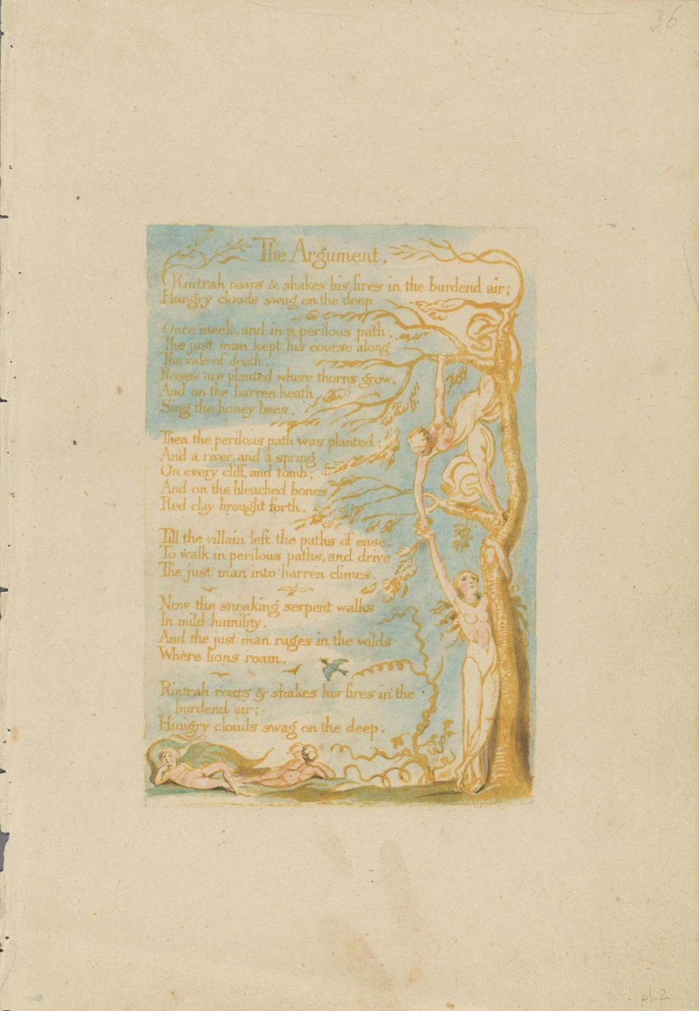
Figure 2. Blake, William (1790). The Marriage of Heaven and Hell (London: William Blake), 2 [Copy A]. Harvard Library, 2024 President and Fellows of Harvard College. Licensed under a Creative Commons Attribution 4.0 International License.
Thus, for Blake, the possibility of environmental flourishing can only be thought through its opposite, environmental decline, which is less its contradiction than what Gilles Deleuze calls its “vice-diction,” the “procedure capable of following multiplicities and themes” through the “specification of adjunct fields” and “the condensation of singularities,” which “intervene in the determination of the conditions of the problem and in the correlative genesis of cases of solution” (Deleuze 2004: 238-239). Thinking these seemingly contradictory elements (ecological decline and the production of ecological flourishing) alongside one another allows for a clear explanation of the problem. Recognizing the entanglement of seemingly contradictory elements generates the conditions for a genuinely radical solution. This solution would be a singularity, something new, rather than a reproduction of the thought which belongs to the problem, as disaster ecology is for Morton. Thus, to get to a notion of “nature’s ecology,” described by Hutchinson, or a “politics of life” as described by Makdisi, Blake and Blake’s interpreters must work through a politics of death and ecological destruction.

Blake and Necropolitics

One way to address the politics of death and ecological destruction in Blake’s work is via Achille Mbembe’s recent theorization of “necropolitics.” Blake’s work is historically coincident with and in close dialogue with the emergence of modernity, characterized by the politicization of life described by Michel Foucault throughout his work. This is evident in Blake’s engagement with emergent modernity’s philosophical underpinnings in Francis Bacon and John Locke, and his interest in disciplinary institutions that work not just on bodies but on the production of individuated subjectivity. Blake both registers these changes and subjects them to critique (Hutchinson 2002: 4-7; Makdisi 2003: 86). Recently, Achille Mbembe has reoriented understandings of Foucault by drawing attention to the persistence of a politics of death in Foucault’s politics of life. In The Will to Power, Foucault describes a sovereign regime that exercises a right of power over death: “one of the characteristic privileges of sovereign power was the right to decide life and death” (Foucault 1998: 135). In this schematic account, modern political power, in contrast, “align[s] itself with the exigencies of a life-administering power […] that endeavors to administer, optimize, and multiply [life], subjecting it to precise controls and comprehensive regulations” (Foucault 1998: 136-137). Power is therefore decentered from the figure of the sovereign, diffused across society in multiple practices and institutions, replacing the exercise of putting to death with practices that optimize life.

Mbembe’s intervention serves to complicate Foucault’s account. He rejects accounts that have “unfortunately privileged normative theories of democracy” and those that ultimately see biopolitics as producing “a body (the demos) comprising free and equal individuals” (Mbembe 2019: 67). Ultimately, the disciplinary regime of the biopolitical produces a “subject [which] is both master and controlling author of his own meaning” in “a twofold process of self-institution and self-limitation” (2019: 68). Such accounts have a tendency to obscure the continuing role of the power over death in the colony while the colony takes a constitutive role in the emergence of modern democratic states. Rather, Mbembe argues for an analysis of diffuse and varied modes of power: “modernity is at the origin of multiple concepts of sovereignty, and thus also of the biopolitical” (2019: 67). Blake’s work resonates with Mbembe’s critique of Foucault by similarly critiquing the vision of the subject as master and controller of both self and meaning and by insisting that modern, liberal democratic subjectivity is co-constituted with necropolitical violence. For Mbembe, liberal democracy supersedes the sovereign power of death, but—in a relation that echoes Blakean structures of co-existing contradictions—also maintains it as a constituting “double” of liberal democracy. Underpinning biopolitics and its production of liberal democracy is “the generalized instrumentalization of human existence and the material destruction of human bodies and populations,” which Mbembe calls necropolitics (2019: 68). Both “the sovereign right of the sword and the mechanisms of biopower are part of the functioning of all modern states; indeed, they can be seen as constitutive elements of state power in modernity” (2019: 71).

However, while necropolitics is a continuation of “that old sovereign right to kill” (2019: 71) in modernity, Mbembe argues that sovereign right takes on a specific and distinctive form when it becomes coextensive with modern biopower. It is organized by norms and systematized practices rather than the arbitrary will and might of the tyrant. Mbembe offers a genealogy of necropolitics: plantation slavery, revolutionary terror, high imperialism, industrialized warfare, the Nazi death camp, apartheid, and the occupation of Palestine. At first glance, some of these examples seem to contradict one another. Industrialized warfare in Europe, for example, became organized by international law at the same historical moment that Europe’s colonies were “ruled in absolute lawlessness” (2019: 77). In practice, however, industrialized slaughter did not appear so differently in the colonies and in the metropole: “World War II shapes up as an extension of methods previously reserved for the ‘savages’ to the ‘civilized peoples’ of Europe” (2019: 76). Moreover, these examples are united by a diffuse and discursive structuring of necropolitical power. For example, the new forms of law which established relations between European states, the “jus publicum, rapidly assumed the form of a distinction between, on the one hand, those parts of the globe available for colonial appropriation, and, on the other, Europe (where the Jus publicum was to hold sway)” (2019: 77). Necropolitics, at the level of theory, is concerned not with arbitrary violence but with the organization and systematization of violence by a division of states and populations:
[t]he writing of new spatial relations (territorialization) ultimately amounted to the production of boundaries and hierarchies, zones and enclaves; the subversion of existing property arrangements; the differential classification of people; resource extraction; and finally, the manufacturing of a large reservoir of cultural imaginaries. (Mbembe 2019: 79)

There seems, at first glance, to be a contradiction between Mbembe’s claim that the techniques of necropolitics returned to Europe for use against Europeans, for example, during the Second World War, and this careful division of territories and populations. However, necropolitics is a form of systematization that produces necropolitical power as naturalized. It is moveable and transferable. For Mbembe, the key process by which this operates is the dispositif of race, which functions “by dividing people into those who must live and those who must die […] in relation to the biological field” (2019: 71). Necropolitics operates by discursively producing and systematizing natural space and difference, such that difference becomes taxonomic and the environment is split into territories and zones for human exploitation.

Blake’s texts offer striking parallels to both parts of this process: government actions vis-à-vis the deployment of death, and its discursive underpinnings in the systematization of nature. Together, these produce a theory of necropolitics—its origin is located in a distinctive historical situation (which includes war, slavery, and revolution), and, as in Mbembe’s theory, possibilities of resistance emerge from counter-politicizations of death. In what is the most overtly historical of the Continental Prophecies, America, Blake narrates the American War of Independence (1775-1783) as a battle between the angels of America and “Albion,” the United Kingdom. In echoes of Biblical plagues, Blake compares the British attempt to destroy the new American state to biological warfare and starvation via environmental destruction. The military campaign against America is described as “a storm to cut them off, / As a blight cuts the tender corn when it begins to appear” (14:5-6 E56). This is later literalized in The Song of Los, where it is presented as a direct military tactic against an unruly or revolutionary population. The government, the “privy admonishers of men”—which suggests the ruling Privy Council of Britain—are described as those who “cut off the bread from the city, / That the remnant may learn to obey” (7:1-2 E69). Similarly, the British Army in America come to the Revolutionary War, “[a]rm’d with diseases of the earth” (13:15 E56) and Albion’s Angel orders “plagues” to fall upon America (14:4-5 E56). Figured alongside the “blight” that kills crops, Blake figures environmental degradation and biological warfare together as necropolitical techniques. Moreover, while this disease has metaphorical dimensions, especially since in Blake’s narrative it is victoriously “recoil’d” on the British (14:20 E56), its description is significant in terms of biological warfare. The “Pestilence [begins] in streaks of red” and is a “spotted plague” (15:1-2 E56). This recalls the smallpox epidemics that were a notable experience of colonial wars in North America, including the theatre of the Seven Years’ War (1756-1763), known as the French and Indian War (1754-1753), and the American Revolutionary War. Ann M. Becker observes that in the Quebec Campaign (1775), for example, the British Captain Thomas Ainslie reported with “pleasure […] that the American forces were susceptible to smallpox and had been free of the disease to this point.” Becker’s conclusion is that smallpox was likely deliberately introduced into the Continental Army as a military tactic, and “was certainly a British advantage” (Becker 2004: 407-408). Similarly, she argues that British “biological warfare” was a major influence on Washington’s tactics during the siege of Boston (1776) (Becker 2004: 429). While Becker acknowledges that biological warfare was often only “rumoured” (Becker 2004: 383) and that Ainslie’s words are “not an overt admission’” (Becker 2004: 407), her conclusions are drawn in part from British admissions of biological warfare during the French and Indian War. Drawing on the work of Elizabeth Fenn, Becker observes that “Jeffrey Amherst, British commander in chief and governor general of North America at the time, justified engaging in biological warfare […] by recourse to the ‘just war’ concept, that is, that any and all means may be used to achieve success in a total war or to defeat an insurrection” (Becker 2004: 400; Fenn 2001: 133-134). Becker adds that Amherst, “condoned a plot to expose Native Americans to smallpox during this war” (Becker 2004: 400), which involved deliberately sending clothing from smallpox hospitals to Indigenous Americans.

By placing biological warfare alongside agricultural destruction, Blake recognizes both as part of an instrumentalization of nature. Disease is no longer a part of a pre-discursive nature, a natural given to which all human life is exposed, but rather something that is managed and organized according to a preceding division of environment and population. Biological warfare was possible due to a recognition by the British that different populations are differently vulnerable to the smallpox virus due to different histories of exposure. Moreover, the colonial context, and the systematization of racial difference, were used to justify such tactics. In the first instance, Indigenous Americans must be established as biologically different from white Britons, a process that Blake associates in The Song of Los with instrumentalizing “Abstract Philosophy” (3:11 E67). As Becker points out, in British military discourse, this inscription of racial difference was applied to the white American rebels, who were also described as “savages” to allow “germ warfare” to “have been justified according to military parameters of the time” (Becker 2004: 400). As Mbembe suggests, “radical selection” found its “first testing ground in the colonial world,” and the “colonies could be ruled in absolute lawlessness” by any means, “due to the racial denial of any common bond between the conqueror and the native. In the conqueror’s eyes, savage life is just another form of animal life, a horrifying experience, something beyond imagination or comprehension” (Mbembe 2019: 76-77). Necropolitics functions by inscribing a systematized nature which renders some humans part of nature while separating others from nature, making the former susceptible to violence, death, and genocide via the very instrumentalized and systematized nature of which they are part.

This reading might suggest that Blake makes an unproblematized equivalence between Indigenous Americans and those white settler colonists who were involved in their dispossession and genocide via environmental necropolitics. However, Blake is more ambiguous than this, establishing parallels insofar as he attempts to defend elements of the American Rebellion, while also recognizing the settler colonists’ complicity in environmental necropolitics. In a compelling recent reading of America, Lucy Cogan has charted the shifting inconsistencies with which Blake depicts the American revolutionaries. On the one hand, he associates the American revolutionaries with the figure of Orc, “Blake’s invented personification of the revolutionary spirit” (Cogan 2021: 382). However, Cogan describes a tension between the main body of Blake’s text and its “Preludium.” In the main body of the text, Orc’s “fires fuel the revolutionaries’ fight for liberty,” but the “Preludium” “tells the seemingly unrelated story of Orc’s own release from imprisonment, which he accomplishes through a coercive sexual encounter with a nebulous female figure, the ‘Shadowy Female’” (Cogan 2021: 382). For Cogan, Orc owes his origin to an act of rape, which stands in opposition to any notion of liberty and thus taints the politics of the American revolutionaries. In addition, Cogan argues, Orc is associated with “the repressive and exploitative logic of empire” because the figure Orc rapes is Oothoon, a character associated in Blake’s earlier poem, Visions of the Daughters of Albion (1793), with the “soft American plains” (1:20 E46) (Cogan 2021: 387). Cogan is right to take the sexual violence, too often treated as ‘symbolic’ or ‘metaphorical’ in Blake studies, literally.

However, it is worth supplementing Cogan’s reading by thinking seriously about Oothoon as the “American plains” that reappear in the “Preludium” to America (2:10 E52). In line with my reading, Blake depicts America not just metaphorically through a personification but engages literally with violence against land and environment. When the “Shadowy Female” of America sees Orc, she describes that her “American plains […] feel the struggling afflictions”(2:10 E52) of Orc. Orc is described as dismembering her in “limb rending pains” (2:15 E52). In the first place, these plains are divided by European powers such that “roots,” which previously “writhe[d] their arms into the nether deep” (2:11 E52) are divided into colonies: “I see a serpent in Canada, who courts me to his love; / In Mexico an Eagle, and a Lion in Peru: / I see a Whale in the South-sea, drinking my soul away” (2:12-14 E52). Next, she feels Orc’s “fire” and her “frost / Mingle […] in furrows by thy lightnings rent” (2:10, 15-16 E52). This is accompanied by an image of Orc emerging from the earth, splitting the entangled roots of an America that is not defined by colonial organization but is rather rhizomatic and deterritorialized (Figure 3). The emergence of Orc is part of the colonial project of dividing the land and preparing it for intensive agriculture. This is later echoed by a description of the Revolutionary War as a threat that will attempt to “smite the wheat […] quench the fatness of the earth […] subdue the plow and spade” (9:5-6 E54), which will be prevented by the Continental Army. This plate depicts a sleeping or perhaps dead child entombed in endless fields of wheat, which blot out the flowers, vines, and trees that surround other plates (Fig. iv). In this image, the American plains have become a sort of biodiversity desert, dominated by intensive, monocultural agriculture. Finally, Blake connects this directly with plantation slavery in an image of “the slave grinding at the mill” (6:6 E53), not here the modern factory but rather, as indicated by the word “grinding,” an agricultural mill. Within Blake’s historical schema, this initial colonial division and organization of nature is a form of environmental necropolitics and the origin of the necropolitical logic of colonial war. Mbembe suggests that the perpetrator of colonial war and genocidal violence imagines a process by which “biophysical elimination would strengthen [one’s] life potential and security,” and is “one of the many imaginary dimensions characteristic of sovereignty in both early and late modernity” (Mbembe 2019: 72). Blake’s poetry develops this insight by suggesting that this also includes the elimination of a diverse biosphere by the discursive inscription of nature and its subsequent use in an instrumentalized system designed only for the biopolitical goal of intensive agriculture.
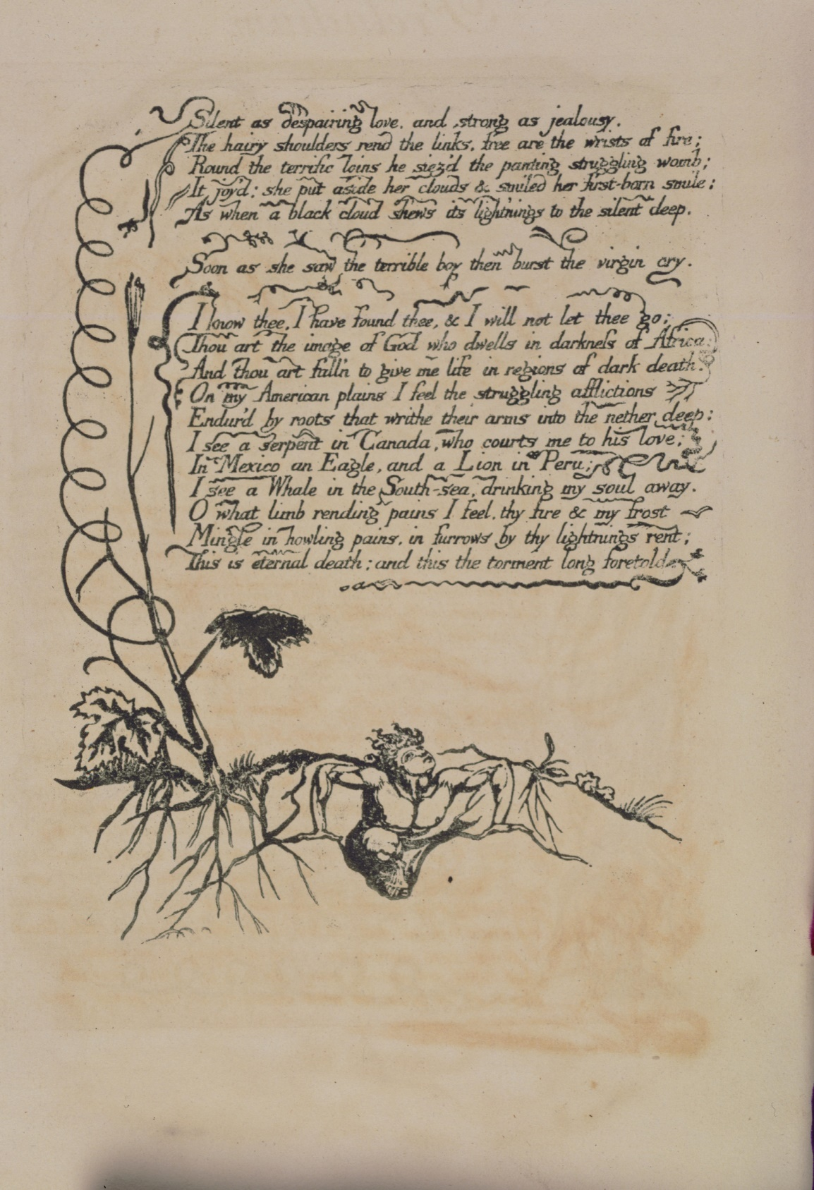
Figure 3. Blake, William (1793). America (Lambeth: Printed by William Blake), 2 [Copy E]. Library of Congress, Rare Book and Special Collections Division - Lessing J. Rosenwald Collection.
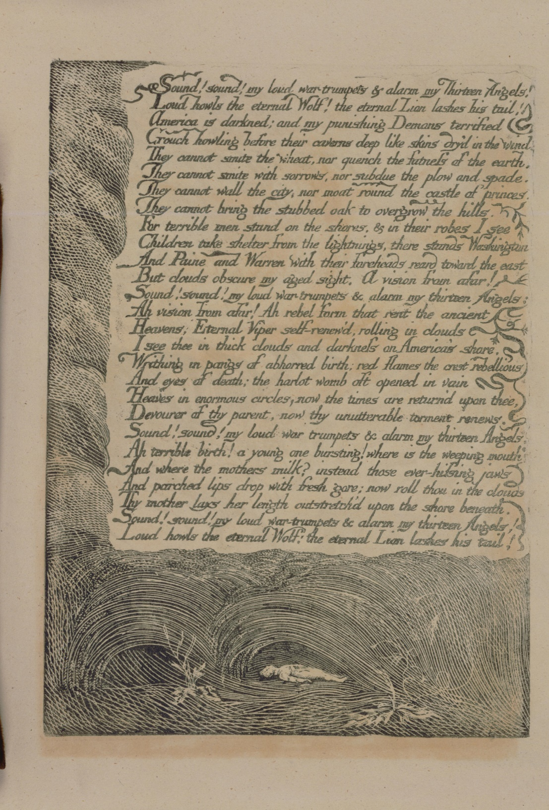
Figure 4. Blake, William (1793). America (Lambeth: Printed by William Blake), 9 [Copy E]. Library of Congress, Rare Book and Special Collections Division - Lessing J. Rosenwald Collection.

Blake, Necropolitics, and Resistance

Blake reworks and theorizes the connection between environmental necropolitics and the necropolitical logic of colonial war in more abstract and mythological terms in the “Preludium” to Europe a Prophecy (1794). Here, another character also referred to as a “nameless shadowy female” rises “from out the breast of Orc” (1:1 E60). Orc is an ever-shifting figure of revolutionary energy and violence, switching roles and relationships across Blake’s work. His nameless daughter makes a complaint to her mother, Enitharmon, about their shared excessive fertility, which strikingly links the previous exploration of colonial agriculture to oppressive and revolutionary political violence; an instrumentalized and precarious natural world; and an esoteric theory of the creation of complex systems. The “nameless female” complains that she is “faint with travel” (1:6 E60), due to both the pangs of labor and her movement over the earth, while “all the overflowing stars rain down prolific pains” (1:15 E61). Heaven and earth, burning stars that also flow like water, the universe and its four elements—all these cause the pain of childbirth. She is giving birth to “howling terrors all devouring fiery kings” (2:4 E61). Simultaneously, she is the mother of oppressive political power, “all devouring fiery kings,” and “howling terrors,” forces that might bring revolution and overthrow those kings. Moreover, she gives birth “[i]n forests of eternal death, shrieking in hollow trees” (2:6 E61). Her complaint of fertility is situated in a devastated, degraded natural environment, where nothing grows anymore. Thus, we have a mythological scene where the birth of political violence and violent revolution are seen as emerging from an abstract concept of death that renders them equal.

And yet, things are rarely so simple in Blake. Close attention to the “Preludium” suggests a number of readings that disrupt the symbolic equivalence of monarchy and revolution rendered by death, suggesting death’s political valence. On the one hand, the “shrieking” among the hollow trees suggests labor pains, but on the other hand, Blake suggests that it is the “devouring kings” themselves who move through the “forests of eternal death.” After she gives birth to the “devouring kings,” the word is repeated in the following sentence, which notably does not have an obvious grammatical subject: “Devouring & devoured roaming on dark and desolate mountains / In forests of eternal death, shrieking in hollow trees” (2:5-6 E61). “Devouring & devoured” here occupy the space of the subject, and, by metonymy, imply the “all devouring fiery kings” of the previous line, but also those who are subject to the violence of monarchic power—those who are devoured. The dialectical process itself, then, moves through a dead and blasted landscape.

Moreover, this seemingly ahistoric landscape is given a history in the “Preludium.” The eternal, which we have seen as Blake’s attempt to imagine a pre-discursive nature brought into discourse, is given a beginning when the “nameless female” describes her first labor, and she becomes a tree: “My roots are brandish’d in the heavens, my fruits, in earth beneath / Surge, foam, and labour into life, first born and first consum’d” (1:8 E60). As Tilottama Rajan has noted, this is an example of Blake’s innovative and distinctive use of catachresis. As Rajan explains:

three heterogeneous entities (woman, tree, and ocean) are violently yoked together in a ‘space they cannot logically share,’ so that the ‘ordinary referentiality of one set of terms wars against the ordinary referentiality of the other.’ These multiple symbolic constructions, far from giving a face to the female, leave her ‘void as death.’ (Rajan 1995: 399)

For Rajan, catachresis is “mutilation”: “[s]ymbolically figured as a tree, the female is disabled from existing as a human being” (1995: 399). I agree, but Blake associates the violence done to her not only with catachresis but also with her entry into a cyclical system that imposes a relationship on the heterogeneous entities of catachresis. It is not just being figured catachrestically that leaves the nameless female “void as death,” but also the order that is imposed on what she brings forth. As she puts it, addressing her mother once again, “I bring forth from my teeming bosom myriads of flames. / And thou dost stamp them with a signet, then they roam abroad / And leave me void as death” (2:9-11 E61). To stamp with a signet brings a document into an official system of meaning. The death that the nameless female suffers is not only the result of catachresis, but of bringing the infinite variations of catachresis—its “teeming […] myriads”—into a signifying system. Hence the earlier pun, where the female as upside-down tree “brandish[es]” her roots, confronting (“brandishing”) the signifying system as she is drawn into it (being branded). To be brought into an official signifying system, in the context of Europe’s “Preludium,” is to move from pre-discursive given (which can only be known discursively) to the moment of historical origin and event in which heterogeneous elements are violently yoked together—a cyclical movement that maintains that relation in “void” repetition. After being branded, after being stamped with a signet, the nameless female’s “first born” are “first consum’d” before entering into a cyclical process with no beginning and no subject, “[c]onsumed and consuming!” (1:10 E60), which echoes but reverses “[d]evouring & devoured” (2:5 E61), to stress the cyclical situation. This echoes the nature-framing organization and political practice of the serpent temple.

The nameless female, then, is characterized by a heterogeneity that is violent but also associated with childbirth as creation. She is used to link together human and natural worlds, such that woman, tree, and ocean enter into a relationship with one another. This is then marked as an officially recognized system, which is characterized by a circular cycle of consuming and being consumed, and which is strongly associated not only with time, history, or space, but also with “eternal” and “void” death. What the “Preludium” narrates, then, is a process where the heterogeneity of the given, pre-discursive existent nature and its relations (which are already violent) undergoes a second order of violence by being brought into an official system that we might call ‘Nature’: the reifying organization of the heterogeneous world, and human relations with it, into that which takes on a single, official name. This results in an endless cycle of consumption without production, described as “eternal death,” and that we might call a signifying-consumption cycle. For Blake, this is a prelude to the history of the present, a prelude to the emergence of modernity in the revolutions of the late eighteenth century. However, if the “Preludium” of Europe suggests that modernity produces a system of nature in permanent, deathly, environmental decline, then it also suggests that the destiny of revolution is to break this cycle and renovate both the human perception of the existent and the existent itself.

Hence, in contrast to this vision of a cycle of eternal death, the nameless female imagines giving birth to a child that cannot be branded or stamped, which she calls the infinite: “[a]nd who shall bind the infinite with an eternal band? / To compass it with swaddling bands?” (2: 13-14 E61). In contrast to the empty repetition of the signifying-consumption system of nature, Blake instead suggests we “cherish” the infinite. The mother implies through her question that this is not only the responsibility of a biological mother: “and who shall cherish it / With milk and honey? / I see it smile & I roll inward & my voice is past” (2:14-16 E61). Milk and honey are provided by others for a mother who can “roll inward,” safe in the knowledge of the infinite child’s care. And this “roll,” too, appears to be contrasted with the cyclical containment of the signifying-consumption cycle, and is associated with a revolution that produces the new: “[s]he ceast & rolld her shady clouds / Into the secret place” (2:17-18 E61). This “secret place” implies her reproductive organs, but also somewhere that cannot be perceived without revolutionizing human perception, which can usually only “see small portions of the eternal world that ever groweth” (iii:4 E60). There is the potential here to find the renovation of revolution, but also the risk of a new “first” birth, which could begin the cycle of signifying-consumption once again.

There is a risk in Mbembe’s work of a kind of total pessimism; the combination of biopolitics and necropolitics is so pervasive as to render any sort of resistance useless. For Jacques Rancière, such pessimism occurs in a similar conjunction in Giorgio Agamben’s work, which presents “an overwhelming historico-ontological destiny from which only a God can save us” (Rancière 2010: 75). In contrast, Mbembe sees necropolitics not just as a mode of control, but also as a source of resistance: “[w]hether read from the perspective of slavery or that of colonial occupation, death and freedom are irrevocably interwoven” (Mbembe 2019: 91). Mbembe’s example of this is the suicide bomber in occupied Palestine. For Mbembe, in a situation such as the colony, the suicide bomber’s “logic of martyrdom” breaks the traditional logic of war, which involves “wishing to impose death on others while preserving one’s own life” (Mbembe 2019: 89). In the unequal conditions of “late-modern occupation,” with its “permanent condition of ‘being in pain,’” such an exchange is impossible, for it would imply that the combatants were equally matched. Thus, the logic of the suicide bomber is threefold: to gain recognition as a human subject via a reciprocal and face-to-face encounter at the moment of death; to take “account of [one’s own] mortality” rather than it being determined by the occupier; and to imagine a future, which Mbembe describes as an “eternity,” “a vision of freedom not yet come” (Mbembe 2019: 89-91).

Eternity, as we have seen, is an important word for Blake. For Blake, the organization of the environment into a discursive system of nature—which forms the basis for biopolitical and necropolitical institutions—is a process of limiting eternity. In The Song of Los, Blake describes a process where “Abstract Philosophy” creates racial difference, “black grew the sunny African” (3:10 E67). It also creates military and disciplinary infrastructure and organizes space in a way that destroys environmental flourishing: “[t]hese were the Churches: Hospitals: Castles: Palaces: / Like nets & gins & traps to catch the joys of Eternity / And all the rest a desart” (4:1-3 E67). A “gin” here is a snare and so synonymous with “nets” and “traps.” These words suggest environmental depletion through hunting. But by the time Blake was writing, a “gin” also meant both “[a] mechanical apparatus used to draw up ore, water, etc., from a mine shaft; esp. one employing a windlass powered by draught animals, wind, or water” and “[a] machine used to remove the seeds from cotton” (OED). Like Mbembe, Blake, though less fully theorized, also recognizes the need to pass through death, to work through death, rather than reject or ignore death in order to realize freedom, which includes environmental flourishing in a necropolitical world. One ecstatic plate of America (Figure 5) depicts a naked man sitting on the earth, seemingly after having emerged from the grave. Surrounded by bones, but also the wildflowers blotted out by monocultural agriculture, Blake offers a song of freedom and release that connects political freedom to ecological flourishing. “The grave is burst,” he writes, and:

The bones of death, the cov’ring clay, the sinews shrunk & dry’d,
Reviving shake, inspiring move, breathing! awakening!
Spring like redeemed captives when their bonds & bars are burst;
Let the slave grinding at the mill run out into the field;
Let him look up into the heavens & laugh in the bright air
[…]
Singing. ‘The sun has left his blackness, & has found a fresher morning
And the fair Moon rejoices in the clear & cloudless night;
For Empire is no more, and now the Lion & Wolf shall cease.’ (6: 2-7, 13-15 E53)

This form of freedom, in the context of Blake’s vision of environmental necropolitics, would also have to be a vision of freedom that passes through, but refuses, the “mental chains” (13:3 E56) that turn catachresis into a signifying system of nature. Given that for Blake, necropolitical control is based on a process of systematizing nature, he requires new ways of relating the natural world to language, or he will only address the symptoms of necropolitics rather than their cause. Blake is able to articulate political freedom but struggles to develop a syntax and style that would escape this signifying system, which testifies to the difficulties of this undertaking. However, he does rise to the challenge (as articulated at the beginning of this essay by Morton) of avoiding recreating the very conditions of environmental decline he seeks to avert. Blake seeks to think beyond system in favor of the potential of the infinite and eternal, but this is also based on a shift of attention from the systematic and global environment to the minute, specific, and differential. The focus is on singularities, here, rather than repeatable and repeating systems.

I want to conclude by returning to the section of Europe that comes before the “Preludium,” in which Blake dramatizes the composition of the text as an attempt to refuse the systematized nature of property, organization, and received signifying systems. As we have seen, a fairy “mock[s]” (iii:6 E60) those who believe that the senses, the “five windows” that “light the cavern’d man” (iii:1 E60), can represent the world, since they are but “small portions of the eternal world that ever groweth” (iii:4 E60). A first-person speaker, a writer, takes “possession” of this fairy “as boys knock down a butterfly” (iii:11, 9 E60). Blake hints at a perception of nature based on the taxonomy of butterfly-collecting, and perhaps by extension the Linnean system or what is perceived by the systematization of the senses. However, he contrasts this with a joint work by the fairy, who accepts its conditions, and laughs at ecological destruction along with the speaker. The fairy “laugh[s]” at the very concept of possession and becomes a companion “in [the speaker’s] warm bosom” (iii:14, 19 E60). Together they seek a way of experiencing the environment beyond death. The speaker asks the fairy, “tell me, what is the material world, and is it dead?” (iii:13 E60), to which the fairy promises a new form of poetry that will “shew you all alive / The world, when every particle of dust breathes forth its joy” (iii:17-18 E60). Ultimately, for Blake, the necropolitics of environmental decline must be resisted with a turn to the extremely specific. As the narrator of America tells us: “every thing that lives is holy, life delights in life” (8:13 E54).
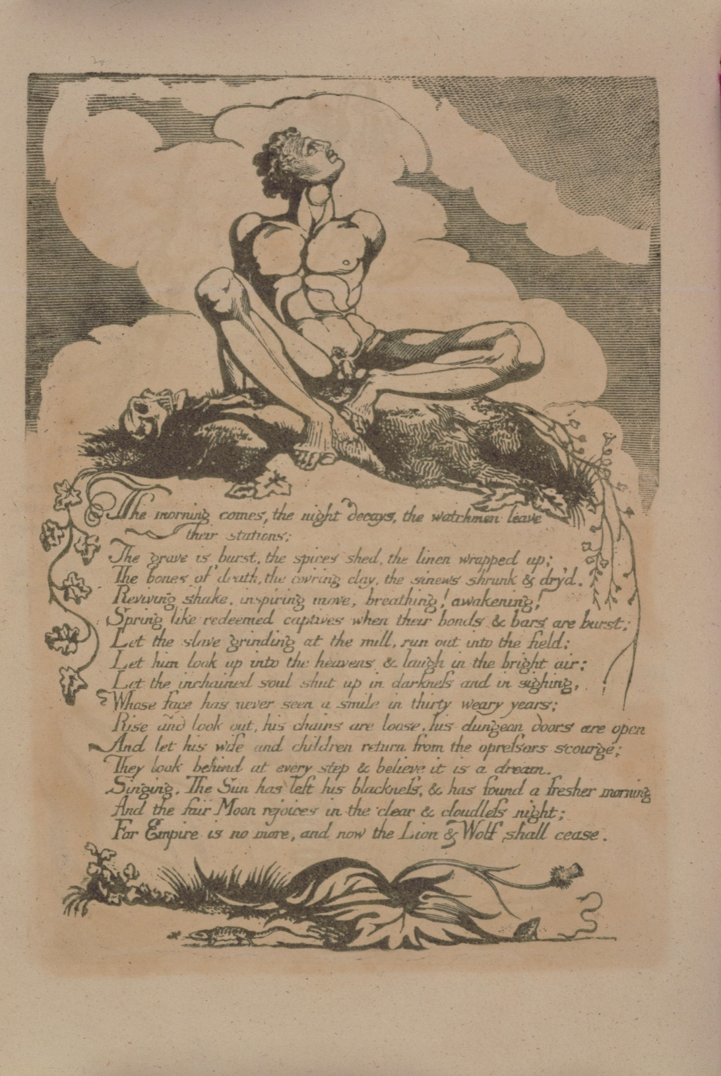
Figure 5. Blake, William (1793). America (Lambeth: Printed by William Blake), 6 [Copy E]. Library of Congress, Rare Book and Special Collections Division - Lessing J. Rosenwald Collection.

List of Figures

Figure 1. Blake, William (1793). America (Lambeth: Printed by William Blake), Plate 13 [Copy E]. Library of Congress, Rare Book and Special Collections Division - Lessing J. Rosenwald Collection.

Figure 2. Blake, William (1790). The Marriage of Heaven and Hell (London: William Blake), 2 [Copy A]. Harvard Library, 2024 President and Fellows of Harvard College. Licensed under a Creative Commons Attribution 4.0 International License.

Figure 3. Blake, William (1793). America (Lambeth: Printed by William Blake), 2 [Copy E]. Library of Congress, Rare Book and Special Collections Division - Lessing J. Rosenwald Collection.

Figure 4. Blake, William (1793). America (Lambeth: Printed by William Blake), 9 [Copy E]. Library of Congress, Rare Book and Special Collections Division - Lessing J. Rosenwald Collection.

Figure 5. Blake, William (1793). America (Lambeth: Printed by William Blake), 6 [Copy E]. Library of Congress, Rare Book and Special Collections Division - Lessing J. Rosenwald Collection.

Works Cited

Becker, Ann M. (2004). “Smallpox in Washington’s Army: Strategic Implications of the
Disease during the American Revolutionary War.” Journal of Military History 68: 381-
430.

Bindman, David (1995). “Blake’s Vision of Slavery Revisited.” Huntington Library Quarterly 58: 373-382.

Blake, William (1988). The Complete Poetry and Prose of William Blake (Revised Edition).
Ed. David V. Erdman. New York, NY: Anchor Books.

Cogan, Lucy (2021). “Rending the ‘Soft Plains’ of America: Rape and Liberation in the
Poetry of William Blake.” European Romantic Review 32: 377-397.

Cronon, William (1995). “The Trouble with Wilderness; or, Getting Back to the Wrong Nature.” Uncommon Ground: Rethinking The Human Place in Nature. New York, NY: Norton, 69-90.

Deleuze, Gilles (2004 [1968]). Difference and Repetition. Trans. Paul Patton. London:
Continuum.

De Luca, Vincent (1991). Words of Eternity: Blake and the Poetics of the Sublime. Princeton,
NJ: Princeton UP.

Faflak, Joel (2019). “Blake’s Milton and the Nonlife of Affect.” The Wordsworth Circle 50: 36-54.

Fenn, Elizabeth A. (2001). Pox Americana: The Great Smallpox Epidemic of 1775-1782. New
York, NY: Hill and Wang.

Foucault, Michel (1998 [1976]). The Will to Knowledge: The History of Sexuality Volume 1.
Trans. Robert Hurley. London: Penguin.

Foucault, Michel (2002 [1969]. The Archaeology of Knowledge. Trans. A.M. Sheridan Smith.
London: Routledge.

Hutchings, Kevin (2002). Imagining Nature: Blake’s Environmental Poetics. Montreal:
McGill-Queen’s UP.

Lee, Haram (2021). “The Critique of Reason and Biopolitics in William Blake’s The Four Zoas.” Texas Studies in Literature and Language 63: 53-77.

MacLure, Jennifer (2023). The Feeling of Letting Die: Necroeconomics and Victorian Fiction. Columbus, OH: Ohio State UP.

Makdisi, Saree (2003). William Blake and the Impossible History of the 1790s. Chicago, IL:
U of Chicago P.

Mbembe, Achille (2019). Necropolitics. Trans. Steven Corcoran. Durham, NC: Duke UP.

Michael, Jennifer Davis (2000). “The Corporeal City in Blake’s Milton and Jerusalem.”
Studies in Eighteenth-Century Culture 29: 105-122.

Morris, David B. (2012). “Dark Ecology: Bio-anthropocentrism in ‘The Marriage of Heaven
and Hell.’” Interdisciplinary Studies in Literature and Environment 19: 274-294.

Morton, Timothy (2009). Ecology Without Nature: Rethinking Environmental Aesthetics.
Cambridge, MA: Harvard UP.

Morton, Timothy (2012). “Romantic Disaster Ecology: Blake, Shelley, Wordsworth.”
Romanticism and Disaster. Ed. Jacques Khalip and David Collings. Romantic Circles
Praxis Series, pars. 1-32. <https://romanticcircles.org/praxis/disaster/ HTML/praxis.2012.morton.html>. [accessed 25 April 2023]

Morton, Timothy (2013). Hyperobjects: Philosophy and Ecology after the End of the World.
Minneapolis: U of Minnesota Press.

Moyer, James F. (2014-15). “‘The Daughters Weave their Work in loud cries’: Blake,
Slavery, and Cotton.” Blake: An Illustrated Quarterly 48.
<https://bq.blakearchive.org/pdfs/48.3.moyer.pdf>. [accessed 13 January 2024]

Rajan, Tilottama (1995). “(Dis)figuring the System: Vision, History, and Trauma in Blake’s
Lambeth Books.” Huntington Library Quarterly 58: 383-411.

Rancière, Jacques (2010). Dissensus: On Politics and Aesthetics. Trans. Steve Corcoran.
London: Continuum.

Stempel, Daniel (1981). “Blake, Foucault, and the Classical Episteme.” PMLA 96: 388-407.

Whittaker, Jason (1999). William Blake and the Myths of Britain. Basingstoke: Macmillan.

For quotations from Blake, I follow the convention of citing plate number and line number, followed by page number in the Erdman edition.
Rajan develops her reading of catachresis based on quotations from De Luca 1991: 384-385.
Lee’s essay can be supplemented with recent work by Jennifer MacLure, who stresses that alongside the Malthusian imperative of self-discipline, there is an explicit necropolitical injunction, “a mandate to let the poor die” (MacLure 2023: 9). Malthusian self-discipline, in this context, is not just the requirement of the subject to regulate her own life force but also to control her affective responses to the necessary death of others (MacLure 2023: Introduction and Ch. 1).
For a close reading of the line “[w]here man is not nature is barren,” see Hutchings 2002: 18-21. For an exemplary close reading of Blake’s annotations to Wordsworth, see Ibid., 38-40.
At least in the United Kingdom, where Bate frequently appears on the BBC and in the broadsheet newspapers.
See Chapter 6 of Makdisi’s text (2003) for a reading of Blake’s philosophy of life.
Stempel has stressed Blake’s transitional status between classical and modern epistemes (Stempel 1981: 402-403).
Mbembe’s emphases throughout unless otherwise noted.
For a discussion of a stronger metaphorical use of biological warfare in Blake’s later work, see Michael 2002: especially 106-110.
James F. Moyer has observed that Blake shows, across his work, a strong sense of how the cotton industry formed a system of “multi-site slavery” (Moyer 2014-15: para. 5). Moyer’s focus is on working conditions rather than how the plantation system might be linked to environmental destruction. For Moyer, in America and the other works under discussion in this essay, the “mapping of multi-site slavery remains somewhat opaque” (para. 7). On Blake and slavery, see also Bindman 1995. The texts under discussion here do not deal with plantation slavery directly, unlike some of Blake’s other works.
A signet is “[a] small seal employed for formal or official purposes instead of, or in addition to, a signature to give authentication or authority to a document for formal or official purposes” (OED).
Nearly synonymous with to stamp with a signet, to brand is “[t]o mark indelibly, as a proof of ownership, as a sign of quality, or for any other purpose; to impress (a word, letter, or device) by way of brand” (OED).

