Capitalising on the Slate Landscape UNESCO World Heritage Site and the development of sustainable tourism in Northwest Wales.

Final Report, June 2024.

Principal Investigators:
Dr Sara Parry
Dr Sonya Hanna

Co-Investigators:
Professor Thora Tenbrink
Dr Hayley Roberts
Dr Einir Young

Funding Body: Bangor University
Award: Bangor Impact & Innovation Award
External Partners: Gwynedd Council, Snowdonia National Park Authority.
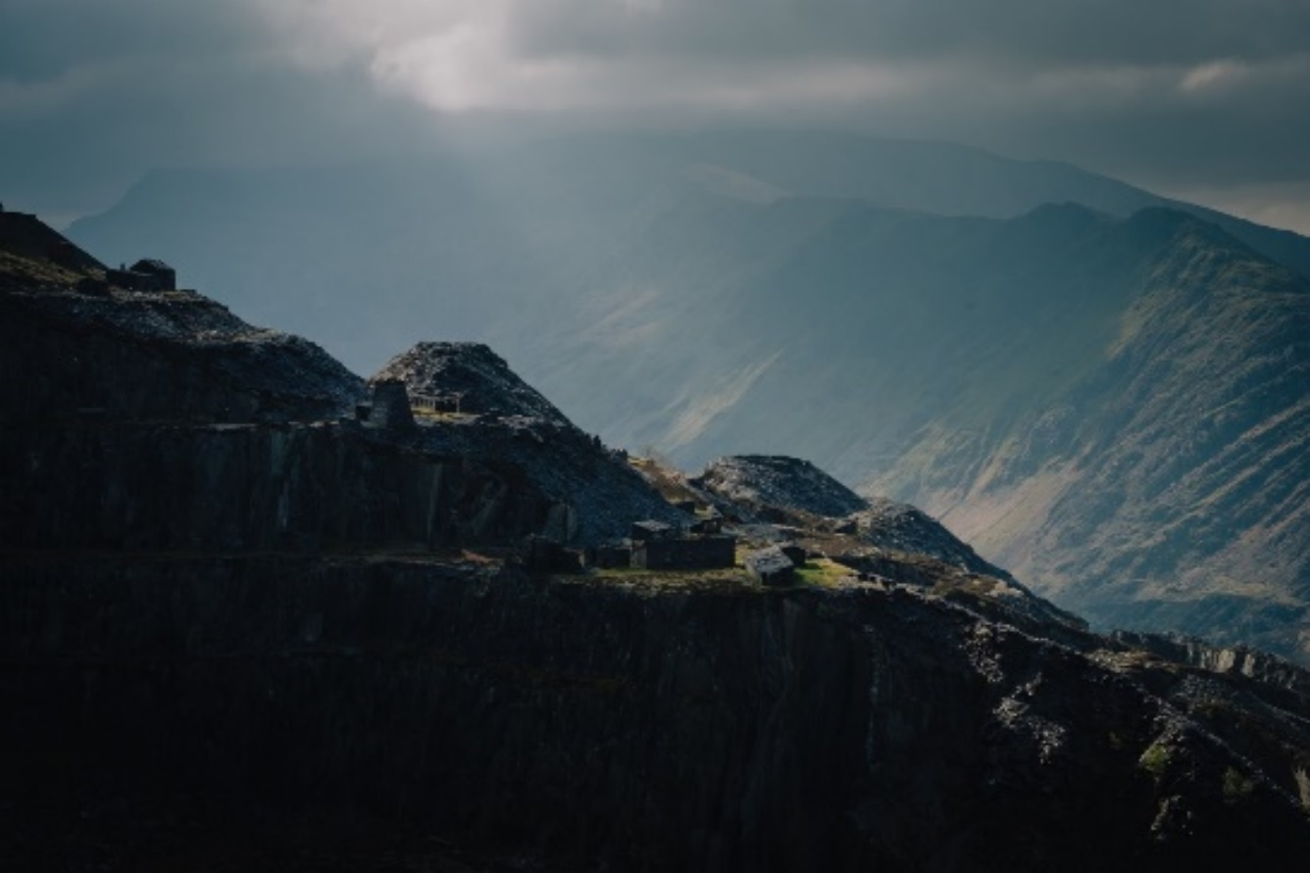

Executive Summary
This study combined expertise in place research, heritage, marketing, and sustainability to (1) examine the younger generation’s perspective of the Slate Landscape of Northwest Wales’s status as a UNESCO World Heritage Site (WHS), and (2) to understand their views of sustainable tourism practices in the region. A mixed methods 2 stage approach was adopted to engage young people (aged 18-25 years) who are indigenous to the area. One focus group and 20 interviews were undertaken (Stage 1) along with a netnographic examination of online user engagement behaviour related to the slate landscape area on social media networks (Stage 2). The research identified four key themes including pride in Welsh heritage (PWH), bonds of personal significance (BPS), uniqueness and attributes of the place (UAP), and community perceptions and global recognition (CPGR). Data from social media platforms indicated the most popular search terms along with user sentiment and busy ‘hotspots’ within the slate landscape area. Recommendations for local authorities and the Llechi Cymru Partnership Board are proposed.

Table of Contents

Introduction 4
Research Questions 4
Methodology 4
Stage 1 4
Stage 2 6
Key themes: Stage 1 7
Key findings: Stage 2 12
Concluding remarks 14
Recommendations 14
Future Research Opportunities 15
References 15

Introduction
The Slate Landscape was designated a UNESCO World Heritage site in July 2021; the fourth WHS in Wales (www.llechicymru/home), affirming its cultural and historical uniqueness and boosting its touristic appeal. In recent years the area has attracted large tourist numbers, particularly during the pandemic, and is an attractive adventure and holiday destination. Further, Priorities for the Visitor Economy 2020-2025 (Welsh Government, 2020) underscores the importance of harnessing young people’s skills and enthusiasm to ensure a prosperous and sustainable tourism sector, aligning with the Well-being of Future Generations Act (Wales) 2015 to apply the principle of sustainable development through collaboration, and to tackle the challenges facing the area. This study (1) examines the younger generation’s perspective of the Slate Landscape of Northwest Wales’s UNESCO World Heritage Site (WHS) status, and (2) aims to understand the segments views of sustainable tourism practices in the region.

Research Questions

- What is the local younger generation’s perceptions of the Slate Landscape WHS status and what it (potentially) means to them?
- How is the WHS affecting the younger generations sense of place, their place attachment and identity?
- What terminology is projected through social media content in reference to the Slate Landscape WHS?
- What are their perceptions of sustainable tourism practices as linked to WHS?

Methodology

Stage 1: Generation Z and the slate landscape, a community-based approach
This stage consisted of an in-depth focus group held with eight participants and 20 interviews with young people indigenous to, and currently residing in the area.

The focus group allowed the researchers to gather information and insights using a card-game methodology allowing for the emergence of an evaluative story. The method involved the presentation of cards with key terms (Table 1) identified as central to addressing the research questions, to prompt reflection and facilitate discussion (Rowley et al., 2012). During discussion, participants were given the task of linking the cards to represent relationships and links between the terms. At the end of the discussion, participants had to put the cards in order of priority to represent which terms were of highest importance to them in comparison to least importance.

Question | Cards with key terms
What do you think of the SL area and its newly awarded status as UNESCO site? | - UNESCO world heritage site  - Slate Landscape  - Welsh heritage
What is your connection to the place? | - Personal interests  - Wales slate trail  - Slate mines of Wales  - Hidden gems
How do you feel about this area? | - Youth empowerment  - Opportunities for young people  - Challenges for young people  - Site improvement
What do you think sustainable tourism is and its relevance to north-west Wales? | - Slate tourism  - Tourism advantages  - Tourism disadvantages  - Sustainable tourism  - Regenerative tourism

Table 1: Focus Group Questions and Cards.

Twenty interviews were undertaken with young people to allow for an in-depth exploration of what is taking place. Using social media, and through collaboration with Gwynedd County Council and a range of community youth groups, such as Partneriaeth Ogwen, GISDA and YouthSheds. Gen Z participants indigenous and/or living in the area, were recruited using purposive and convenient sampling methods from the six areas of the slate landscape WHS as identified by UNESCO (2021). Areas included, (1) Bryneglwys Slate Quarry, Abergynolwyn Village and Talyllyn Railway, (2) Dinorwig Slate Quarry Mountain Landscape, (3) Ffestiniog, it’s Slate Mines and Quarries ‘city of slates’ and Railway to Porthmadog, (4) Gorseddau and Prince of Wales Slate Quarries, Railways and Mill, (5) Nantlle Valley Slate Quarry Landscape, (6) Penrhyn slate quarry and Bethesda, and the Ogwen Valley to Port Penrhyn. In keeping with the participants’ wishes for anonymity, names are substituted for P1 through to P20 (Table 2).

An interview guide was developed with pre-determined open-ended questions covering general knowledge of the slate landscape, opinions of the WHS, place identity and attachment and the challenges and opportunities associated with the WHS status. Ethics approval was granted by the University’s College Ethics Committee with informed consent obtained from all participants prior to data collection. Both focus group and interviews lasted about an hour and were audio recorded before being transcribed giving the researcher an additional opportunity to review what was said and the context within which it was said. The six-step thematic analysis procedure was adopted to explore the transcripts in detail and to identify main themes (Braun and Clarke, 2006). Two of the authors independently and inductively coded the transcripts. During the thematic analysis, detailed descriptors were developed and associated verbatim quotations noted.

Participant Code | Gender | Language | In-person/  Virtual interview | Resident Location
P1 | Male | English | In-person | Bethesda
P2 | Male | English | In-person | Y Felinheli
P3 | Female | English | In-person | Bangor
P4 | Male | English | In-person | Brynteg
P5 | Male | English | Virtual | Bethesda
P6 | Female | English | Virtual | Bangor
P7 | Male | English | Virtual | Bethesda
P8 | Male | Welsh | In-person | Tanygrisiau
P9 | Female | English | In-person | Llanberis
P10 | Female | English | Virtual | Y Felinheli
P11 | Male | English | Virtual | Bangor
P12 | Female | Welsh | Virtual | Y Felinheli
P13 | Male | Welsh | Virtual | Bethesda
P14 | Female | Welsh | Virtual | Blaenau Ffestiniog
P15 | Male | English | Virtual | Waunfawr
P16 | Female | English | In-person | Blaenau Ffestiniog
P17 | Male | English | In-person | Blaenau Ffestiniog
P18 | Male | English | In-person | Blaenau Ffestiniog
P19 | Male | English | Virtual | Bangor
P20 | Female | English | Virtual | Bangor

Table 2: Participant Details

Stage 2: Social-media textual and sentiment analysis
To better understand engagement behaviour with the slate landscape in social media networks and to capture user’s sentiments of the slate landscape, a netnographic study was conducted. Netnography has been used to explore online user-generated content in tourism research (e.g., Barros et al., 2022). In line with the recommendation by Kozinets (2010) to use diverse contexts, Twitter, Instagram, Tik Tok and Google were selected for analysis as they are the among the biggest social networking platforms worldwide with a critical mass of communicators.

Using APIFY (https://apify.com/), a web scraping data extraction tool, user-generated content was extracted from the four social media platforms identified. Tracking applications such as Strava and Slow Ways were scanned to identify visitor hotspots and areas of tourism pressure around the site. Popular keywords of interest (e.g., Slate, Slate Landscape, Llechi Cymru) with a maximum of 300 posts scraped per keyword were examined resulting in a total of 8945 posts from Instagram, 10,172 posts from Twitter, 285 posts from TikTok and 6,379 posts from Google. User locations were only available if the user had enabled this on their social media profiles, and this spatiotemporal data was inputted into a map to create a heat map of popular user locations. A sentiment analysis of the data examined positive, negative, and neutral emotions, providing meaningful insights on feelings and opinions related to the slate landscape.

Key themes: Stage 1This section presents the four core themes (Table 3) and the relationship identified between () that emerged from the focus group and interview transcripts. The four themes are: pride in Welsh heritage (PWH), bonds of personal significance (BPS), uniqueness and attributes of the place (UAP), and community perceptions and global recognition (CPGR).

Primary themes (4) | Code | Description | Subthemes (8, including exemplars)
Pride in Welsh Heritage | PWH | An inclusive approach to heritage to include the preservation of ‘language’ and ‘culture’, and the knowledge of history, and their significance and interrelationship with place identity and image. | - Historic value: Preservation of industrial and social history (sites and people), appreciation for the processes of slate mining, extensive knowledge of history and desire to learn, informal education -educated on heritage by family and community.  - Preservation of language: Anglicising Welsh culture is a problem, respect for language and place names.
Bonds of  Personal Significance | BPS | The degree of emotional attachment to the place which emanates from home connections, personal identity, and enjoyment of the site. | - Home connections: Hiraeth (a deep longing for something, especially one's home in the context of Wales/Welsh culture), personal enjoyment and social influences, family influence, identity.  - Emotional attachment: Memories and nostalgia, artefacts.
Uniqueness and Attributes of the Place | UAP | Utilitarian, hedonic, and symbolic characteristics all of which are subsumed by our perceptions of the place (i.e., place image). | - Functional (utilitarian): Fitness, recreation, and well-being activities, transport, and access difficulties.  - Experiential (hedonic and symbolic): Nature of landscape (size and scale, beauty, unique, dangerous, dramatic, colour) a ‘film set’, anti-social behaviour, evolving landscape.
Community Perceptions and Global Recognition | CPGR | Image derived from diverse touch points that include a places functional and experiential attribute. | - Site impact on place: Major tourist attraction, value of UNESCO status, increase in tourism after the pandemic and lockdown, over-tourism, pollution, and waste issues, tourism advantages and disadvantages.  - Stakeholder communications: Exposure of site on social media and the news, lack of strategic marketing communications, community concerns.

Table 3: Primary themes from interview and focus group data.

Uniqueness and Attributes of the Place
Experiential
Functional
Pride in Welsh Heritage
Preservation of Language and Culture
Emotional Attachment
Historic Value

Community Perceptions and Global Recognition
Stakeholder Communications
Site Impact on Place
Bonds of Personal Significance
Home Connections

Relationship between themes

Theme
Sub-theme
Link to sub-theme

Figure 1: Mapping of the core themes and subthemes
The FOUR core themes

Pride in Welsh heritage (PWH)
The younger generation’s level of pride in their Welsh heritage and culture was strong, and they spoke in detail about their knowledge of the history in the Slate Landscape and appreciated the processes and wide reach of the slate mining industry. They also discussed the importance of respecting and protecting the Welsh language and voiced concerns about Anglicising Welsh culture:

“It's the history of it. You know, the slate that was imported from this area covered almost half of New York at one point. And the kind of the labour and the work that was put in to take the sites out, that was done by the local quarrymen here, it's something that is worth preserving” (Focus Group Participant)
“I think it's very important to connect with your heritage as much as possible, especially within Wales. I think that's part of the reason I am learning Welsh again, is because it was so sort of repressed, especially in certain areas. And I think the same does go for the heritage and the history of people in the area, especially across North Wales” (P2)
Many of the participants had learnt a great deal about the site from their families and were pleased to share their knowledge of the area’s history and informally educate friends and visitors:
“mae’n braf i ni rwan i gawl rhywfaint o barch di cael ei ddangos tuag at yr hanes, eu crefft nhw a pwysigrwydd y crefft a’r gwaith oedden nhw’n ei wneud…dwi’n falch o gael rhannu’r hanes” (Participant 13)

Bonds of personal significance (BPS)
The degree of emotional attachment to the place emanated from the younger generation’s home connections, personal identity, and enjoyment of the site, with personal familial connections to the quarries and words such as ‘hiraeth’ used to describe the longing felt from being away from the landscape. Several of the participants discussed the unique colour of the slate and possessed physical artefacts which represented their place attachment:

“For me, being Welsh and kind of being in this landscape is something that is it's intrinsic with where you live; It's more about kind of being connected with the people who live here and people who used to live here, you know, because this story, ultimately the story of this landscape is the story of us as well; that’s what Welsh identity is to me.” (Focus Group Participant)

“Hiraeth, longing, the feeling of being homesick of the landscape in a way that you are connected with the mountains.” (Focus Group Participant)

“I've got a lot of slate jewellery, which always reminds me of home. I think with climbing as well, it's meant that I've grown up with a specific type of rock, which influences the way you climb. So, it means something to me in that sense as well.” (P10)
Many of the young participants enjoyed spending time in particular spots, or hidden gems either alone or socially, often alluding to the site’s positive impact on their well-being, the comfort and escapism provided by their favourite places and the importance of the site for leisure activities:

“The Secret Lake. I think I just have some good memories there. Quite a lot of summers, especially when it just hits the light nice, like you get. It's a perfect calm water that's almost like turquoise blue. You get reflections top and bottom and then the sun just sort of get swallowed up by the slate. I love that” (P4)

Uniqueness and attributes of the place (UAP)
The participants had an intimate knowledge of the site and marvelled at the landscape’s beaty, uniqueness and dramatic nature. They also spoke about the various outdoor activities which they enjoyed including climbing, trekking and mountain biking, and felt that there is potential in developing events and facilities which links to the site to enhance leisure, fitness, and well-being. They also emphasised the dangerous aspects of the terrain, the need for safety guidance and specialist walking tours:

“I think for us we need walking groups that you can actually choose because a lot of people don't have parents that are actually outdoorsy going into mountains.” (Focus Group Participant)
“dwi'n meddwl bod dringo yn hiwj yn yr area 'ma so efalle 'dan ni angen datblygu'r cyfleon i bobol jyst fynd allan i dringo, ac trwy hwnna 'dan ni'n gallu dysgu am y hanes y lle” (P8)

“I think it's really beautiful. It's very beautiful colour, even though compared to like, the mountains, it's quite brutal. I think as. I know you feel like a sense of especially exploring the Dinorwig quarries you feel a sense of the history because there's a lot of like, markings in the slate and the old, like miner’s huts, which are really like going to because you just get a feel of like what it was actually like to be working in them and living there” (P10)
“Sometimes during the lockdowns would go there and it was sort of like our escape. Rather than being trapped indoors, you'd go there and climb, and it felt like freedom and stuff, and you would never see that many people there. And that was another reason it felt really, really special, I think” (P19)

Community perceptions and global recognition (CPGR)
Most of our sample were aware of the UNESCO accolade and reacted positively to the site’s new status as they perceived it to provide global recognition and promotion to the area, its language and culture. Many had viewed media coverage of the new status although some wanted to see further celebratory events to enhance local awareness. Some questioned whether the UNESCO status is ‘just a title?’ and wanted to see tangible and practical outcomes. Hope for subsequent economic investment into the area, the creation of quality jobs and a focus on improving skills was clear, with this demographic reflecting on their career prospects and opportunities to stay in the area that they love and preventing ‘brain drain’. However, several participants did not want to see the place being exploited by extractive tourism and voiced concerns about ‘too many visitors’ who do not engage with the site’s heritage, and who do not respect the local communities:

“…the majority of the site has been exposed in a way, like when it’s been put on social media or on the news.” (Focus Group Participant)
“I think tourism at the moment is, is a disastrous and parasitic industry in North Wales”. (P1)
Sustainable tourism practices were encouraged in relation to site development and several issues were raised including pollution, waste management, site safety, access, involvement of local communities in decision making processes and effective stakeholder communications:

“People who will come to places from around the UK without travelling to far. It’s an alternative to holidays abroad and it feels like it is something that potentially can improve the sustainability of the communities around the slate because it brings money in, which gives people a push of how to improve the sustainability” (P7)

Key findings: Stage 2
This section presents the study’s netnographic findings providing an overview of Slate-Landscape-relevant user-generated content on social media, the pertinent terms used and their associated sentiments. Table 4 presents the top 20 keywords (hashtag and search terms) across all four social media platforms, showing that Instagram and Twitter are most frequently used by users. Figure 2 shows the popular ‘hotspots’ within the site as provided by combining user-generated content and location data. Figure 3 shows that terms including ‘hidden gems north wales’, ‘slate heritage’, ‘slate tourism’ and ‘chwarel’ are classed as positively valenced terms with not many negatively valenced terms associated with the Slate Landscape area.

Keyword/Search term (grouped together for hashtags) | Instagram | Twitter | Tik Tok | Google
Blaenau Ffestiniog quarry | 300+ | 300+ | 32 | 111
Chwarel | 300+ | 300+ | 2 | 128
Cwm pennant | 300+ | 300+ | 5 | 138
Dinorwic slate quarry | 300+ | 300+ | 0 | 92
Dinorwig quarry | 300+ | 300+ | 19 | 110
Dyrffryn nantlle | 300+ | 300+ | 9 | 121
Llanberis quarry | 300+ | 300+ | 0 | 111
Llanberis slate | 290 | 291 | 16 | 170
Llechi | 300 | 300+ | 7 | 100
Llechi cymru | 300+ | 300+ | 0 | 51
Llyn padarn | 300+ | 300+ | 19 | 143
Nantlle ridge | 300+ | 300+ | 19 | 110
Penrhyn quarry | 300+ | 300+ | 20 | 144
Slate landscape | 300+ | 299 | 1 | 253
Slate mill | 252 | 300+ | 20 | 155
Slate mines of wales | 300+ | 300+ | 0 | 155
Slate mining | 221 | 300+ | 2 | 177
Slate quarry | 300+ | 300+ | 0 | 179
Snowdonia slate trail | 300+ | 300+ | 17 | 137
Talyllyn railway | 300+ | 300+ | 32 | 132

Table 4: Top 20 keywords related to the Slate Landscape area across four social media platforms.

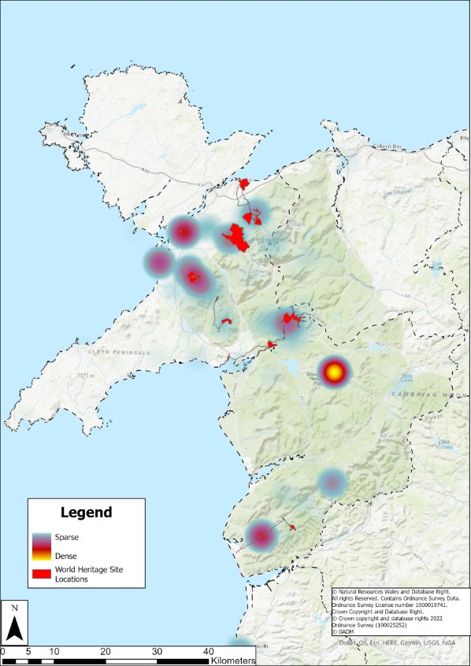

Figure 2: A heat map indicating the most popular places by social media users in the Slate Landscape area.

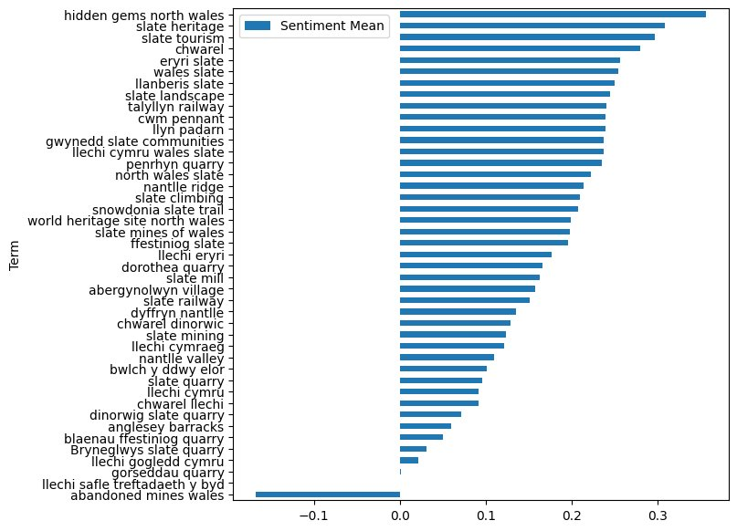
Figure 3: Sentiment analysis of popular keywords associated with the Slate Landscape

Concluding Remarks
This study demonstrates that the indigenous younger generation are proud of the slate landscape area and display a strong emotional attachment towards the place, its history, and their heritage. The participants were positive and celebratory about the site’s UNESCO status but despite the perceived advantages including global recognition, they had mixed feelings about how the new status could affect sustainable tourism practices and visitor numbers, the local economy and the site’s unique communities. Our findings showed that young people are deeply engaged with the slate sites in terms of their historical knowledge and their enjoyment is based on leisure, fitness, and social activities. However, some felt that their voices are not always heard, and they had concerns about the lack of opportunities in a broadly rural and in some deprived places. User-generated content related to the slate landscape is also predominantly positive.

Recommendations
Developing co-productive relationships between the tourism industry and the locals, with the aim of achieving strategic and measurable mile stone driven outcomes, for the younger generation, the local communities, the public and private sector, recommendations include:
- Hosting co-creation workshops to include young people and key stakeholders from public and private sector with the aim of discussing and developing creative ideas on site promotion, development, and opportunities. For example:
  - Leveraging the younger generation’s unique knowledge of the landscape by co-creating sustainable tours that combine leisure with heritage e.g., rock climbing or guided walks along with showcasing the area’s natural and cultural heritage.
  - Utilizing the slate caverns to host events for young people linked to the site and its UNESCO status to enhance local awareness e.g., festivals, competitive events, and exploring the potential of building an auditorium.
  - Evaluating and measuring the extent to which hiking and climbing safety for young people is promoted within the site and on social media.
  - Develop online and on-site campaigns e.g., social media campaigns that promote the use of specific hashtags by site visitors that encourage sustainable tourism and safe practices when hiking/climbing and signage around the sites to promote on various social media pages and platforms.
  - Implementing creative practices of place-making and environmental design that interpret and play with people’s sensory experiences, to enhance visitor experiences and engage communities with the wider context of the site (e.g., a sensory walking route with map and audio tour).
  - Exploring IoT (Internet of Things) technologies to monitor litter in scenic areas (e.g., SMART bins).
  - Developing initiatives and collaborations linked to educational tourism.

Future Research Opportunities
- Future research opportunities include a large-scale survey of young people in the slate landscape area to improve generalisation of results, and further interviews with young people who are first language Welsh.
- Netnographic analysis could extend to a more detailed audit of slate landscape-related social media sites and online communities to assess their effectiveness in communicating and engagement with this demographic.

References
Barros, C., Gutiérrez, J., and García-Palomares, J. (2022). Geotagged data from social media in visitor monitoring of protected areas; a scoping review. Current Issues in Tourism, 25(9), 1399-1415.
Braun, V. and Clarke, V., 2006. Using thematic analysis in psychology. Qualitative Research in Psychology, 3, 77-101.
Kozinets, R. V., De Valck, K., Wojnicki, A. C., and Wilner, S. J. (2010). Networked narratives: Understanding word-of-mouth marketing in online communities. Journal of marketing, 74(2), 71-89.
Rowley, J., Jones, R., Vassiliou, M. and Hanna, S. (2012). Using card-based games to enhance the value of semi-structured interviews. International Journal of Market Research, 54, 93-110.
Welsh Government. (2020). Welcome to Wales: Priorities for the Visitor Economy 2020-2025. https://www.gov.wales/sites/default/files/publications/2020-02/welcome-to-wales-priorities-for-the-visitor-economy-2020-2025.pdf

